**Git repository:**

1)basic git concept

2)foundational git flow

start a new project

working git

collaborate with others

3)More resources

**Course overview:**

1.KEYPoints about git:

Git is distributed and decentralized source control system,most operation of git are local

2.Set up and configuration:

Install in desktop,MAC,

3.Initial project

4.Working locally

5.Basic command

6.Branch and merge

7.Git hub

8.Tool set up

9.Conculsion

**Source control: it’s a backup**

We can back what change we have done in previous version .suppose we released one new version snd it was got corrupted then we can go back to the previous version and restored

* We can see the history
* Undo the changes
* Compare-what is changed in last two weeks
* Collabration and team work
* Blame
* Isolation of changes
* Experimentation-doubt
* Context switching
* Code review

**Need of source control:**

**Devolpers and engineer who are part of prog they need source control**

**They can write the code in different language**

**Source control option:**

**2 main option centralized and decentralized**

**Centralized:**

Sub version, CVS- FREE AND OPENSOURCWE OPTION

COMMERICAIL: there is a team foundation server-

Certral server means -it require connection to most of operation

Distributed means -loacl server

**Why Git**

Distributed souce control means local server it can be used ,why local server means: its secure to use all files or data/code within ur project.server is most repositry

* Massively scale:git is version control system and it can be handed external prjkct
* Open source:
* Developed for linus prjct requirement-suppose 1200 devlopers are working and 6000 code writtern all are mainted by git
* Most operations are local

**Git key concepts:**

Collection a version control; files kept together in a repository

The repository also contain the history of changes

A repository generally contain all files related to that project or application

3 states of git-that how files are manged

* Woking directory-directory in ur folder which contains all files of ur prjct.it is not manged by git
* Satging area-pre-commit holding are
* Commit -git repository

Remort repository -doubt

**Master branch:**

In master branches contains commands

**Git installation:**

Git for windows(git_scm.com)

Google chrome(install bonus section)

There are multiple ways to installing git in MAC

We need to install the latest version of git

Go to (git-for-windows.github.io)

One page load click download button

Home page will come now choose 2nd option 64bit.exe

Once installed go to download and click on open

Click run

Dn click yes

Once git set up on nxt page click yes

Click nxt

Select destination area dn after select component pop up-check additional icons

Nxt 2nd optn

After 4 time nxt click dn it automatically extracted

On final uncheck view release note dn click finish

Now click on git icon and type git version

Then close

**Git hub**

**1st create a repository on git hub then copy on local system**

**And finally sncronising the changes from local to git hub**

**Go to the** [**https://github.com**](https://github.com)

**Default account also we can use prezelicon**

**Click on cat icon then new repository button should display**

**Create new repository**

**Repository name we can give**

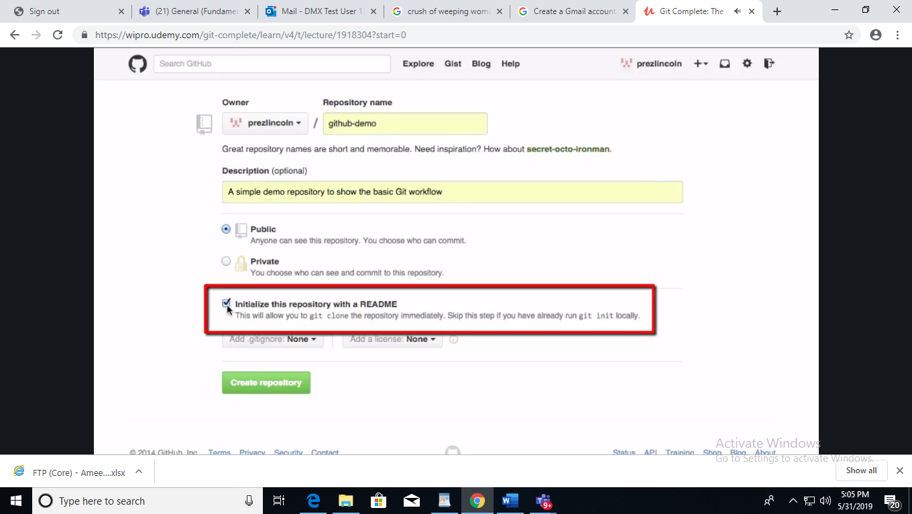

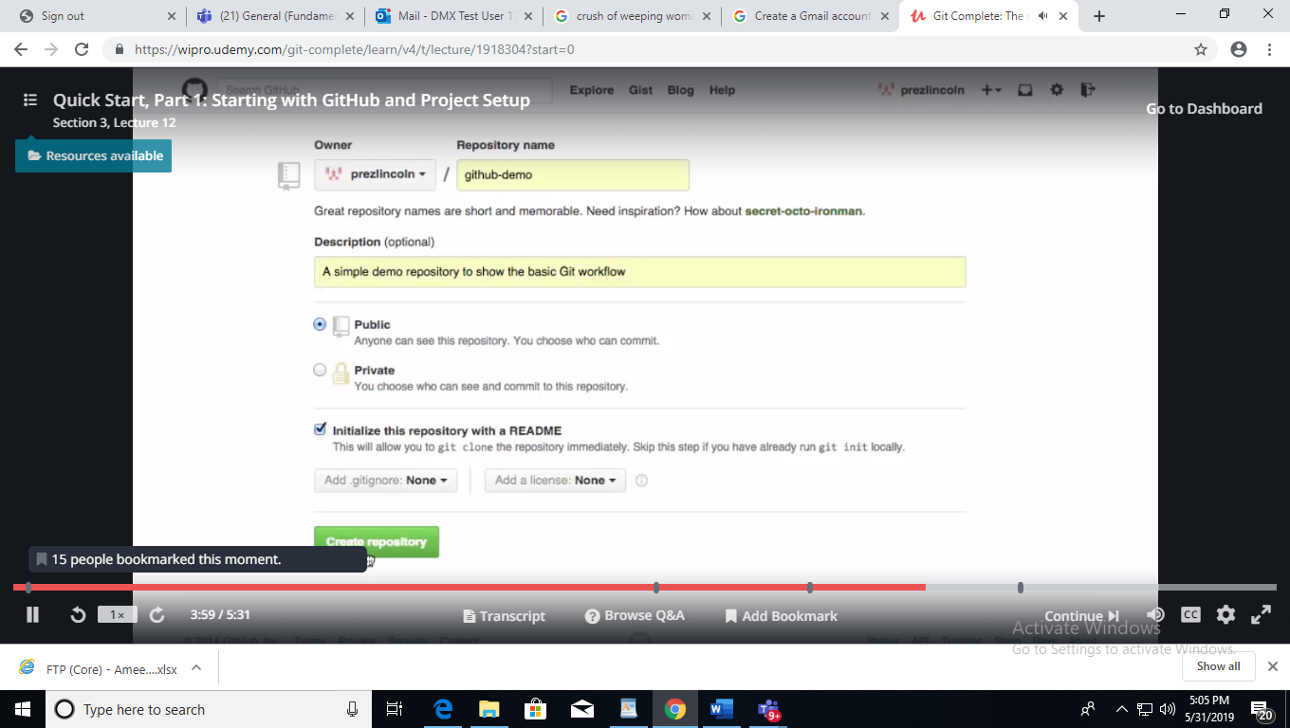

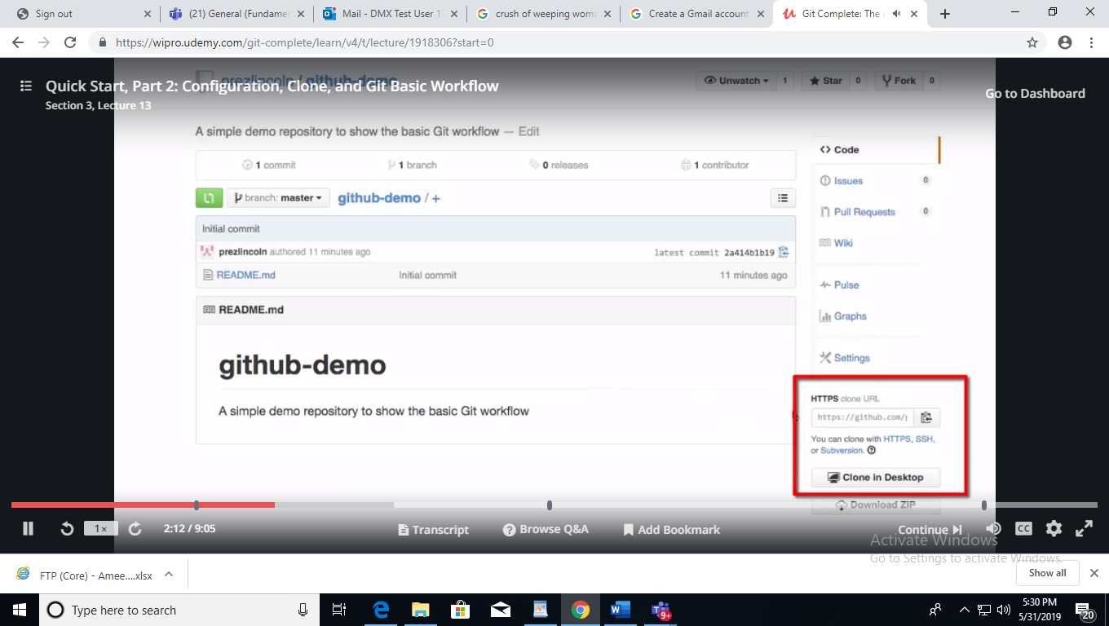

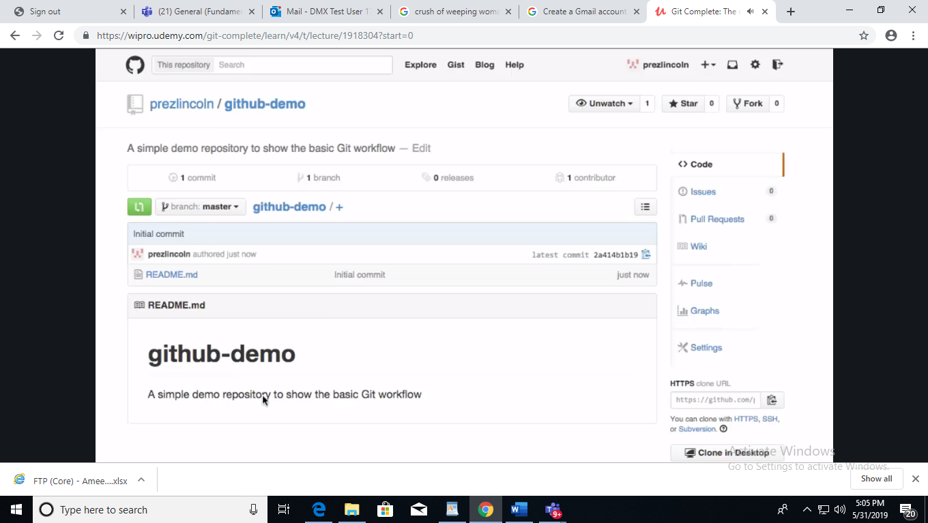

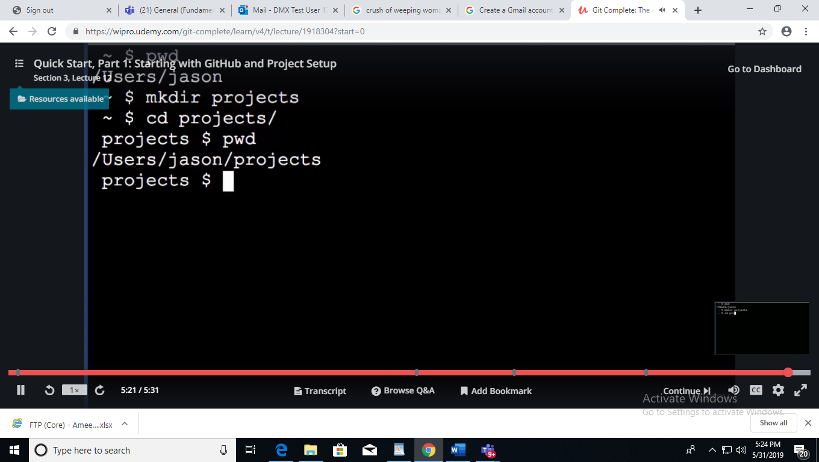

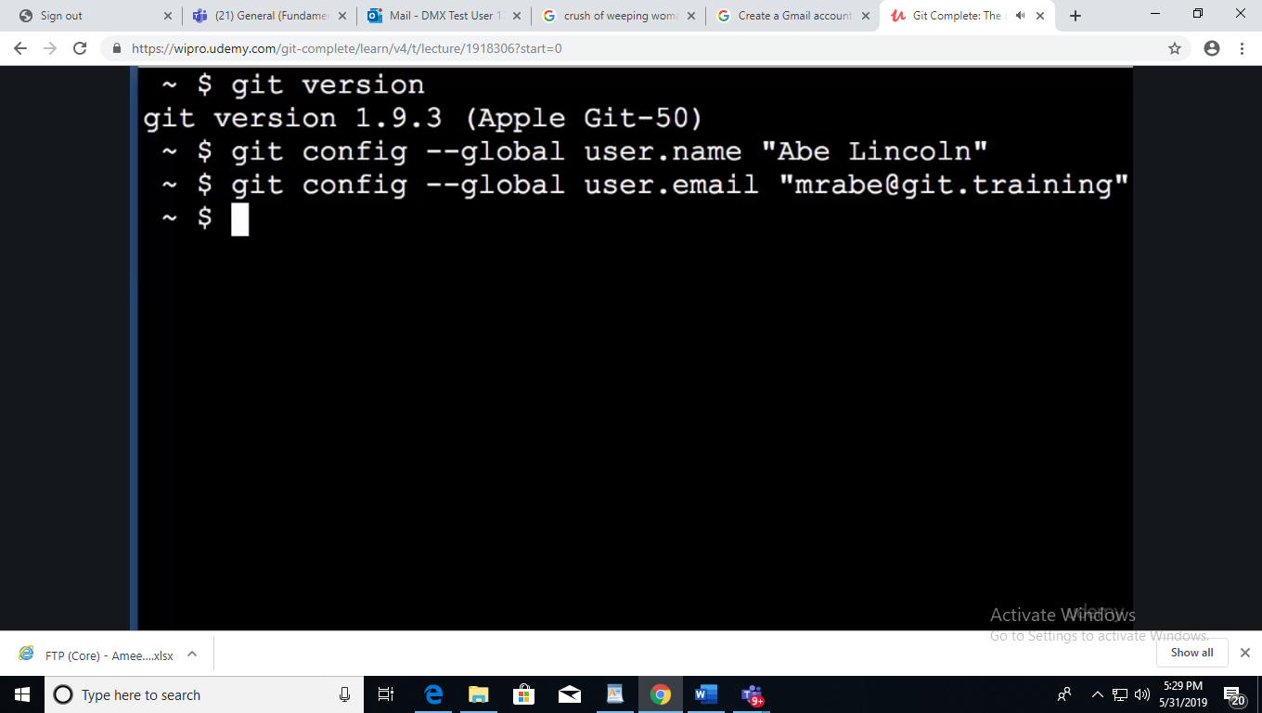

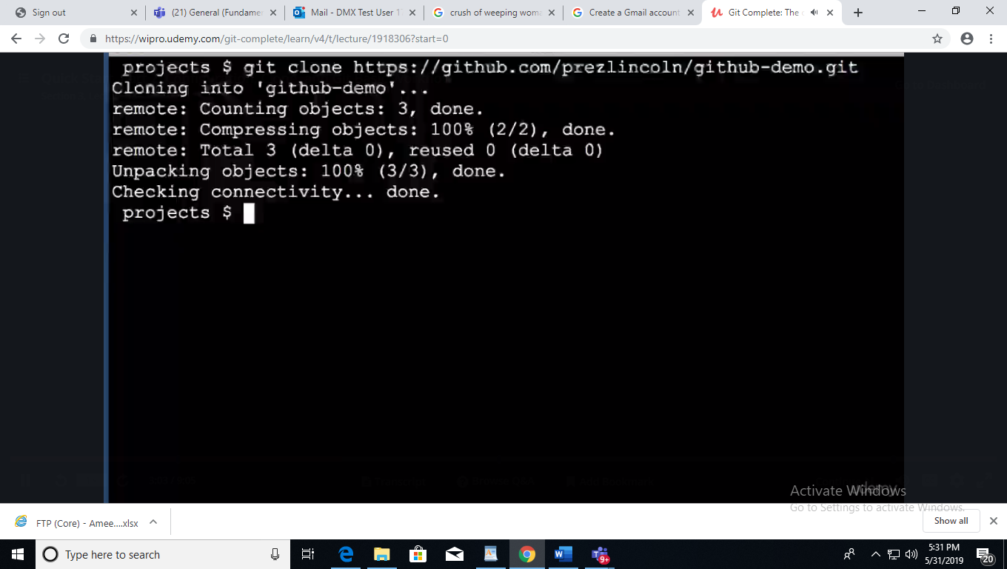

**Go git which in ur system then type the command**

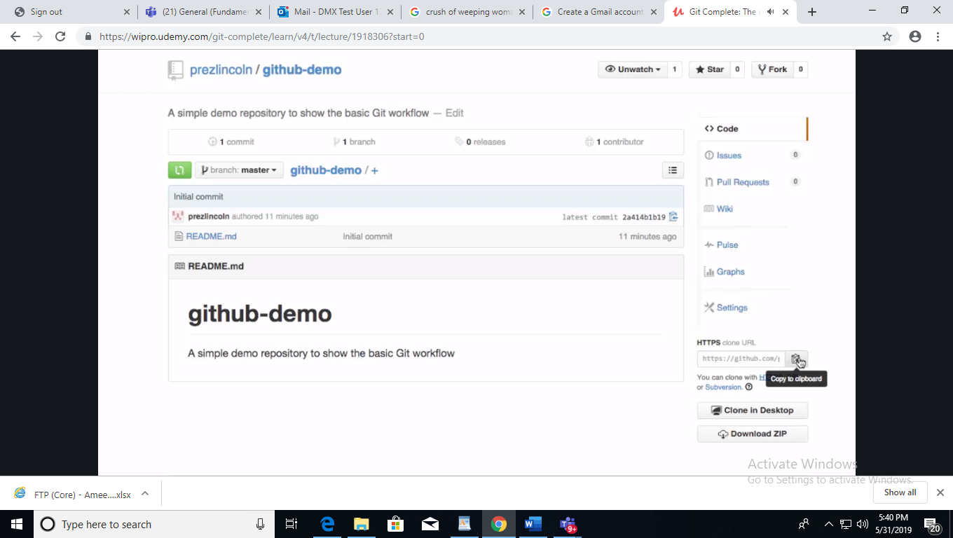

**Clone the repository**

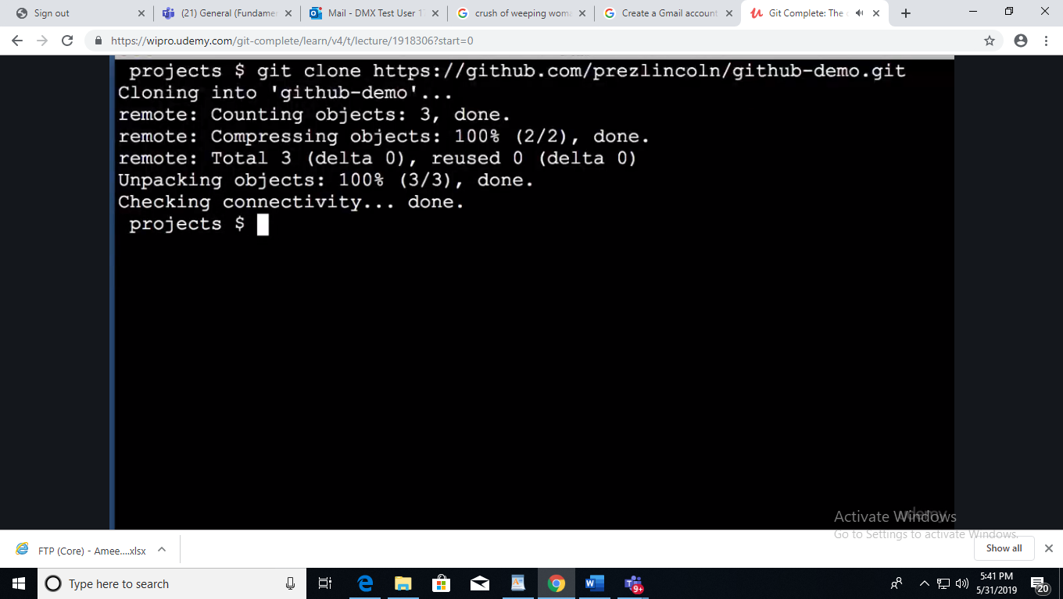

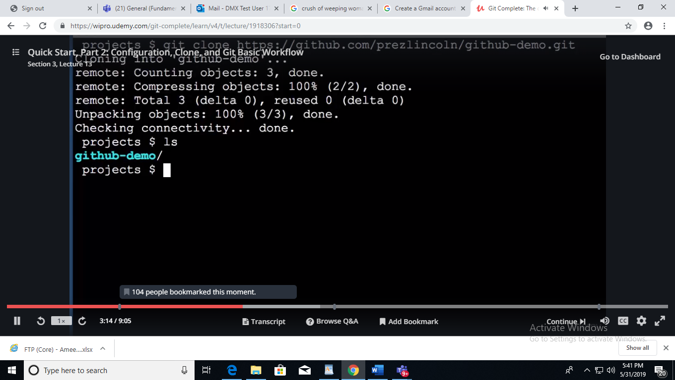

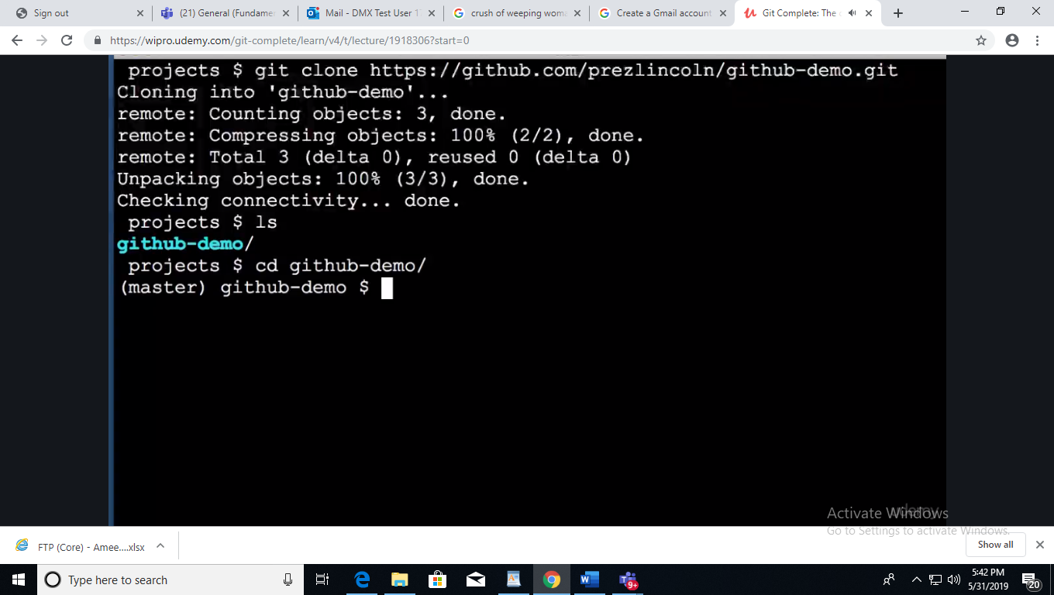**\**

**Section3 lectecure 13 re stop**

**Powershell also we can do this**

