Budget Entry Screen

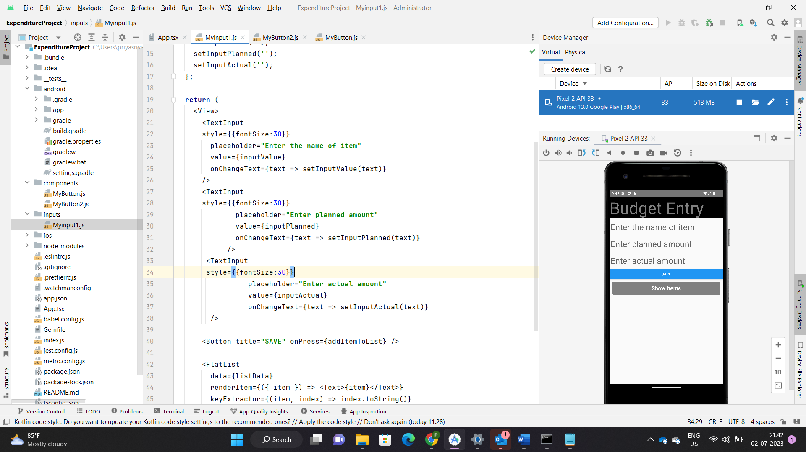User inputs to the fields

SavedValue screen

