Secure File Sharing System

# Project Overview

The **File Security System** is a web-based application designed to securely handle file storage, upload, and download using **encryption**. The system ensures confidentiality, integrity, and controlled access to sensitive files.

# Objectives

* Protect files from unauthorized access
* Enable secure upload and download functionality
* Implement encryption for stored files
* Demonstrate cybersecurity best practices in web applications

# Tools & Technologies Used

* **Backend:** Python (Flask Framework)
* **Frontend:** HTML, Tailwind CSS
* **Encryption:** Python Cryptography (Fernet)
* **IDE:** Visual Studio Code

# System Architecture / Website Flow

1. **File Upload** – User uploads a file through the web interface
2. **Encryption** – The system encrypts the file using **Fernet key** before saving
3. **Storage** – Encrypted files are stored securely in the server directory
4. **File Download** – When requested, the file is **decrypted** and shared with the authenticated user
5. **Key Management** – Encryption keys are generated, stored, and reused for consistent encryption/decryption

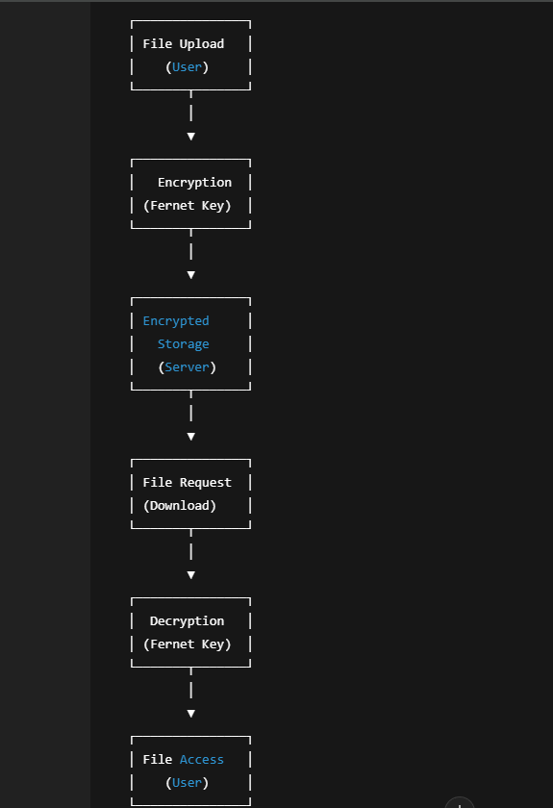

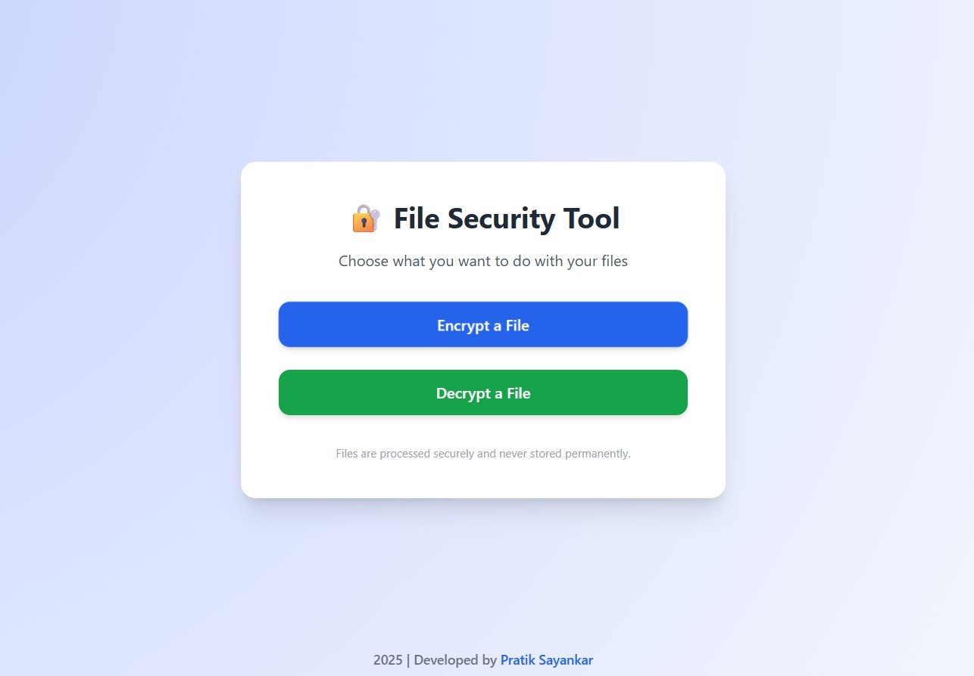

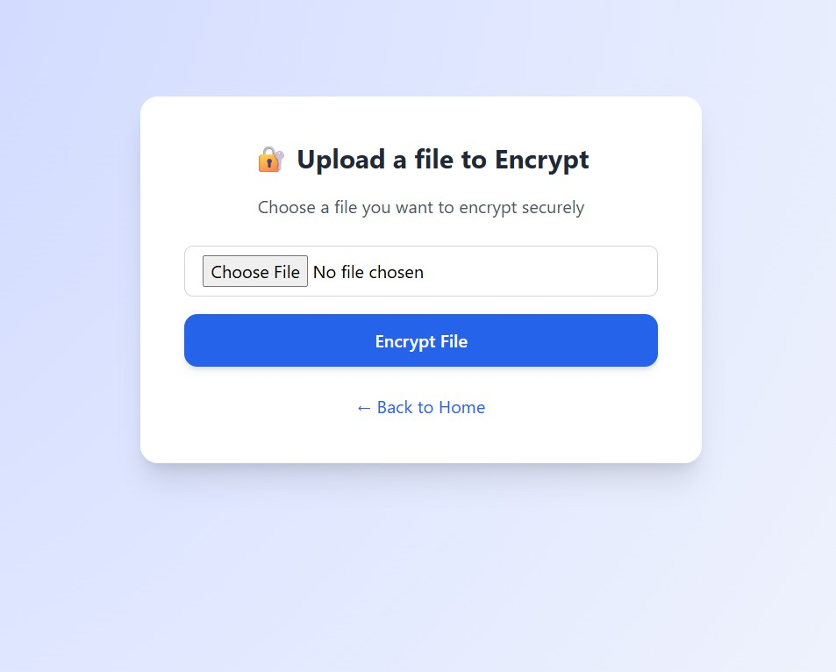

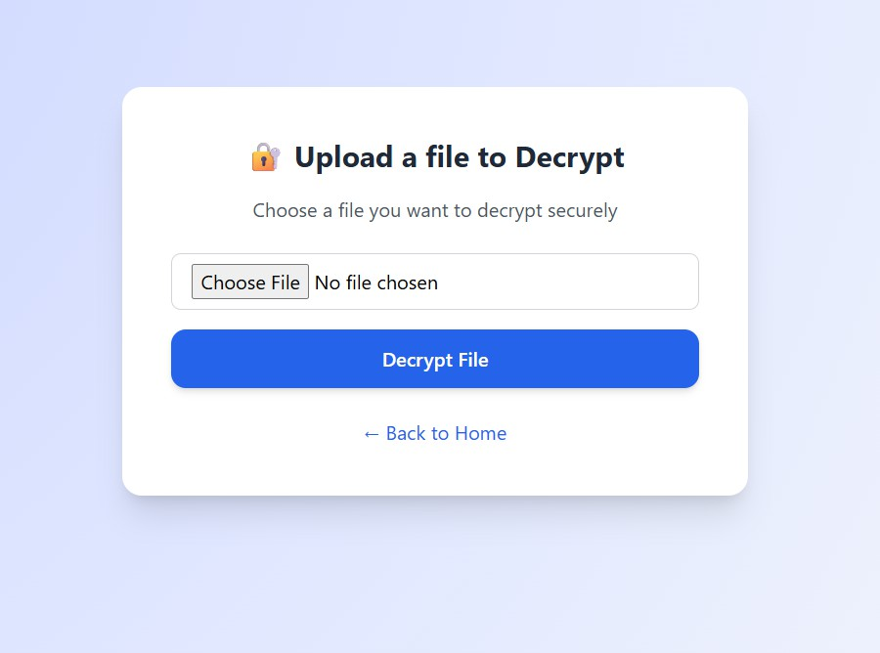

# Key Features

* + Secure **file upload & download**
  + Strong **encryption (AES via Fernet)**
  + Protection against unauthorized access
  + Lightweight **Flask web interface**

/project-root

│── main.py # Flask application

│── secret.key # Encryption key file

│── /uploads # Encrypted file storage

│── /templates # HTML templates

│ ├── index.html

│ ├── preview.html

│ └──success.html

Main Code Snippets:

* **Key Generation & Loading**
* **Encryption & Decryption Functions**
* **Upload & Download Routes (Flask)**
* 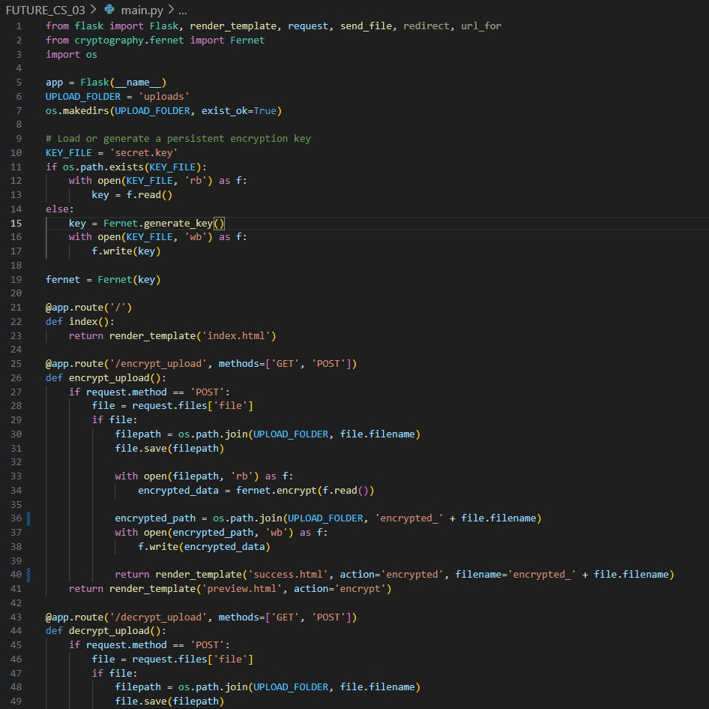**HTML Frontend Templates –** [**main.py**](http://main.py/)

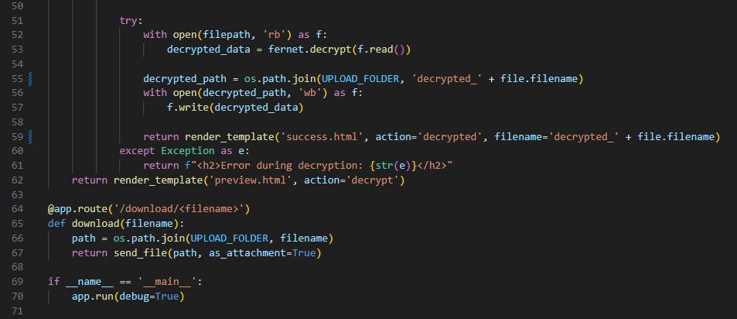

* **index.html**

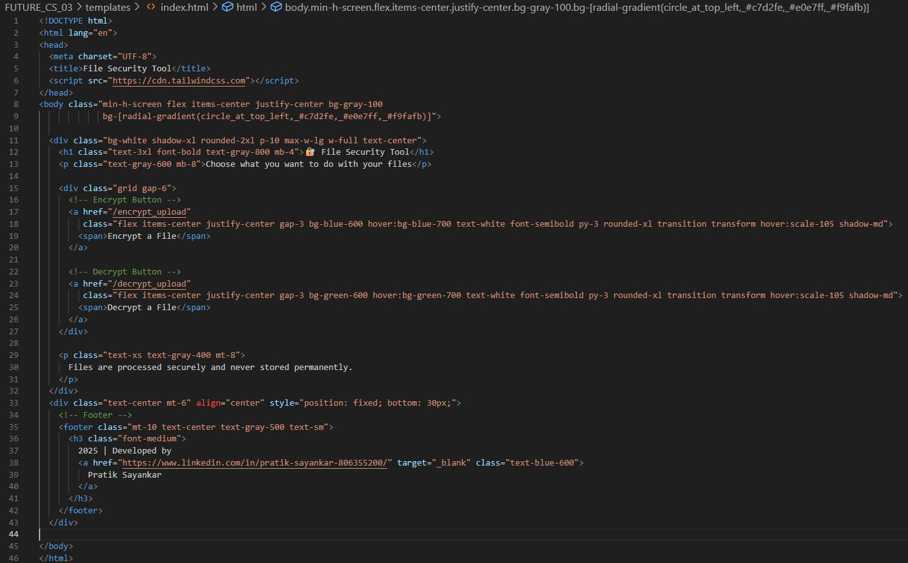

* **preview.html**

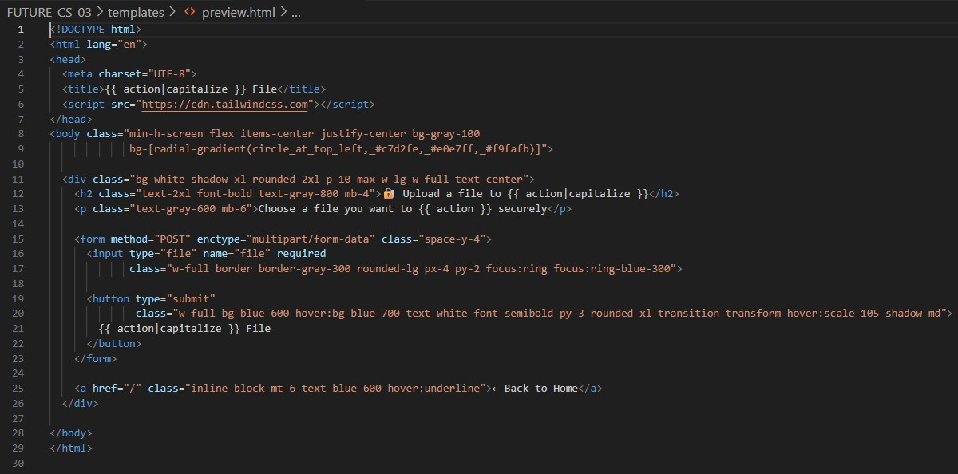

* **success.html**

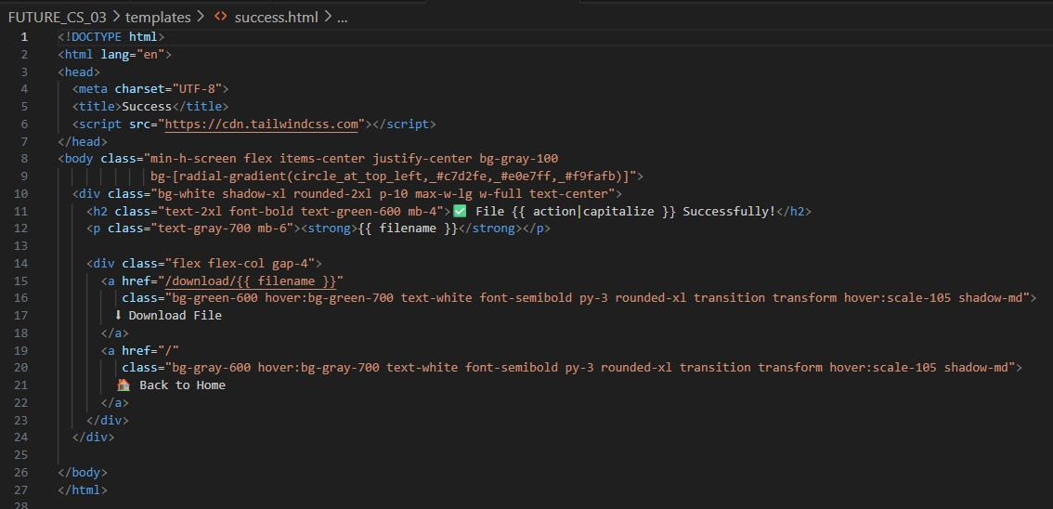

# Security Considerations

* + **Files are encrypted before storage**
  + **Encryption key is kept persistent and safe**

# Learning Outcomes

* + **Applied cryptography in real-world web apps**
  + **Understood file security workflow**
  + **Improved problem-solving in secure coding**
  + **Learned integration of backend + frontend + security**
  + **Strengthened fundamentals of confidentiality, integrity, availability (CIA triad)**

# Acknowledgement

This project was developed as part of the Future Intern Program.

Special thanks to Future Intern for the opportunity to enhance my cybersecurity and software development skills.

Priyanka Malisetty