**Catering Management System**

**Roll No: 1927**

**Introduction:**

**Online catering management system is a web application designed for a catering service where the customers can place their orders. The customers can choose from a list of menus’ displayed or can select dishes individually and place their order. The customer also needs to pay an advance amount, which is 50% of the total amount of the order, at the time of placing the order. The advance amount will not be refunded once the order has been placed. The remaining amount can either be paid using card or COD. The services are available only within the state of Goa.**

**Objective:**

**Online catering system would make it easier for the customer to place an order as the customer can view the dishes offered by the caterers and then select the dishes based on the price.**

**ERD:**

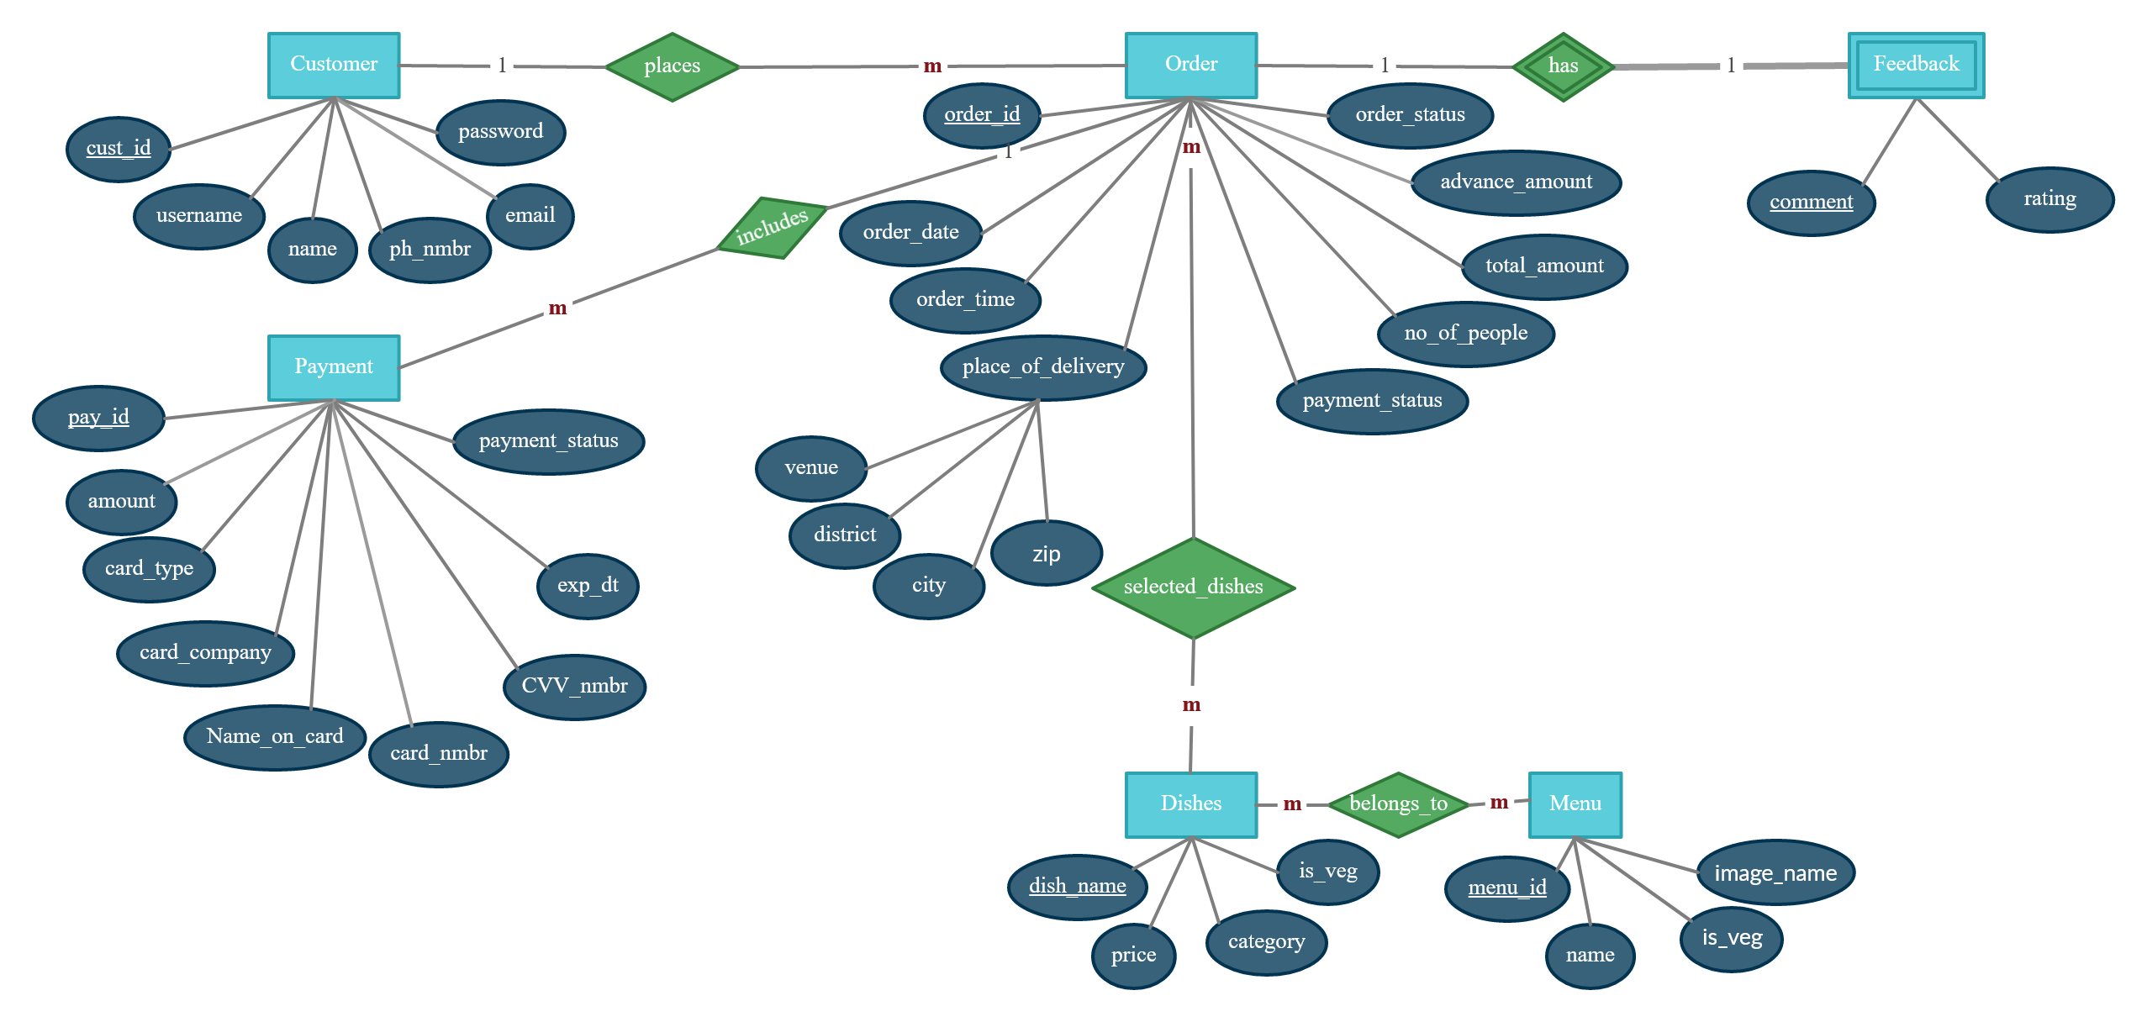

**Use case diagram:**

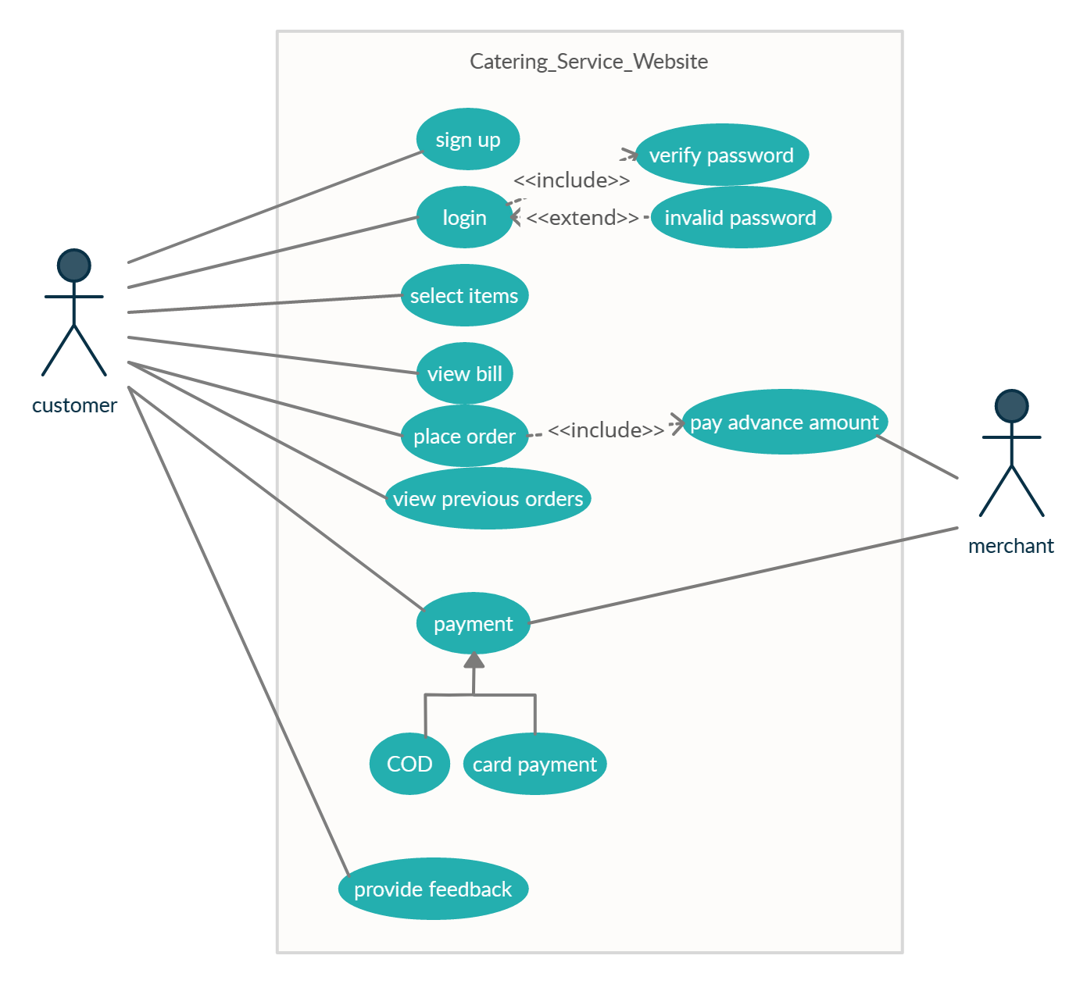

**Implementation:**

**functions.php :**

**<?php**

**include_once 'dbh.inc.php';**

**function emptyInputSignUp($name,$email,$username,$phone,$password,$password_repeat){**

**$result;**

**if(empty($name) || empty($email) || empty($username) || empty($phone) || empty($password) || empty($password_repeat)){**

**$result=true;**

**}**

**else{**

**$result=false;**

**}**

**return $result;**

**}**

**function invalidUid($username){**

**$result;**

**if(!preg_match("/^[a-zA-Z0-9]*$@/", $username)){**

**$result=true;**

**}**

**else{**

**$result=false;**

**}**

**return $result;**

**}**

**function pwdMatch($password,$password_repeat){**

**$result;**

**if($password !== $password_repeat){**

**$result=true;**

**}**

**else{**

**$result=false;**

**}**

**return $result;**

**}**

**function uidExists($conn,$username,$email){**

**$sql="SELECT * FROM customer WHERE username = ? OR email= ?;";**

**$stmt=mysqli_stmt_init($conn);**

**if(!mysqli_stmt_prepare($stmt,$sql)){**

**header("location: ../sign_up.php?error=stmtfailed");**

**exit();**

**}**

**mysqli_stmt_bind_param($stmt,"ss",$username,$email);**

**mysqli_stmt_execute($stmt);**

**$resultData=mysqli_stmt_get_result($stmt);**

**if($row=mysqli_fetch_assoc($resultData)){**

**return $row;**

**}**

**else{**

**$result=false;**

**return $result;**

**}**

**mysqli_stmt_close($stmt);**

**}**

**function createCustomer($conn,$name,$email,$phone,$username,$password){**

**$sql="INSERT INTO customer(name,email,username,phone,password) values (?,?,?,?,?);";**

**$stmt=mysqli_stmt_init($conn);**

**if(!mysqli_stmt_prepare($stmt,$sql)){**

**header("location: sign_up.php?error=stmtfailed");**

**exit();**

**}**

**$hashedPwd=password_hash($password, PASSWORD_DEFAULT);**

**mysqli_stmt_bind_param($stmt,"sssss",$name,$email,$username,$phone,$hashedPwd);**

**mysqli_stmt_execute($stmt);**

**mysqli_stmt_close($stmt);**

**session_start();**

**$_SESSION["cust_id"]=$uidExists["cust_id"];**

**$_SESSION["username"]=$uidExists["username"];**

**header("location: first_page.php");**

**exit();**

**}**

**function emptyInputLogin($username,$password){**

**$result;**

**if(empty($username) || empty($password)){**

**$result=true;**

**}**

**else{**

**$result=false;**

**}**

**return $result;**

**}**

**function loginUser($conn,$username,$password){**

**$uidExists=uidExists($conn,$username,$username);**

**if($uidExists === false){**

**header("location: login.php?error=wrong");**

**exit();**

**}**

**$pwdHashed=$uidExists["password"];**

**$checkPwd=password_verify($password, $pwdHashed);**

**if($checkPwd === false){**

**header("location: login.php?error=wronglogin");**

**exit();**

**}**

**else if ($checkPwd === true) {**

**session_start();**

**$_SESSION["cust_id"]=$uidExists["cust_id"];**

**$_SESSION["username"]=$uidExists["username"];**

**header("location: first_page.php");**

**exit();**

**}**

**}**

**?>**

**Reports:**

**1)displaying dishes category wise:**

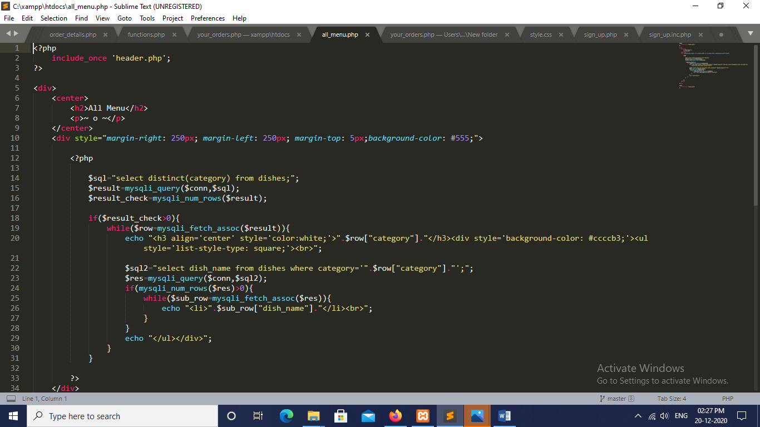

**2)Generating bill:**

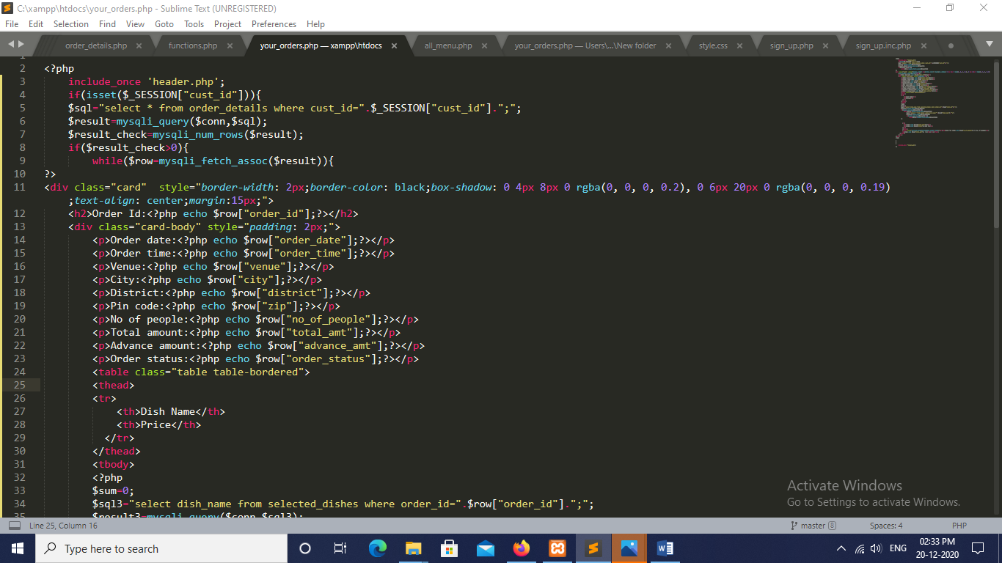

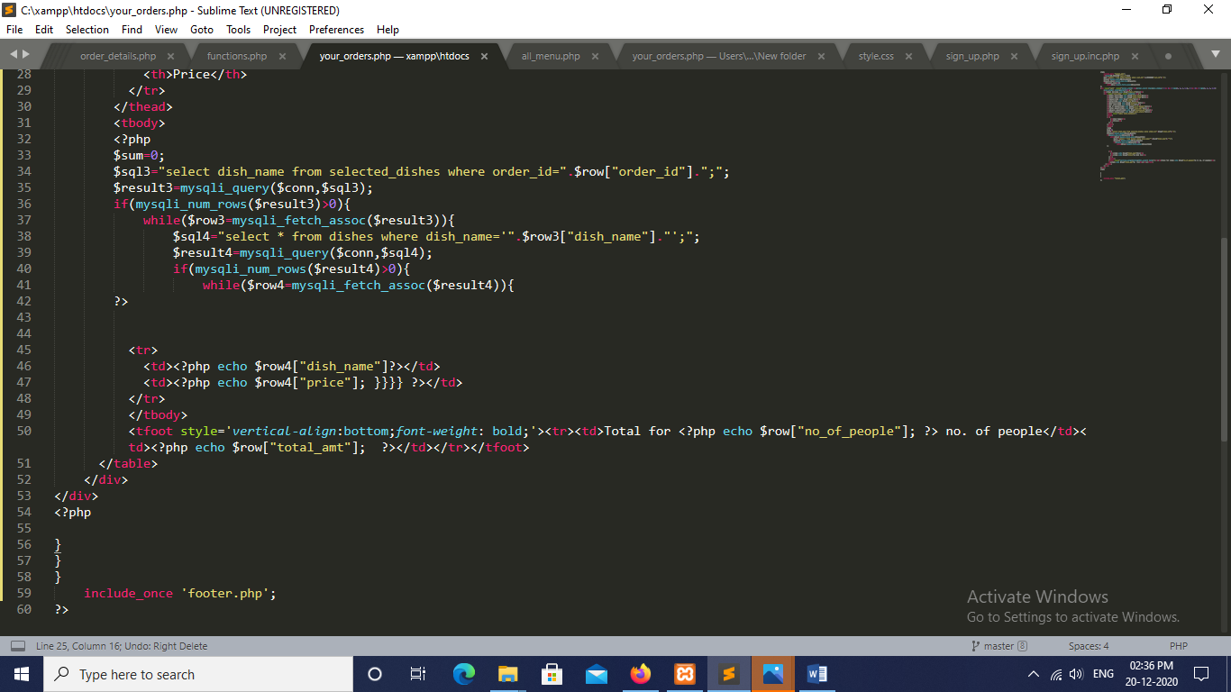

**3)Getting the additional dishes after the customer selects a menu:**

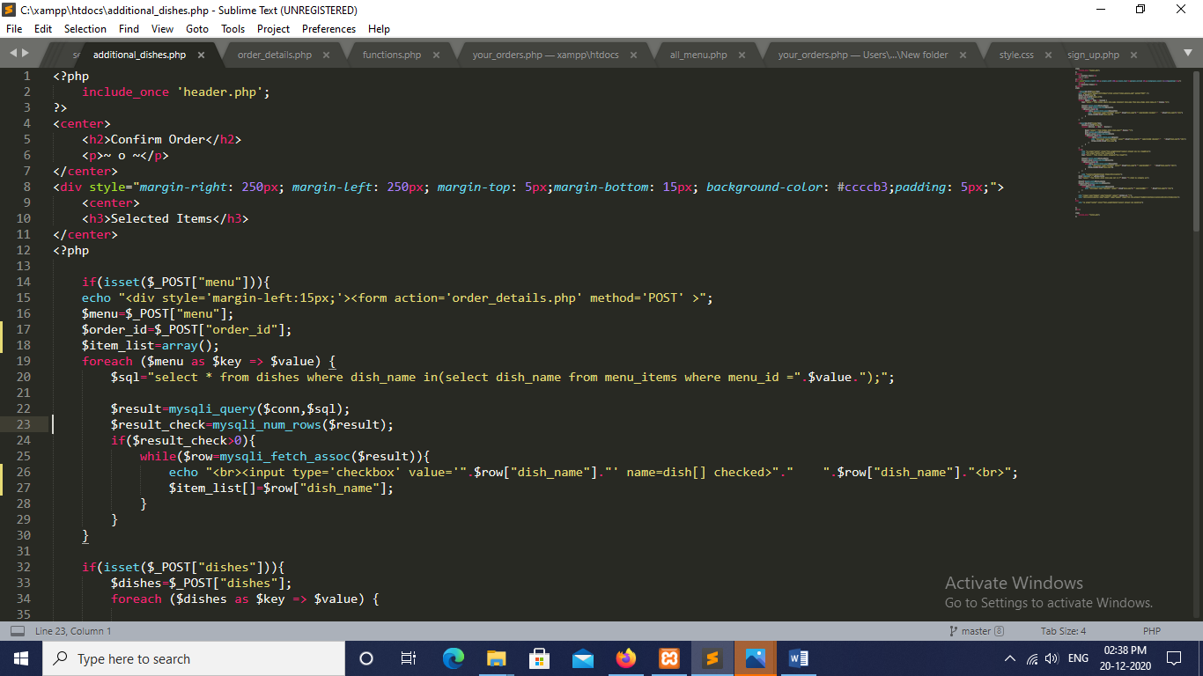

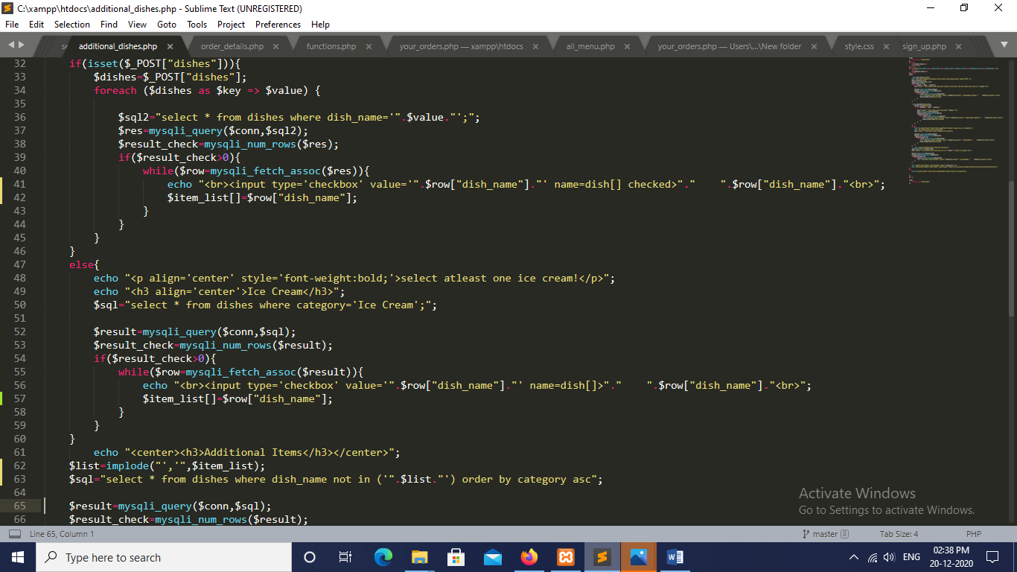

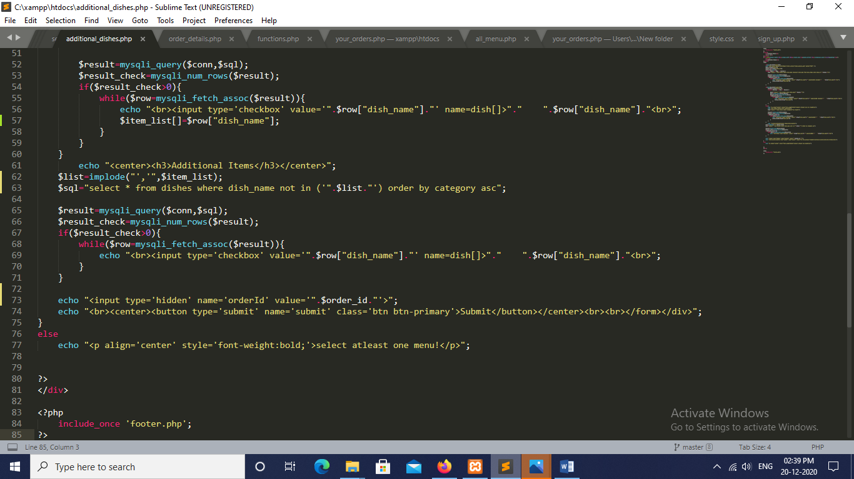

**Output Screenshots:**



