**Introduction:**

Here we bring an mobile application for water management system in rural and urban areas. As we know that there are many problems are facing in rural area related to cannel supply of water for irrigation no arrangement of water within particular distance area of light no well, no hand pump, no cannels, no ponds so with this app the people can directly communicate with government officials and similarly in urban areas we have seen that the water scarcity problem it’s happening now a days and like water distribution management problem. This problem are generally resultant in wastage of water, cost, time instead of the problem is not being solved. So far solving all problems we have smart WMS.

**Smart water management system:**

* Rural
* Urban
* Public place

**Current system problem:**

* In rural area we have seen that due to improper water utilisation and due to erosion and cutting of cannels farmer suffer from irrigation problem and also when they go for the government offices then have to wait for month for resolving the problem and hence it take time travel satigue and also loss of money due improper convenience and still there are many problems of water management related to irrigation.
* We have also seen that on many public places mostly on railway station there are wastage of water and usually like flowing of water form a pipeline that sent water in much amount and the railway official don’t resolve the problem at the time the precious water flow unusually.

**Current system problem:**

* In the urban area some water tank is very cold and near to collapse also there found to be many unusual leakage of water and there are many problems related to road and gutter.

**Benefits of water management:**

* It lowers your water related cost .
* Prioritizing water management help you eliminate water waves and keep your water infrastructure operating in peak condition using water efficiently decrease your water bill and where there are several other ways it drives down water related cost.

**Advantages:**

* Ensure that their water is nutrient rich and safe for human consumption even in remote areas. In addition they can also monitor the quality of water in pipeline and overhead tank this information empower analysis of consumption pattern and encourages more rational water consumption.

**Disadvantages of compulsory smart water meters:**

**High installation costs:** Smart water meters can be expensive to install, and some households may not be able to afford the upfront costs. This could disproportionately affect low-income households, leading to further inequalities.

**Privacy concerns:** Smart water meters can collect data on household water usage, raising privacy concerns. Some households may be uncomfortable with this level of monitoring, especially if the data is shared with third parties.

**Technical issues:** Smart water meters require a reliable internet connection and may encounter technical issues. This could lead to inaccurate billing and frustration for customers.

**Impacts on different stakeholders:**

**Water companies:** Smart water meters could help water companies to reduce their costs, as they would not have to send staff to read meters manually. However, they would need to invest in the installation and maintenance of smart meters.

**Households:** Households could benefit from more accurate billing and the ability to monitor their water usage. However, some may be unable to afford the upfront costs of installation, or may be uncomfortable with the level of monitoring.

**Rural problem:**

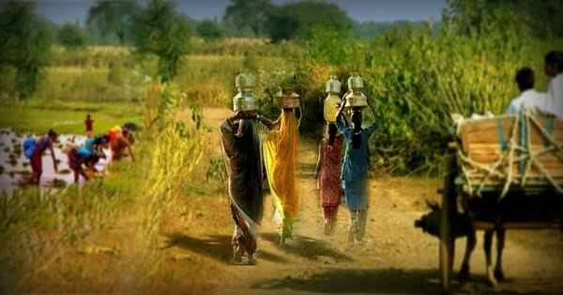

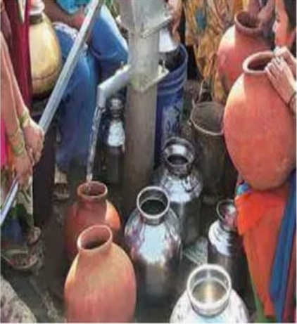

**Current problem scenario:**

* 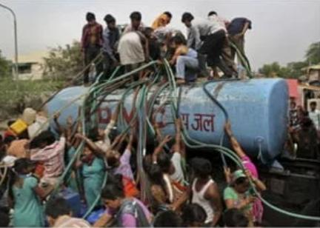Poor peoples suffering from water scarcity in urban areas
* Villagers outside the block demanding to solve a problem



**OBJECTIVE FOR SMART WATER MANAGEMENT:**

The primary objective of smart water management is reasonable and sustainable usage and recycling of water resources. Growing population, increasing environmental issues and pressure on the food and agriculture sector make water even a more precious asset.

In this respect, water management technologies and activities pursue the following objectives:

Reduce wasting water used in high volumes for agriculture, manufacturing, power production. It implies the introduction of high-tech practices like precision farming, smart irrigation, crop water management, real-time water metering and other applications of Internet of Things in agriculture. Learn about our agriculture software development services.

Improve water quality and prevent contamination by chemical waste and natural pollution such as acidification. In order to improve and maintain the quality of water, companies use sensors and IoT technology for real-time monitoring and control.

Enhance the efficiency of water systems such as water collectors, treatment plants, distribution mains and wastewater recycling centres. Using IoT and data solutions for asset management, companies can keep important measurements such as water pressure, temperature, flow, etc. At hand, integrate predictive maintenance and avoid breakage and downtime of equipment.

Implement leakage control by using smart water management devices equipped with leak and moisture sensors. Given that almost $3 billion are spent on fixing the damage caused by leakage yearly, leakage control is essential to keep water resources and budgets safe.

Practice consumption monitoring via IoT-based water management systems. It helps to optimize and keep under control the usage of water resources at different levels — households, communities, countries and the whole planet.

IoT applications in water management

There’re many Internet of Things water management systems and big data solutions in the market that demonstrate the impact these technologies make on the entire industry.

**Smart irrigation**

**IoT water management**

One of the leaders among IoT professionals, Bosch provides a sensor-based solution for smart on-demand irrigation. It measures water status in plants to make sure they get just enough water for the best nutritional value and highest yield.

Collected data on the plant’s “thirst” is combined with the weather forecast. AI algorithms then calculate the ideal irrigation scheme based on this data and help farmers keep their crops at the ultimate health.

**Water system integrity**

Sensitive strips are sensor-based leak detectors that help identify pipe or connection damage immediately and prevent heavy leakage and waste of water resources. These strips are incredibly simple to install and use both indoor and outdoor and therefore are great for households, offices and public places.

**Smart water monitoring**

Adson is a smart water company that provides a wide range of water management services from leakage detectors to irrigation management and rainwater monitoring. One of the company’s solutions is focused on smart water measurement and quality monitoring for different businesses in the supply chain — farmers, meteorologists, utility services, etc. The solution includes sensors, stations, telemetry units and software which processes generated data and creates insights for the decision-makers.

**IoT water management**

**Smart water management**

Senses provides water suppliers and utility networks with sensor and data solutions for smart water management.

Their toolkits include hardware for smart metering and reading, data analytics and customer portals as well as specific solutions for leak prevention and regulations compliance.

**Rain and storm water management**

Companies like Rain grid turn rain and storm water into a water resource able to fully provide water needs for independent households and the whole neighbourhoods. The company designs and implements IoT and data solutions to harvest rainwater and transform it into a major water source for off-grid communities. This approach shows how the application of Internet of Things in water resources management helps unlock the new options for more sustainable and resilient living.

SUBMITTED BY:

Priyadharshini P