Project-7 Submitted By:

Priyadharshini P

**PHASE 2: Put your design into innovation to solve the problem.**

# Abstract

As we know water is so precious for human being as well as for the complete nature without which it will not be possible to survive. Now a day we many complain and so many activities are going on to increase the awareness among the people for saving water and efficient utilization of it. Even though lot many efforts have been taken by government through various schemes it is becoming difficult day by day to save water for future and make efficient utilization of it. Here the main focus is on water utilization in big apartments and save water with proper distribution and monitoring system. There are two major factors for water wastage or non-efficient utilization of water in big apartment of urban areas, first point is water is available without much efforts and second point are no control on utilization of it. The intension of this work is water management, monitoring and proper distribution of water to save water and make efficient use of it so that we can satisfy the trust of others. The system has been designed in such a way that it will monitor the available water level continuously. Distribute the water in each block as per the demand or requirement and send the bill on developed application as per water utilization. System had been implemented using embedded system and communication will take through IoT.

# INTRODUCTION

In urban areas water distribution is among those issues which are not taken seriously. There are a lots of issues related to water, among those a small issue is fight among the peoples of apartments for acquiring water as per their requirement. Here this paper will define the system which will supply water in each block in channelized form from first to last user. Embedded system had been implemented using Arduino controller, as one of the easily available option so that complete model will become cost effective. Arduino will regulate the required quantity of water in proper time interval. When the flow rate of water will exceed the predetermined limit a solenoid valve will help in controlling the flow. Water supply has been done for defined duration with required speed of flow, by controlling solenoid valve turning on and off. Billing will be done as per the water utilized. If you are saving water it means saving money. One more possibility we had considered is that more requirement of water occasionally. In such cases it is possible to put the message for more water requirement, based on the available water storage it will decide that how much water you are going to get. System will continuously update about the water utilized and available storage at central place. All the details will be updated on cloud through IoT. User can communicate through the mobile application implemented for demand, monitoring and billing system.

# LITERATURE SURVEY

As per literature survey water management systems had been already implemented and invented by various researches. In the implemented system various features has been working together like uniform water distribution, monitoring of water level available in a tank, supply on demand, and online billing and payment of the water utilized. Using existing IoT (mobile network) these data could be sent to the remote server for billing from each flat and accepting request, monitoring and getting notifications are also done in this project. In this paper author has implemented a system which is monitoring the water utilization and preparing a bill as per utilization of water also water monitoring has been done remotely. Control and real time monitoring has been focused in this paper, by electronic flow rate sensors. When the system is turned on the amount of water utilized by each user is monitored and controlled by using micro controller by counting the pulses from all channels continuously. Water level indicating sensors were used to determine the level of the water in the master tank, based on the level pumping motor has been controlled. This paper presents an IoT device which helps to manage/monitor and plan the usage of water by observing the level of water in the tank.

# SYSTEM IMPLEMENTED

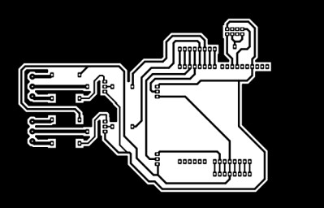

Implemented system layout

The complete project has been divided in three different modules; first module is monitoring of water level in real time. Second module will work for uniform distribution of water in every block. Third module is working for distribution of water on demand as per water utilization using IoT based mobile application. The very first step in implementation of monitoring system is to measure the water level of main tank by using ultrasonic sensor, which will provide the exact storage available. This level can be converted into volume for distribution purpose. Then allocate the water as per the persons / as per the requirement, in each flat by using IoT (mobile). Flow meter at each flat will measures the water flow provided in each flat. After predefined allocation automatically Arduino will stop supply of water. The water notification will go on registered mobile number that Today’s water supply is over so that user will also become alert while spending water. All these details will be uploaded on cloud for billing and storage purpose. If any flat user wants to use more water, he/she have to login through the mobile application. Put the complete information like User name, wing no, flat number and required amount of water. Based on the demanded amount of water, data will be verified against the available storage and only some % of available amount of water can be release for the demanded user. Complete system layout has been shown in figure.

# HARDWARE AND SOFTWARE DETAILS

**DETAILS OF HARDWARE COMPONENTS USED**

**Flow meter:**

Flow meter is used to measure the flow of water which passed through it. Inside the meter there is turbine’s structure available, when water is entered into the pipe the turbines are rotated and flow meter provide the pulses accordingly. This get measured based on the volume of water flowing.

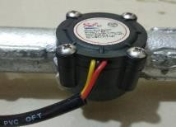

Flow sensor **Electronic valve:**

This device is used to turn on and off the flow of water according to the status of the flow meter. This uses solenoid for on and off the tap in the valve. When current start flowing magnetic field get generated which helps in controlling the turning on and off the valve.

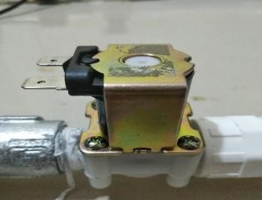

Electronic valve

**pH sensor with Arduino:**

A pH meter is a scientific instrument that measures the hydrogen-ion activity in water-based solutions, indicating its acidity or alkalinity expressed as ph. The pH meter is used in many applications ranging from laboratory experimentation to quality control.

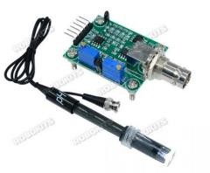

pH sensor

**Wi-Fi (ESP 8266):**

Wi-Fi module is used to upload all the data from the Arduino to the cloud and it will monitor the data, accepting requests for extra water utilization and send the notifications to the user. The Wi-Fi module works on 2.4GHz frequency and it will also use different protocols like MQTT, HTTP, HTTPS. It works on 3.3v to3.6v and it also have general purpose input and output terminals The actual used module has been shown in figure.

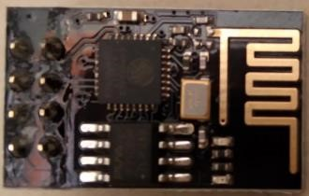

Wi-Fi module (ESP-8266)

Following is the complete functional block diagram for implemented system in figure.

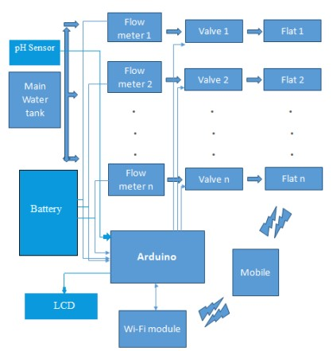

System block diagram

**Relay Circuit:**

The relay circuit is used to switch on off the electronic valve. Which is controlled by the Arduino the electronic valve works on 12v supply to provide 12v to electronic valve relay circuit is used using Arduino we can switch on and off the relay which will control the switching operation of electronic valve.

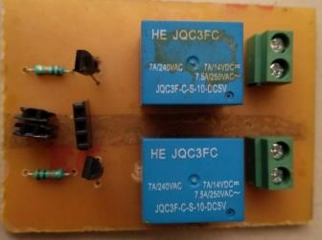 Relay circuit

**IoT:**

For the communication with the internet, we required one open server, as the data is sent to the cloud and the data can receive to client as well as stored in the server. The Blynk open server is used in the system for IoT purpose. The total Liters is used by each flat is displayed on the Blynk app. This blynk app is provided to each flat as well as owner of apartment. The request can possible through this app for extra requirement of water of each flat and according to the water level of main water tank the request is accepted by the owner of the apartment and extra charges is taken for the extra usage of water.

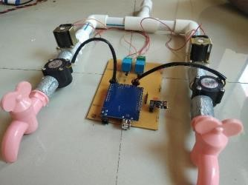

Hardware implementation of a system

**DETAILS OF SOFTWARE COMPONENTS USED**

Arduino IDE is used for the programming purpose this software is very user friendly from this software we can upload the code into Arduino and we also compile and correct the errors. Initially we test the flow sensors and solenoid valves without interfacing with Wi-Fi module.

The two taps are used to indicate to flats in the apartment, the flat 1 is named as Home 1 and flat 2 named as Home 2. As shown in the below diagram Home 1 and Home 2 water usage in the apartment is displayed on Serial monitor.

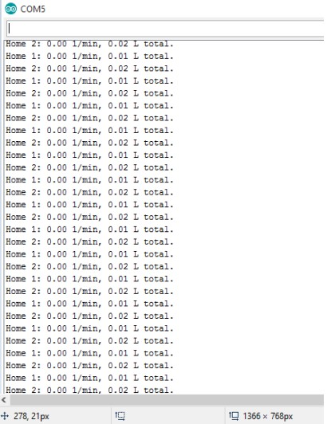

Software results

# RESULT

Water is one of the essential parts of the life. The aim of the paper is to develop a real time system which will regulate the utilization of water. It also helps in management such as water consumption and distribution there by reducing the wastage of water. Sets of sensors are used. These sensors inform about the water level of tank if the water level reaches minimum position the motor automatically starts and when it reaches maximum the motor stop automatically. This system also aims to check the quality of water using pH sensor and use to calculate the consumption of water by each of individual user which can be used for the purpose of billing.

# CONCLUSION

In this paper water management and monitoring system is designed for regulating the usage and consumption of water which is advantages to large residential societies. It also checks quality of water and is also able to do real time monitoring and calculate the consumption of water which can be used for billing purpose.