**PHASE 3:** Deploy IoT sensors (e.g., temperature sensors, pressure sensors) in public water fountains to monitor water flow and detect malfunctions. Develop a Python script on the IoT sensors to send real-time water fountain status data to the platform.

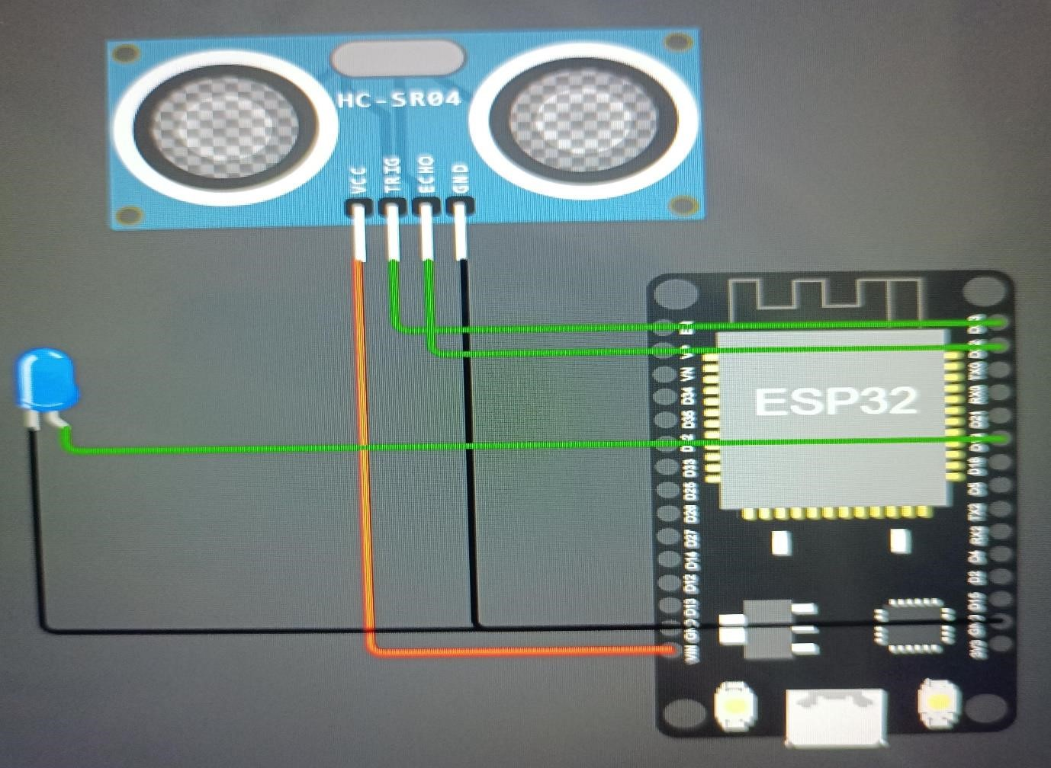

# Program

import machine import time

# Pin assignments for the ultrasonic sensor

TRIGGER_PIN = 23 # GPIO23 for trigger

ECHO_PIN = 22 # GPIO22 for echo

# Pin assignment for the LED

LEAK_LED_PIN = 19 # GPIO19 for the LED

# Set the pin modes

trigger =machine.Pin(TRIGGER_PIN,machine.Pin.OUT)

echo = machine.Pin(ECHO_PIN, machine.Pin.IN) leak_led=machine.Pin(LEAK_LED_PIN,machine.Pin.OUT)

# Function to measure distance using the ultrasonic sensor def measure_distance():

# Generate a short trigger pulse

trigger.value(0)

time.sleep_us(5)

trigger.value(1)

time.sleep_us(10)

trigger.value(0)

# Measure the echo pulse duration to calculate distance pulse_start = pulse_end = 0

while echo.value() == 0:

pulse_start = time.ticks_us() while echo.value() == 1:

pulse_end = time.ticks_us()

pulse_duration = pulse_end - pulse_start

# Calculate distance in centimeters (assuming the speed of sound is 343 m/s) distance = (pulse_duration * 0.0343) / 2 # Divide by 2 for one-way travel

return distance

# Function to check for a waterleak def check_for_leak():

# Measure the distance from the ultrasonic sensor distance = measure_distance()

# Set the threshold distance for detecting a leak (adjust as needed) threshold_distance = 10 # Adjust this value based on your tank setup

if distance < threshold_distance:

# If the distance is less than the threshold, a leak is detected return True else:

return False

# Main loop while True:

if check_for_leak():

# Blink the LED to indicate a leak leak_led.value(1) #LED ON time.sleep(0.5)

leak_led.value(0) # LED OFF time.sleep(0.5)

else:

leak_led.value(0) # LED OFF time.sleep.(1) # Delay between measurements

{

"version": 1,

"author": "Uri Shaked",

"editor": "wokwi",

"parts": [

{ "type": "wokwi-esp32-devkit-v1", "id": "esp", "top": -14.5, "left": 81.4, "attrs": {} },

{ "type": "wokwi-led", "id": "led2", "top": 6, "left": -111.4, "attrs": { "color": "blue" } },

{ "type": "wokwi-hc-sr04", "id": "ultrasonic1", "top": -113.7, "left": -71.3, "attrs": {} }

],

"connections": [

[ "esp:TX0", "$serialMonitor:RX", "", [] ],

[ "esp:RX0", "$serialMonitor:TX", "", [] ],

[ "ultrasonic1:GND", "esp:GND.2", "black", [ "v0" ] ],

[ "ultrasonic1:ECHO", "esp:D22", "green", [ "v0" ] ],

[ "ultrasonic1:TRIG", "esp:D23", "green", [ "v0" ] ],

[ "ultrasonic1:VCC", "esp:VIN", "red", [ "v0" ] ],

[ "led2:A", "esp:D19", "green", [ "v0" ] ],

[ "led2:C", "esp:GND.1", "black", [ "v0" ] ]

],

"dependencies": {}

}

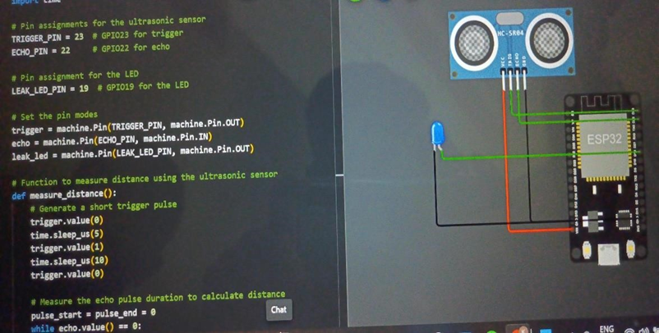

SUBMITTED BY:

Priyadharshini P