**PROJECT-NAME: IMDb**

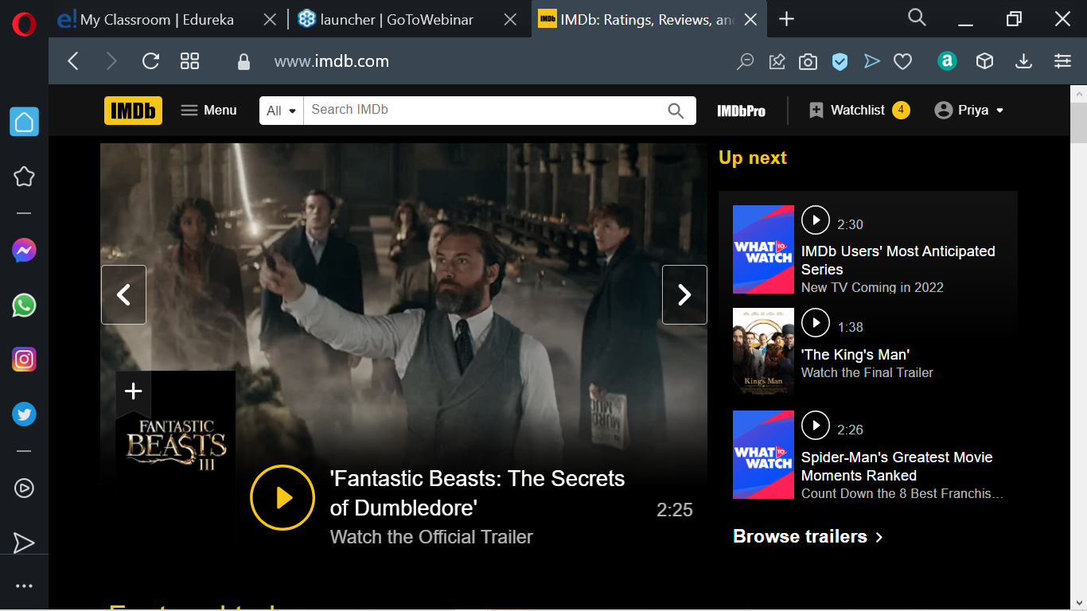

**OVERVIEW**

* It’s a repository of details about movies helps people in judging movies based on user’s ratings and reviews
* Tracks record of Oscar winners and other global awards
* Has an link to OTT platforms
* Has a record of Crew Members

1. **Details:**

* **Login**
* **Signup**
* **Movie cards**
* **Details Page**
* **Trailers**
* **Review page**
* **Star Ratings**
* **Filter Movies by Genre**
* **Adding Watchlist**
* **Direct link to OTT Plantform**
* **Casting Members page**
* **Award Film Section**
* **Booking Ticket**
* **Top Movies List rated by IMDb users**
* **Details about TV shows .**
* **OTT Series and Link**

**Movie Card has a Link that took you directly to the where we want such as through a washlist or OTT links or take you to review and rating page.**

**Through that ratings and review page where you can rate movies based out of 10 and can review your thoughts about that movies.**

**Critic’s review or news page about the movie-basically the link.**