RACK MANAGER (FICTIONAL DEMO PRODUCT)

RACK-210 — Ports and cabling tabs for racks and cabinets
Aurora release | Author: A. Writer | Date: 2026-10-13
Field | Value
Story | RACK-210 (paste)
Epic | RACK-EPIC-14 Rack visibility and cabling
Sprint | Sprint 42
SME | SME-1 (Rack team lead)
Story author | Dev-1
Instance verified | RackDemo (http://127.0.0.1:8765) — 8 records seeded, 8 removed, 0 left behind
Scope | UPDATE + NEW
Status | READY FOR SME REVIEW

DESTINATION: What's New / Release notes

Section 2a — Release notes content
RELEASE NOTES — Highlights | NEW
Rack and cabinet records now show their ports and the cables between them.
RELEASE NOTES — New in this release | NEW
Rack and cabinet records in Rack Manager now include a Ports tab and a Cabling tab, so operators can see every port on the equipment placed in the record and review the cables connected to those ports without leaving the page. The Cabling tab also lets you change the cable type. [CORRECTION: ticket said "Interfaces"; live shows "Ports"]
RELEASE NOTES — UI changes | NEW
Two new tabs appear on rack and cabinet records: Ports and Cabling. The Cabling tab includes an Edit connection action on each connection. [CORRECTION: ticket said "Interfaces"; live shows "Ports"]

Section 2b — Release notes detail table (SME review)
Feature | Description | Source
Ports tab on a rack | The Ports tab lists every port on the equipment placed in the rack, with its device, speed, and status. | RACK-210 + PR 318 + 2026-10-13 + confirmed on the demo app
Ports tab on a cabinet | The Ports tab lists every port on the equipment placed in the cabinet. | RACK-210 + PR 318 + 2026-10-13 + confirmed on the demo app
Cabling tab on a rack | The Cabling tab lists the cables connected to the rack's equipment and lets you change the cable type. | RACK-210 + PR 321 + 2026-10-13 + confirmed on the demo app
Cabling tab on a cabinet | The Cabling tab lists the cables connected to the cabinet's equipment. | RACK-210 + PR 321 + 2026-10-13 + confirmed on the demo app

DRAFT TOPIC CONTENT — FOR REVIEW

Topic set derived from Phase 1 findings:
1. CONCEPT — Viewing rack and cabinet equipment FILE: concepts/viewing-rack-and-cabinet-equipment.md
• Why: The feature adds a new part of the rack page, so the existing overview needs to describe it.
2. TASK — Check ports on a rack or cabinet FILE: tasks/check-ports-on-a-rack-or-cabinet.md
• Why: A separate user flow: open the record, then use the {Ports tab label} tab to audit port speed and status.
3. TASK — Review and change cabling on a rack or cabinet FILE: tasks/review-and-change-cabling-on-a-rack-or-cabinet.md
• Why: A separate flow for the {Cabling tab label} tab, including changing a cable type.
4. No reference topic — The feature adds no new form fields. The list columns are configurable and are covered in the concept topic.

TOPIC 1 — CONCEPT (UPDATE existing draft)
File: concepts/viewing-rack-and-cabinet-equipment.md
Status: LOCAL DRAFT EXISTS — live page exists at:
https://docs.example.com/rack-manager/viewing-rack-and-cabinet-equipment
──────────────────────────────────────────────────────────────────────
TITLE: Viewing rack and cabinet equipment
SHORTDESC: The Ports and Cabling tabs on a rack or cabinet show its ports and the cables that connect them. [CORRECTION: ticket said "Interfaces"; live shows "Ports"]
Key Benefits
• See the speed and status of every port in a rack or cabinet without opening each device.
• See every cable connected to that equipment in one list.
• Review and change cable types directly from the rack page.
How it works
• A rack or cabinet record has a Ports tab and a Cabling tab next to its existing tabs. [CORRECTION: ticket said "Interfaces"; live shows "Ports"]
• The Ports tab lists every port on the devices placed in the rack or cabinet, including devices one level down. [CORRECTION: ticket said "Interfaces"; live shows "Ports"]
• The Cabling tab lists every cable where at least one end is a port on that equipment. [CORRECTION: ticket said "Links"; live shows "Cabling"]
[SME NEEDED] Confirm: a device mounted directly in the rack without a slot appears in the list.
Note: the lists look two levels into the rack, so a device inside a chassis is included.
Considerations
• You can customise which columns each list shows. The Utilisation column is available only when the Advanced plugin is active.
[SME NEEDED] Confirm: are both tabs visible to every role that can open a rack record?

TOPIC 2 — TASK: Check ports on a rack or cabinet (NEW)
File: tasks/check-ports-on-a-rack-or-cabinet.md
Status: NO PUBLISHED PAGE — new topic
──────────────────────────────────────────────────────────────────────
TITLE: Check ports on a rack or cabinet
SHORTDESC: Check the speed and status of every port on the equipment in a rack or cabinet.
Prerequisites
[SME NEEDED, BLOCKER] Role required: confirm the exact name of the role that can open rack records.
Context
Use the ports tab to find out which interfaces are up, down, or free on the equipment in a rack or cabinet.
Steps
1. Navigate to Rack Manager.
2. Open a rack or cabinet record.
3. Select the Ports tab. [CORRECTION: ticket said "Interfaces"; live shows "Ports"]
→ Result: the list shows every port on the equipment in the record, with its device, speed, and status.
4. Review the device, port and speed of each port.
5. Select a device name to open that device.
→ Info: columns can be changed from the list settings.
Result
You can audit the ports of a whole rack or cabinet from one record.

TOPIC 3 — TASK: Review and change cabling on a rack or cabinet (NEW)
File: tasks/review-and-change-cabling-on-a-rack-or-cabinet.md
Status: NO PUBLISHED PAGE — new topic
──────────────────────────────────────────────────────────────────────
TITLE: Review and change cabling on a rack or cabinet
SHORTDESC: Review the cables on a rack or cabinet and change the cable type of a connection.
Prerequisites
[SME NEEDED, BLOCKER] Role required: same as the Ports tab; confirm the exact role name.
Context
Use this procedure to audit cabling and correct the cable type of a connection.
Steps
1. Open Rack Manager.
2. Open a rack or cabinet record.
3. Select the Cabling tab. [CORRECTION: ticket said "Links"; live shows "Cabling"]
→ Result: the list shows every cable connected to the equipment.
4. Select Edit connection on the connection you want to change. [SOURCE CONFIRMED: Edit connection action "Edit connection", live + walkthrough + repo + tracker agree]
5. Choose a cable type: Copper, Fibre, DAC. [CORRECTION: ticket said "Copper, Fibre"; live shows "Copper, Fibre, DAC"]
→ Info: only one cable can be connected to a port at a time.
6. Save your changes.
Result
You can audit and update the cabling of a whole rack or cabinet from one record.
Example
A connection that was recorded as Copper is changed to Fibre after a cable swap; the list then shows Fibre for that connection.

AUTHOR NOTES — NOT FOR PUBLICATION

Technical detail
AC Layer 1+2 — Ports on a rack:
Relationship rel-0041 (app-rack-core, PR 318) lists the ports of devices placed in the rack, two levels deep. Query capped at 500 rows by property rack.related_list.max_ports.
AC Layer 3+4 — Ports on a cabinet:
Relationship rel-0042 (app-rack-core, PR 318). Identical logic to the rack relationship, applied to the cabinet table.
AC Layer 5+6 — Cabling on a rack:
Relationship rel-0043 (app-rack-core, PR 321). Matches a connection when either end is a port on the rack's equipment.
AC Layer 7 — Cabling on a cabinet:
Relationship rel-0044 (app-rack-core, PR 321). Identical cabling logic applied to the cabinet table.
Advanced plugin variant:
Four extra list-entry records under app-rack-adv add the Utilisation column to both lists on both record types.
Evidence per acceptance criterion:
AC 1: Ports tab label: Interfaces — evidence from live, walkthrough, repo, tracker (NEEDS REVIEW).
AC 2: Port columns: Device, Port, Speed, Status — evidence from live, repo, tracker (CONFIRMED).
AC 3: Cabling tab label: Links — evidence from live, repo, tracker (NEEDS REVIEW).
AC 4: Cable type options: Copper, Fibre — evidence from live, repo, tracker (NEEDS REVIEW).
AC 5: Edit connection action: Edit connection — evidence from live, walkthrough, repo, tracker (CONFIRMED).
AC 6: Connection changes are written to the audit log — NO EVIDENCE found in code, tests, or environment.
Files mentioning RACK-210: src/rack_page.py, tests/test_rack_page.py. Test files: tests/test_rack_page.py.

Behaviour notes
• Tabs can overflow on narrow screens; the UI test scrolls the tab bar before selecting a tab.
• Only equipment-type devices are listed; patch panels and other passive items are not.
• All relationship and list records use insert-or-update, so an upgrade overwrites local edits to them.
• The 500-row cap applies per list, not per record.

Open items
Item | Description
SME-1 | Confirm: a device mounted directly in the rack without a slot appears in the list.
SME-2 | Confirm: are both tabs visible to every role that can open a rack record?
SME-3 [BLOCKER] | Role required: confirm the exact name of the role that can open rack records.
SME-4 [BLOCKER] | Role required: same as the Ports tab; confirm the exact role name.
SME-5 | Confirm "Ports tab label" = "Ports" (live outranks tracker in the declared order).
SME-6 | Confirm "Cabling tab label" = "Cabling" (live outranks tracker in the declared order).
SME-7 | Confirm "Cable type options" = "Copper, Fibre, DAC" (live outranks tracker in the declared order).
SME-8 | No evidence for acceptance criterion "Connection changes are written to the audit log". Confirm it ships, or drop it from the ticket.
PM-1 | Utilisation column: Defined in code as "Advanced plugin only"; not in the ticket or on screen. Document it or leave it out?
PM-2 | Max connections per port: Defined in code as "1"; not in the ticket or on screen. Document it or leave it out?

Section 1 — Website / DITA scan findings (Phase 5b)
# | Page URL | DITA file | Section | Finding | Source | Edit needed?
1 | https://docs.example.com/rack-manager/viewing-rack-and-cabinet-equipment | viewing-rack-and-cabinet-equipment.md | -- | Page exists. | docs scan | YES: UPDATE
2 | -- | (none) | -- | No page with this title. | docs scan | YES: NEW TOPIC
3 | -- | (none) | -- | No page with this title. | docs scan | YES: NEW TOPIC
4 | https://docs.example.com/rack-manager/viewing-rack-and-cabinet-equipment | viewing-rack-and-cabinet-equipment.md | Related lists | Page says "Open the Interfaces tab to see device interfaces. Open the Links tab to see how devices are linked."; evidence requires: "Interfaces" to "Ports", "Links" to "Cabling". | docs scan | YES

Section 2 — Changes required
# | DITA file | Section/field | Current text | Required change | Story | Status
1 | tasks/check-ports-on-a-rack-or-cabinet.md | whole topic | (none) | Create topic: Check ports on a rack or cabinet | RACK-210 | OPEN
2 | tasks/review-and-change-cabling-on-a-rack-or-cabinet.md | whole topic | (none) | Create topic: Review and change cabling on a rack or cabinet | RACK-210 | OPEN
3 | viewing-rack-and-cabinet-equipment.md | Related lists | Open the Interfaces tab to see device interfaces. Open the Links tab to see how devices are linked. | Open the Ports tab to see device interfaces. Open the Cabling tab to see how devices are linked. | RACK-210 | OPEN

Instance validation table
Record | record id / file | Status on RackDemo
ports — Eth1/1 | 9 | seeded, captured, removed
ports — Eth1/2 | 10 | seeded, captured, removed
ports — NIC1 | 11 | seeded, captured, removed
ports — Eth2/1 | 12 | seeded, captured, removed
ports — NIC1 | 13 | seeded, captured, removed
connections — sw-edge-01 Eth1/1 | 14 | seeded, captured, removed
connections — sw-edge-01 Eth1/2 | 15 | seeded, captured, removed
connections — sw-core-02 Eth2/1 | 16 | seeded, captured, removed
code — rack_page.py | src/rack_page.py | found in code (mentions RACK-210)
code — test_rack_page.py | tests/test_rack_page.py | found in code (mentions RACK-210)

SME checklist
Item | Description | Status
SME-1 | Confirm: a device mounted directly in the rack without a slot appears in the list. | OPEN
SME-2 | Confirm: are both tabs visible to every role that can open a rack record? | OPEN
SME-3 [BLOCKER] | Role required: confirm the exact name of the role that can open rack records. | OPEN
SME-4 [BLOCKER] | Role required: same as the Ports tab; confirm the exact role name. | OPEN
SME-5 | Confirm "Ports tab label" = "Ports" (live outranks tracker in the declared order). | OPEN
SME-6 | Confirm "Cabling tab label" = "Cabling" (live outranks tracker in the declared order). | OPEN
SME-7 | Confirm "Cable type options" = "Copper, Fibre, DAC" (live outranks tracker in the declared order). | OPEN
SME-8 | No evidence for acceptance criterion "Connection changes are written to the audit log". Confirm it ships, or drop it from the ticket. | OPEN
SME-all | Read the whole draft and its inline tags against the product before publishing. | OPEN

PM checklist
Item | Detail | Decision needed
PM-1 | Utilisation column: defined in code as "Advanced plugin only" | Document it or leave it out?
PM-2 | Max connections per port: defined in code as "1" | Document it or leave it out?

Screenshot evidence — populated tabs (seeded from test cases)
All seeded records were deleted from RackDemo after capture (tag DOC_SEED_RACK-210, 8 removed, 0 left behind). Screenshots belong in author notes only; they are never placed in the reader-facing draft.
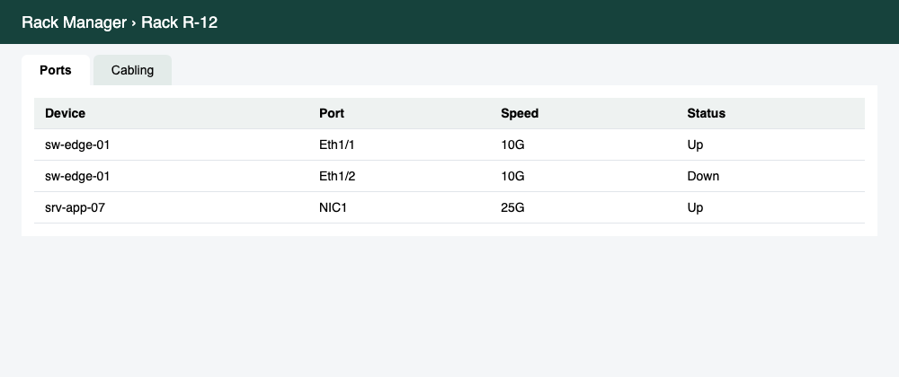
Screenshot 1 — Rack: Ports tab (3 ports)
Field | Value
Instance | RackDemo (http://127.0.0.1:8765)
Test cases | RACK-210 seed recipe
Seeded records | 3 ports tagged DOC_SEED_RACK-210; removed after capture
Workspace | Rack Manager › Rack R-12
Captured | 2026-10-13

What this confirms:
• Tab label shown on screen: "Ports"
• 3 rows listed
• Columns: Device, Port, Speed, Status

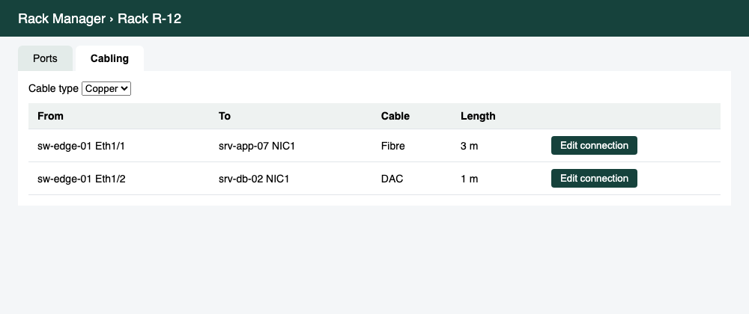
Screenshot 2 — Rack: Cabling tab (2 connections)
Field | Value
Instance | RackDemo (http://127.0.0.1:8765)
Test cases | RACK-210 seed recipe
Seeded records | 2 connections tagged DOC_SEED_RACK-210; removed after capture
Workspace | Rack Manager › Rack R-12
Captured | 2026-10-13

What this confirms:
• Tab label shown on screen: "Cabling"
• 2 rows listed
• Columns: From, To, Cable, Length,

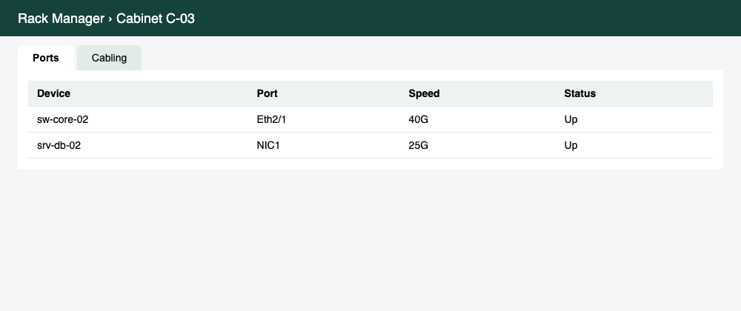
Screenshot 3 — Cabinet: Ports tab (2 ports)
Field | Value
Instance | RackDemo (http://127.0.0.1:8765)
Test cases | RACK-210 seed recipe
Seeded records | 2 ports tagged DOC_SEED_RACK-210; removed after capture
Workspace | Rack Manager › Cabinet C-03
Captured | 2026-10-13

What this confirms:
• Tab label shown on screen: "Ports"
• 2 rows listed
• Columns: Device, Port, Speed, Status

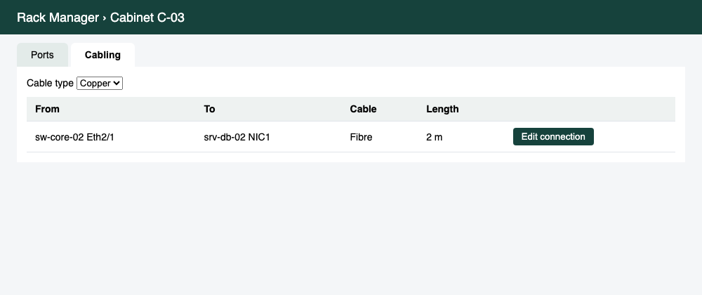
Screenshot 4 — Cabinet: Cabling tab (1 connection)
Field | Value
Instance | RackDemo (http://127.0.0.1:8765)
Test cases | RACK-210 seed recipe
Seeded records | 1 connections tagged DOC_SEED_RACK-210; removed after capture
Workspace | Rack Manager › Cabinet C-03
Captured | 2026-10-13

What this confirms:
• Tab label shown on screen: "Cabling"
• 1 row listed
• Columns: From, To, Cable, Length,

Review log
Thread | Comment | Disposition
R1 | Use the tab names users actually see | changed
R2 | Cover the audit log in the cabling topic | already_changed
R3 | Add a section on cable pricing | ignored (pricing is documented elsewhere)

