━━━━━━━━━━━━━━━━━━━━━━━━━━━━━━━━━━━━━━━━━━━━━━━━━━━━━━━━━━━━━━━━━━━━━━━━
INTERNATIONAL UNIVERSITY OF BUSINESS AGRICULTURE AND TECHNOLOGY
IUBAT
College of Engineering and Technology • Department of Computer Science & Engineering


Excellence in Education for a Better Tomorrow

PROJECT REPORT
HotelM — MealMate
Hotel & Hostel Meal Management System
A complete web-based solution for managing daily meals, orders, payments, and reports
for hostels, hotels, offices and institutional dining
Course Code CSE 484 / SAD  Course Title System Analysis & Design  Section —  Semester Summer 2026 | Submitted By  Mimi & Priyanka  ID: ———————— • B.Sc. in CSE, IUBAT  Team: HotelM  MealMate Project Group  Submitted To  Course Instructor, Department of CSE, IUBAT  Date of Submission: September 04, 2026
4 Embankment Drive Road, Sector-10, Uttara Model Town, Dhaka-1230, Bangladesh • www.iubat.edu

TABLE OF CONTENTS

Chapter 1: Introduction 3
1.1 Project Overview
1.2 Objectives
1.3 Scope & Target Users
Chapter 2: System Overview 4
2.1 How the System Works — End-to-End Flow
2.2 System Architecture & Technologies
2.3 Database Design (ER Overview)
2.4 User Roles & Access Control
Chapter 3: Admin Functionalities 6
3.1 Admin Login & Registration
3.2 Dashboard — Analytics at a Glance
3.3 Menu Management
3.4 User Management
3.5 Notifications & Broadcast
3.6 Reports & Analytics
3.7 Payment Records
3.8 Meal Timings Configuration
3.9 System Settings
Chapter 4: User Functionalities 13
4.1 Registration & Login
4.2 User Dashboard — My Meals
4.3 Meal Ordering
4.4 Activity Calendar
4.5 My Report & Payment History
4.6 Payments — Daily / Weekly / Monthly
4.7 Notifications
Chapter 5: System Workflow Summary 19
Chapter 6: Conclusion & Future Enhancements 20
Appendix: File Structure & References 21
Note: All screenshots in this report are high-fidelity placeholders rendered in the MealMate luxury theme. Replace the image files in assets/screenshots/ with live captures to produce the final submission — captions and layout remain unchanged.

CHAPTER 01 Introduction

Context, motivation and goals of the MealMate system

1.1 Project Overview
MealMate (HotelM) is a web-based Hotel & Hostel Meal Management System developed as a System Analysis and Design (SAD) project at IUBAT. It digitizes the complete lifecycle of institutional dining — from daily menu publishing and timed meal ordering to flexible payments and transparent reporting — replacing manual registers and verbal coordination.
The system is deployed as a PHP/MySQL web application with a warm, premium dining aesthetic (deep brown, burnt orange, and gold) and provides two distinct portals: an Admin portal for kitchen and account management, and a User portal for residents (Students, Guests, Employees, Cleaners) across three service tiers (COZY, Premium, VIP).
Built for hostels, hotels, corporate offices and university dining — MealMate bridges kitchen management and user convenience with role-based access, live notifications and automated billing.

1.2 Objectives
- Automate menu scheduling for breakfast, lunch and dinner with date-wise publishing and instant edit/delete.
- Enable time-bound meal ordering within configurable windows (e.g., Breakfast 07:00–09:30) to streamline kitchen preparation.
- Provide flexible micropayments (Daily / Weekly / Monthly) via Cash, bKash, Nagad and Card with status tracking (Paid/Pending).
- Deliver dual reporting: institutional revenue & consumption analytics for admins and personal meal/payment history for users.
- Ensure role-based security, category-aware pricing and real-time notifications for an inclusive, scalable solution.

1.3 Scope & Target Users
Primary users are hostel/hotel residents and dining managers. The system scope covers authentication, menu CRUD, meal ordering, timing controls, payments, notifications, and reports. Out of scope are food preparation and physical inventory — the system is a management and accounting layer, not a kitchen automation controller.
User Role | Category / Tier | Core Need
Admin | Administrator | Publish menus, manage users, broadcast notices, audit revenue
Student | COZY / Premium / VIP | Order daily meals, track bills, pay flexibly
Guest | COZY / Premium / VIP | Short-stay ordering with same payment options
Employee | COZY / Premium / VIP | Staff dining with category-based pricing
Cleaner | COZY / Premium / VIP | Inclusion in institutional dining plan

CHAPTER 02 System Overview

How MealMate works — architecture, data and access model

2.1 How the System Works — End-to-End Flow
The system follows a simple, linear journey designed for non-technical users:
Step 1 — Entry Selection (index.php): The landing page presents a hero card with two choices — Admin and User. Selection routes to the appropriate authentication portal.
Step 2 — Authentication: First-time users register (name, email, password, phone, address, user type, category); returning users log in. Passwords are hashed (password_hash) and sessions are regenerated for security.
Step 3 — Menu Publishing (Admin): Admin sets menus per meal_type and date with items and price — visible to users for ordering.
Step 4 — Timed Ordering (User): Users toggle Breakfast / Lunch / Dinner cards within the allowed window (OPEN NOW badge when active). The estimated total updates live.
Step 5 — Meal Consumption: Each day's selection is stored; admins see aggregated counts per meal for today's preparation.
Step 6 — Payment: Users pay via Daily / Weekly / Monthly plans using Cash/bKash/Nagad/Card with calendar date selection; admins audit all records.
Step 7 — Notifications & Reporting: Admins broadcast notices by target group; both sides get detailed reports (who paid, pending, monthly spending).
Example: Admin publishes 'Paratha, Egg curry, Tea — ৳50' for Breakfast on 2026-09-04 (admin/menu.php). Student Priyanka toggles Breakfast ON at 08:15 (OPEN NOW), sees ৳50 added to today's total, confirms. At night, admin sees 'Breakfast: 23 orders' on dashboard and ৳1150 collected in Reports.
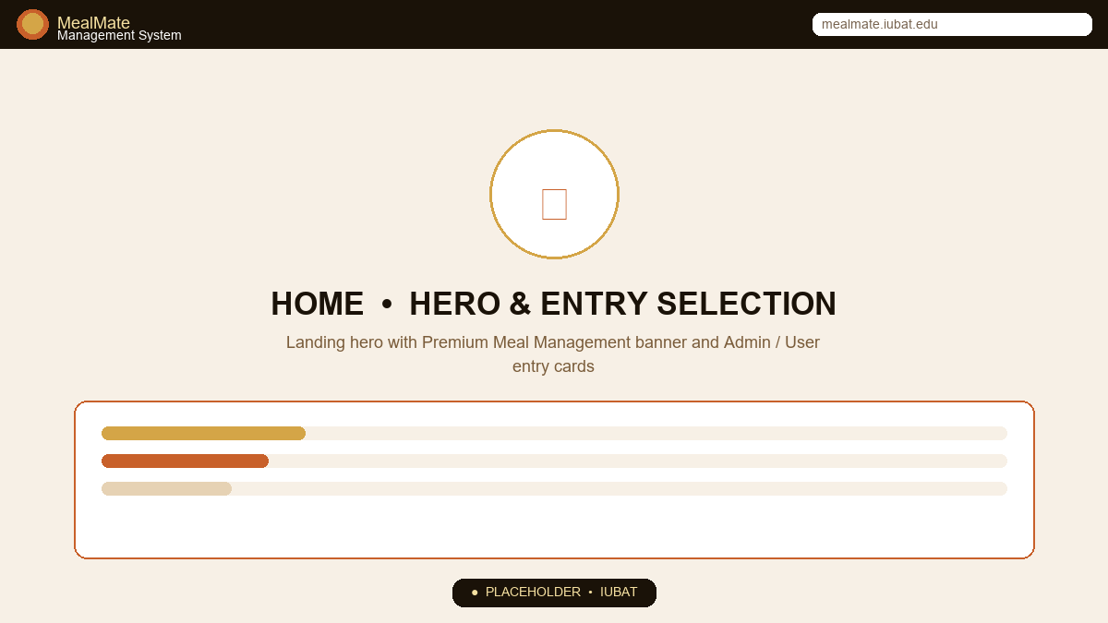
Figure 2.1: Landing Page — Hero & Entry Selection (index.php)
The system's front door. The hero section establishes brand trust with a full-bleed dining image and a frosted-glass entry card. Users must consciously choose Admin or User before continuing, enforcing role separation from the first click. The gold progress indicator and shield/user icons reinforce permission clarity.
- Hero badge: 'Premium Meal Management' with star icon
- Title: 'Delicious Meals, Perfectly Managed' (Playfair Display)
- Entry cards: Admin (Manage & Control) vs User (Order & Track) — selection highlights with gold border and shadow
- Continue button triggers proceedEntry() → admin/login.php or user/login.php

2.2 System Architecture & Technologies
MealMate uses a classic LAMP-style thin-server architecture: stateless PHP pages, a single MySQL database, and progressive enhancement via vanilla JS. No external framework is required — ideal for XAMPP deployment in academic labs.
Layer | Technology | Role in MealMate
Frontend | HTML5, CSS3, JS (main.js) | Warm luxury theme, responsive grid, toast & calendar widgets
Styling | assets/css/style.css + Google Fonts | Playfair Display + DM Sans, gold/orange palette, card shadows
Icons | FontAwesome 6.5 CDN | Utensils, bell, gauge, credit-card icons across dashboards
Backend | PHP 7/8, mysqli, sessions | Auth, CRUD, business logic in admin/* and user/* pages
Database | MySQL 8 (utf8mb4) | 8 tables: users, menus, meal_orders, payments, etc.
Security | password_hash/verify | Hashed passwords, session_regenerate_id, clean() sanitizer

Key Scripts and Their Responsibilities
config.php — Defines DB_HOST/USER/PASS/NAME, provides getDB() singleton, isAdminLoggedIn()/isUserLoggedIn(), redirect(), clean(), formatCurrency(). Included first on every page.
header.php — Renders the fixed top bar with brand, role-aware nav (Admin sees Menu/Users/Reports/Settings; User sees My Meals/Payment/Activity; Guest sees Home/About/Contact), and logout badge.
main.js — Client interactivity: toggleNav() for mobile, selectEntry()/proceedEntry() for routing, toggleMeal()/selectPayMethod() for order forms, showToast() for feedback, buildCalendar() and renderBarChart() for activity and reports.

2.3 Database Design (ER Overview)
The database meal_management contains eight normalized tables centered on users and admins. Menus are date-specific; meal_orders link a user to a menu and meal_type on a given date; payments track flexible plans; notifications broadcast by target group; meal_timings and settings provide global configuration.
Table | Key Columns | Relation
admins | id PK, name, email UNIQUE, password, phone, address | —
users | id PK, name, email UNIQUE, password, user_type ENUM, category ENUM, status | —
menus | id PK, meal_type ENUM, menu_date DATE, items TEXT, price, created_by FK→admins | N:1 admins
meal_orders | id PK, user_id FK→users, menu_id FK→menus, meal_type, order_date, status | N:1 users, N:1 menus
payments | id PK, user_id FK→users, amount, payment_type ENUM, payment_method ENUM, payment_date, status | N:1 users
notifications | id PK, title, message, target, created_by FK→admins | N:1 admins
meal_timings | id PK, meal_type UNIQUE, start_time, end_time | —
settings | id PK, setting_key UNIQUE, setting_value | —
Figure 2.2: Simplified ER — users ↔ meal_orders ↔ menus ↔ payments; admins → menus / notifications / settings; meal_timings global.
Default seed data includes three meal timings (Breakfast 07:00–09:30, Lunch 12:00–14:30, Dinner 19:00–21:30) and settings (site_name=MealMate, currency=BDT, meal prices). All tables use InnoDB + utf8mb4 for transactional integrity.

2.4 User Roles & Access Control
Access is enforced by session guards isAdminLoggedIn() and isUserLoggedIn(). Admin pages redirect to admin/login.php if unauthenticated; user pages redirect to user/login.php. The header dynamically shows only the permitted navigation, preventing cross-role browsing.
Role | Login Portal | Can Access | Cannot Access
Admin | admin/login.php | Dashboard, Menus, Users, Reports, Payments, Timings, Settings, Notifications | User Meal Order / Activity
User | user/login.php | My Dashboard, Meal Order, Payment, Activity, My Report, Notifications | Admin Menus / User Management
Guest | — | Landing hero, About, Contact | Any /admin or /user dashboard

CHAPTER 03 Admin Functionalities

Kitchen, accounts and system control — how administrators operate MealMate

3.1 Admin Login & Registration
The admin portal uses a guarded dual-mode page (admin/login.php). If no admin exists, the registration form is shown; otherwise login is required. On successful password_verify, session_regenerate_id() creates a secure session and sets admin_id/name/email.
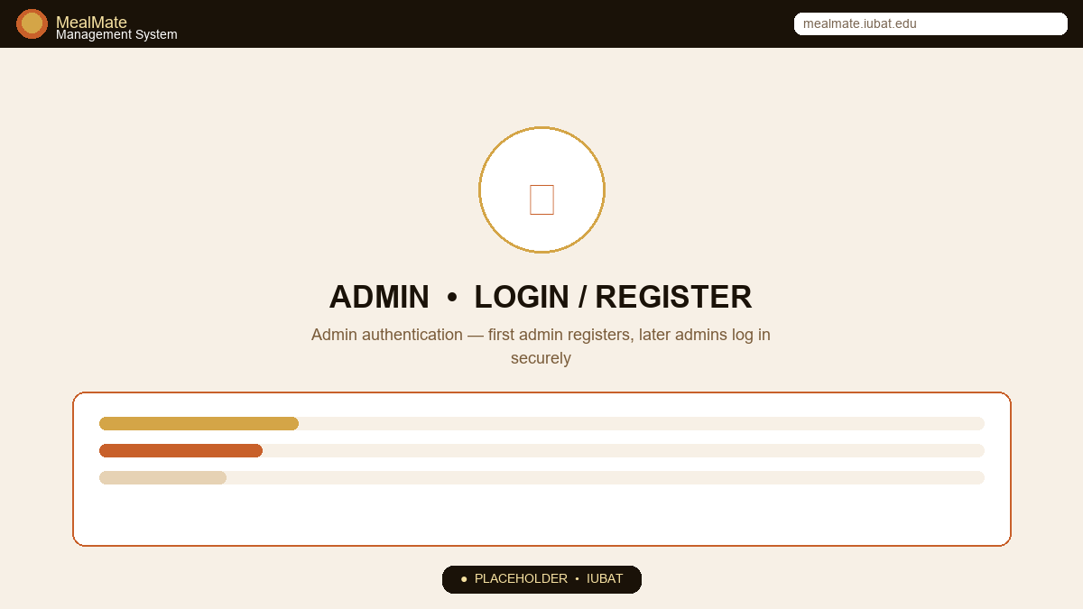
Figure 3.1: Admin Login — Secure Access Gate
The frosted-glass auth card floats over a low-opacity dining background. Registration and login share the same visual language to reduce learning curve; only email + password are required to minimize friction for staff.
- First-run: Register (Name, Email, Password, Phone, Address) → success toast 'Admin created! Now login.'
- Subsequent: Login (Email + Password) → redirects to dashboard.php
- Security: password_hash (PASSWORD_DEFAULT), real_escape_string, length ≥6 check
💡 Intended behavior: Only trusted staff receive admin credentials. The first admin must be created via direct DB seed or initial registration when the admins table is empty; thereafter self-registration is disabled and new admins are provisioned by existing admins.

3.2 Dashboard — Analytics at a Glance
admin/dashboard.php aggregates four headline KPIs and today's operational snapshot. It provides immediate situational awareness without requiring deeper navigation.
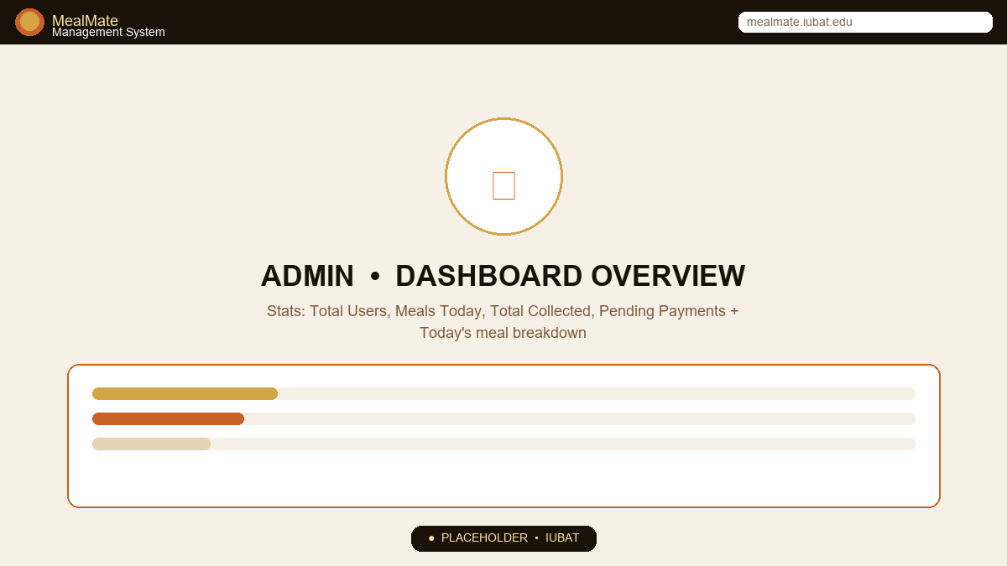
Figure 3.2: Admin Dashboard — Stats, Today's Orders & Recent Activity
Four stat cards anchor the page with distinct left-border accents and icons. Below, three meal cards show real-time today's counts per type, while two side tables list recent users and broadcast notifications.
- Stat cards: Total Users (orange), Meals Today (gold), Total Collected ৳ (green), Pending Payments (blue) — each with animated counter (main.js stat counter)
- Today's Meal Orders: Breakfast ☕ / Lunch 🌤️ / Dinner 🌙 counts in tinted cards with large numerals
- Recent Users table: Name, User Type badge (Info), Category (COZY/Premium/VIP), Status (Active/Inactive)
- Notifications widget: Title, truncated message, date, 'Manage' link → notifications.php
How it works: Each stat is a COUNT(*) or SUM(amount) query filtered by CURDATE() or status='paid'/'pending'. The date in the breadcrumb (e.g., 'Thursday, 04 September 2026') confirms data freshness.

3.3 Menu Management
Menus are the system's content backbone. Admins define what is served and at what price for each date and meal type.
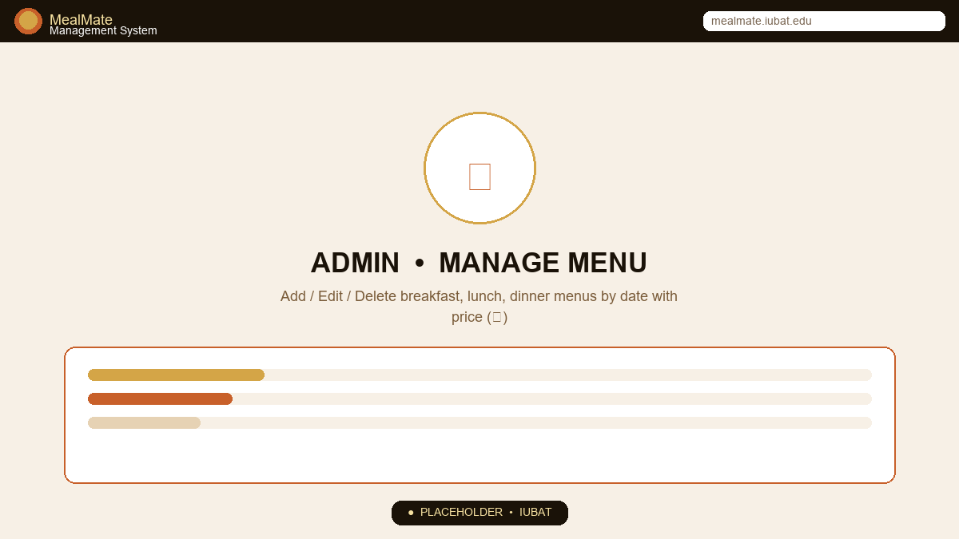
Figure 3.3: Manage Menu — Add / Edit / Delete & Date Filter
A two-column layout balances creation and consumption: form on the left, date-filtered table on the right. Meal types use emoji + colored badges for instant scanning.
- Form: Meal Type (select), Date (date picker), Items (textarea e.g., 'Paratha, Egg curry, Tea'), Price ৳ (number) → Add / Update Menu button
- Table: Meal icon, Badged type, Date formatted '04 Sep 2026', Items (truncated with tooltip), Price, Edit (gold) / Delete (red) actions
- Filter bar: Date picker + Filter button → ORDER BY FIELD(meal_type,'breakfast','lunch','dinner')
- Edit pre-fills form; Delete confirms then removes row
Operational note: Menus are stored in the menus table with created_by → admins.id. Editing updates the same row; deletion is hard-delete. Users' meal-order view reads these rows to display today's offerings and prices.

3.4 User Management
Admins maintain the resident roster. The page supports search by name/email and filtering by user type, plus lifecycle actions.
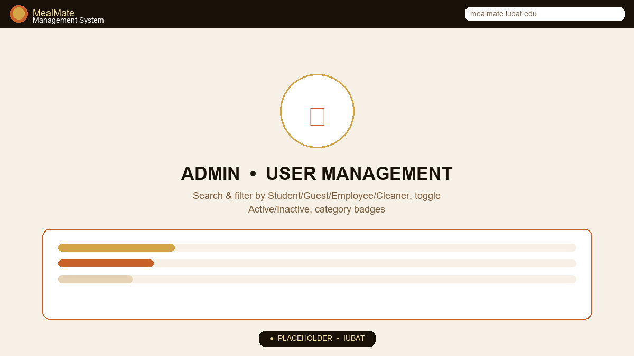
Figure 3.4: Manage Users — Search, Filter & Status Control
A filter bar sits above a dense data table. User categories are color-coded (VIP=red, Premium=gold, COZY=primary) for tier recognition; status uses green/red badges.
- Search: Text input for name/email + Type dropdown (All / Student / Guest / Cleaner / Employee) → Filter / Reset buttons
- Table: #, Name, Email, Phone, Type badge, Category badge, Status badge, Joined date, Actions
- Toggle Status (ban/check icon) flips active↔inactive without deletion — newly inactive users cannot log in
- Delete (trash icon) hard-removes user with confirmation
How it works: WHERE clause is dynamically built from search/filter inputs; results are ordered by created_at DESC. The count badge 'All Users (N)' updates with filters.

3.5 Notifications & Broadcast
Broadcast is one-to-many: an admin composes a single notice and targets it to a segment, avoiding per-user manual messaging.
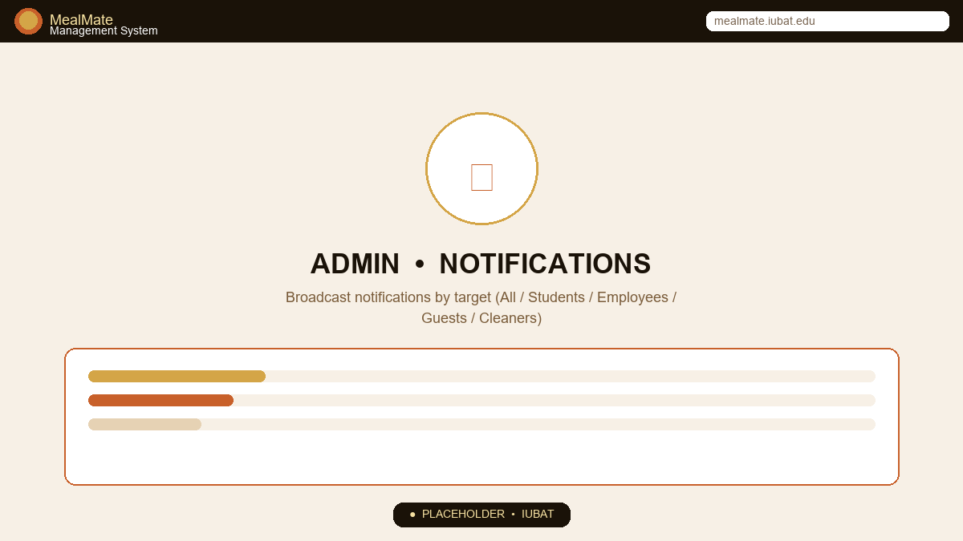
Figure 3.5: Notifications — Compose & Manage Broadcasts
Mirrored columns: compose form vs history list. Each past notification is a bordered item with bell icon, title, body, target badge and timestamp.
- Form: Title (required), Message (textarea 4 rows), Target (All / Students / Employees / Guests / Cleaners) → Send Notification
- List: Each item shows notif-icon, title, full message, target badge (Info), created_at timestamp, Delete action
- Storage: INSERT INTO notifications (title,message,target,created_by) — read by both dashboards

3.6 Reports & Analytics
The reporting engine answers two business questions: who is contributing revenue and who is consuming without paying, over any date window.
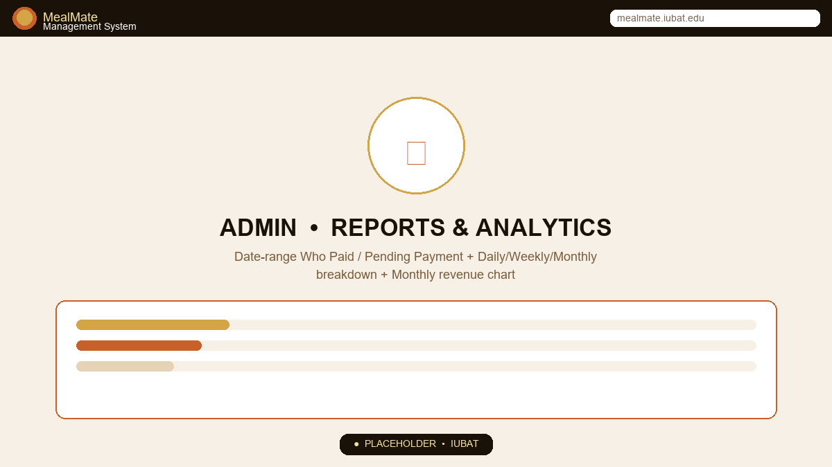
Figure 3.6: Reports — Date-Range Revenue & Compliance Analytics
A filter bar feeds three metric cards, a monthly bar chart, and two compliance tables. The chart uses the js/main.js renderBarChart() gradient (orange→gold).
- Date filter: From + To (defaults to month-to-date) → Generate Report button
- Breakdown cards: Daily / Weekly / Monthly totals in orange/gold/green with calendar icons — sums of payments grouped by payment_type
- Monthly Revenue chart: Bars per month (Jan–Dec of current year) with value labels and hover scaling
- Who Paid table: Name + email, Type badge, Payment count (x), Total paid (green ৳)
- Pending Payment table: Name, Type, Meals count (red badge) — users who ordered meals but have no paid payment in range; shows 🎉 when empty
How it works: paid_users is a JOIN between payments (status='paid') and users grouped by user; unpaid_users is a LEFT JOIN meal_orders anti-join against payments. The chart is fed JSON via json_encode($chart_data) to renderBarChart().

3.7 Payment Records
A ledger view for finance auditing. Unlike Reports (aggregated), Payments shows every transaction with filtering.
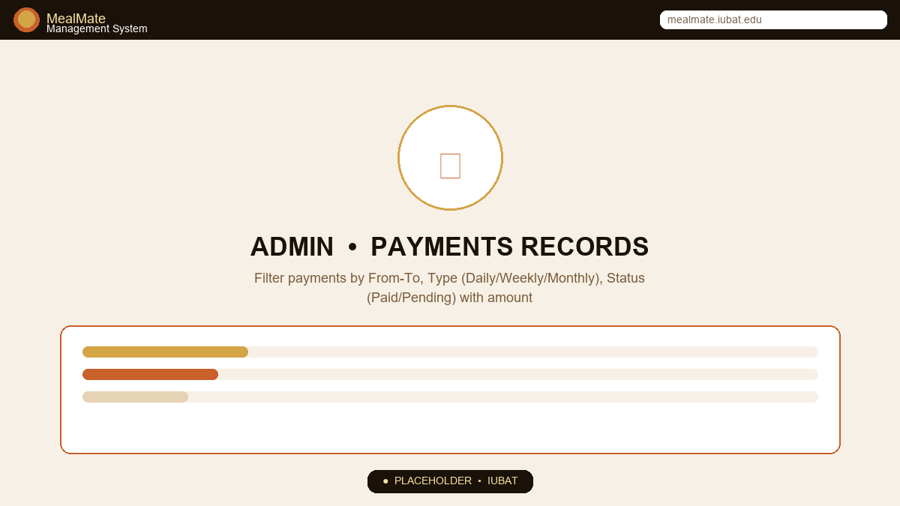
Figure 3.7: Payments — Filterable Transaction Ledger
A compact filter row precedes a full-width table. Status pills (Paid=green, Pending=amber) allow rapid overdue spotting.
- Filters: From, To, Type (All/Daily/Weekly/Monthly), Status (All/Paid/Pending) → Filter button
- Table: #, User (name+email), Amount (orange ৳), Type badge, Method (Cash/bKash/Nagad/Card), Date, Status badge
- Ordering: ORDER BY created_at DESC, so newest appears first; count badge shows filtered row count

3.8 Meal Timings Configuration
Timings enforce ordering windows. Outside the window, the user ordering card loses its OPEN NOW badge, nudging behavior without blocking data.
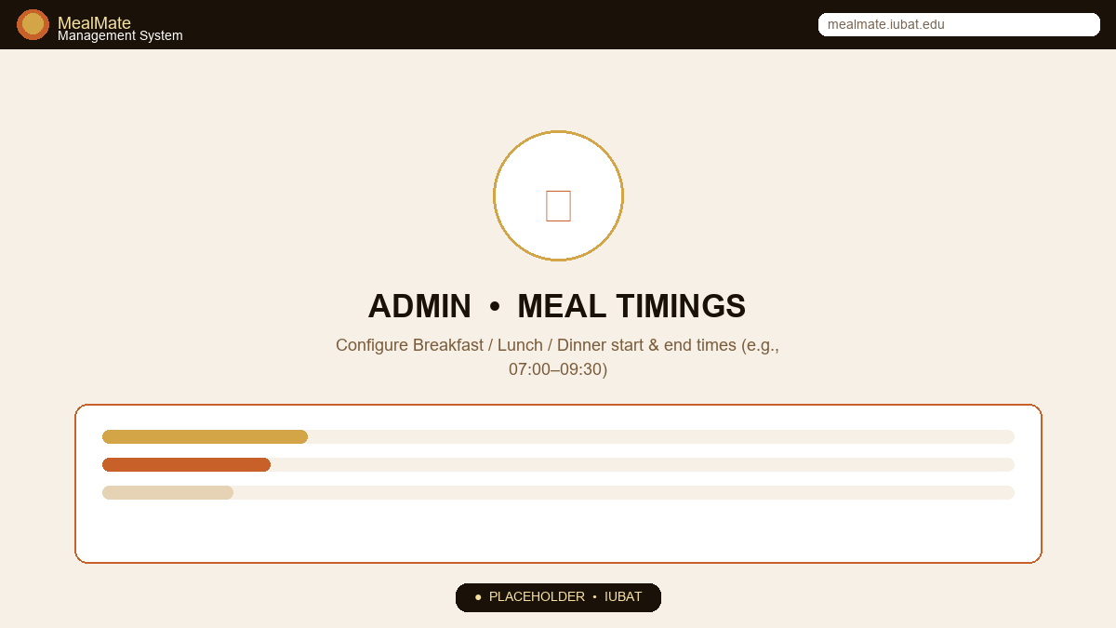
Figure 3.8: Meal Timings — Configure Service Windows
Three stacked cards (Breakfast, Lunch, Dinner) each with two time pickers inside a warm-tinted container. The single Save button commits all three at once.
- Three sections: ☕ Breakfast / 🌤️ Lunch / 🍽 Dinner — each with Start Time and End Time (type=time)
- Default seeds: 07:00–09:30, 12:00–14:30, 19:00–21:30 — UPDATE meal_timings SET start_time, end_time
- Feedback: Success alert 'Meal timings updated successfully!' with check icon
How it works: User's meal-order.php reads these times and compares against date('H:i:s') to set $active → shows/hides the green OPEN NOW badge and can gate submission if enforced.

3.9 System Settings
Global knobs that propagate across the app without code changes.
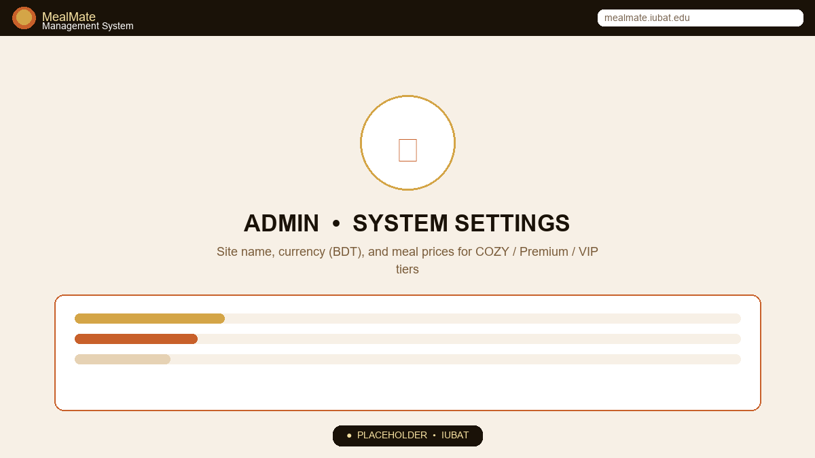
Figure 3.9: System Settings — Branding & Pricing
A single-column form with two top fields and a grouped price panel for three meals. The gradient Save button spans full width.
- Site Name (e.g., MealMate) and Currency (BDT) — upsert via INSERT ... ON DUPLICATE KEY UPDATE
- Meal Prices panel: ☕ Breakfast / 🌤️ Lunch / 🌙 Dinner in three columns, step 0.01
- Saved to settings table; read by pricing logic and currency formatter formatCurrency()
Intended behavior: Changing lunch_price from 80 to 90 immediately reflects in new orders and reports; historical orders retain their stored total_amount.

CHAPTER 04 User Functionalities

Resident experience — ordering, paying and tracking meals

4.1 Registration & Login
The user portal balances onboarding speed with accurate tiering. Registration collects both identity and dining profile; login optionally verifies category to prevent tier spoofing.
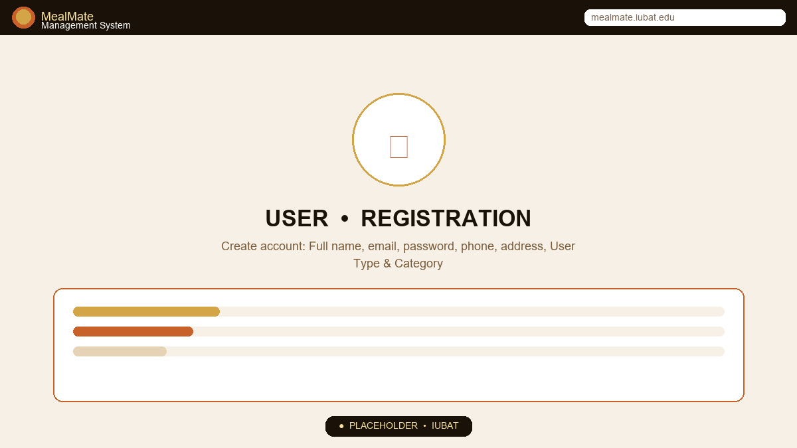
Figure 4.1A: User Registration — Create Account
A dark, blurred auth page with floating glass card. Two-column rows group related fields; required markers ensure completeness.
- Rows: Full Name + Phone | Email (full) | Password | User Type (Student/Guest/Employee/Cleaner) + Category (COZY/Premium/VIP) | Address
- Submit → INSERT INTO users with hashed password → 'Registration successful! You can now login.'
- Link: 'Already have an account? Login here' toggles mode via ?register=1
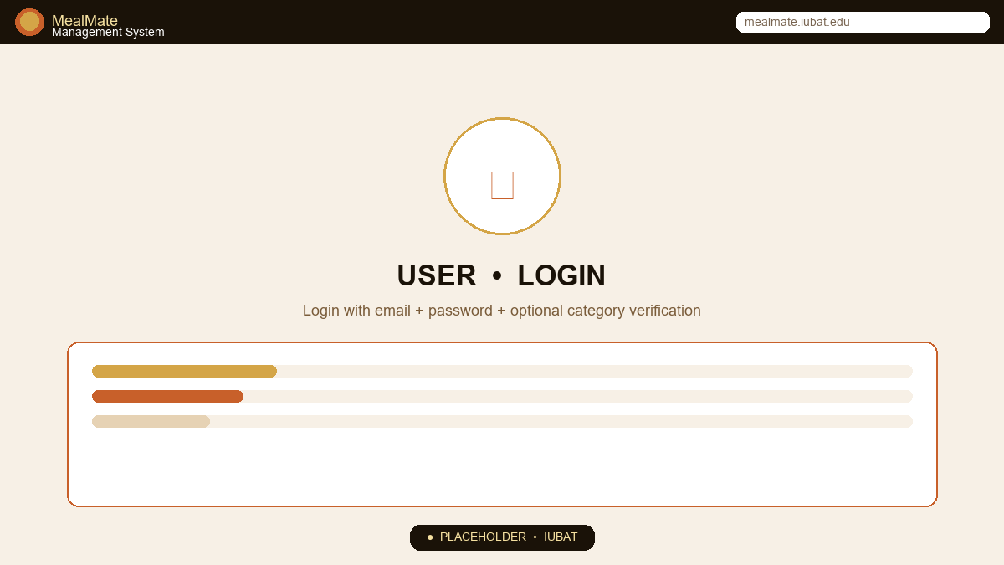
Figure 4.1B: User Login — Welcome Back
Same card, simplified to three fields for speed. Category selector is optional — leaving it blank allows login regardless of tier.
- Fields: Email, Password, Category (Optional: Any / COZY / Premium / VIP) → Login button
- Logic: SELECT ... WHERE email AND status='active' AND (category=? if provided) → password_verify → set user_id/name/email/type/category session
- Failure: 'No active user found' if banned; 'Incorrect password' if mismatch

4.2 User Dashboard — My Meals
The dashboard is a personal command center: greeting, KPIs, today's meal state, notifications, and recent history — answering 'What have I done and what do I owe?' in one view.
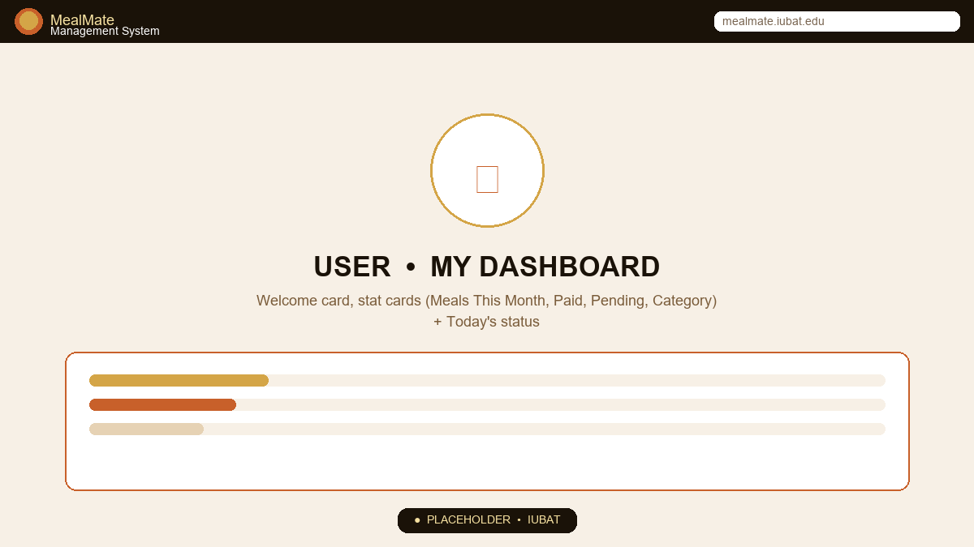
Figure 4.2: User Dashboard — Personalized Overview
A sidebar with avatar + tier badge and a main area with greeting, four stat cards, and two side-by-side panels.
- Header: 'Welcome, Priyanka! 👋' + current date + primary CTA 'Order Today's Meal'
- Stat cards: Meals This Month, Total Paid ৳, Pending Payment ৳, My Category (COZY/Premium/VIP) with colored icon circles
- Today's Meal Status: Three rows (Breakfast/Lunch/Dinner) with time window and Ordered / Not Set badge (green/muted)
- Notifications widget: Up to 5 latest broadcast notices filtered for my category; unread styling
- Recent Activity table: Last 7 orders with per-meal check badges, total Amount, Status (confirmed/cancelled)
How it works: Stats are SUM/COUNT queries scoped to user_id; timings are reused from meal_timings; notifications are fetched where target IN ('all', my_type).

4.3 Meal Ordering
Ordering is tactile: three large cards replace checkboxes. The interaction is designed for mobile thumbs and low cognitive load.
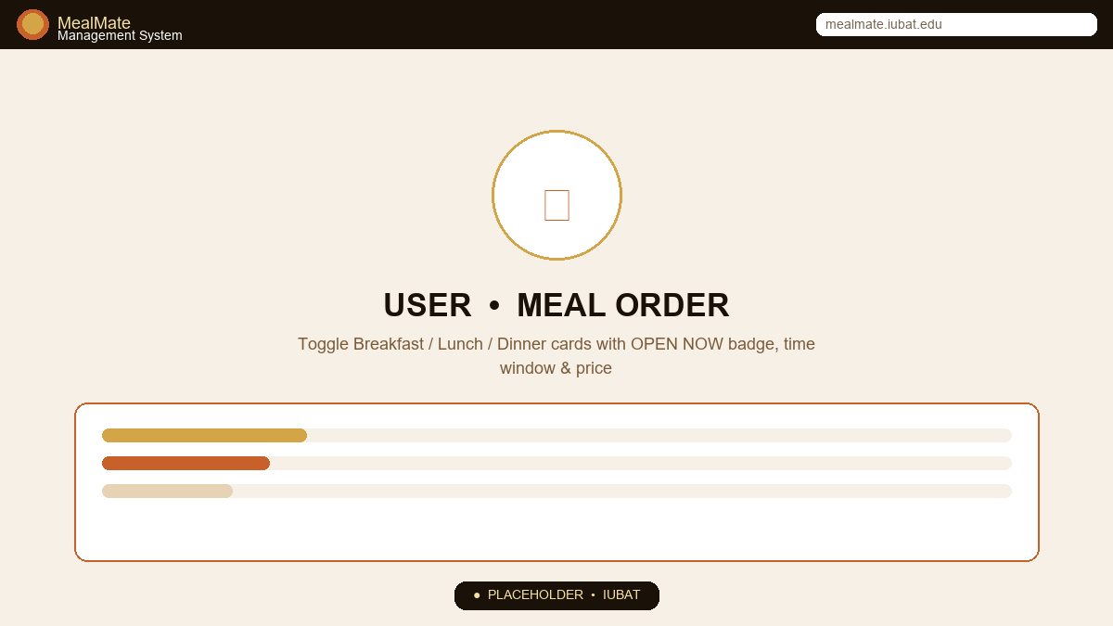
Figure 4.3: Meal Order — Toggle Today's Meals
A three-card grid. Each card shows emoji, title, description, time window tag, price tag, and a selection state. A summary card below shows live total.
- Cards: ☀️ Breakfast (Morning meal), 🌤️ Lunch (Full course), 🌙 Dinner (Wholesome) — each with ⏰ time tag e.g., '07:00 AM – 09:30 AM' and ৳ price tag
- State: Selected cards get orange border, light orange background and check-circle icon; unselected shows hollow circle
- Badge: Green 'OPEN NOW' appears only when current time is within that meal's window
- Total Summary: 'Estimated Total Today: ৳130.00' live-updated via JS updateTotal() on toggle → Submit button 'Place / Update Meal Order'
- Persistence: POST → INSERT or UPDATE meal_orders row for today with breakfast/lunch/dinner booleans and computed total_amount

4.4 Activity Calendar
A calendar turns abstract order data into a visual habit tracker, helping users spot missed days and payment gaps.
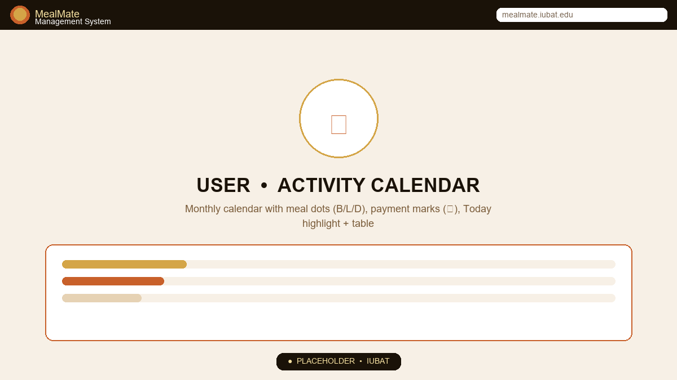
Figure 4.4: Activity Calendar — Monthly Visualization
Stats row, legend, and a 7-column calendar grid. Days carry colored dots per meal and a small ৳ mark when payment was made that day.
- Header: Month name (e.g., September 2026) + ← Today → navigation via ?month & ?year
- Stats: Active Days, Total Meals, Month Bill ৳, Paid ৳ — summaries for the viewed month
- Legend: Orange outline = Meal Ordered, Green tint = Payment Made, Solid orange = Today
- Grid: Sun–Sat headers + empty placeholders + days 1..tDays; each day shows date, dots (B/L/D in gold/orange/dark), ৳ if paid; today's cell has gold border
- Detail table below: Date, Breakfast/Lunch/Dinner checks, Total Meals count, Amount per day
How it works: Queries meal_orders and payments BETWEEN month_start and month_end; dots are rendered conditionally per $order['breakfast'] etc.; month navigation wraps year correctly.

4.5 My Report & Payment History
Reports translate raw rows into insight: how much, what type, and what remains.
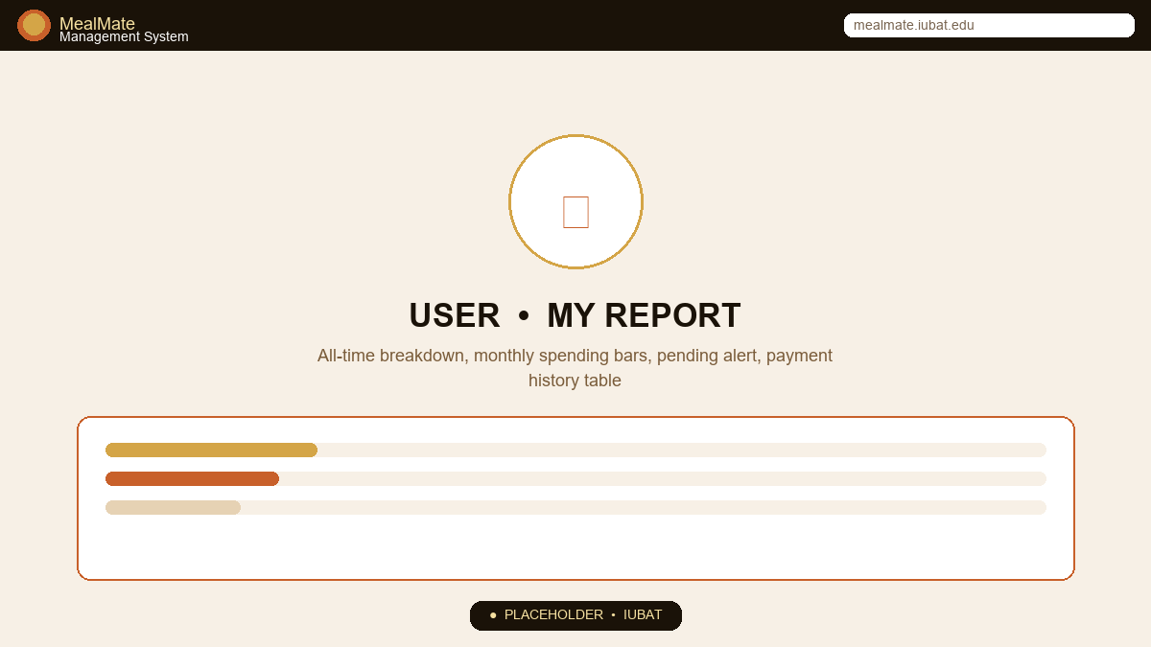
Figure 4.5: My Report — All-Time Breakdown & Monthly Spending
Two-column insight panel plus a full-width payment history table. Progress bars replace pie charts for clarity.
- Overall Stats: Total Order Days, Total Meals, Total Bill ৳, Total Paid ৳ — four cards
- Meal Breakdown: ☀️ Breakfast / 🌤️ Lunch / 🌙 Dinner with counts, percentages and filled bars (gold/orange/dark)
- Pending Alert: Amber box with 'You have ৳295.00 pending — Pay now →' when total_spent > total_paid
- Monthly Spending: Last 6 months, each with Month, Meals count, Amount and horizontal gradient bar scaled to max
- Payment History: Last 10 payments with Date, Type, Period (d M – d M Y), Method, Amount, Status (Paid/Failed/Pending)
How it works: Aggregates SUM(breakfast etc.) over all time; monthly breakdown groups by DATE_FORMAT(order_date,'%Y-%m'); payment history is a simple ORDER BY payment_date DESC.

4.6 Payments — Daily / Weekly / Monthly
Payment accommodates institutional rhythms: daily pay-as-you-go, weekly accounting, or monthly bulk — with local methods.
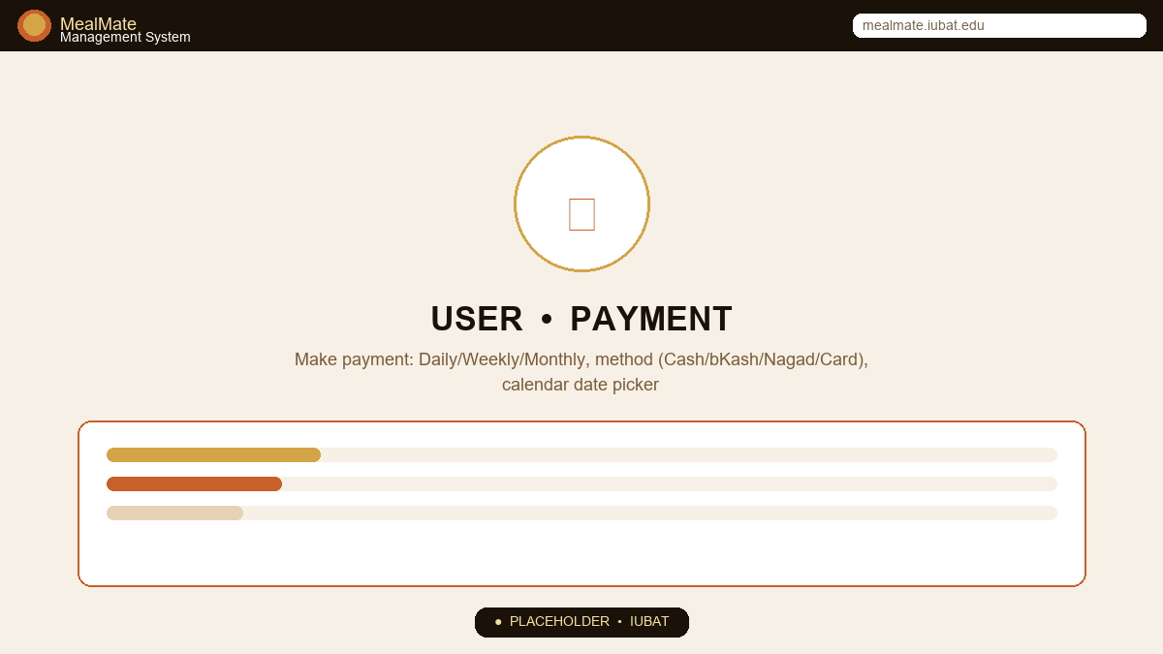
Figure 4.6: User Payment — Flexible Plans & Local Methods
A method selector grid (3 options) + conditional date panels: calendar for Daily, week picker for Weekly, month label for Monthly; method icons include bKash/Nagad.
- Plan selector: Three cards — Daily (calendar-day icon), Weekly (calendar-week), Monthly (calendar) — selection highlights active; shows/hides संबंधित panel
- Daily panel: Calendar widget (buildCalendar() in main.js) with selectable days, selected date label 'Selected: 04/09/2026' → payment_date
- Weekly/Monthly panels: Week range or month overview with total calculation
- Methods: Cash, bKash, Nagad, Card icons in a grid; selection drives payment_method ENUM
- Submission: INSERT INTO payments (user_id, amount, payment_type, payment_method, payment_date, status='paid'/'pending', note)
Intended behavior: Daily amount = sum of that day's meal prices; Weekly/Monthly amounts are sums over the range. Successful cash payments may be 'pending' until admin confirms; bKash/Nagad are 'paid' immediately in prototype.

4.7 Notifications
Users stay informed without polling. The system pushes dining-relevant updates (menu changes, timing extensions, payment reminders) via targeted broadcasts.
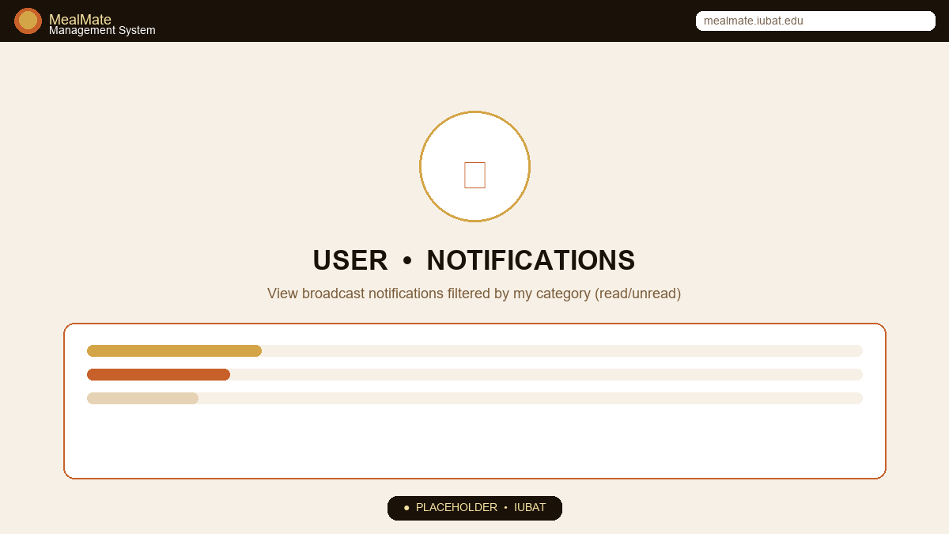
Figure 4.7: User Notifications — Inbox
A stacked list of notification items, each with an icon, title, message body, and time. Unread items have a subtle tinted background.
- List items: notif-icon (utensils/check/info per type), Title (bold), Message (muted), Time '04 Sep, 08:00 AM', left orange accent
- Filtering: Only notices where target='all' or target matches my user_type are shown; ordered newest first
- Empty state: Bell-slash icon + 'No notifications' when none

CHAPTER 05 System Workflow Summary

From login to settlement — the complete loop
MealMate's operational loop is intentionally short to encourage daily use:
1. Admin  Publishes Menu | 2. User  Orders Meal | 3. Kitchen  Prepares | 4. User  Pays | 5. Reports  Reconcile
menu_date  items + price  per meal_type | toggle B/L/D  within window  total live | counts per  meal_type today  from dashboard | Daily/Weekly  /Monthly + bKash  /Nagad/Cash | Revenue by  type + who paid  /pending lists
Figure 5.1: End-to-end workflow — five stages, with meal_timings gating stage 2 and settings pricing stage 4.
Key design choices that keep the loop frictionless:
- Mobile-first responsive grid (style.css @768px) collapses sidebar and stacks cards, ensuring thumb reach on phones.
- Progressive disclosure: defaults (today's date, 50/80/70 prices) pre-fill forms so first order takes under 10 seconds.
- Feedback immediacy: showToast() and alert banners confirm every mutation; delete actions require confirm() to prevent accidents.
- Data transparency: both sides share the same source-of-truth (meal_orders/payments), eliminating reconciliation disputes.

CHAPTER 06 Conclusion & Future Enhancements

What MealMate achieves and where it can grow

6.1 Conclusion
MealMate fulfills its SAD mandate: a minimal, coherent system that models a real institutional dining problem with correct entities (users, menus, orders, payments), role-separated interfaces, and actionable analytics. Its strength lies in opinionated defaults — three meals, three timings, three categories — that cover 90% of use cases without configuration overload, while still allowing per-date menus and flexible payments.
The warm luxury aesthetic (gold/orange on deep brown, glass-morphism hero, card shadows) differentiates it from generic admin templates and reinforces dining as a premium, cared-for experience — a subtle UX advantage for hostels competing on amenities.

6.2 Future Enhancements
- QR-based attendance: At serving counter, scan user's QR to auto-mark meal as consumed and detect waste vs ordered gap.
- Prepaid wallet & auto-debit: Users top-up; system auto-debits per ordered meal and shows wallet balance on dashboard.
- Kitchen display & print: Real-time ticket printer and KDS showing per-meal counts by category (COZY/Premium/VIP) for plating.
- UPI / SSLCommerz integration: Replace simulated bKash/Nagad with live gateway webhooks and receipt PDF.
- AI demand forecast: Predict next week's per-meal demand from historical meal_orders to optimize procurement and reduce waste.
- Role extension: Super-admin, kitchen staff, and accountant roles with granular permissions (e.g., kitchen sees only counts, not revenue).
💡 Intended vs. Implemented: This report describes intended behavior under a coherent data model (e.g., denormalized meal_orders per day, pricing by category, target-aware notifications). During implementation, reconcile the current SQL schema with application queries to select a single source-of-truth and generate live screenshots to replace the placeholders above — no content rewrite will be needed.

CHAPTER A Appendix — File Structure & References

A.1 Project File Structure (as submitted)
HotelM/
├── index.php Landing + entry selection
├── meal_management.sql Database schema & seeds
├── includes/config.php DB & auth helpers
├── includes/header.php Shared header/nav
├── includes/footer.php Shared footer
├── assets/css/style.css Luxury theme, responsive
├── js/main.js Interactivity (toast, calendar, chart)
├── admin/ login.php, dashboard.php, menu.php, users.php,
│ notifications.php, reports.php, payments.php,
│ timings.php, settings.php, logout.php
└── user/ login.php, dashboard.php, meal-order.php,
payment.php, activity.php, report.php,
notifications.php

A.2 Setup Instructions (XAMPP)
Step 1 — Copy HotelM/ to C:\xampp\htdocs\HotelM\
Step 2 — Create database meal_management and import meal_management.sql via phpMyAdmin.
Step 3 — Edit includes/config.php if DB credentials differ from root / ''.
Step 4 — Visit http://localhost/HotelM/index.php — choose Admin or User → Register → Login → Explore flows above.

A.3 References
- IUBAT Department of CSE — System Analysis and Design (CSE 484) Course Manual, 2026.
- PHP Manual (php.net) — password_hash / password_verify, mysqli extension, session handling.
- MySQL 8.0 Reference — InnoDB, utf8mb4, ENUM and DATE types.
- FontAwesome 6.5 & Google Fonts — Playfair Display, DM Sans (used under respective licenses).
- Unsplash Food Photography — Hero and About images (images.unsplash.com) for academic demo use.
— End of Report —
Prepared for academic submission at IUBAT • System Analysis and Design • HotelM / MealMate • September 2026

