

VIT BHOPAL UNIVERSITY

NAME – Akshitha Sanu
REGESTRATION NUMBER – 26BAC10026
SLOT – B21+E14+E21+B22+E22+C14+B23
EMAIL – akshita.26bac10026@vitbhopal.ac.in
FACULTY/PROFESSOR NAME – Dr. Ajeet Singh

# 1. Introduction

In today's academic environment, students have to manage multiple subjects, assignments, practical work, examinations, projects, and personal study goals. Managing all these activities manually can sometimes become difficult. A student may know what needs to be studied but may not have a proper plan regarding ,what to study, when to study, how much time to spend, and which task should be completed first.

To address this problem, the project "Personal Study Planner" has been developed using the Python programming language.

The Personal Study Planner is a simple, menu driven application that allows students to create and manage their study tasks. The user can enter the subject, study activity, duration, and priority of each task. The program stores these details and allows the student to view the complete study plan and mark tasks as completed.
The project demonstrates the practical use of fundamental programming concept such as:
- Variables
- Data types
- Lists
- Dictionaries
- Function
- Conditional statement
- Loops
- Exception handling
- User input and output
- Menu-driven programming
The main purpose of this project is not only to create a timetable but also to demonstrate how programming can be used to solve a real-life student problem.

# 2. Problem Statement
Students often have several academic responsibilities at the same time. For example, a student may need to:
* Study for an upcoming examination.
* Complete programming assignments.
* Prepare laboratory work.
* Revise lecture topics.
* Complete project work.
* Practice coding questions.
* Prepare presentations.
When these activities are not organized properly, students may forget important tasks or spend too much time on less important activities.
Traditional methods such as maintaining a notebook or manually writing a timetable can work, but they do not provide the flexibility of a computerized system.
Therefore, there is a need for a simple software application that allows students to maintain their study activities in an organized manner.

- Proposed Solution
The“Personal Study Planner” provides a computerized solution to this problem. It allows the student to enter study tasks along with their:
- Subject
- Task description
- Study duration
- Priority
- Completion status
The system then stores and displays the information in an organized form.

# 3. Objectives of the Project
- The main objective of the project is to develop a simple Python application that helps students organize and track their study activities.

### Specific objectives
1. To provide a simple interface for adding study tasks.
2. To allow students to specify the subject associated with each task.
3. To record the expected study duration.
4. To assign priority to different tasks.
5. To display all planned study activities.
6. To allow completed tasks to be identified.
7. To reduce manual effort in maintaining study plans.
8. To demonstrate practical implementation of Python programming concepts.
9. To develop logical thinking and problem-solving skills.
10. To create a project that can be extended into a more advanced study-management application.

# 4. Scope of the Project
The current version of the Personal Study Planner focuses on basic study-task management.
The system can:
* Add study tasks.
* Store subject names.
* Store task descriptions.
* Store study duration.
* Store task priority.
* Display all tasks.
* Mark tasks as completed.
* Handle invalid input.
* Continue running until the user chooses to exit.
- Future scope:
The project can later be expanded with:
* Date and time scheduling.
* Daily and weekly timetables.
* Examination reminders.
* Notifications.
* Progress tracking.
* Percentage completion.
* File storage.
* Database integration.
* Graphical User Interface.
* Login system.
* Cloud synchronization.
* AI-based study recommendations.

# 5. System Analysis
System analysis involves understanding the existing problem, identifying requirements, and designing a suitable solution.
## 5.1 Existing System
In the existing manual system, students may use:
* Notebooks
* Diaries
* Paper timetables
* Mobile notes
* General reminder applications
Although these methods can be useful, they may not be specifically designed around academic study tasks.
For example, a student may write:
text
Python - Study
Maths - Revision
Physics - Assignment

However, the student may not record:
* How much time is required?
* What is the priority?
* Is the task completed?
* What tasks are still pending?
The proposed system addresses these requirements.
# 6. Proposed System
The proposed Personal Study Planner is a Python-based console application.
The system maintains a collection of study tasks. Each task contains multiple pieces of information.
For example:
text
Subject: Python
Task: Practice Functions
Duration: 60 minutes
Priority: High
Status: Pending
The user can interact with the system through a menu.
- Main Menu
==============================
PERSONAL STUDY PLANNER
1. Add Study Task
2. View Study Plan
3. Mark Task as Completed
4. Exit
The user selects an option and the program performs the corresponding operation.

#7. Functional Requirements
Functional requirements define the operations that the system must perform.
- Functional requirement1 – Add Study Task
The system should allow the user to add a new study task.
The user enters:
* Subject
* Task description
* Duration
* Priority
The program creates a task and stores it.
- Functional requirement2 – View Study Plan
The system should display all stored tasks.
For each task, it should display:
* Task number
* Subject
* Task
* Duration
* Priority
* Status
- Functional requirement3 – Mark Task as Completed
The user should be able to select a task and change its status from:
text
Pending
To:
text
Completed
- Functional requirement4 – Exit
The system should provide an option to terminate the program.
- Functional requirement5 – Input Validation
The system should prevent invalid inputs where possible.
For example, study duration should be a positive number.

# 8. Non-Functional Requirements
Non-functional requirements describe the quality and characteristics of the system.
8.1 Usability
The application should be simple and easy to understand.The menu-driven approach makes it suitable for beginners.
8.2 Performance
The program should respond quickly to user commands because the application performs only small-scale data processing.
8.3 Reliability
The application should correctly store and display the tasks entered during the current program session.
8.4 Maintainability
The program is divided into separate functions, making it easier to modify and extend.
For example:
python
add_task()
view_plan()
complete_task()
8.5 Portability
The application can run on different operating systems as long as Python is installed.
8.6 Scalability
Although the current project is small, additional features can be added in the future, such as databases, graphical interfaces, and reminders.

# 9. Software Requirements

| Software | Requirement |
| -------------------- | --------------------------- |
| Operating System | Windows/Linux/macOS |
| Programming Language | Python 3.x |
| IDE | VS Code / IDLE / PyCharm |
| Interface | Command Line |
| Storage | Temporary in-memory storage

# 10. Data Structure Used
The project uses a list of dictionaries.
- List
The list stores multiple study tasks.
python
study_tasks = []
For example:
text
Task 1
Task 2
Task 3
- Dictionary
Each individual task is represented using a dictionary.
Python
study_task = {
"subject": subject,
"task": task,
"duration": duration,
"priority": priority,
"status": "Pending"
}
So conceptually:
text

study_tasks
|
|---- Task 1 → Dictionary
|
|---- Task 2 → Dictionary
|
|---- Task 3 → Dictionary
This makes it convenient to access individual properties of a task.
For example:
python
item["subject"]
returns the subject.
And:
python
item["priority"]
returns the priority.

# 11. Modules/Functions Used
The program is divided into functions.
##add_task()
Responsible for collecting information from the user and creating a new task.
## view_plan()
Responsible for displaying all tasks stored in the list.
## complete_task()
Responsible for changing the status of a selected task.
## main()
Controls the entire program and displays the menu.

# 12. Algorithm
- Algorithm: Personal Study Planner
Step 1: Start the program.
Step 2: Create an empty list named `study_tasks`.
Step 3: Display the main menu.
Step 4:Ask the user to enter a choice.
Step 5: If the choice is 1:
- Ask for subject.
- Ask for task.
- Ask for duration.
- Ask for priority.
- Set status to Pending.
- Create a dictionary.
- Add the dictionary to study_tasks.
Step 6: If the choice is 2:
- Check whether the list is empty.
- If empty, display "No study tasks available."
- Otherwise, display all tasks.
Step 7: If the choice is 3:
- Display the study plan.
- Ask the user for the task number.
- Check whether the task number is valid.
- Change the selected task's status to Completed.
Step 8:If the choice is 4:
- Display a thank-you message.
- Terminate the program.
Step 9: If any other choice is entered:
- Display an invalid choice message.
- Step 10:Repeat the menu until the user chooses Exit

#13.Input
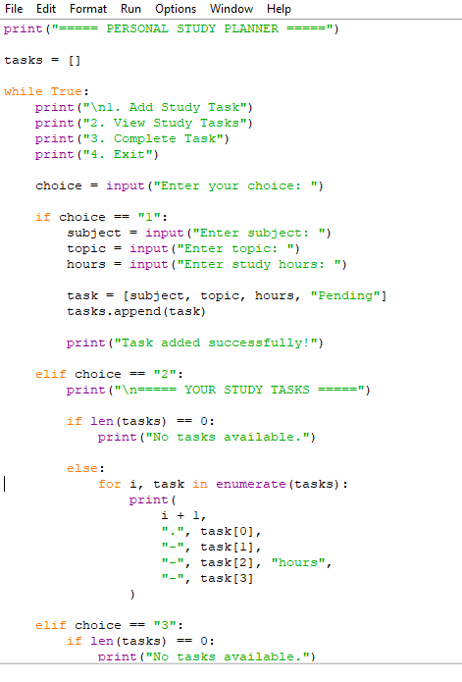
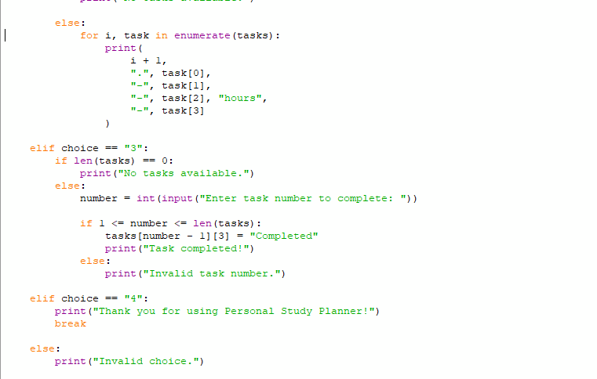

#14.Output
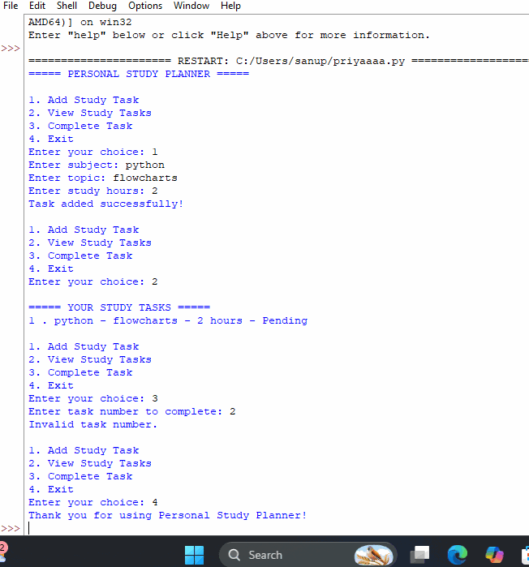
#15.Advantages
The personal study planner has several advantages:
- Simple
The menu-driven interface is easy to understand.
- Organised
All study tasks are displayed in a structured format.
- Priority management
Students can identify high priority task is pending or completed.
- Task Tracking
Student can determine whether a task is pending or completed.
- Time management
Study duration can be recorded for each task.
- Educational
The project demonstrates several fundamental Python concepts.

#16.Limitations
The current version also has some limitations.
- Data is stored only during program execution.
- Closing the program removes the current task list.
- There is no login system.
- There are no automatic reminders.
- There is no graphical user interface.
- There is no database.
- The current system does not automatically create a timetable based on available hours.
#17.Conclusion
The “Personal Study Planner” is a Python-based application designed to help students organize their academic study activities. The system allows students to add tasks, specify subjects, record study duration, assign priorities, view their study plan, and mark tasks as completed.

From a programming perspective, the project demonstrates the practical implementation of important Python concepts including variables, strings, integers, lists, dictionaries, functions, loops, conditional statements, exception handling, and user input/output.

The project successfully converts a common student time management problem into a simple computational solution. Although the current version is console based and stores information temporarily for future development . Features such as database , graphical interfaces , notifications, calendars, progress analysis, and automated scheduling can be incorporated to make the system more advanced.
#18.Bibliography
1. Python Software Foundation Python Documentation.
2. Python Crash Course - Eric Matthes.
3. Automate the Boring Stuff with Python - Al Sweigart.
4. VIT Bhopal University programming/laboratory learning materials.
5. Python programming lecture notes and classroom resources.

