Session 1 : How to solve big data
Asssignment 1
Import Acadgild VM into Oracle virtual box by following the document shared in the dashboard.
1.Open the virtual box and then follow the below steps:
Click on File --Import Appliance.
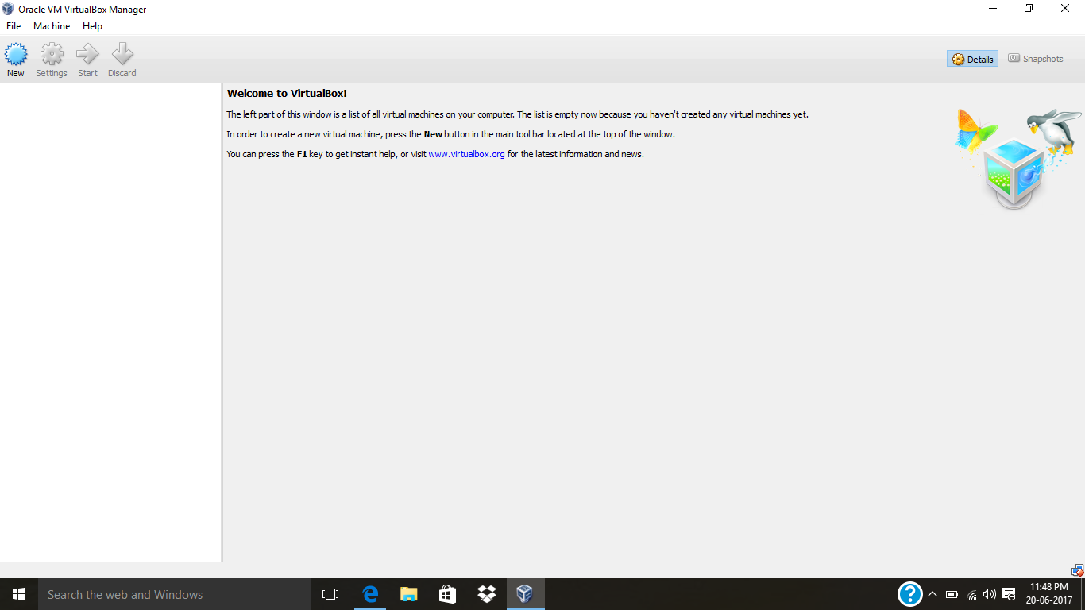

2. Click on the Folder option as shown in the below screenshot to browse to the location where Hadoop VM is present.

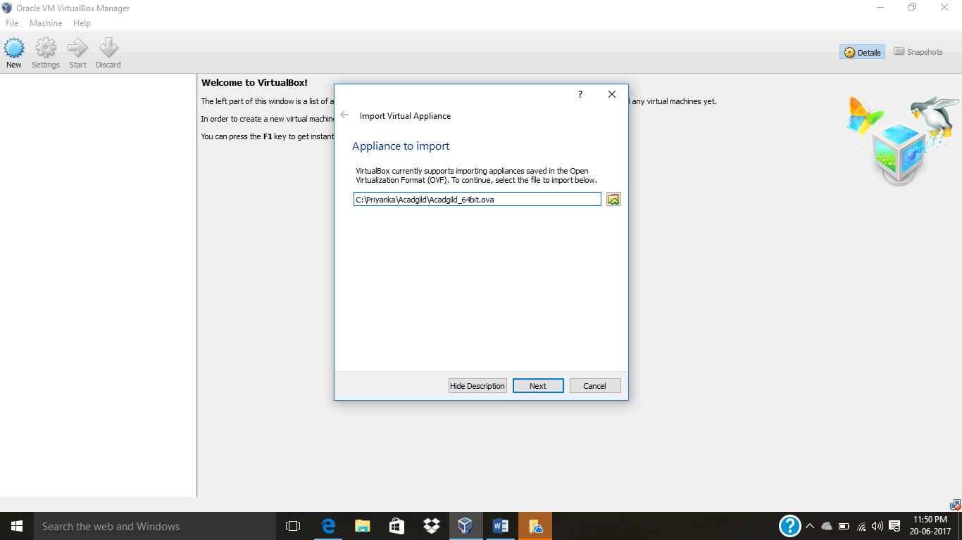
3. Select the VM to be imported and then click on Open button.
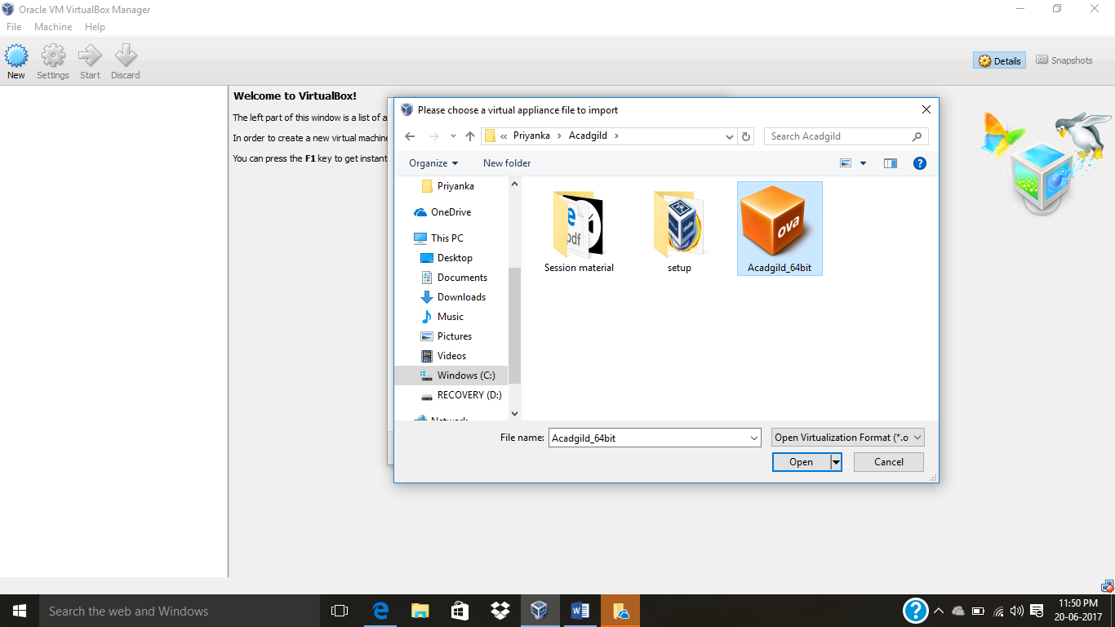

4. Click on Next to proceed to next step:

5. Click on import button to start importing the Acadgild VM.

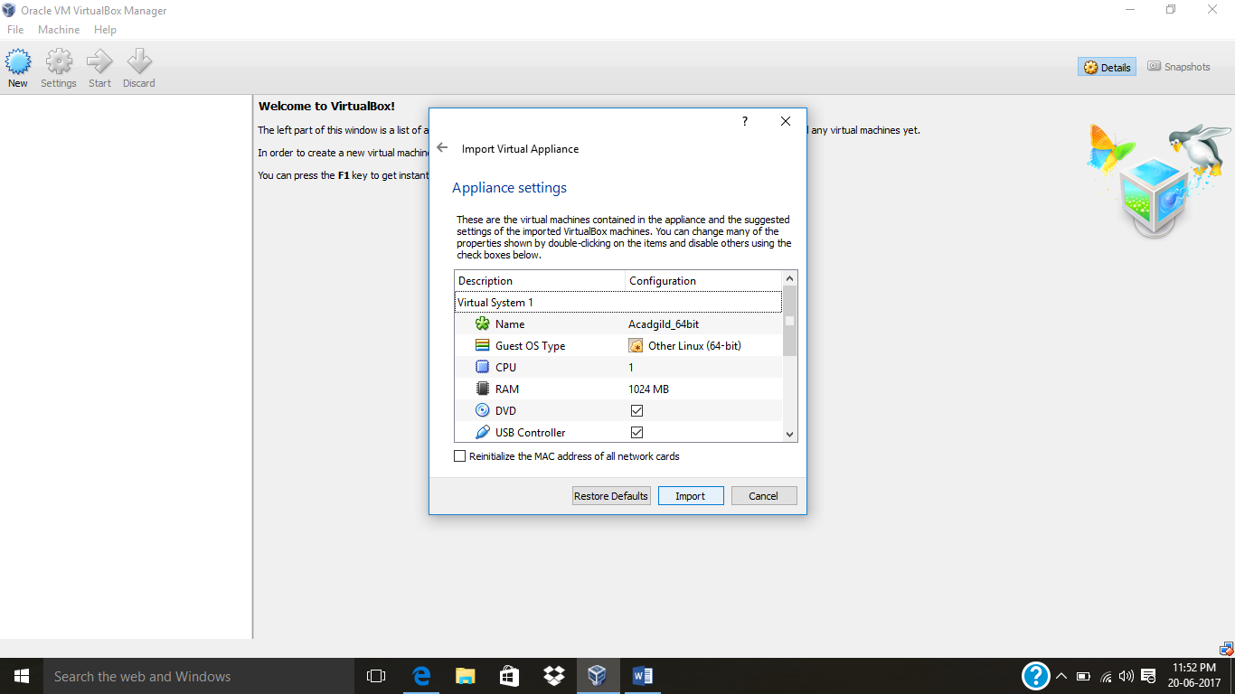

6. Once the vm starts getting imported it gives a prompt as shown below:

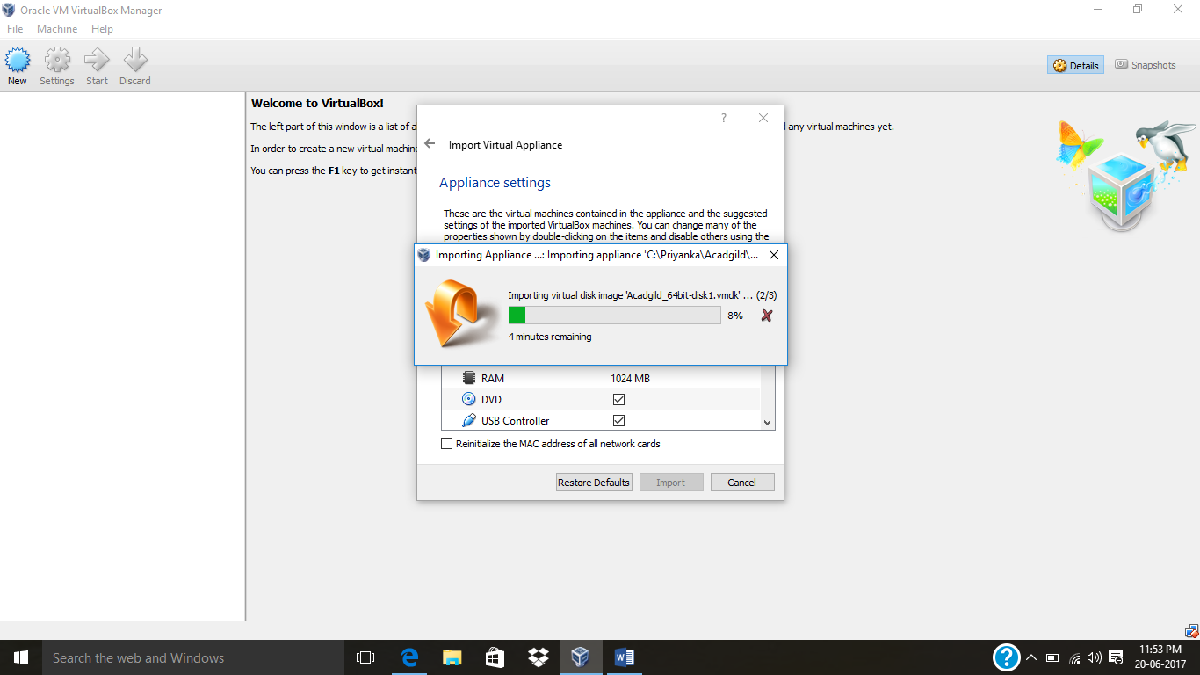

7. Once the importing gets finished, we need to click on the start button as shown in the below screenshot:

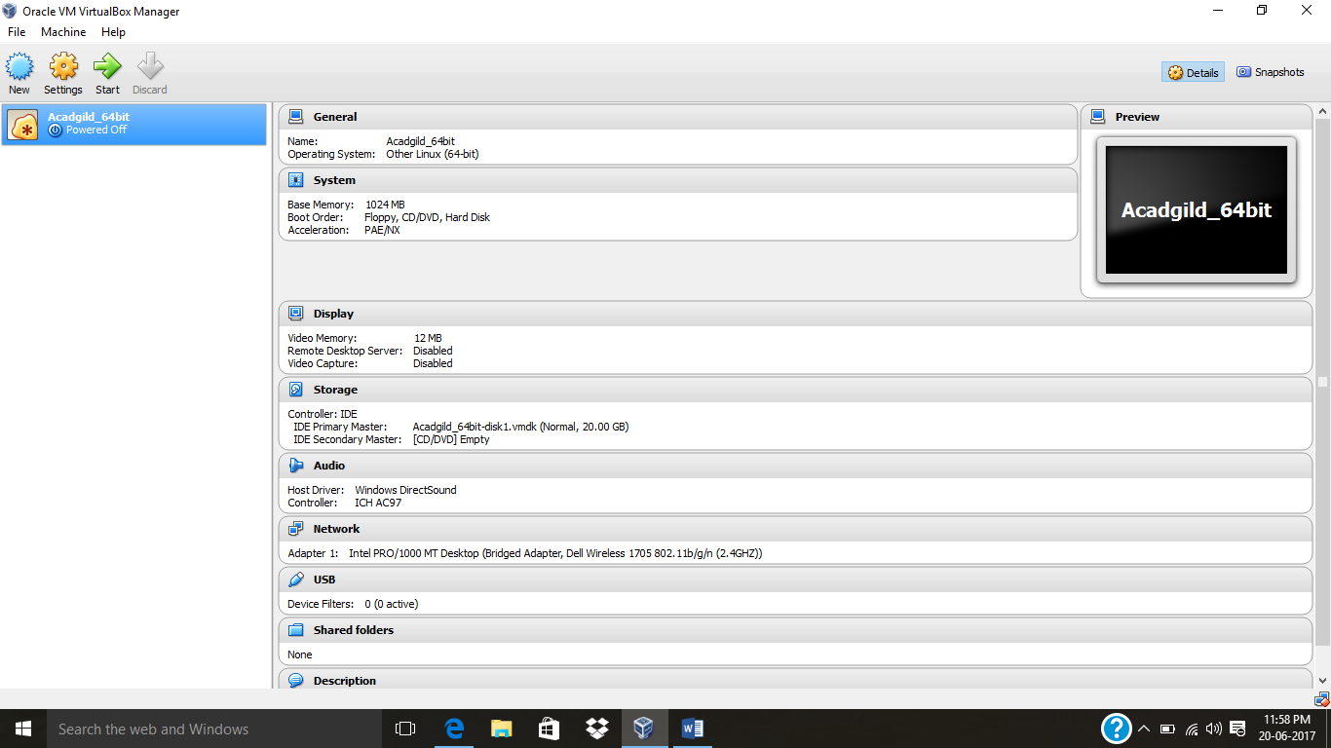

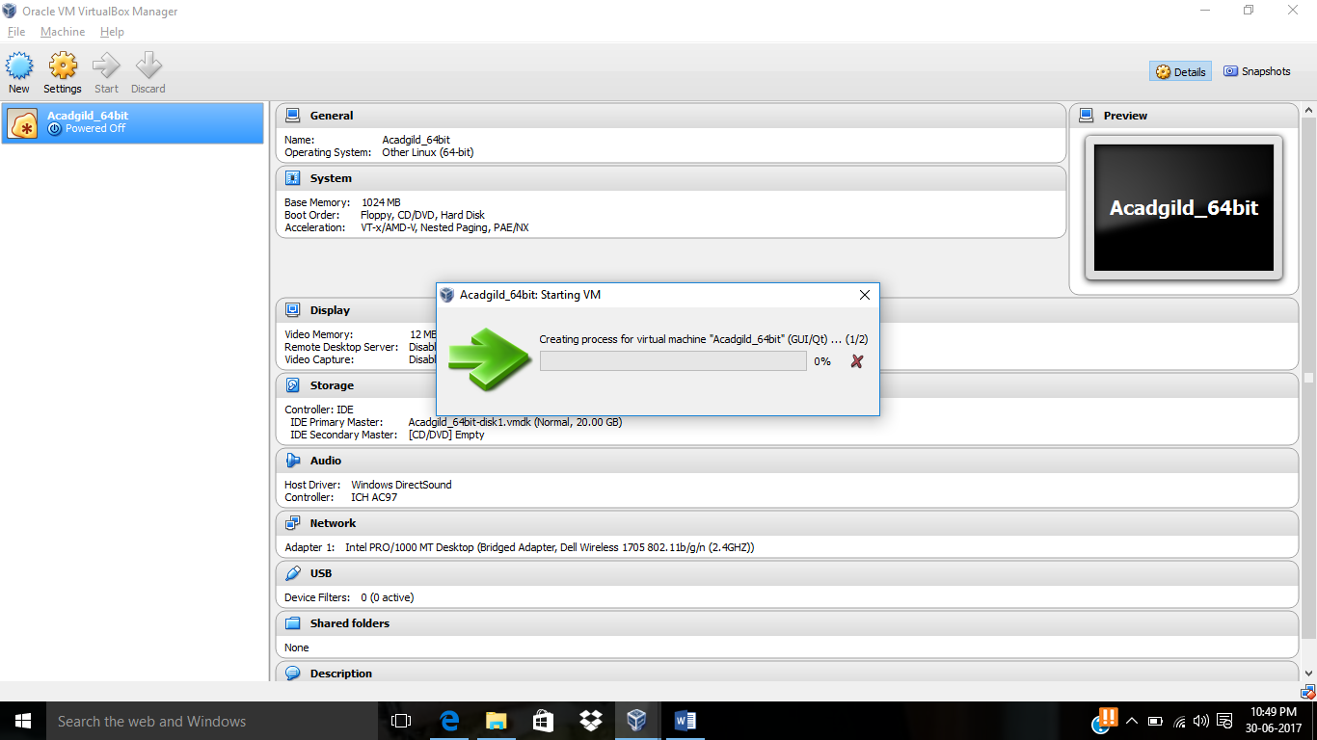

8. We need to give the password as acadgild.
Password: acadgild
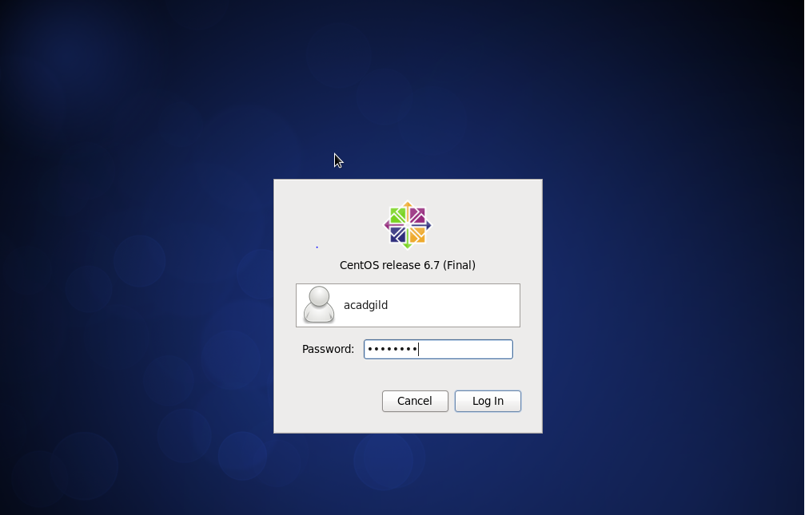

9. Open the terminal and type the command jps to check the list of daemons, we need to start all the daemons for the first time.

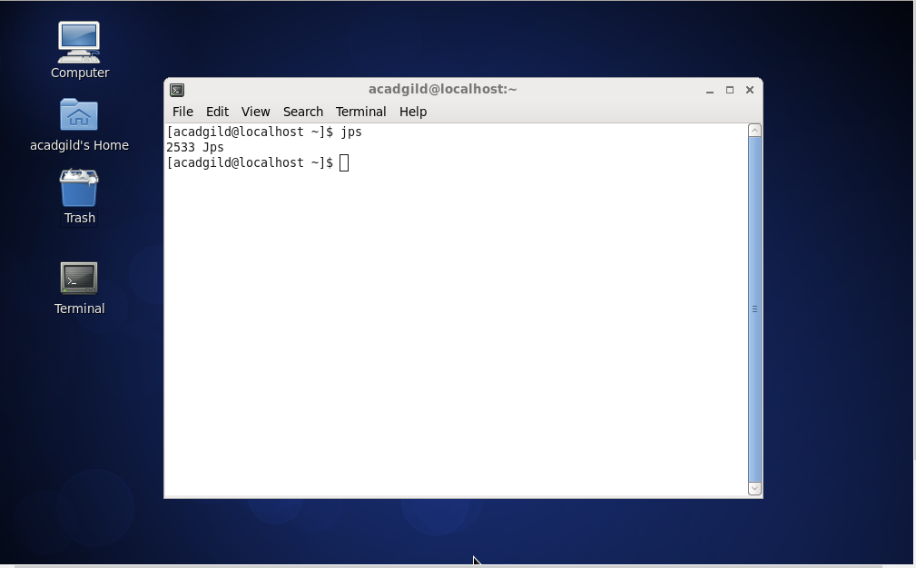

10. Open the terminal and start the ssh server. Start all the daemons.
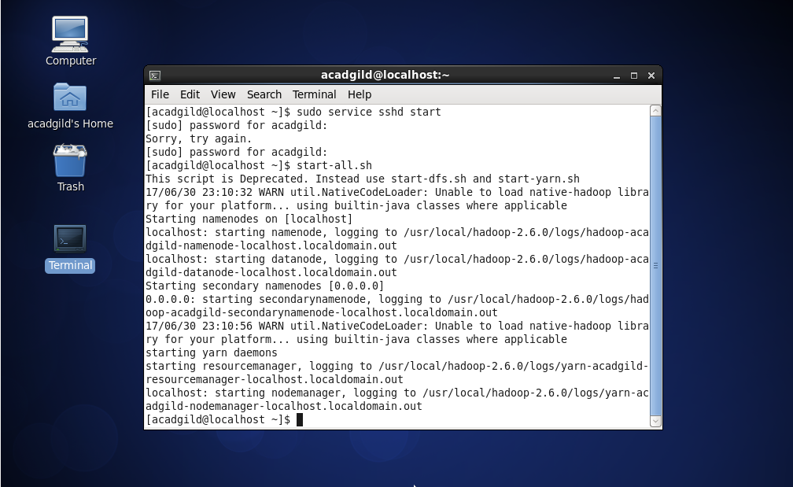

11. Start the historyserver:

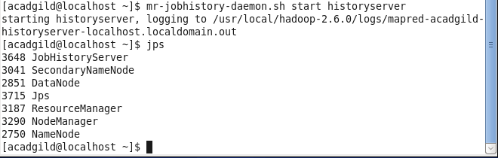

12. To start pig in hdfs mode ,type the command pig in terminal.
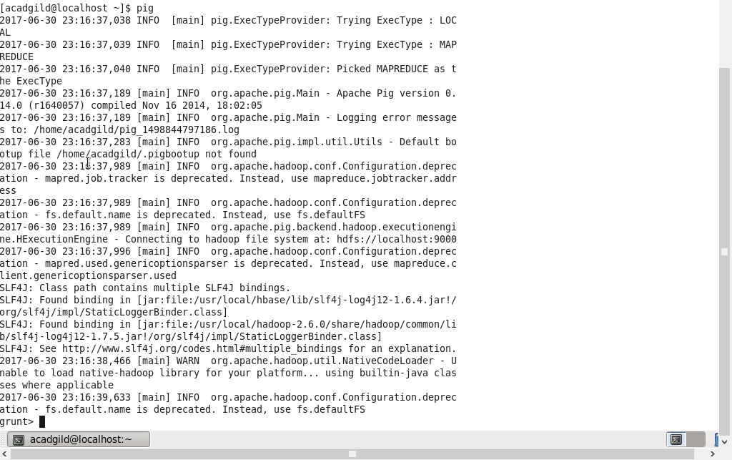

13. To start hive first start mysql service and then type the command hive.
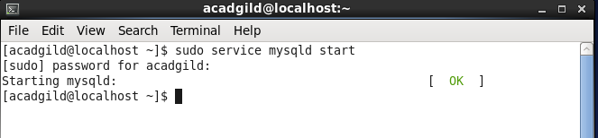
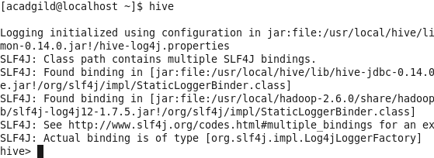

14. To start hbase type the below command as shown in the below screenshot.

