**Session 12: Spark**

**Assignment 1**

**Importing acadgild_spark vm using Oracle vm**

**1.Open the virtual box and then follow the below steps:**

**Click on File --→ Import Appliance.**

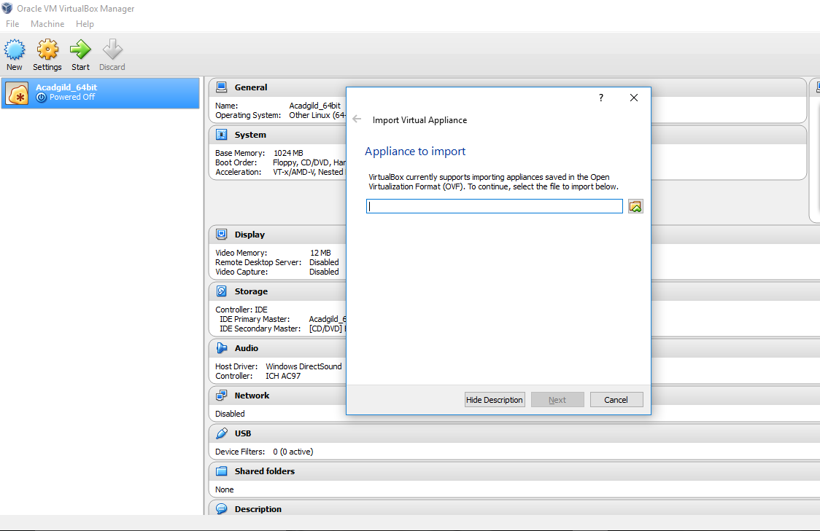

**2. Click on the Folder option as shown in the below screenshot**

**to browse to the location where hadoop vm is present.**

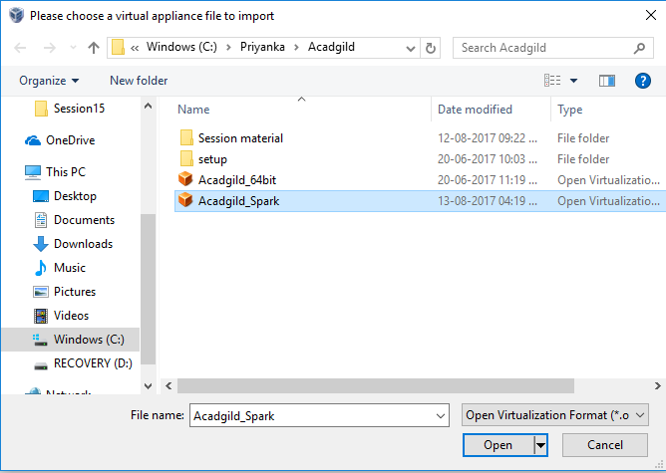

**3.Select the VM to be imported and then click on Open button.**

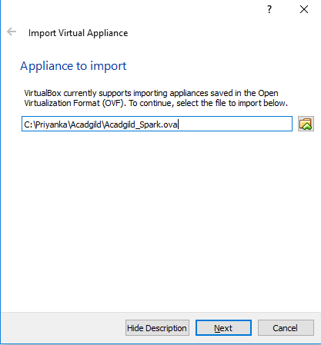

**4. Click on import button to start importing the acadgild**

**VM.**

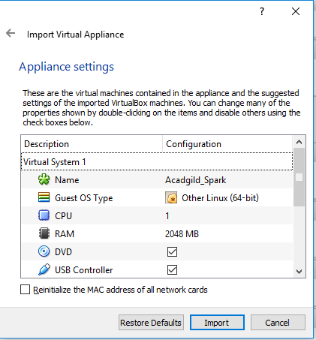

**5. Once the vm starts getting imported it gives a prompt**

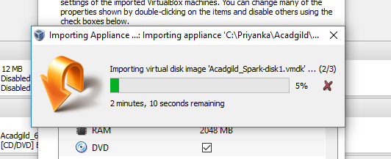

**6.Once the importing gets finished, we need to click**

**on the start button**

**7. We need to give the password as acadgild.**

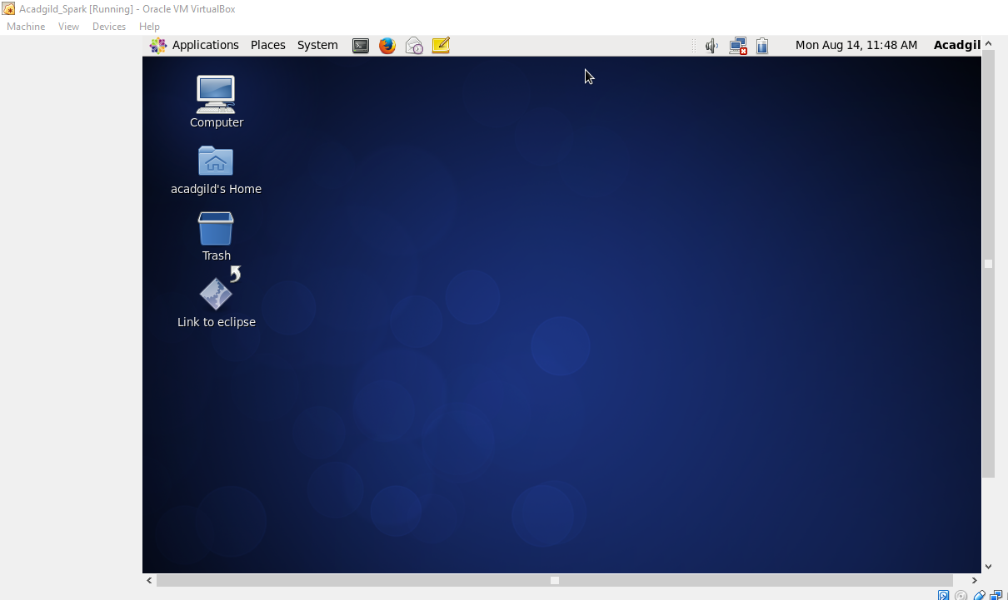

**8. Open the terminal and type the command jps to**

**check the list of daemons, we need to start all the**

**daemons for the first time.**

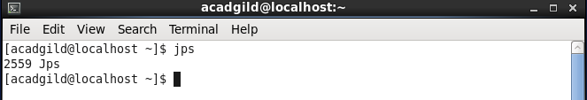

**9.Starting Hadoop daemons**

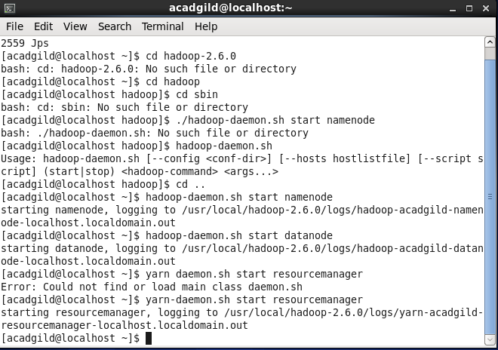

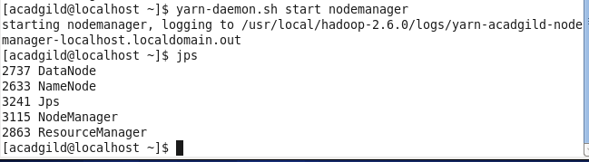

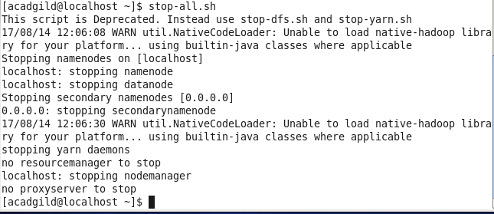

**10.Starting Spark daemons Master,Workers**

