**Session 6 : Hive Introduction**

**Assignment 2**

* **Fetch date and temperature from temperature_data where zip code is greater than**

**300000 and less than 399999.**

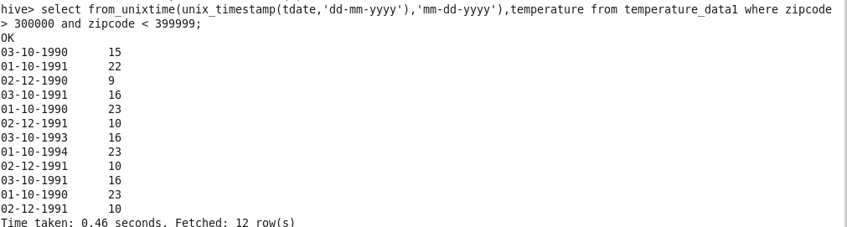

* **Calculate maximum temperature corresponding to every year from temperature_data**

**table.**

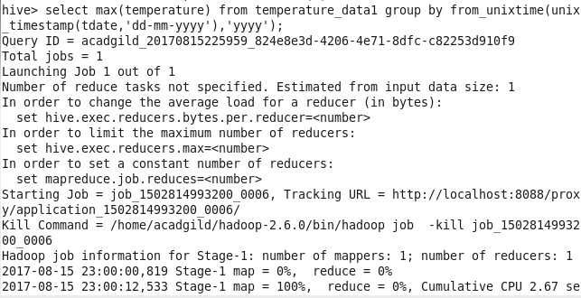

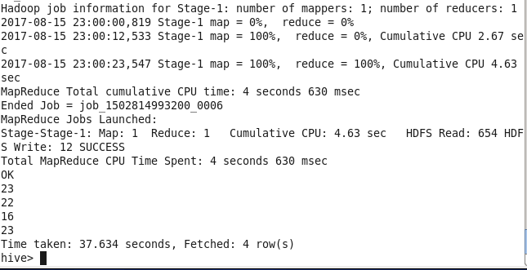

* **Calculate maximum temperature from temperature_data table corresponding to those**

**years which have at least 2 entries in the table.**

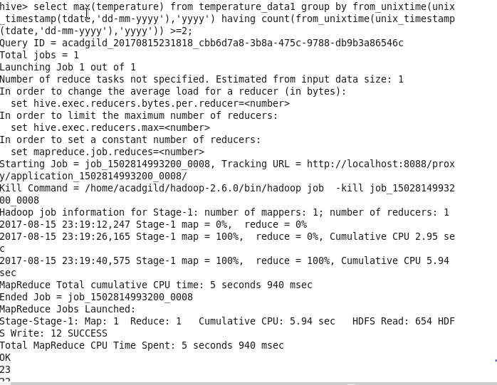

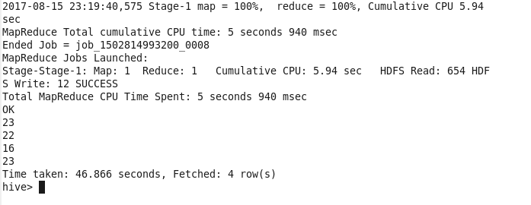

* **Create a view on the top of last query, name it temperature_data_vw.**

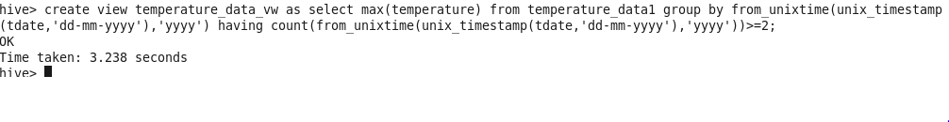

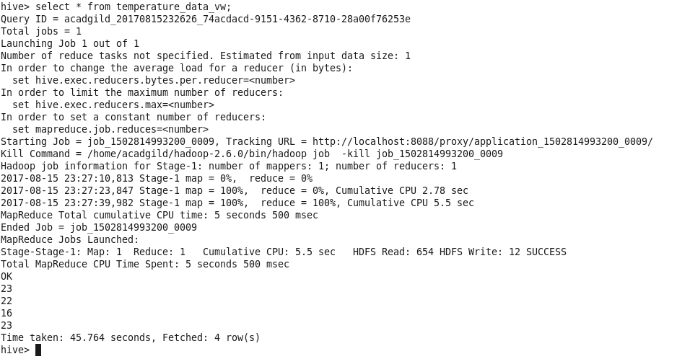

* **Export contents from temperature_data_vw to a file in local file system, such that each**

**file is '|' delimited.**

