**Session 7. Hive Operations**

**Assignment 2**

**1. Write a Hive program to find the number of medals won by each country in swimming.**

**2. Write a Hive program to find the number of medals that India won year wise.**

**3. Write a Hive Program to find the total number of medals each country won.**

**4. Write a Hive program to find the number of gold medals each country won.**

**1. Write a Hive program to find the number of medals won by each country in swimming.**

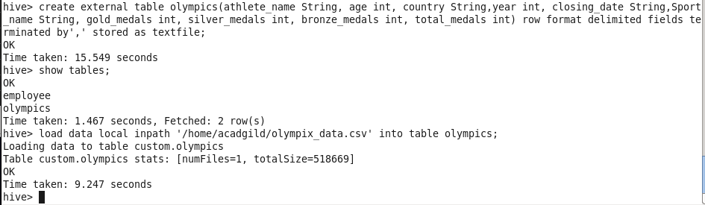

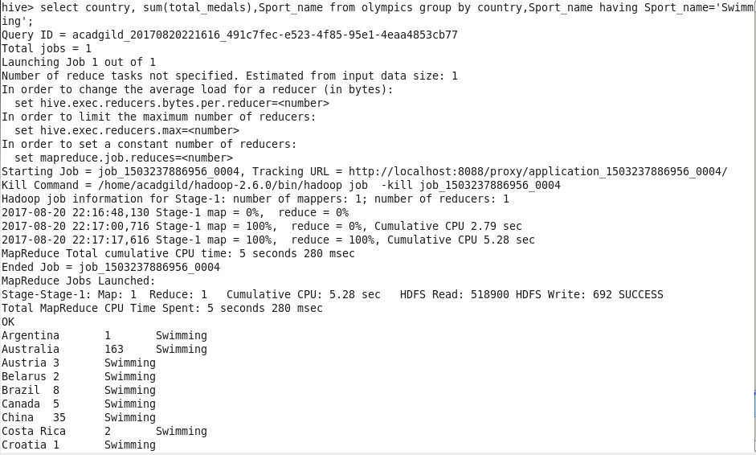

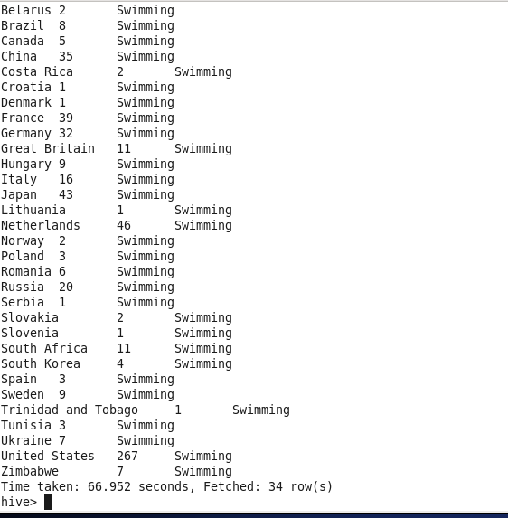

**2. Write a Hive program to find the number of medals that India won year wise.**

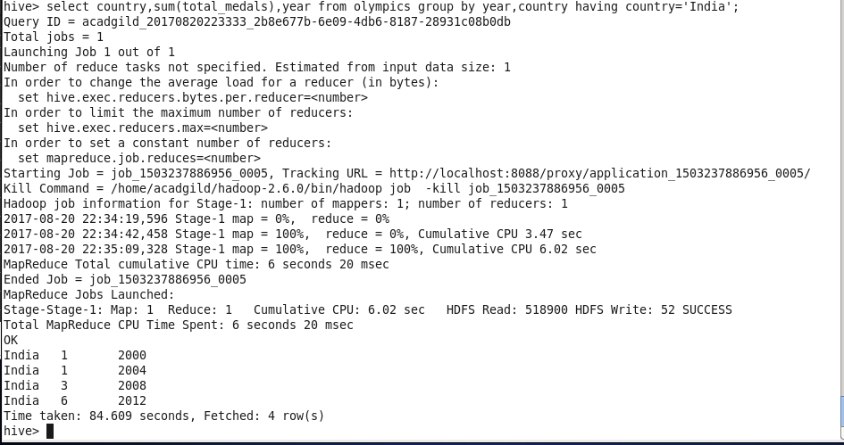

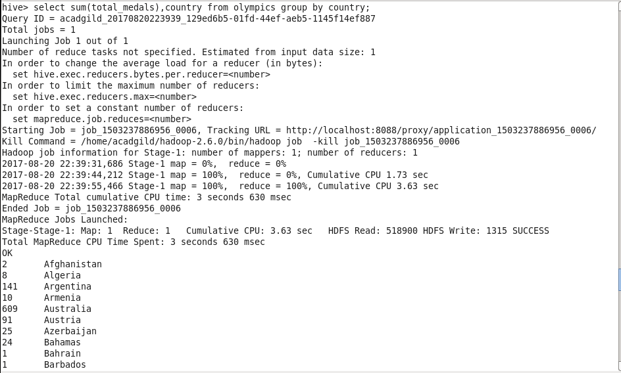

**3. Write a Hive Program to find the total number of medals each country won.**

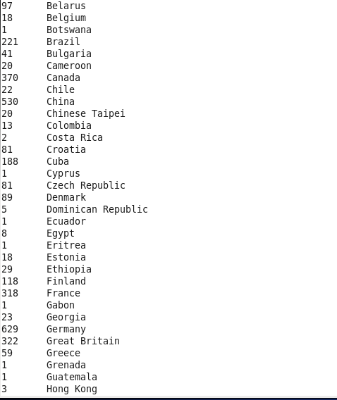

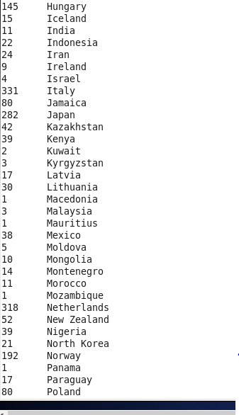

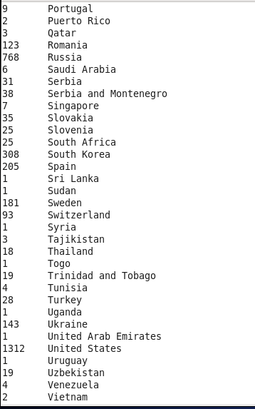

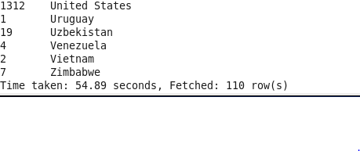

**4. Write a Hive program to find the number of gold medals each country won.**

