**Session 9 : HBase**

**Assignment 2**

**Problem 1:**

**Create an HBase table named 'clicks' with a column family 'hits' such that it should be able to store last 5 values of qualifiers inside 'hits' column family.**

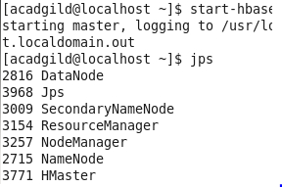

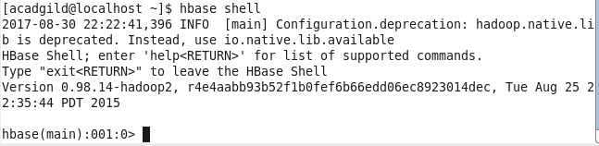

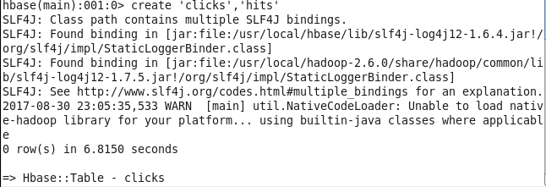

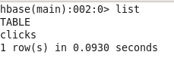

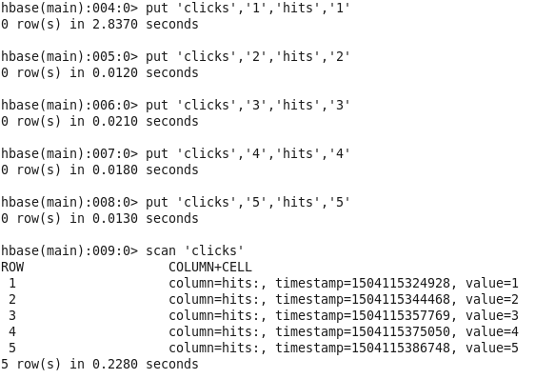

**Problem 2:**

**Add few records in the table and update some of them. Use IP Address as row-key. Scan the table to view if all the previous versions are getting displayed.**

