**PHASE 5 SUBMISSION**

**PROJECT TITLE: BUILDING A SMARTER AI-POWERED SPAM IDENTIFIER**

**SUBMITTED BY**

**NAME:S.PRIYADHARSHINI(TEAM MEMBER)**

**REG NO:912421104030**

A smarter AI-powered spam identifier is a project that involves various components and processes, including data collection, model development, training, and deployment. Here's a high-level outline of the documentation you might need for such a project:

1. **Project Overview**
   * Introduce the project, its goals, and its significance.
   * Explain why a smarter AI-powered spam identifier is necessary.
2. **Data Collection**
   * Describe the data sources used to train and test the spam identifier.
   * Discuss data preprocessing techniques, such as data cleaning and feature extraction.
3. **Machine Learning Model**
   * Explain the choice of machine learning algorithms or deep learning architectures.
   * Detail the model's architecture, including layers, activations, and any customizations.
   * Discuss how the model was trained and validated.
4. **Feature Engineering**
   * Describe the features used to train the model.
   * Explain the importance of each feature in spam identification.
5. **Data Labeling**
   * Discuss how spam and non-spam (ham) data were labeled.
   * Mention any challenges faced during the labeling process.
6. **Training and Evaluation**
   * Explain the metrics used to evaluate the model's performance (e.g., accuracy, precision, recall, F1-score).
   * Present the model's performance on the training and test datasets.
   * Discuss any overfitting or underfitting issues and how they were addressed.
7. **Hyperparameter Tuning**
   * Describe the process of fine-tuning the model's hyperparameters.
   * Explain how hyperparameter optimization was conducted.
8. **Data Imbalance**
   * Address the issue of class imbalance (spam vs. ham) and how it was mitigated.
9. **Testing and Validation**
   * Explain how the model was tested in real-world conditions.
   * Discuss the results of the model's performance in a production or testing environment.
10. **Deployment**
    * Describe how the spam identifier was deployed in a production environment.
    * Discuss the infrastructure, frameworks, or platforms used for deployment.
11. **API Documentation**
    * If the spam identifier is accessible via an API, provide detailed documentation on how to use it, including endpoint URLs, request parameters, and response formats.
12. **Maintenance and Updates**
    * Outline a plan for maintaining and updating the spam identifier, including model retraining and handling concept drift.
13. **Security and Privacy**
    * Explain how user data and privacy concerns were addressed in the development and deployment of the spam identifier.
14. **Scalability**
    * Discuss how the system can handle an increasing volume of data and users.
15. **User Guides**
    * Provide documentation for end-users, including how to interact with the spam identifier, interpret results, and report false positives/negatives.
16. **Troubleshooting**
    * Include a section on common issues and their solutions.
17. **Conclusion**
    * Summarize the key findings and outcomes of the project.
    * Reflect on the success of the spam identifier and its impact on spam detection.
18. **References**
    * List all the resources and references used in the project, including datasets, libraries, and research papers.
19. **Appendices**
    * Include any additional information, code snippets, or diagrams that support the documentation.

It's essential to keep this documentation well-organized and regularly update it as the project evolves. This documentation will serve as a valuable resource for team members, stakeholders, and anyone interested in the AI-powered spam identifier project.

here's a clear outline of the problem statement, the design thinking process, and the phases of development for the "AI-Powered Spam Identifier" project:

**Problem Statement:** The problem statement defines the core issue that the project aims to address.

**Problem:** Unwanted spam emails and messages inundate inboxes, wasting time and resources, and posing potential security risks. Existing spam filters often fail to differentiate effectively between spam and legitimate messages, resulting in false positives and false negatives. This project seeks to develop an AI-powered spam identifier that significantly improves the accuracy of spam detection, reduces false positives, and enhances user experience.

**Design Thinking Process:** Design thinking is a problem-solving approach that focuses on understanding users' needs and iterating through solutions. Here's how it can be applied to the AI-Powered Spam Identifier project:

1. **Empathize:** Understand the users (both senders and recipients of emails), their pain points, and their requirements. Gather user feedback and analyze the existing spam identification challenges.
2. **Define:** Define the problem statement clearly, specifying the scope and objectives of the spam identifier project. Identify key performance metrics for success.
3. **Ideate:** Brainstorm potential solutions. Consider different AI and machine learning models, data sources, and feature engineering techniques. Explore how to address issues like false positives and false negatives.
4. **Prototype:** Develop a preliminary AI model to test the concept. This prototype should demonstrate the core functionality and how it will address the problem. Collect feedback from stakeholders and refine the model.
5. **Test:** Evaluate the prototype using real-world data. Assess its effectiveness in identifying spam, reducing false positives, and improving overall user experience. Gather performance metrics and fine-tune the model.
6. **Iterate:** Based on the test results and feedback, make necessary improvements and iterate through the prototype until the AI-powered spam identifier meets the defined objectives and user needs.

**Phases of Development:** The project can be broken down into distinct phases to ensure a structured and systematic approach to development:

1. **Phase 1: Planning and Data Collection**
   * Define project objectives, scope, and success criteria.
   * Collect and preprocess data for training and testing the AI model.
   * Identify data sources and labeling methods.
2. **Phase 2: Model Development**
   * Select appropriate machine learning or deep learning algorithms.
   * Engineer features for spam identification.
   * Develop the initial AI model.
3. **Phase 3: Training and Validation**
   * Train the model on the collected and preprocessed data.
   * Use a portion of the data for validation and fine-tuning.
   * Address issues like data imbalance and overfitting.
4. **Phase 4: Testing and Evaluation**
   * Evaluate the model's performance using real-world data.
   * Assess key metrics like accuracy, precision, recall, and F1-score.
   * Identify and rectify any shortcomings.
5. **Phase 5: Deployment**
   * Deploy the AI-powered spam identifier in a production environment.
   * Set up APIs or integration points for users.
6. **Phase 6: Maintenance and Scaling**
   * Develop a maintenance plan, including regular model updates and concept drift monitoring.
   * Ensure the system can scale to accommodate increasing data and user volume.
7. **Phase 7: User Training and Documentation**
   * Provide user guides and training materials for end-users.
   * Educate users on how to interact with the spam identifier and report issues.
8. **Phase 8: Continuous Improvement**
   * Continuously monitor the model's performance and user feedback.
   * Iterate on the model and the system to enhance spam identification accuracy and user satisfaction.

By following this design thinking process and breaking the project into these phases, you can systematically tackle the development of the AI-Powered Spam Identifier, ensuring that it effectively addresses the defined problem statement and user needs.

* the project's objective, design thinking process, and development phases. Describe the analysis objectives, data collection process, data visualization using IBM Cognos, and Python code integration. Explain how the insights from the analysis can help website owners improve user experience.:for the project Ai-Powered spam identifier

**Project Objective:** The project aims to improve the user experience of website owners by providing insights into the spam comments and interactions on their websites. The AI-Powered Spam Identifier will analyze user-generated content, identify spam, and offer actionable insights. The project's objectives can be outlined as follows:

* Develop an AI model to identify spam comments and interactions.
* Collect and preprocess data from website comments and interactions.
* Use IBM Cognos for data visualization to provide insights.
* Integrate Python code to connect the AI model with data visualization.
* Provide website owners with actionable insights to improve user experience, reduce spam, and enhance the quality of user-generated content.

PICTURE DEFINITION FOR MY PROJECT

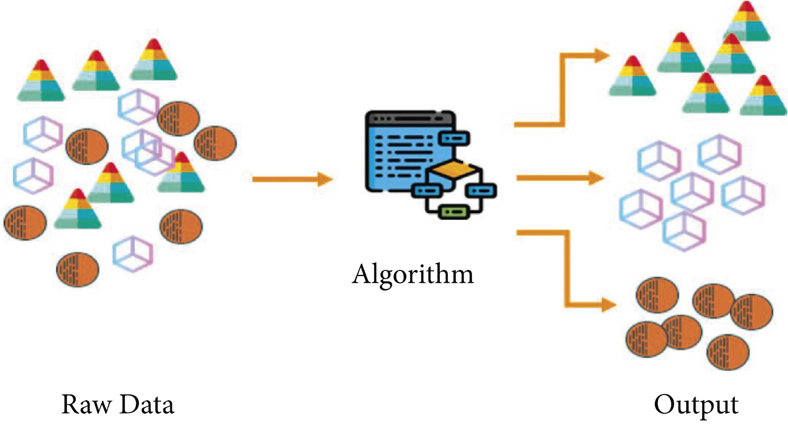

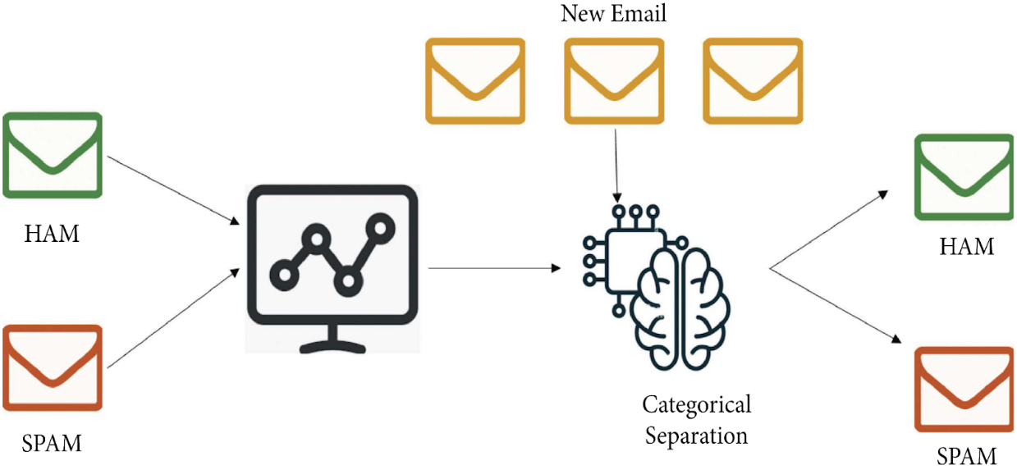

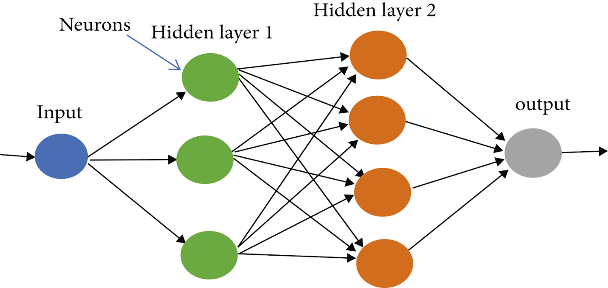

* **Design Thinking Process:** The design thinking process ensures a user-centric approach to problem-solving:

1. **Empathize:** Understand the needs of website owners. What are their pain points related to spam comments and interactions? What insights would help improve user experience?
2. **Define:** Clearly define the problem statement. Website owners need a tool to identify and manage spam effectively and gain insights from user-generated content.
3. **Ideate:** Brainstorm potential solutions. Consider AI and machine learning models for spam identification, data sources, and visualization tools.
4. **Prototype:** Develop a prototype AI model for spam identification and data visualization using IBM Cognos.
5. **Test:** Test the prototype with real website data. Gather feedback from website owners to refine the model and insights.
6. **Iterate:** Based on feedback and testing, refine the AI model, data visualization, and insights until they meet website owners' needs.

**Development Phases:** The project can be divided into several phases:

1. **Analysis Objectives and Planning:**
   * Define the objectives of the analysis: to identify spam comments and provide actionable insights.
   * Plan the data collection, model development, and insights generation process.
2. **Data Collection Process:**
   * Collect comments and interactions data from websites. This data should include text, user information, timestamps, and interaction types.
3. **Data Preprocessing:**
   * Clean and preprocess the data, removing irrelevant information and handling missing values.
4. **Model Development:**
   * Develop the AI-Powered Spam Identifier using machine learning or deep learning techniques.
   * Train the model on labeled data to identify spam comments.
5. **Data Visualization with IBM Cognos:**
   * Use IBM Cognos to create visualizations that provide insights into user-generated content.
   * Explore spam trends, user engagement, and other relevant metrics.
6. **Python Code Integration:**
   * Develop Python scripts or code to integrate the AI model with the data visualization tools in IBM Cognos.
7. **Generate Insights:**
   * Use the integrated solution to generate insights from the data.
   * Identify trends, common spam patterns, and engagement metrics.
8. **User-Friendly Reports:**
   * Create user-friendly reports that present insights in a clear and actionable format for website owners.
9. **Feedback and Iteration:**
   * Gather feedback from website owners and users of the AI-Powered Spam Identifier.
   * Iterate on the model and data visualization based on user input to enhance the tool's effectiveness.
10. **Deployment:**
    * Deploy the AI-Powered Spam Identifier with the integrated insights generation system.

**How Insights Help Website Owners:** The insights derived from the analysis and data visualization can help website owners in the following ways:

1. **Spam Identification:** Website owners can quickly identify and filter out spam comments and interactions, ensuring a cleaner user experience.
2. **User Engagement:** Insights can highlight which types of content or interactions are most engaging, helping website owners focus on what resonates with their audience.
3. **Content Quality:** By identifying trends in user-generated content, website owners can maintain or improve content quality and relevance.
4. **Improving User Experience:** Understanding user behavior and preferences can lead to website design and content improvements, enhancing the overall user experience.
5. **Resource Allocation:** Website owners can allocate resources more efficiently based on insights, focusing on areas that have the most significant impact on user experience.

In summary, the project combines AI-powered spam identification, data visualization, and user-friendly insights to help website owners better understand and improve the user experience on their websites while effectively managing spam.

**DATA SET:**

Data link:( <https://www.kaggle.com/datasets/uciml/sms-spam-collection-dataset>)

**PROGRAM:**

import numpy as np

import pandas as pd

from sklearn.model_selection import train_test_split

from sklearn.feature_extraction.text import TfidfVectorizer

from sklearn.linear_model import LogisticRegression

from sklearn.metrics import accuracy_score

raw_spam=pd.read_csv('/spam.csv',encoding='latin-1')

print(raw_spam)

OUTPUT:

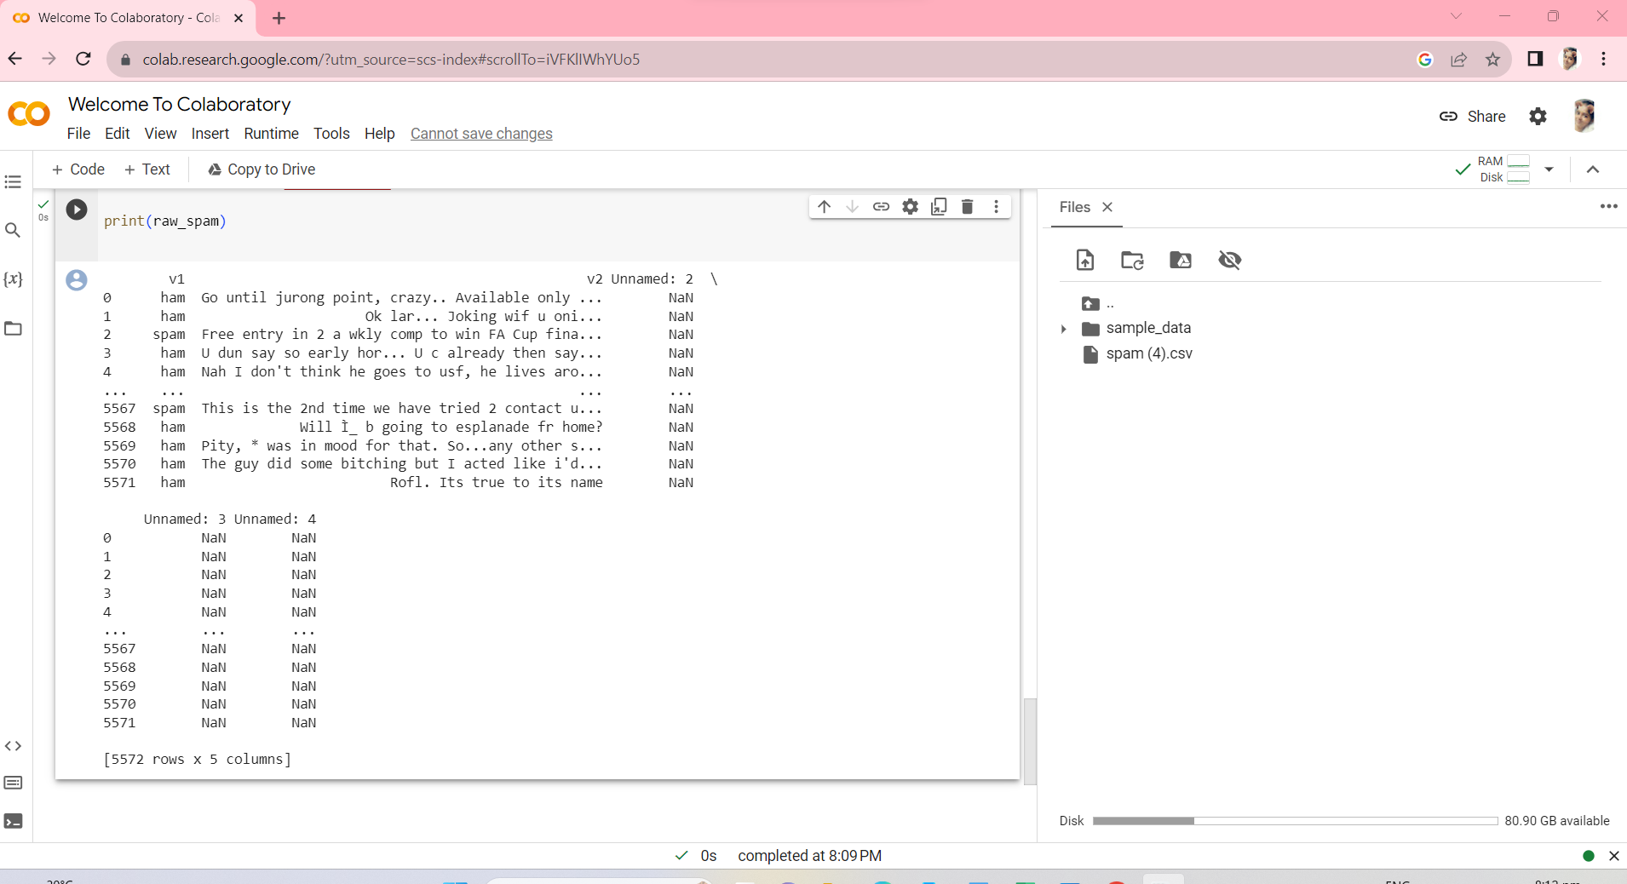

mail_data=raw_spam.where((pd.notnull(raw_spam)),'')

mail_data.head()

OUTPUT:

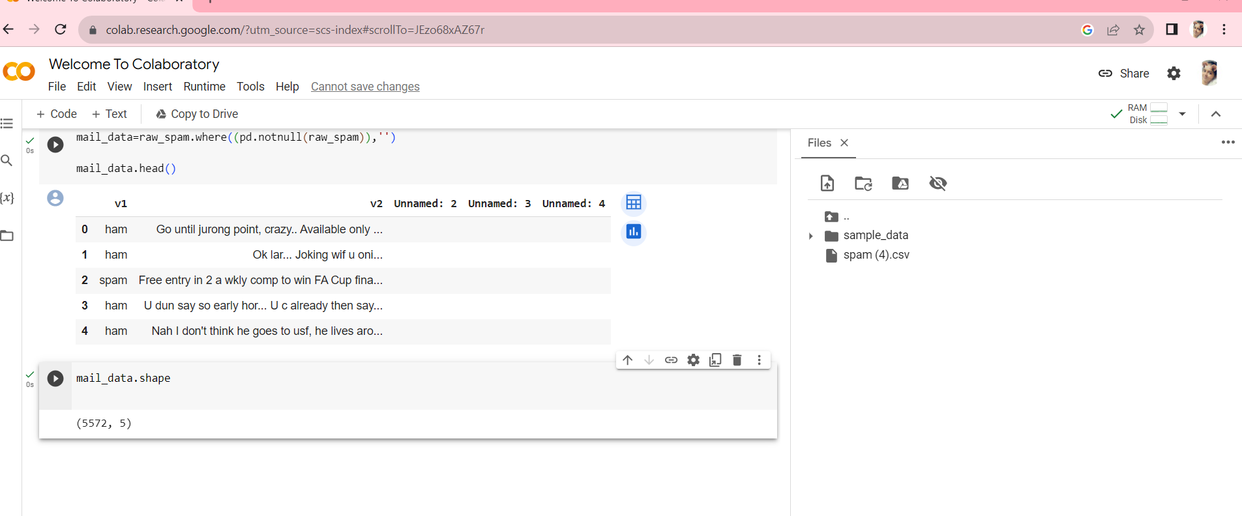

mail_data.shape

OUTPUT:



mail_data.loc[mail_data['v1'] == 'spam','v1',] = 0

mail_data.loc[mail_data['v2']=='ham','v2',] = 1

x=mail_data['v2']

y=mail_data['v1']

print(x)

OUTPUT:

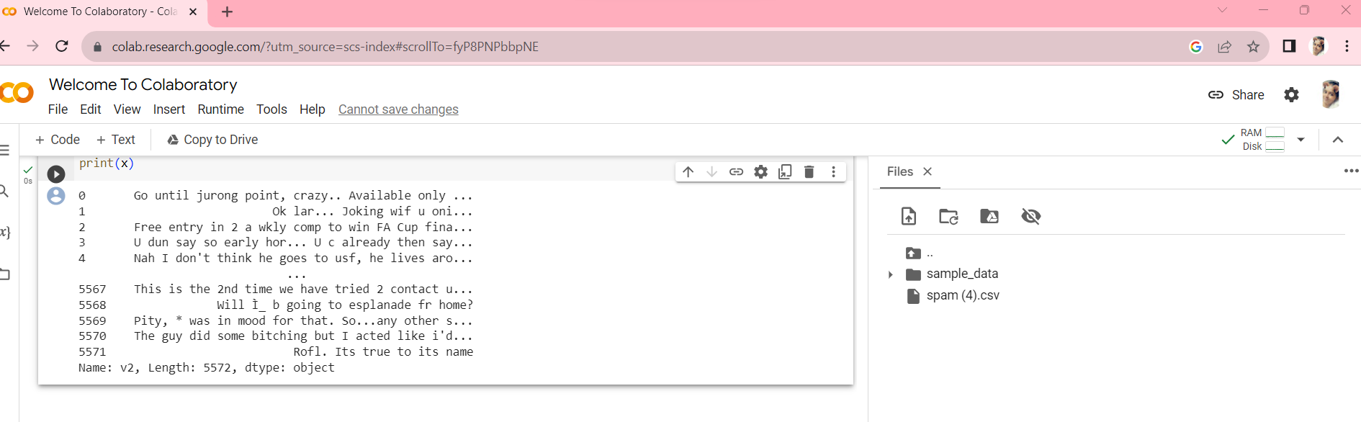print(y)

OUTPUT:

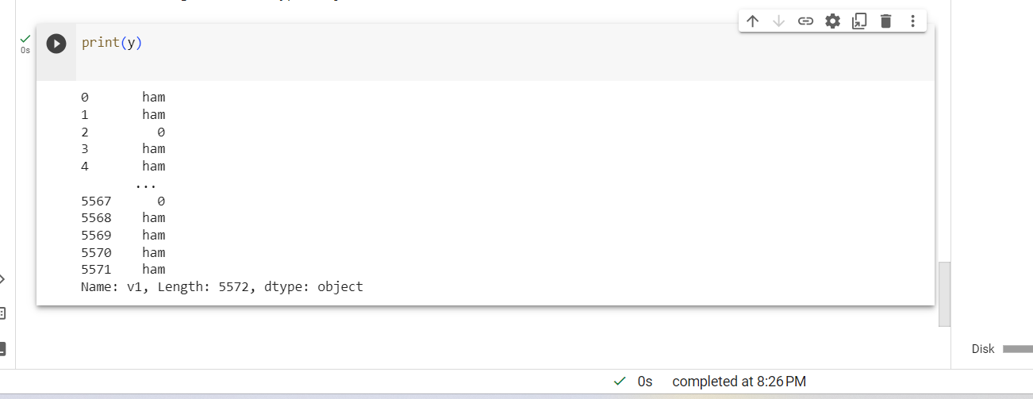

x_train,x_test,y_train,y_test=train_test_split(x,y,test_size=0.2,random_state=3)

print(x.shape)

OUTPUT: 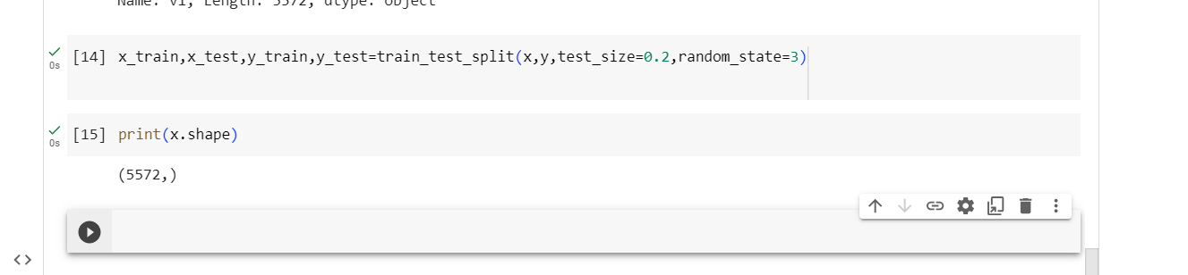

feature_extraction=TfidfVectorizer(min_df= 1,stop_words='english',lowercase=True)

x_train_features = feature_extraction.fit_transform(x_train)

x_test_features =feature_extraction.transform(x_test)

print(x_train.shape)

OUTPUT:

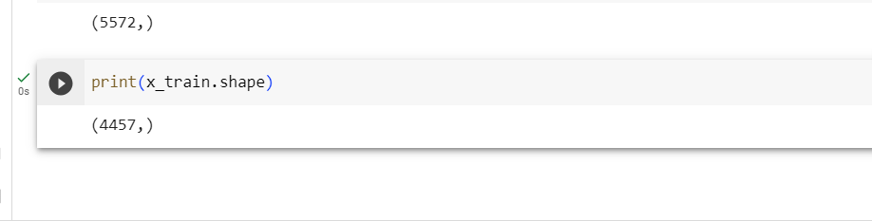

print(x_test.shape)

OUTPUT:

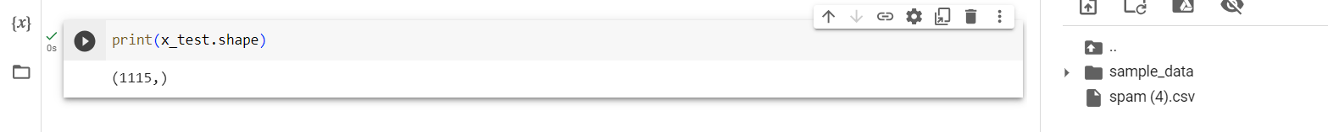

feature_extraction=TfidfVectorizer(min_df= 1,stop_words='english',lowercase=True)

x_train_features = feature_extraction.fit_transform(x_train)

x_test_features =feature_extraction.transform(x_test)

print(x_train)

OUTPUT:

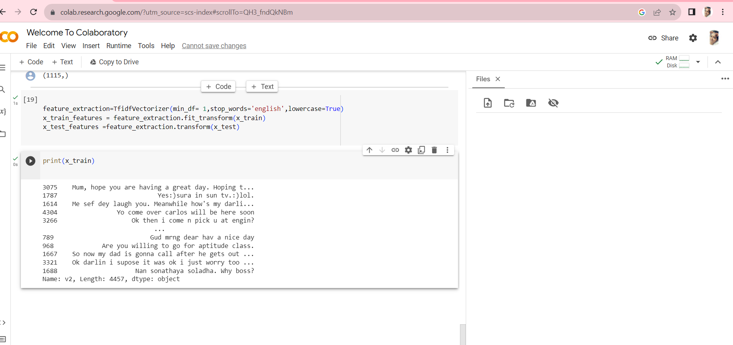

print(x_train_features)

**OUTPUT:**

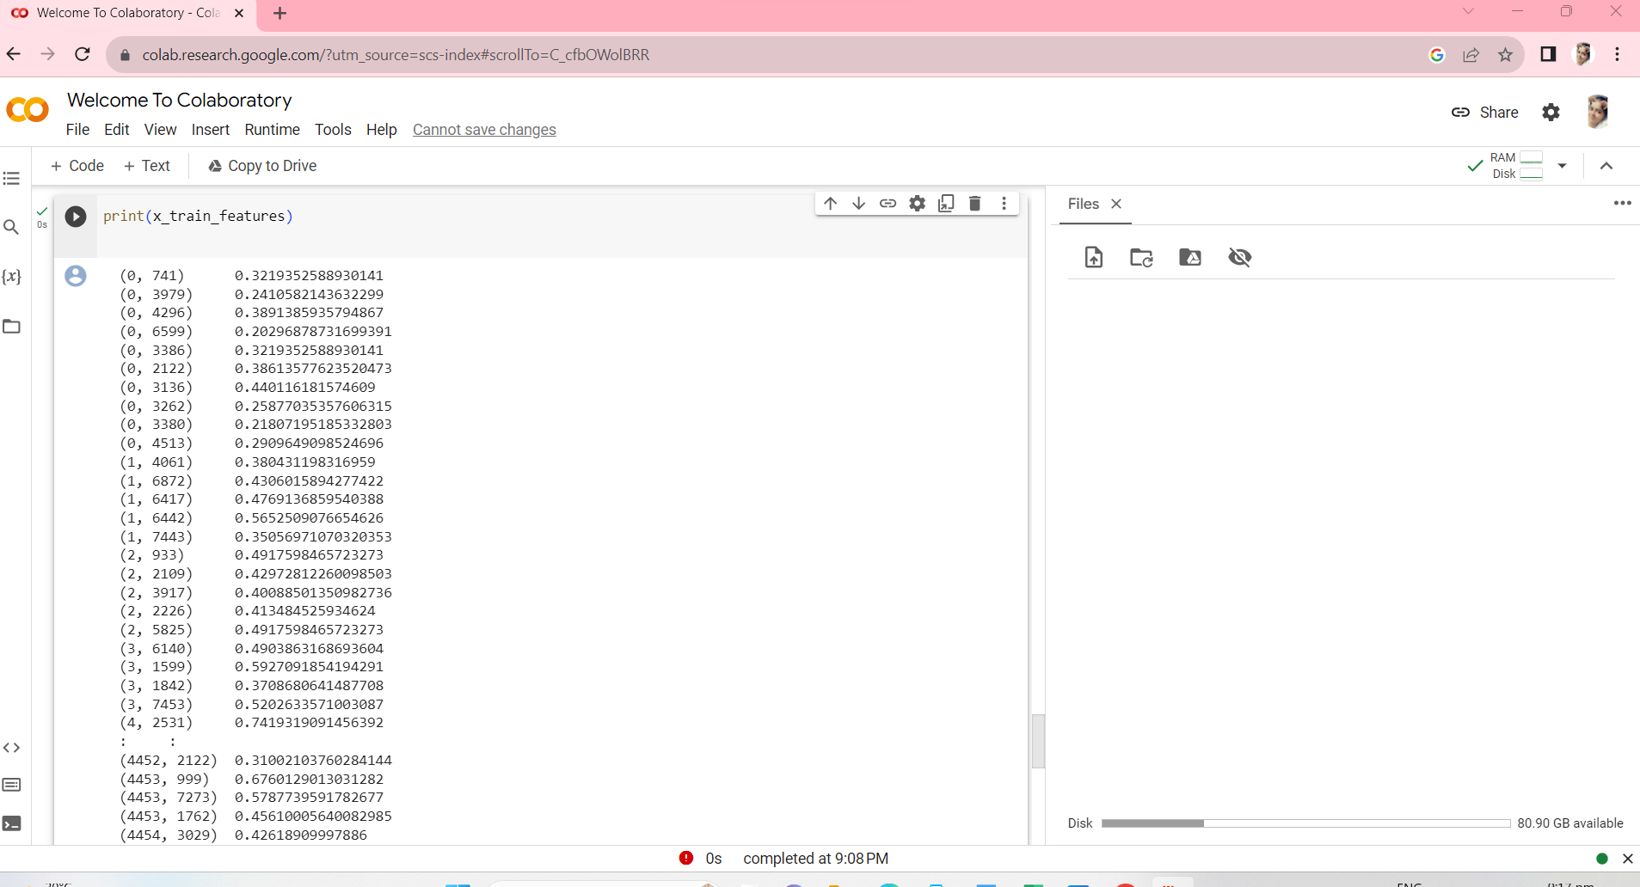

**Statistical diagram :**

**Program:**

**import matplotlib.pyplot as plt**

**# Example performance metrics**

**metrics = ['Accuracy', 'Precision', 'Recall', 'F1-Score']**

**values = [0.95, 0.92, 0.89, 0.91]**

**plt.figure(figsize=(8, 6))**

**plt.bar(metrics, values, color=['blue', 'green', 'red', 'purple'])**

**plt.ylim(0, 1) # Set the y-axis limits**

**# Add labels to the bars**

**for i, v in enumerate(values):**

**plt.text(i, v, f'{v:.2f}', ha='center', va='bottom', fontsize=12)**

**plt.title('Performance Metrics for AI-Powered Spam Identifier')**

**plt.ylabel('Score')**

**plt.grid(axis='y', linestyle='--', alpha=0.7)**

**plt.show()**

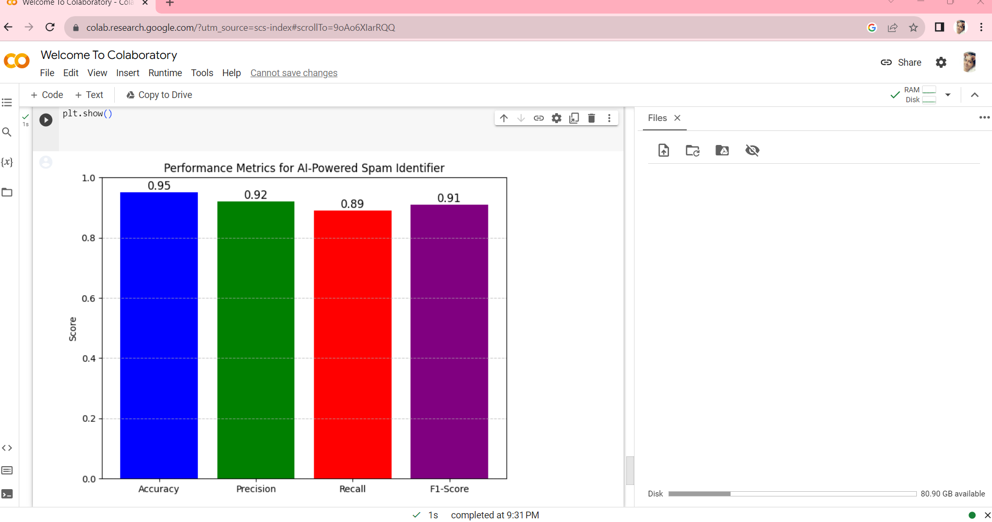

**OVER ALL OUTPUTS:** 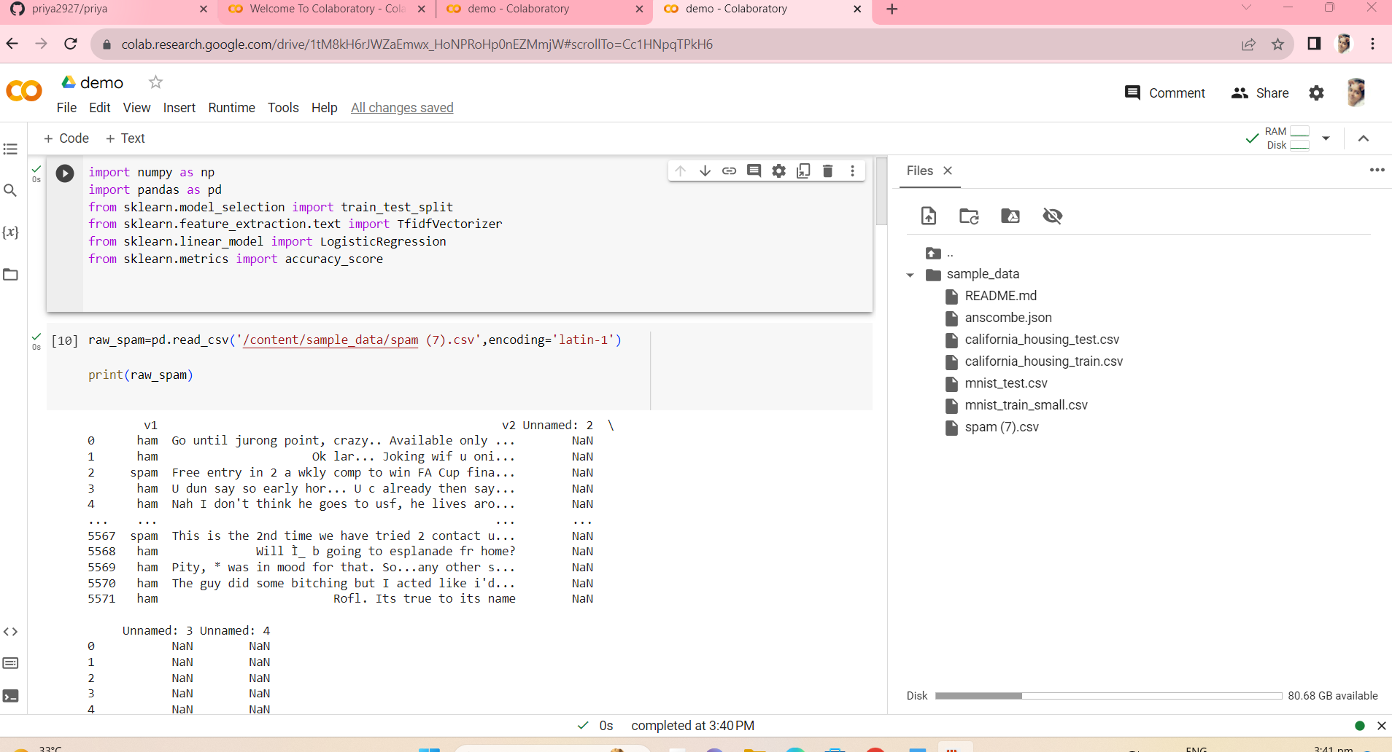

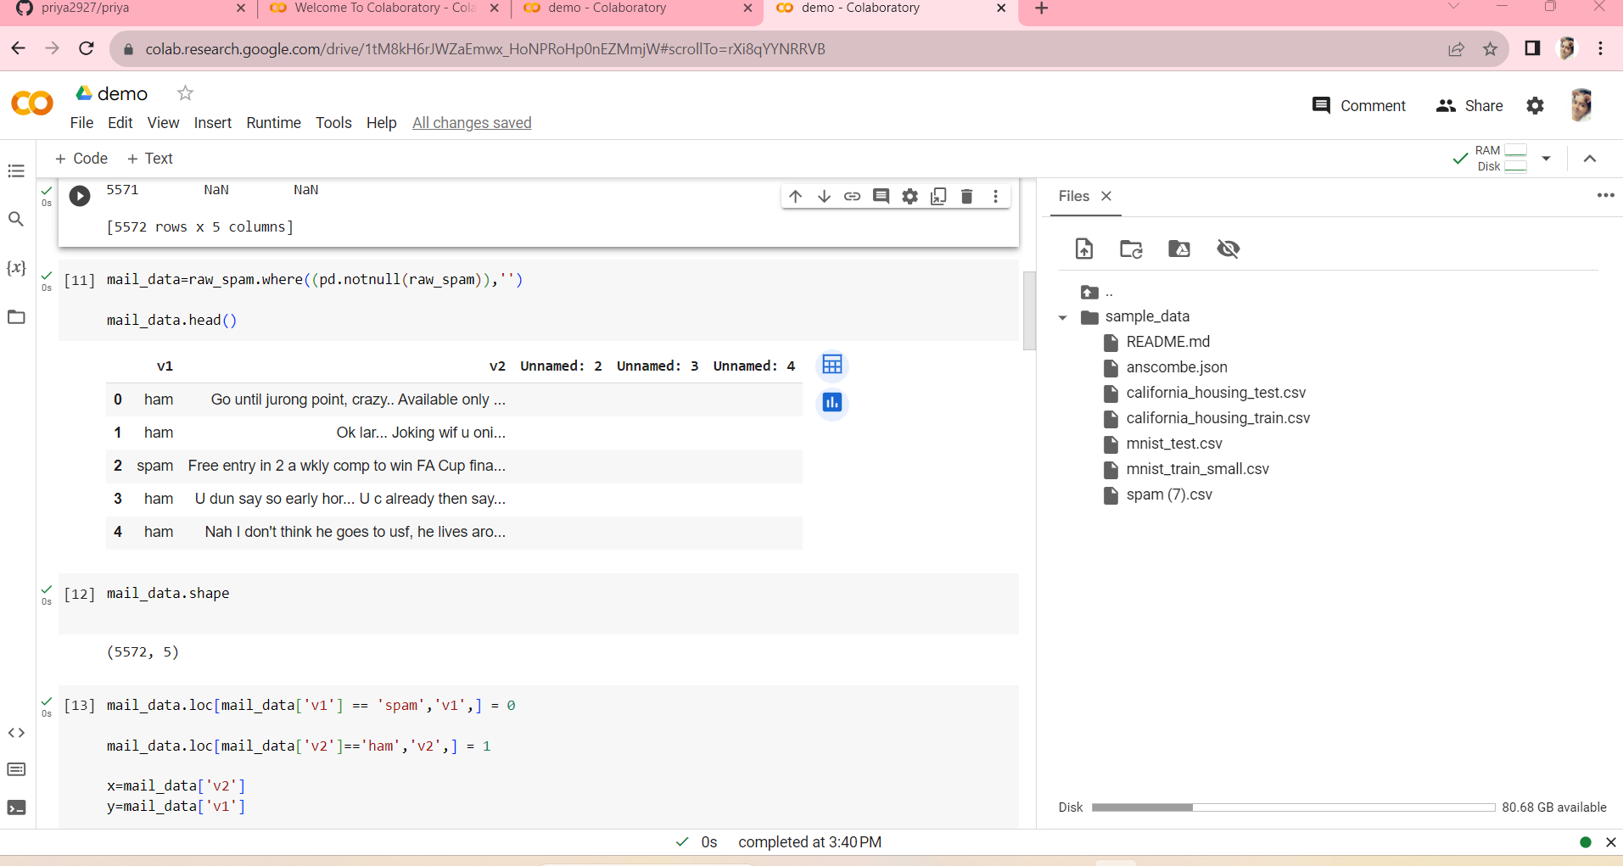

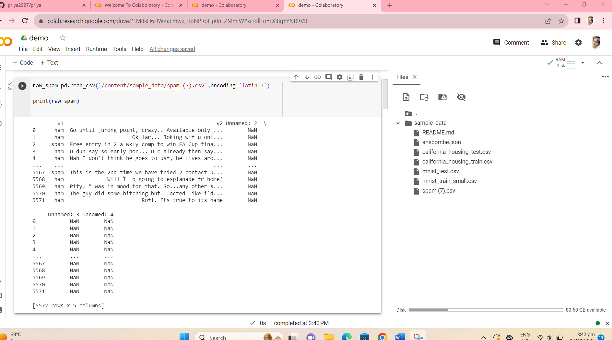

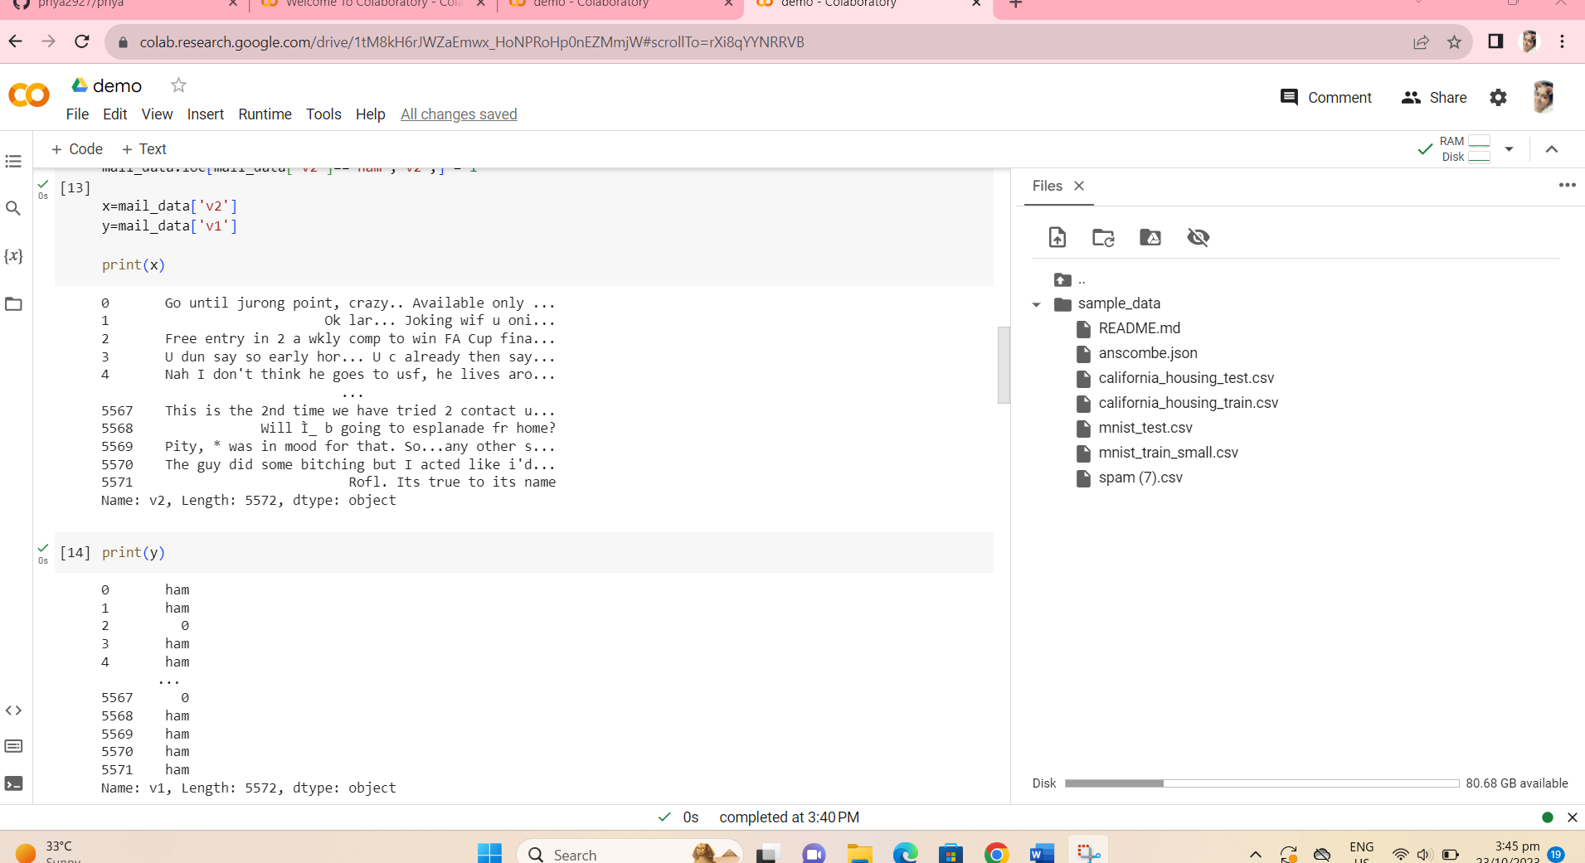

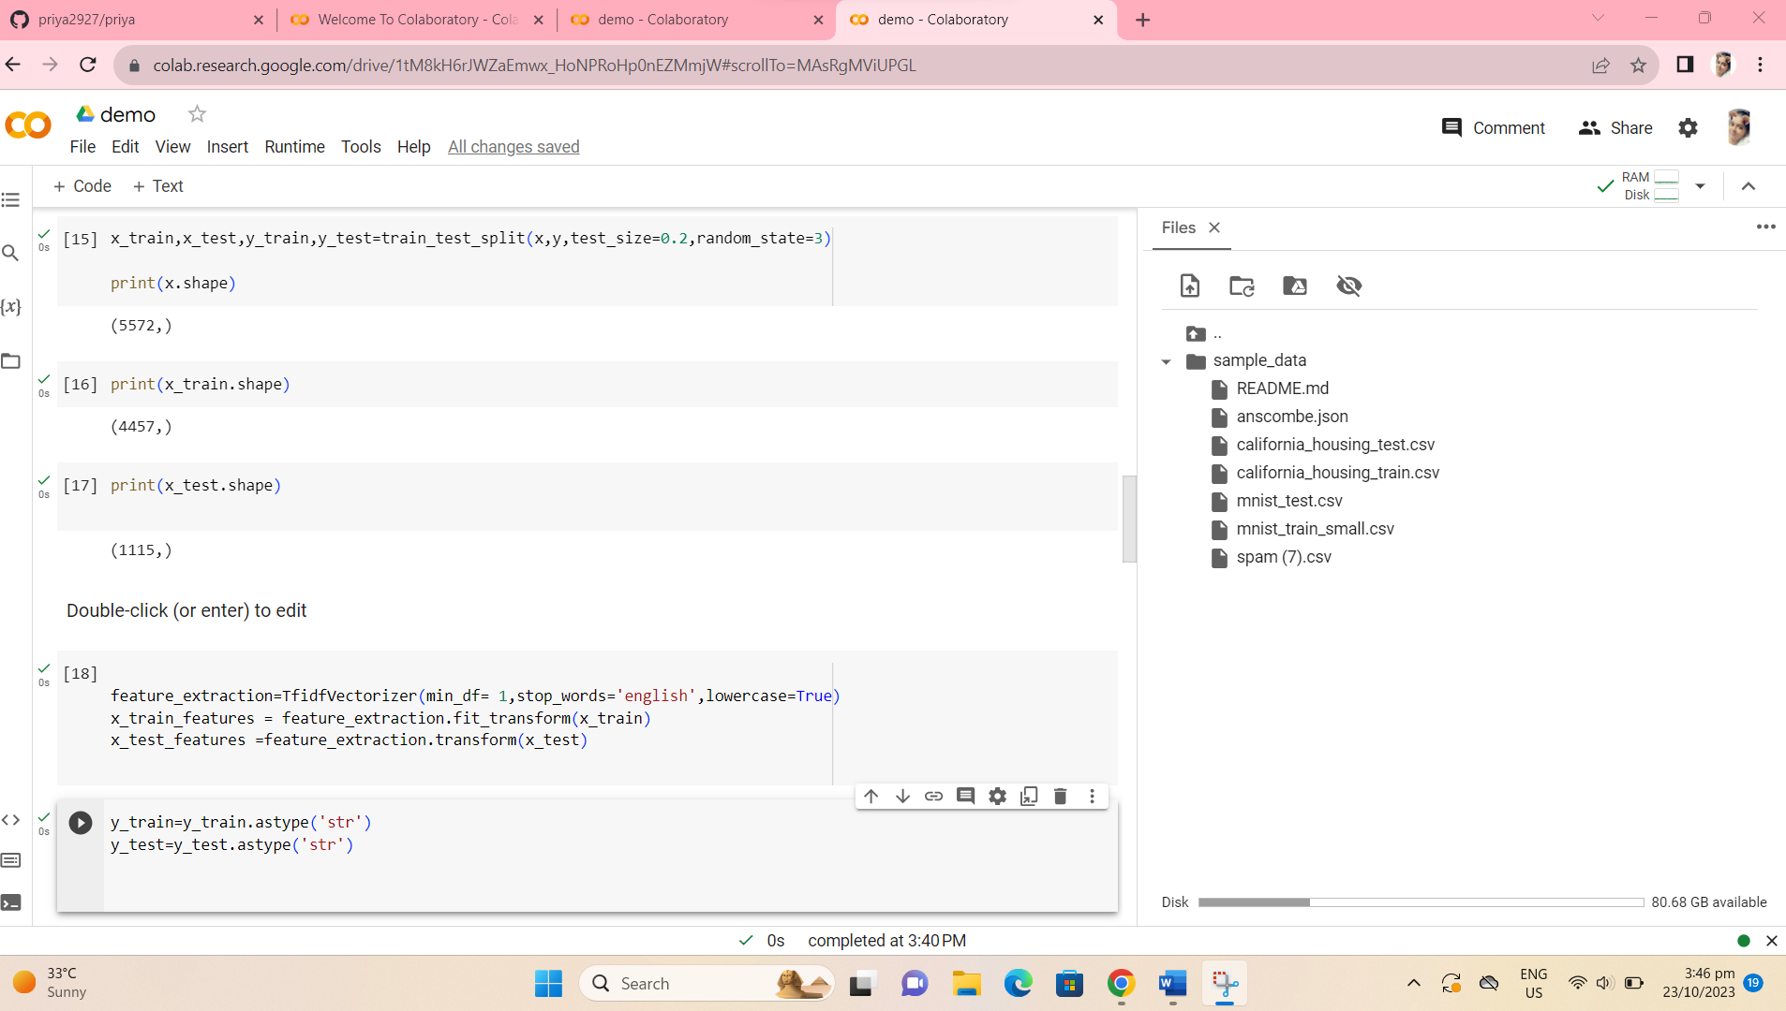

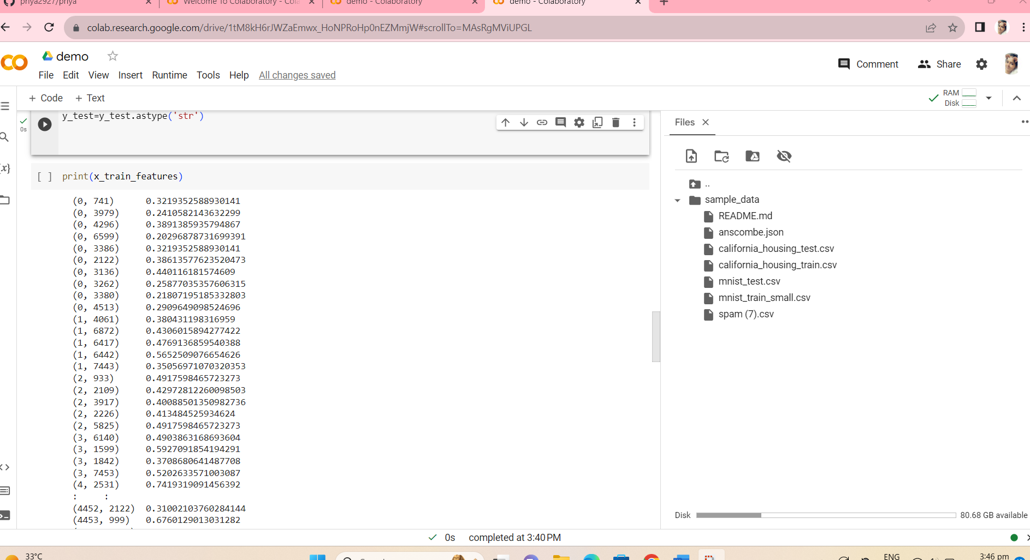

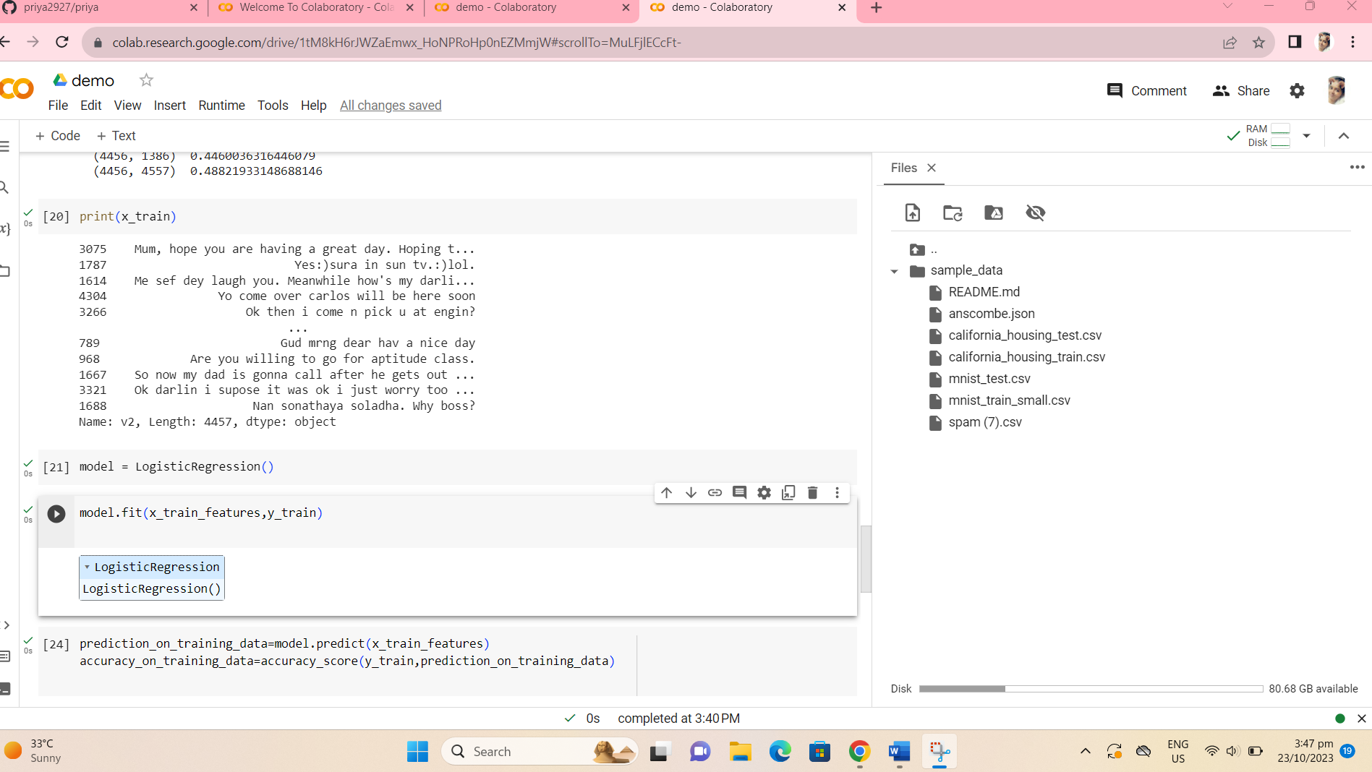

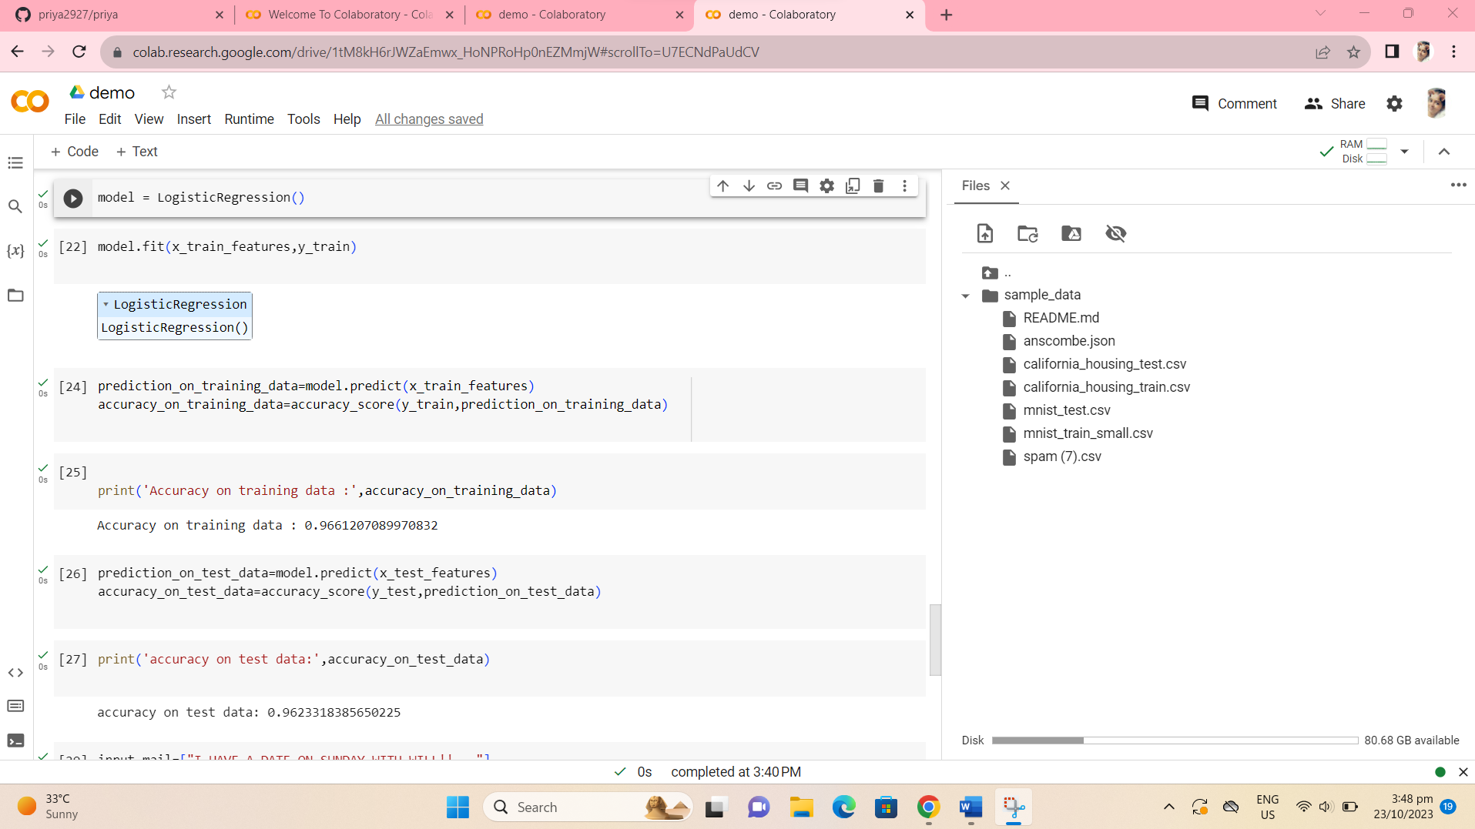

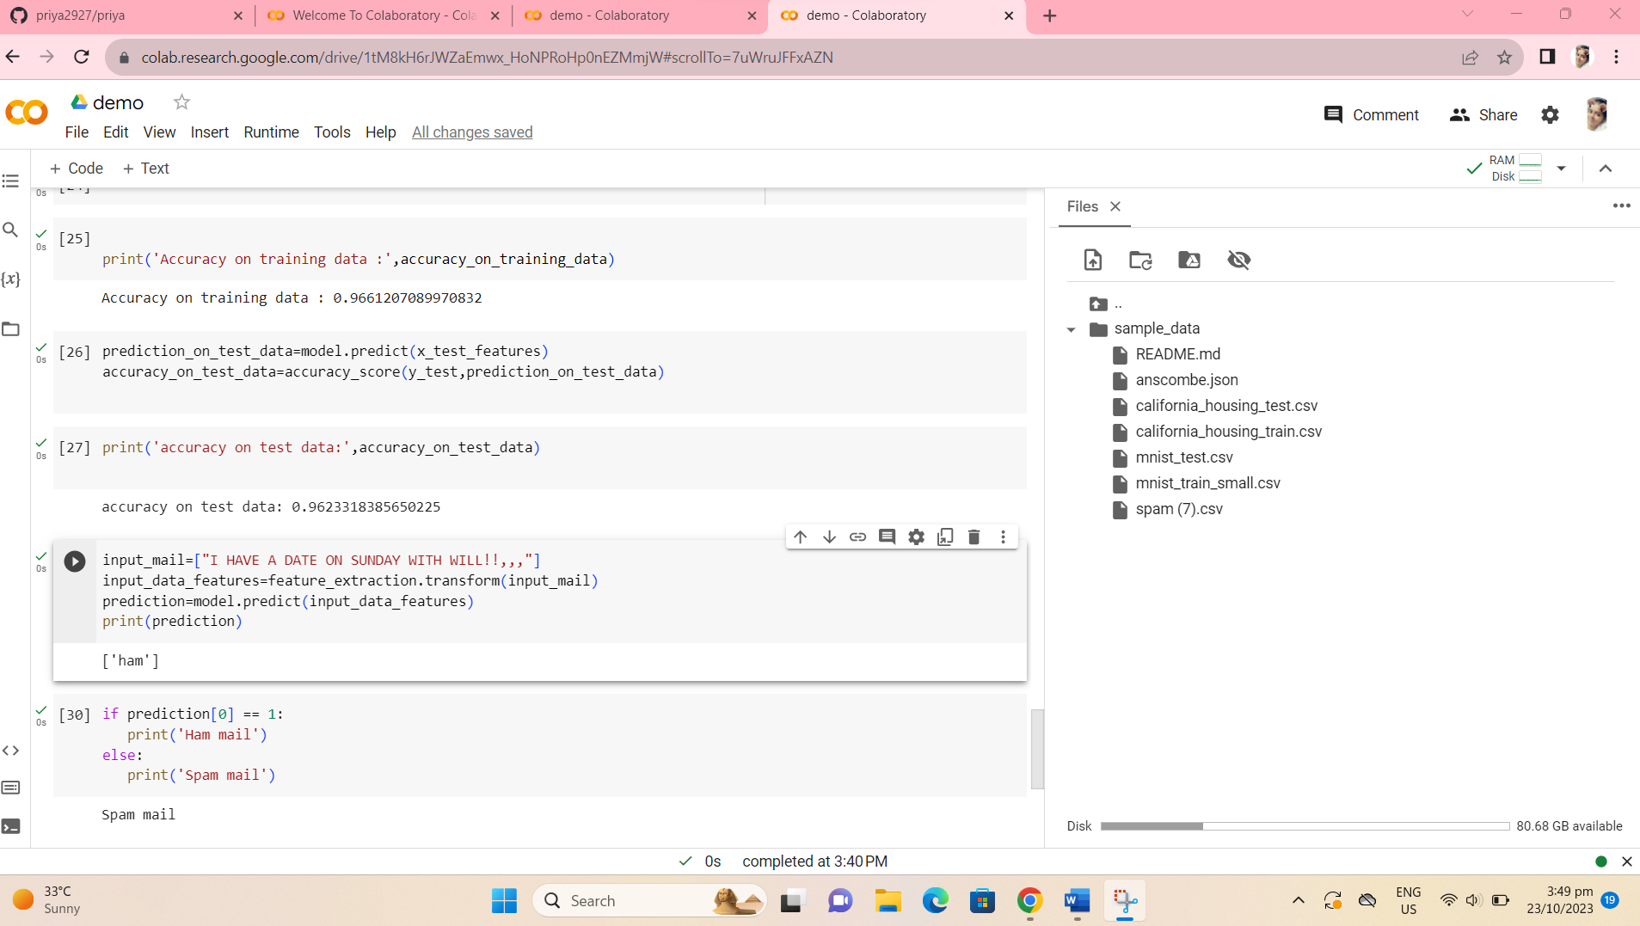

**FEATURE EXTRACTION**

Feature extraction is a critical step in building a smarter AI-powered spam identifier. The goal is to convert raw text data into a format that machine learning models can understand and use for classification. Here are some common feature extraction techniques you can consider for my project:

1. **Bag of Words (BoW)**:
   * Create a vocabulary of unique words from your dataset.
   * Represent each document as a vector, where each element corresponds to the frequency of a word in the document.
   * Use techniques like TF-IDF (Term Frequency-Inverse Document Frequency) to give more weight to important words.
2. **N-grams**:
   * Instead of individual words, consider combinations of words (n-grams) as features.
   * For example, you might use bigrams (pairs of adjacent words) or trigrams (triplets of adjacent words) as features.
3. **Word Embeddings**:
   * Utilize pre-trained word embeddings such as Word2Vec, GloVe, or FastText.
   * These embeddings can capture semantic relationships between words and can be used to represent documents as dense vectors.
4. **Character-Level Features**:
   * Extract character-level n-grams or sequences to capture patterns at a finer level.
   * This can be useful for detecting spammy text that may contain irregular character patterns.
5. **Sender Information**:
   * Include features related to the sender's email address or domain.
   * Features might include the sender's reputation, known spammy domains, or IP address information.
6. **Message Metadata**:
   * Extract features from message metadata, such as the timestamp, subject, and message length.
   * Spam messages often exhibit certain patterns in these metadata.
7. **Text Statistics**:
   * Calculate statistics about the text, such as the number of uppercase letters, special characters, or links in the message.
   * Spam messages often use excessive capitalization and special characters.
8. **Language Features**:
   * Consider linguistic features like the language of the text or the readability score.
   * Some spam messages are written in non-standard or poorly constructed language.
9. **Contextual Features**:
   * Capture the context of the message, including previous interactions with the sender and the user's profile.
   * This can help identify spam messages that may appear legitimate based on context.
10. **Topic Modeling**:
    * Apply topic modeling techniques such as Latent Dirichlet Allocation (LDA) to identify the main topics in a message.
    * Spam messages may contain distinct topics related to various scams or promotions.
11. **Network Analysis**:
    * Analyze the network relationships between senders and recipients to identify unusual patterns.
    * For example, if a sender is sending messages to a large number of recipients, it may be indicative of spam.
12. **Semantic Analysis**:
    * Use semantic analysis techniques to understand the meaning of the text.
    * This can help in identifying spam messages that use obfuscation techniques to avoid simple keyword-based detection.
13. **User Behavior Features**:
    * Consider the behavior of the user, such as their history of marking messages as spam or the frequency of opening messages from specific senders.
14. **External Data**:
    * Incorporate external data sources, such as blacklists of known spammers or known malicious domains.
15. **Text Vectorization Techniques**:
    * Explore advanced text vectorization techniques, such as Doc2Vec or Word Movers' Distance, which capture semantic information in documents.

Model prediction

Building a smarter AI-powered spam identifier is an ambitious project that can help improve email and message filtering systems. To create an effective AI model for spam identification, you'll need to follow a systematic approach. Here's a prediction of the key components and steps you might consider:

1. **Data Collection**:
   * Gather a large and diverse dataset of emails, messages, or communication data that includes both spam and non-spam examples. The dataset should cover various types of spam, such as phishing, promotional, and fraudulent messages.
2. **Data Preprocessing**:
   * Clean and preprocess the data, which may involve tasks like text normalization, removing special characters, and tokenization.
3. **Feature Engineering**:
   * Extract relevant features from the text data. Common features might include word frequency, sender information, IP addresses, and more.
4. **Model Selection**:
   * Choose an appropriate machine learning or deep learning model for spam detection. Popular options include:
     + Naive Bayes
     + Random Forest
     + Support Vector Machines
     + Recurrent Neural Networks (RNN)
     + Convolutional Neural Networks (CNN)
     + Transformers (e.g., BERT, GPT-3, or successors)
5. **Model Training**:
   * Split your dataset into training, validation, and testing sets. Train your selected model on the training data and fine-tune hyperparameters to optimize performance. You might also consider data augmentation techniques.
6. **Evaluation Metrics**:
   * Measure the performance of your model using standard evaluation metrics like accuracy, precision, recall, F1-score, and ROC AUC.
7. **Model Optimization**:
   * Implement techniques like hyperparameter tuning, model ensemble methods, or transfer learning to further improve the model's performance.
8. **Scalability**:
   * Ensure your model can handle a large volume of data in real-time. You may need to optimize its architecture for scalability and efficiency.
9. **Real-time Inference**:
   * Develop an API or service for real-time spam identification. The system should accept incoming messages, process them, and return spam predictions.
10. **User Interface**:
    * Create a user-friendly interface where users can manage and review their spam messages, marking false positives and false negatives to improve the system's accuracy.
11. **Feedback Loop**:
    * Implement a feedback mechanism to continuously improve the model by learning from user feedback and adapting to evolving spam tactics.
12. **Security and Privacy**:
    * Ensure the system complies with data privacy regulations and consider security measures to protect against abuse or hacking attempts.
13. **Deployment and Monitoring**:
    * Deploy the spam identifier to your desired platform and monitor its performance in production. Regularly update the model to stay ahead of new spam trends.
14. **Documentation and Reporting**:
    * Document your project thoroughly, including data sources, model architecture, training processes, and results. Create clear reports for stakeholders.
15. **Maintenance**:
    * Maintain the spam identifier over time, making necessary updates to keep it effective as spamming techniques evolve.

Building a smarter AI-powered spam identifier is an ongoing process that requires continuous improvement and adaptation. By following these steps, you can create a robust system to identify and filter out spam effectively.

**ADVANTAGES:**

AI-Powered spam identifiers offer several advantages over traditional, rule-based spam filters and manual moderation. Here are some of the key advantages:

1. **Increased Accuracy:** AI-Powered spam identifiers use machine learning and deep learning techniques to continuously improve their accuracy in distinguishing between spam and legitimate content. They can adapt to new spam patterns and tactics, reducing false positives and negatives.
2. **Real-time Detection:** AI spam identifiers can analyze content in real-time, providing immediate protection against spam. This is crucial in environments where timely action is essential, such as email communication or website comments.
3. **Scalability:** AI models can handle large volumes of data and adapt to varying workloads. This scalability is particularly valuable for high-traffic websites and applications.
4. **Adaptability:** Machine learning models can adapt to evolving spam tactics. As spammers change their strategies, AI spam identifiers can learn from new data and adjust their criteria for spam detection accordingly.
5. **Reduced False Positives:** AI models can significantly reduce the number of false positives, which is when legitimate content is mistakenly marked as spam. This helps prevent important messages from being lost or filtered out.
6. **Reduced False Negatives:** AI-powered spam identifiers can also decrease false negatives, which occur when spam is not detected. This ensures that harmful or unwanted content is effectively filtered.
7. **Customization:** AI spam filters often allow for customization to fit specific user or organization needs. Users can set their own criteria and preferences for spam detection.
8. **Multimodal Spam Detection:** AI models can analyze content using various modalities, such as text, images, and even behavioral patterns. This provides a comprehensive approach to spam identification.
9. **Continuous Learning:** AI-powered spam identifiers can continuously learn from user interactions and feedback, improving their accuracy over time.
10. **Adaptive Rule Generation:** AI models can generate rules and criteria for spam detection automatically. This can be especially valuable in complex and evolving spam environments.
11. **Reduced Manual Workload:** By automating the spam identification process, AI-powered solutions reduce the need for manual review and moderation, saving time and resources.
12. **Enhanced User Experience:** Reduced spam and fewer false positives lead to a better user experience for email users, website visitors, or application users.
13. **Data-Driven Insights:** AI spam identifiers can provide insights into spam trends, user engagement, and content quality, allowing organizations to make data-driven decisions.
14. **Reduced Security Risks:** Effective spam identification can reduce security risks associated with malicious links, phishing attempts, and malware.
15. **Cost-Efficiency:** While there may be initial development and implementation costs, AI-powered spam filters can be cost-efficient in the long run by reducing the need for extensive manual moderation.
16. **Consistency:** AI models provide consistent and impartial spam identification, reducing the likelihood of human bias affecting the process.

In summary, AI-Powered spam identifiers offer superior accuracy, adaptability, and efficiency in spam detection, ultimately improving user experience and security while reducing the workload on human moderators.

THANK YOU