**DAILY ONLINE ACTIVITIES SUMMARY**

|  |  |  |  |  |  |  |  |  |
| --- | --- | --- | --- | --- | --- | --- | --- | --- |
| **Date:** | **23-06-2020** | | | | | **Name:** | **Priya H T** | |
| **Sem & Sec** | **VI B** | | | | | **USN:** | **4AL17CS066** | |
| **Online Test Summary** | | | | | | | | |
| **Subject** | | **Java & J2EE, Data Structure with C and PAP Assignment 4** | | | | | | |
| **Max. Marks** | | **--** | | **Score** | | | **--** | |
| **Certification Course Summary** | | | | | | | | |
| **Course** | **Placement Training** | | | | | | | |
| **Certificate Provider** | | | **--** | | **Duration** | | | **--** |
| **Coding Challenges** | | | | | | | | |
| **Problem Statement:2 program** | | | | | | | | |
| **Status: solved** | | | | | | | | |
| **Uploaded the report in Github** | | | | | **yes** | | | |
| **If yes Repository name** | | | | | <https://github.com/priya3028/Onlinecodingupdate> | | | |
| **Uploaded the report in slack** | | | | | **yes** | | | |

Online test details

PAP Assignment 4:

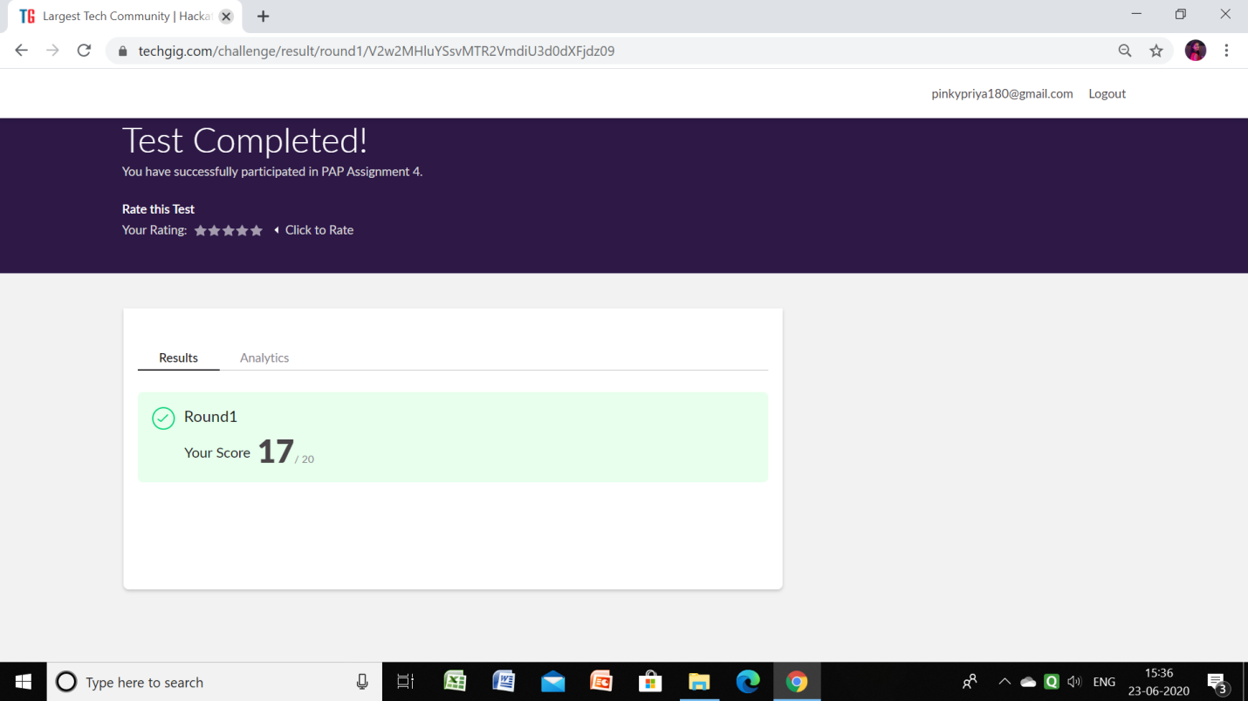

JAVA & J2EE: (9:15 TO 11:15am)

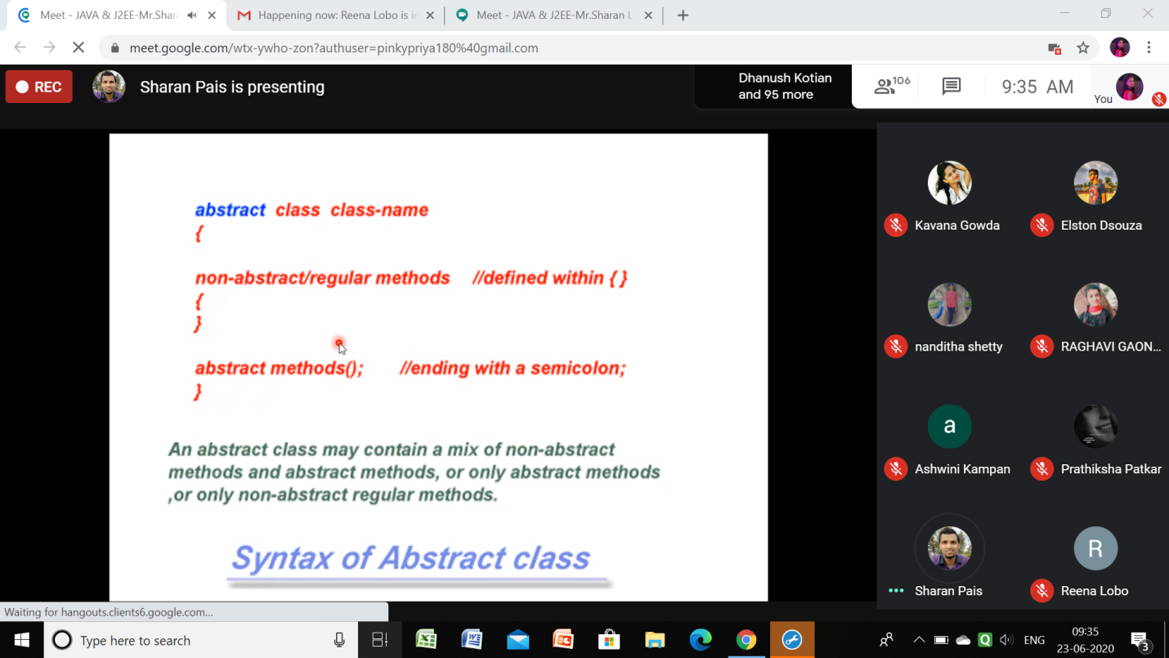

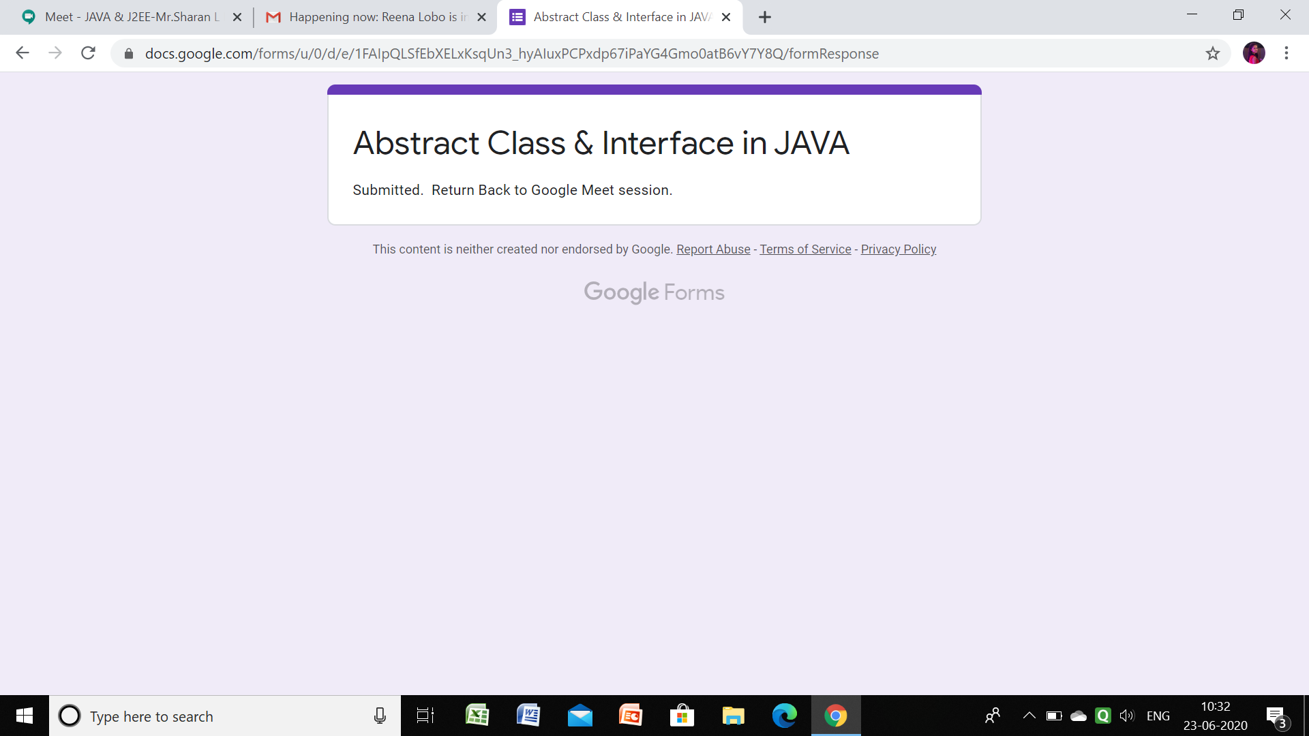

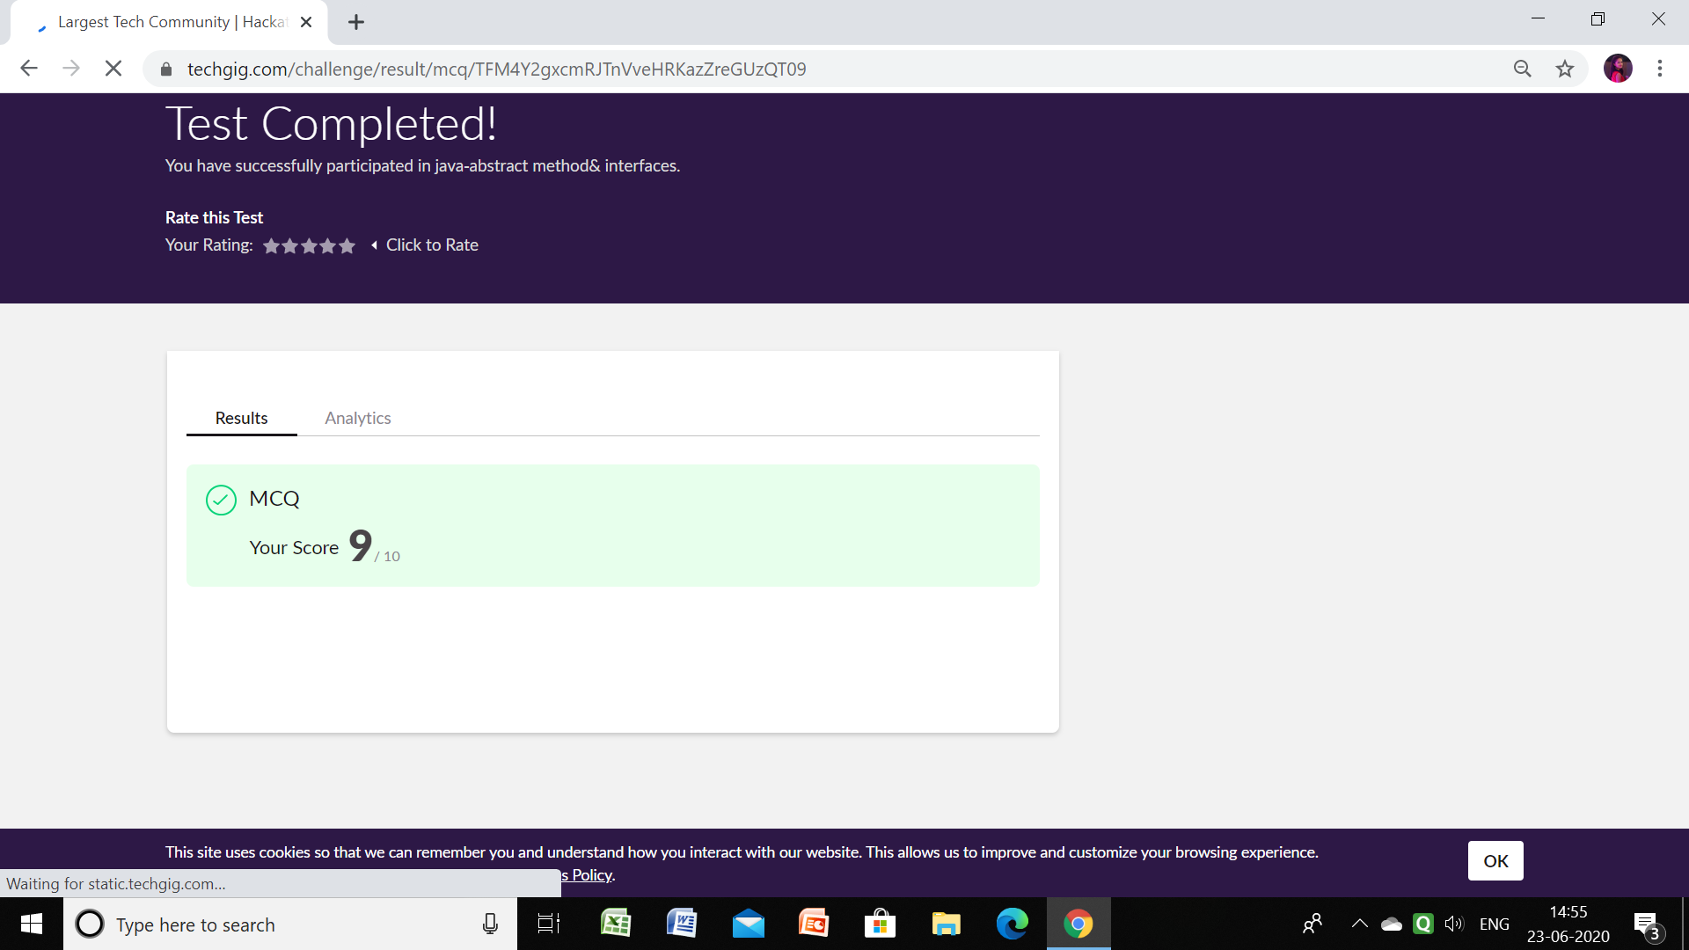

Data Structure with C:(11am to 1pm)

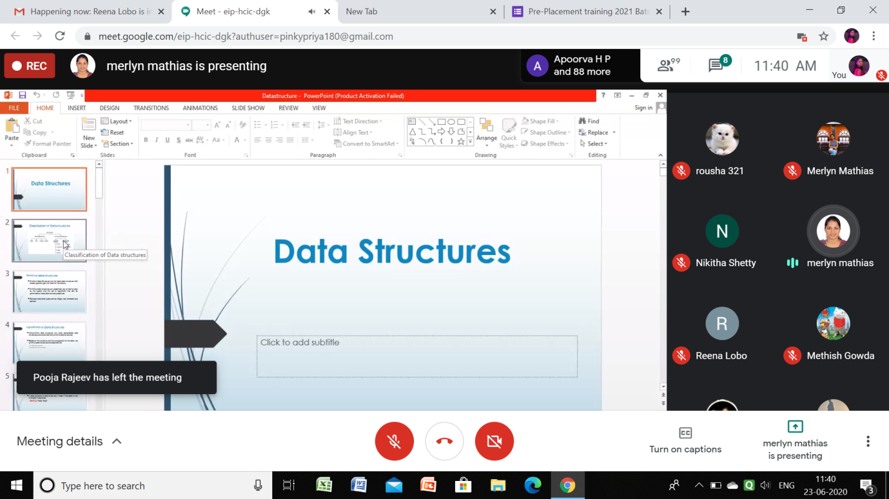

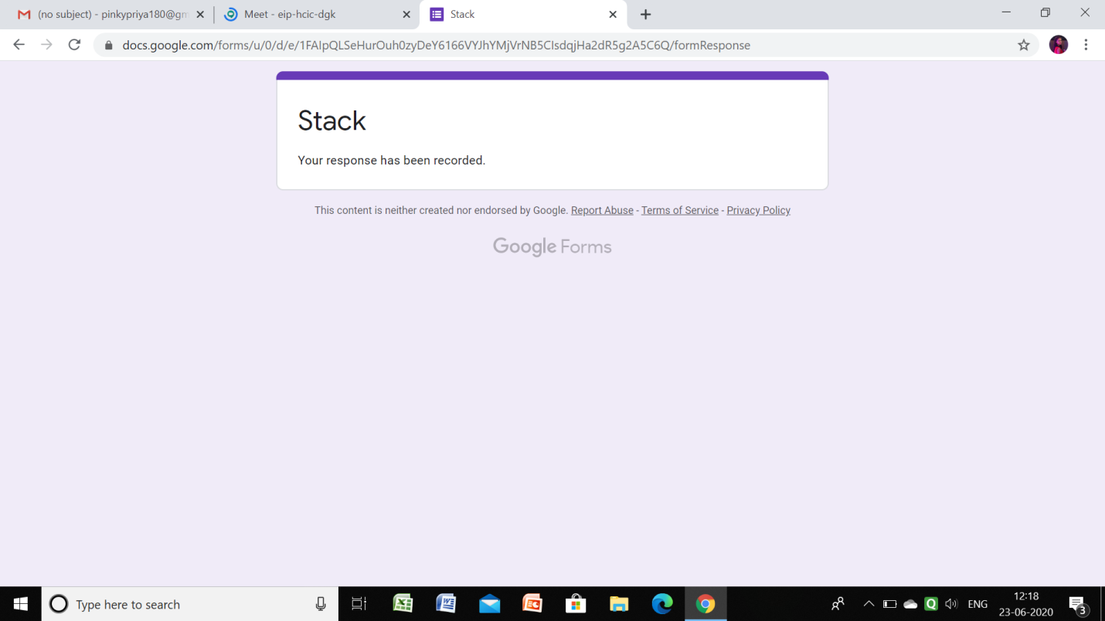

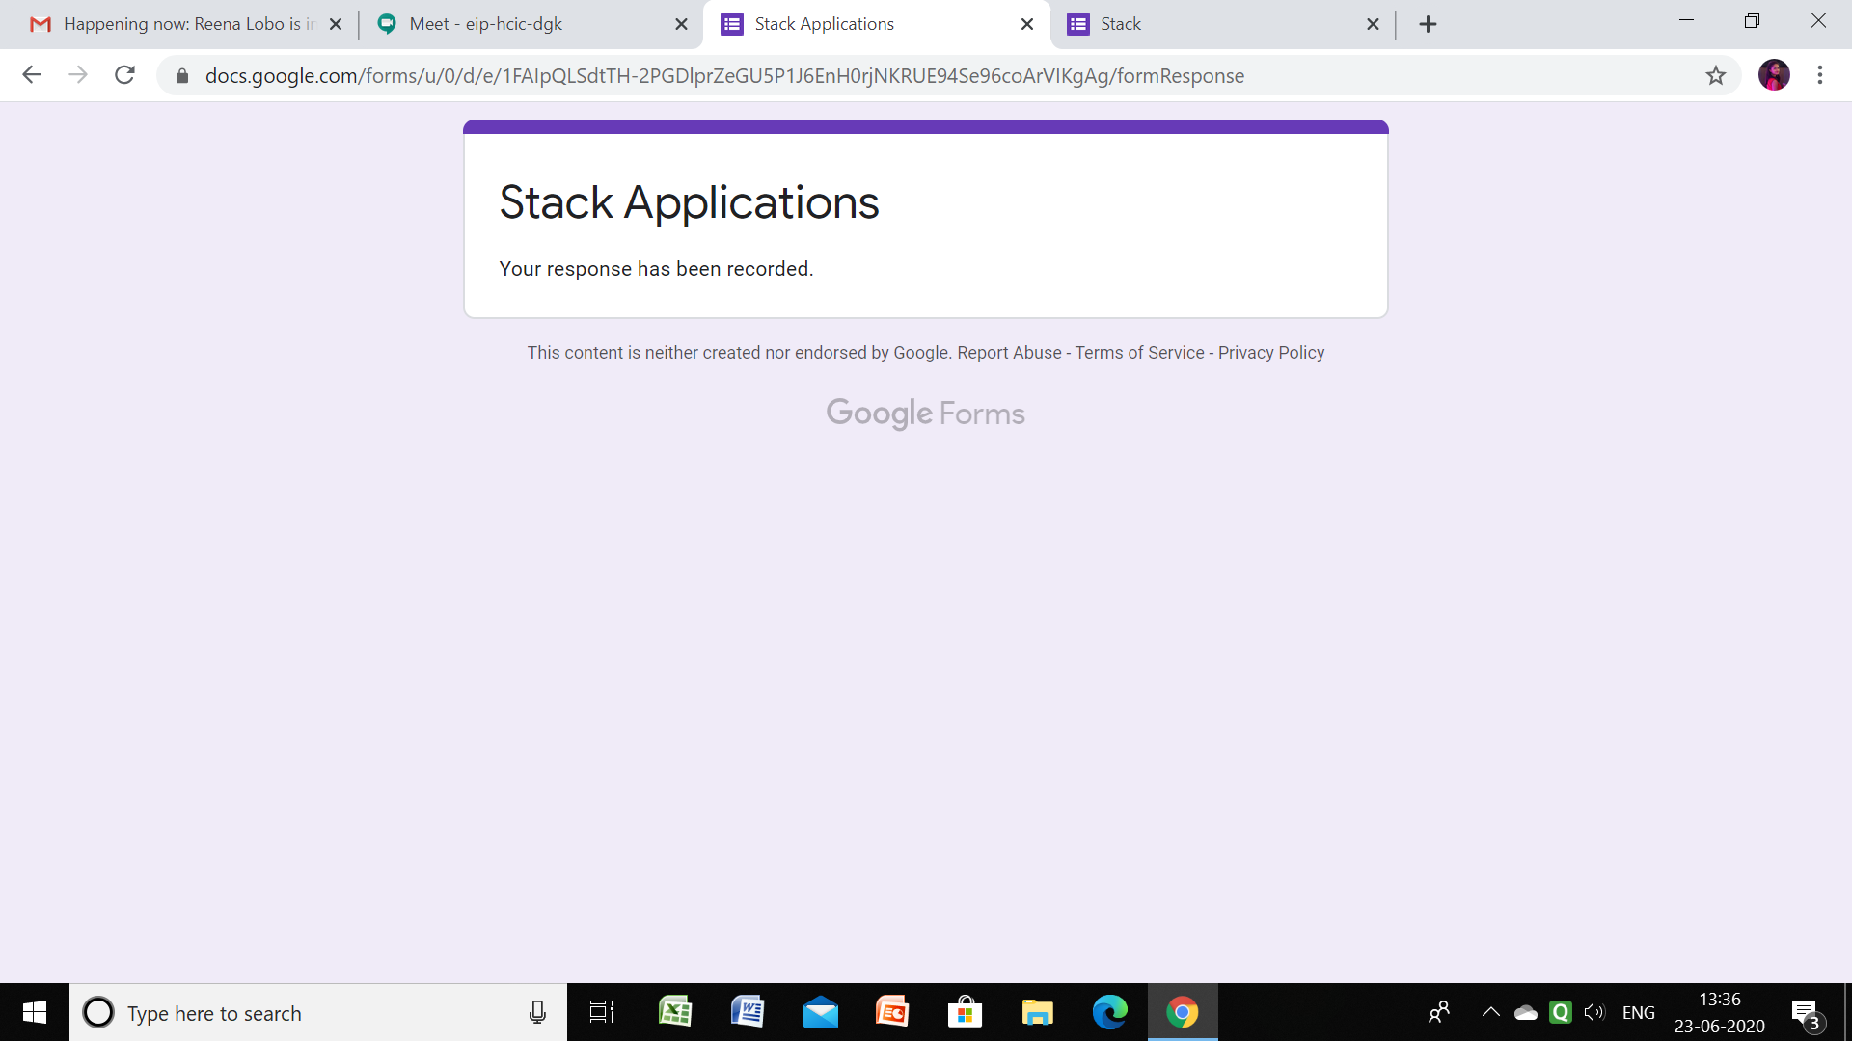

Github link for information: <https://github.com/priya3028/Daily-status>

**Coding Challenge details:**

Github link for detail information: <https://github.com/priya3028/Onlinecodingupdate>

Solved and uploaded in github