**DAILY ONLINE ACTIVITIES SUMMARY**

|  |  |  |  |  |  |  |  |  |
| --- | --- | --- | --- | --- | --- | --- | --- | --- |
| **Date:** | **22-05-2020** | | | | | **Name:** | **Priya H T** | |
| **Sem & Sec** | **VI B** | | | | | **USN:** | **4AL17CS066** | |
| **Online Test Summary** | | | | | | | | |
| **Subject** | | **OR** | | | | | | |
| **Max. Marks** | | **30** | | **Score** | | | **30** | |
| **Certification Course Summary** | | | | | | | | |
| **Course** | **Machine Learning With Python** | | | | | | | |
| **Certificate Provider** | | | **IBM** | | **Duration** | | | **10HR**  **Completed 2hrs** |
| **Coding Challenges** | | | | | | | | |
| **Problem Statement:3problems**  **2programs solved using java & 1 using c** | | | | | | | | |
| **Status: solved all 3** | | | | | | | | |
| **Uploaded the report in Github** | | | | | **yes** | | | |
| **If yes Repository name** | | | | | <https://github.com/priya3028/Onlinecodingupdate> | | | |
| **Uploaded the report in slack** | | | | | **yes** | | | |

Online test details

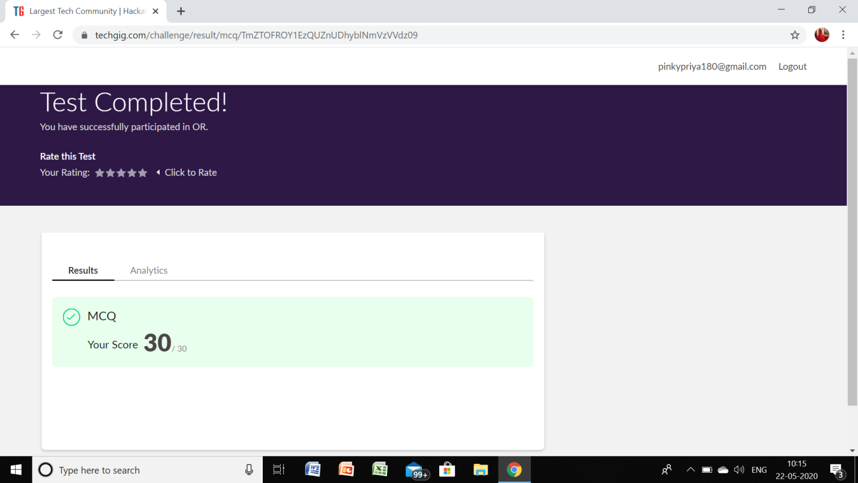

**Certification Course Details:**

Github link for information: <https://github.com/priya3028/Daily-status>

**Topics completed today:**

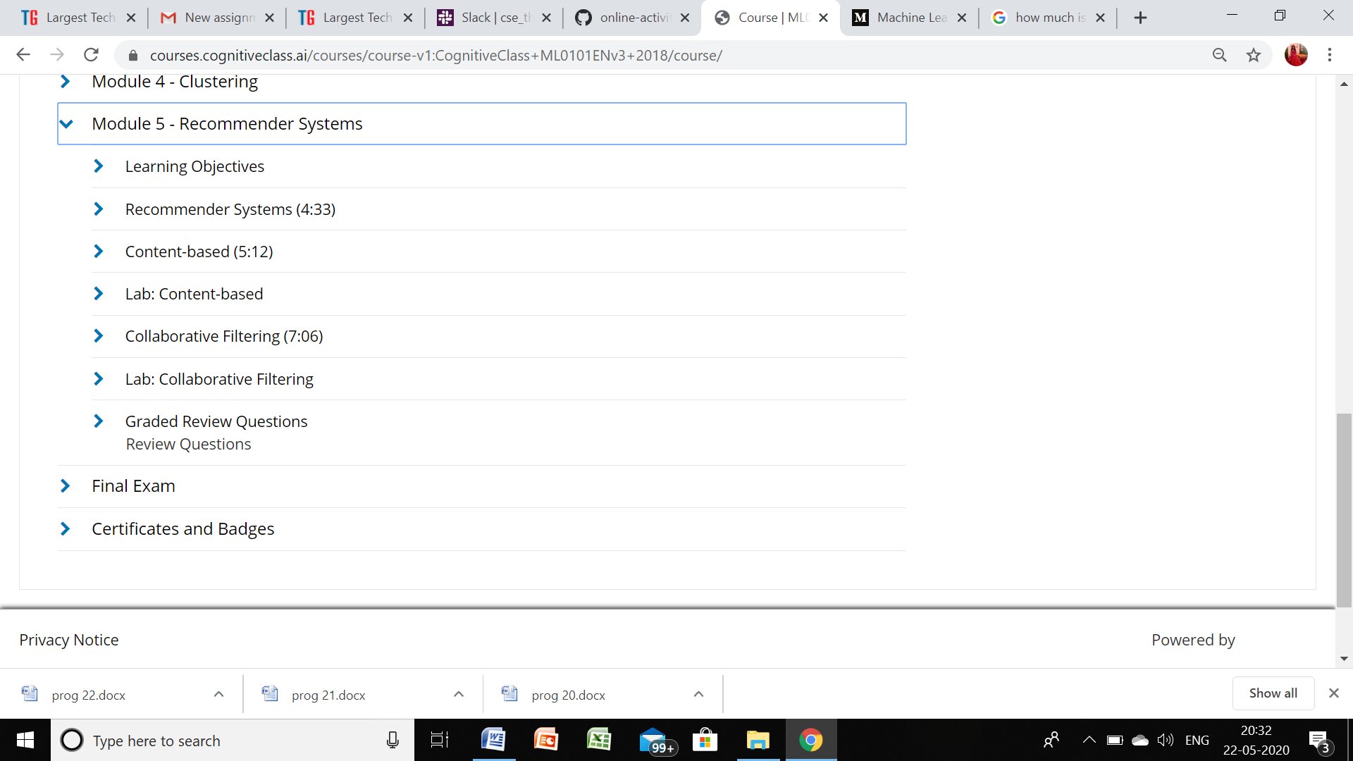

**Progress report:**

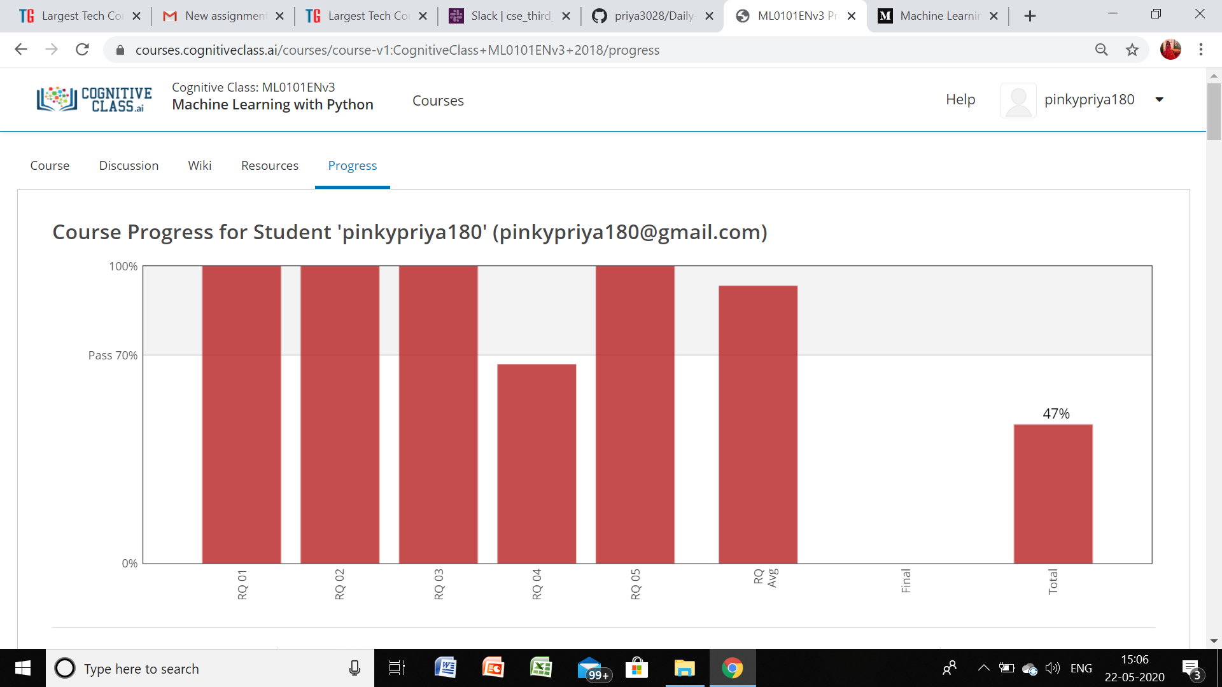

**Coding Challenge details:**

Github link for detail information: <https://github.com/priya3028/Onlinecodingupdate>

Solved and uploaded in github