**DAILY ONLINE ACTIVITIES SUMMARY**

|  |  |  |  |  |  |  |  |  |
| --- | --- | --- | --- | --- | --- | --- | --- | --- |
| **Date:** | **26-05-2020** | | | | | **Name:** | **Priya H T** | |
| **Sem & Sec** | **VI B** | | | | | **USN:** | **4AL17CS066** | |
| **Online Test Summary** | | | | | | | | |
| **Subject** | | **CGV** | | | | | | |
| **Max. Marks** | | **30** | | **Score** | | |  | |
| **Certification Course Summary** | | | | | | | | |
| **Course** | **Python for Data Science** | | | | | | | |
| **Certificate Provider** | | | **IBM** | | **Duration** | | | **5Hr** |
| **Coding Challenges** | | | | | | | | |
| **Problem Statement:4 python program ,2 c program** | | | | | | | | |
| **Status: solved** | | | | | | | | |
| **Uploaded the report in Github** | | | | | **yes** | | | |
| **If yes Repository name** | | | | | <https://github.com/priya3028/Onlinecodingupdate> | | | |
| **Uploaded the report in slack** | | | | | **yes** | | | |

**Certification Course Details:**

**Topics completed:**

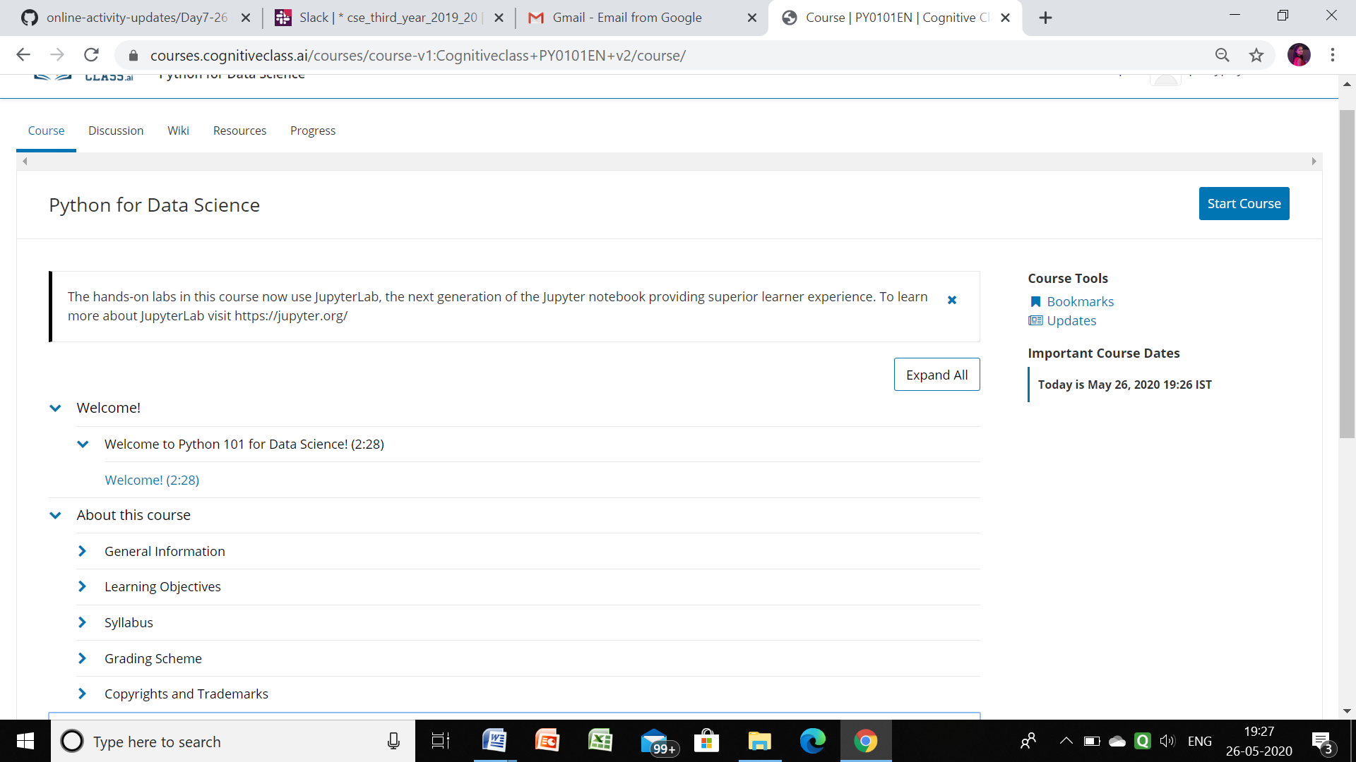

Github link for information: <https://github.com/priya3028/Daily-status>

**Coding Challenge details:**

Github link for detail information: <https://github.com/priya3028/Onlinecodingupdate>

Solved and uploaded in github