**IDEATION PHASE**

**PROBLEM STATEMENT**

|  |  |
| --- | --- |
| **DATE** | 26-09-2023 |
| **TEAM ID** | PROJ_224694_TEAM_2 |
| **PROJECT TITLE** | CUSTOMER CHURN PREDICTION-TELECOMMUNICATION CUSTOMER CHURN PREDICTION |

**PROBLEM STATEMENT:**

1.Telecommunication companies (telco’s) have a significant problem with customer churn, which is the loss of customers who stop using their services.

2.To solve this problem, telco’s need to identify the customers who are likely to churn and take preemptive measures to retain them.

**CUSTOMER PROBLEM STATEMENT TEMPLATE**

|  |  |  |  |  |  |  |  |  |  |
| --- | --- | --- | --- | --- | --- | --- | --- | --- | --- |
| I am   |  | | --- | | Telecommunication  manager | | I’m trying to   |  | | --- | | Take care of communications technologies in an organization & retain customers | | But   |  | | --- | | Due to untrained or incompetent agents , high customer effort, it has led to customer churn | | Because   |  | | --- | | The service provided by the telecom industry doesn’t meet the customers expectations | | Which makes me feel   |  | | --- | | The risk of losing customer and profits | |

**OBJECTIVES:**

* Explore and visualize the dataset.
* Build a classification model to predict if the customer is going to churn or not.
* Optimize the model using appropriate techniques.
* Generate a set of insights and recommendations that will help the bank.

**STEPS TO PREDICT CUSTOMER CHURN**



Monitoring, refinement

Actionable insights

im

Integration

Training model

Model selection

Data pre- processing

data collection

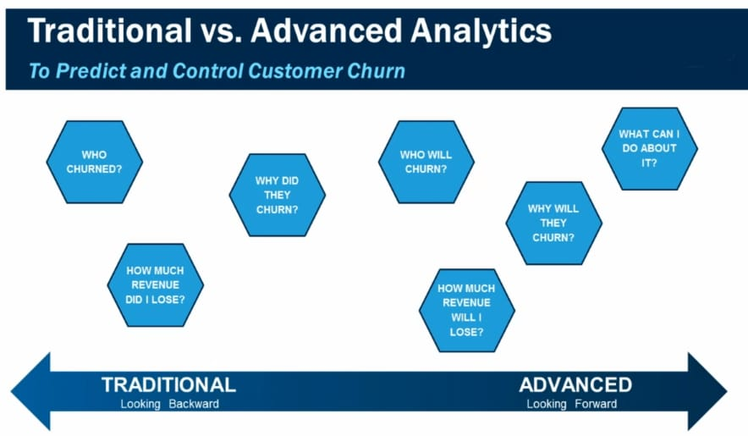

## FACTORS THAT PREVENT CUSTOMER CHURN:

## 1. Product or service quality

### **2.** Price

### **3.** Customer support

### **4.** Competitor offerings

### **5.** Customer engagement

### **6.** Customer experience

### **7.** Life changes

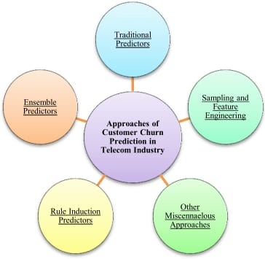

|  |  |
| --- | --- |
| **TEAM ID** | **PROJ_224694_TEAM_2** |
| **TEAM MEMBERS** | **S.RAJARAJESHWARI**  **SANDHIYA.S**  **S.PRIYADHARSHINI**  **U.KOKILA**  **P.VISHNUPRIYA** |
| **NAME** | **P.VISHNUPRIYA** |
| **REGISTER NUMBER** | **420421205025** |