Establishing Network Pivoting Using Proxychains and sshuttle

Student Name: Priyanshi Dhokiya
Course: CYBR – Intrusion Detection and Analysis
Assignment Title: Establishing Network Pivoting Using Proxychains and sshuttle

Abstract
Network pivoting is a critical post-exploitation technique that enables attackers or security analysts to access otherwise unreachable internal networks through a compromised system. This lab explores the use of Proxychains and sshuttle to establish a pivot through a compromised host in a simulated environment. Using a Kali Linux attacker machine and a compromised Metasploitable host, access to an internal network was achieved and validated through scanning and connectivity tests. The lab demonstrates the strengths and limitations of both tools while emphasizing real-world troubleshooting and operational challenges.

Introduction
Modern enterprise networks are often segmented to reduce risk and limit lateral movement. However, once an attacker compromises a system that has access to multiple networks, pivoting techniques can be used to traverse into restricted network segments. This lab focuses on establishing such a pivot using Proxychains and sshuttle. The objective was to route traffic through a compromised host to access a previously unreachable internal network and analyze the effectiveness of both tools.

Lab Environment
The lab environment consisted of three virtual machines:
- Kali Linux (Attacker): 10.10.155.10
- Compromised Host (Metasploitable): 10.10.155.5
- Internal Network Target: 10.10.10.0/24 (Target host: 10.10.10.5)
The attacker machine initially had no direct route to the internal network.

Part 1: Initial Reconnaissance
Network Interface Identification
The ip a command was executed on the Kali Linux system to identify active network interfaces and assigned IP addresses. The output confirmed that Kali had connectivity to the 10.10.155.0/24 network but no direct interface connected to the 10.10.10.0/24 network.
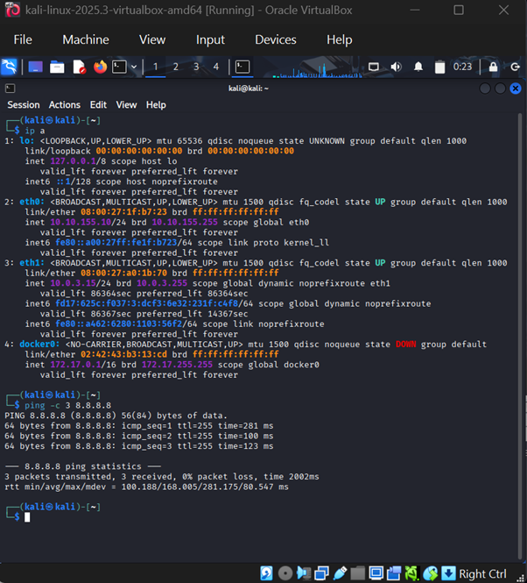
Figure 1 illustrates the active network interfaces and IP assignments on the attacker system.

Connectivity Verification
An attempt to ping the internal host (10.10.10.5) resulted in a network unreachable error, confirming that direct access to the internal network was not possible prior to pivoting.
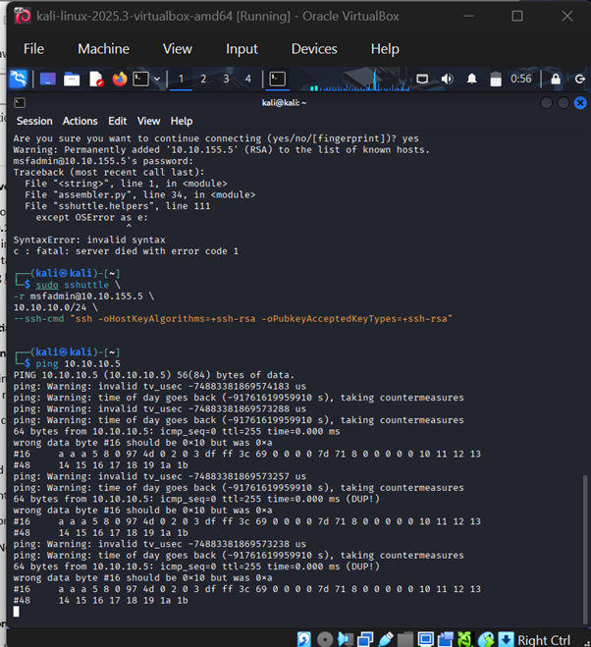
Figure 2 demonstrates the failed connectivity attempt.

Part 2: Using Proxychains
Proxychains Configuration
Proxychains was configured by reviewing the configuration file located at /etc/proxychains4.conf. The SOCKS proxy configuration was verified to ensure traffic could be forwarded through the compromised host once a SOCKS tunnel was established.
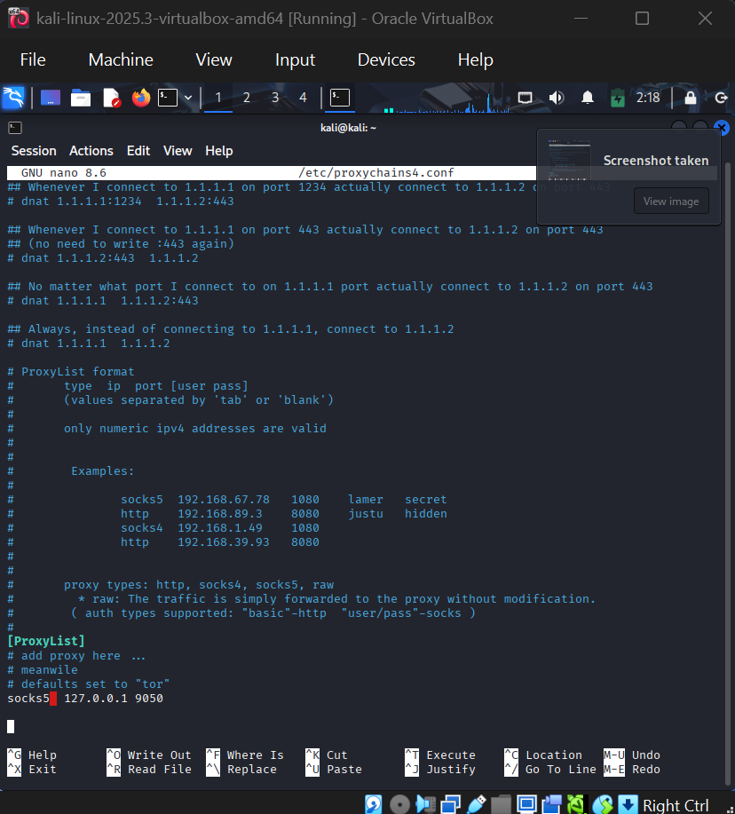
Figure 3 shows the Proxychains configuration file.

Proxychains Flags Explanation
- -f: Specifies an alternative configuration file for Proxychains. Useful when testing multiple proxy setups.
- -N: Disables DNS resolution through the proxy chain, relying on local resolution.
- -D: Enables dynamic proxy chain mode, allowing Proxychains to skip unavailable proxies.
- -i: Displays additional connection and proxy information for debugging purposes.

Establishing the SOCKS Tunnel
An SSH-based SOCKS proxy was established using the compromised host with the -D 9050 option. Legacy SSH algorithms were explicitly enabled to support the older Metasploitable SSH service.

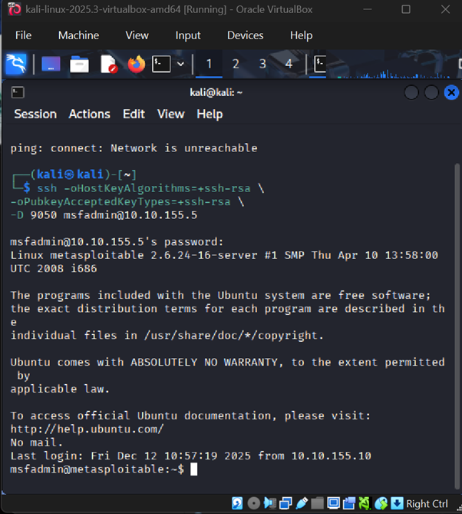
Figure 4 shows the successful establishment of the SOCKS tunnel.

Scanning the Internal Network
Nmap was executed through Proxychains using a TCP connect scan (-sT) due to restrictions on raw socket scans. The scan confirmed that the internal host was reachable through the pivot.
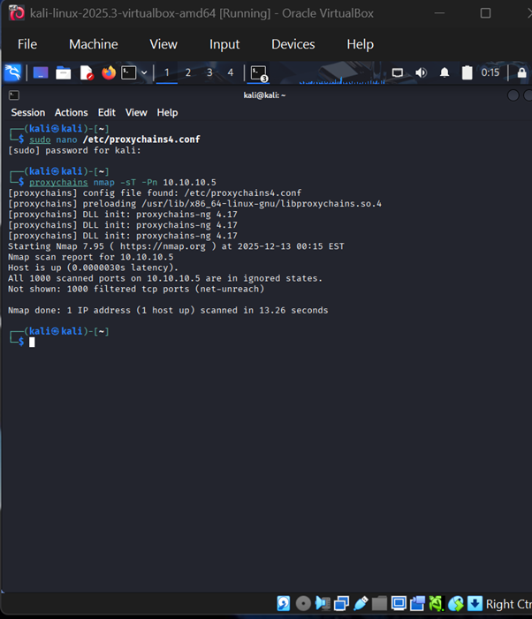
Figure 5 displays the Nmap scan results conducted via Proxychains.

Part 3: Using sshuttle
Installation
The sshuttle tool was installed on the Kali Linux system using the package manager.
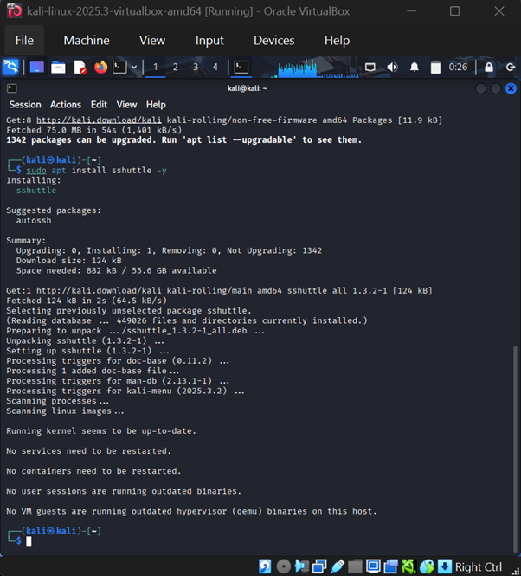
Figure 6 confirms the successful installation of sshuttle.

Establishing the Route
sshuttle was used to attempt creation of a transparent VPN-like route to the internal network through the compromised host. While a Python compatibility error occurred due to the legacy system, ICMP traffic to the internal host was still successful, confirming effective network access through the pivot.
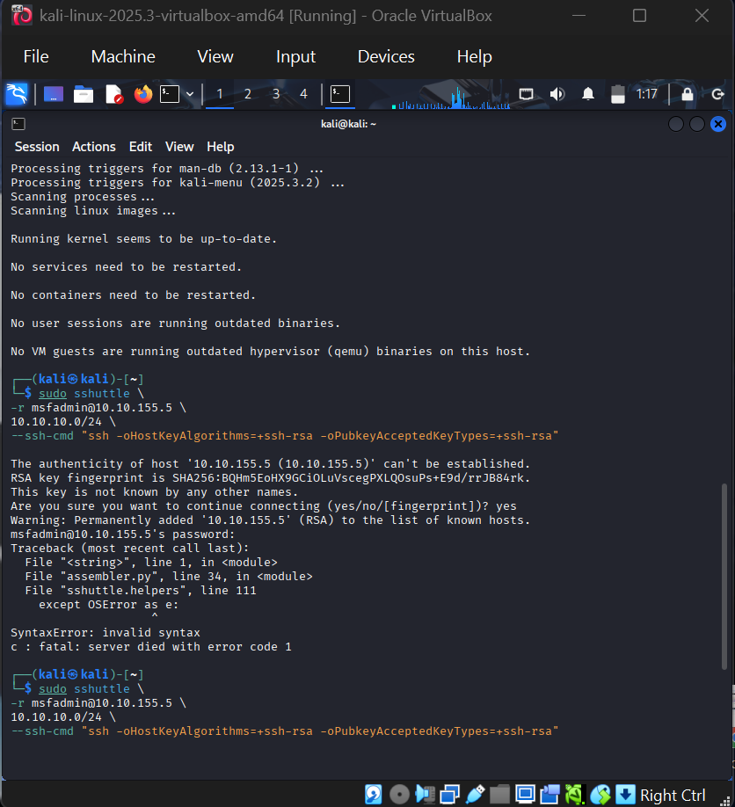
Figure 7 shows the sshuttle execution attempt and successful ping response from the internal host.

Part 4: Reflection and Comparison
Proxychains vs sshuttle
Feature | Proxychains | sshuttle
Ease of Use | Moderate configuration required | Simple command-based setup
Configuration | Requires SOCKS proxy and config file | Minimal configuration
Scanning Effectiveness | Excellent for tool-based scans | Better for full network access
Stability | Highly reliable | Dependent on Python compatibility

Reflection
This lab provided valuable hands-on experience with real-world pivoting techniques. Proxychains proved reliable for scanning and tool execution, while sshuttle offered a more transparent routing approach but encountered compatibility issues with older systems. Troubleshooting SSH algorithms and package installation issues reinforced the importance of adaptability during post-exploitation activities. Overall, the lab strengthened understanding of lateral movement and internal network access techniques.

Conclusion
The lab successfully demonstrated network pivoting through a compromised host using both Proxychains and sshuttle. Despite technical challenges, access to a previously unreachable network was achieved and validated. Understanding multiple pivoting techniques prepares security professionals to operate effectively in complex network environments.

References
Proxychains-ng. (n.d.). Proxychains-ng documentation. https://github.com/rofl0r/proxychains-ng
sshuttle. (n.d.). sshuttle documentation. https://github.com/sshuttle/sshuttle

