**TASK-3 EVENT MANAGEMENT SYSTEM (using PostgreSQL)**

**1.Database Creation**

**Create a database named "EventsManagement"**

CREATE DATABASE EventsManagement;

**Create tables for Events, Attendees, and Registrations.**

**Events·Event_ld,Event_ Name, Event_Date, Event_Location,Event_ Description**

CREATE TABLE Events (

Event_Id SERIAL PRIMARY KEY,

Event_Name TEXT,

Event_Date DATE,

Event_Location TEXT,

Event_Description TEXT

);

**Attendees· Attendee_ld,Attendee_Name, Attendee_Phone,Attendee_Email,Attendee_City**

CREATE TABLE Attendees (

Attendee_Id SERIAL PRIMARY KEY,

Attendee_Name TEXT,

Attendee_Phone VARCHAR(20),

Attendee_Email TEXT,

Attendee_City TEXT

);

**Registrations-Registration_id, Event_ld,Attendee_ld,Registration_Date,Registration_Amount.**

**The FOREIGN KEY constraint in the Registrations table references the Event_ld column in the**

**Events table and the Attendee_ld column in the Attendees table**

CREATE TABLE Registrations (

Registration_Id SERIAL PRIMARY KEY,

Event_Id INT,

Attendee_Id INT,

Registration_Date DATE,

Registration_Amount NUMERIC,

FOREIGN KEY (Event_Id) REFERENCES Events (Event_Id),

FOREIGN KEY (Attendee_Id) REFERENCES Attendees (Attendee_Id)

);

**2.Data Creation**

**Insert some sample data for Events, Attendees, and Registrations tables with respective fields.**

INSERT INTO Events (Event_Id, Event_Name, Event_Date, Event_Location, Event_Description)

VALUES

(1, 'Conference', '2023-07-10', 'New York', 'Annual tech conference'),

(2, 'Workshop', '2023-08-15', 'San Francisco', 'Introduction to Data Science'),

(3, 'Seminar', '2023-09-20', 'London', 'Marketing trends in the digital era');

INSERT INTO Attendees (Attendee_Id, Attendee_Name, Attendee_Phone, Attendee_Email, Attendee_City)

VALUES

(1, 'John Smith', '123456789', 'john@example.com', 'New York'),

(2, 'Jane Doe', '987654321', 'jane@example.com', 'San Francisco'),

(3, 'Mike Johnson', '789456123', 'mike@example.com', 'London');

INSERT INTO Registrations (Registration_Id, Event_Id, Attendee_Id, Registration_Date, Registration_Amount)

VALUES

(1, 1, 1, '2023-07-05', 50.00),

(2, 1, 2, '2023-07-06', 50.00),

(3, 2, 1, '2023-07-07', 75.00),

(4, 3, 3, '2023-07-08', 0.00);

**3. Manage Event Details**

**a) Inserting a new event**

INSERT INTO Events (Event_Id, Event_Name, Event_Date, Event_Location, Event_Description)

VALUES (4,'Seminar', '2023-10-25', 'Tokyo', 'Latest trends in artificial intelligence');

**b) Updating an event's information**

UPDATE Events

SET Event_Name = 'Conference 2023',

Event_Date = '2023-11-15',

Event_Location = 'Paris',

Event_Description = 'International tech conference'

WHERE Event_Id = 1;

**c) Deleting an event.**

DELETE FROM Events

WHERE Event_Id = 4;

**4) Manage Track Attendees & Handle Events**

**a) lnserting a new attendee.**

INSERT INTO Attendees (Attendee_Id,Attendee_Name, Attendee_Phone, Attendee_Email, Attendee_City)

VALUES (4,'Alice Johnson', '9876543210', 'alice@example.com', 'New York');

**b) Registering an attendee for an event.**

INSERT INTO Registrations (Registration_Id ,Event_Id, Attendee_Id, Registration_Date, Registration_Amount)

VALUES (5,1, 1, '2023-07-05', 50.00);

**5 .Develop queries to retrieve event information, generate attendee lists, and calculate event attendance statistics**

Query to Retrieve Event Information:

SELECT * FROM Events;

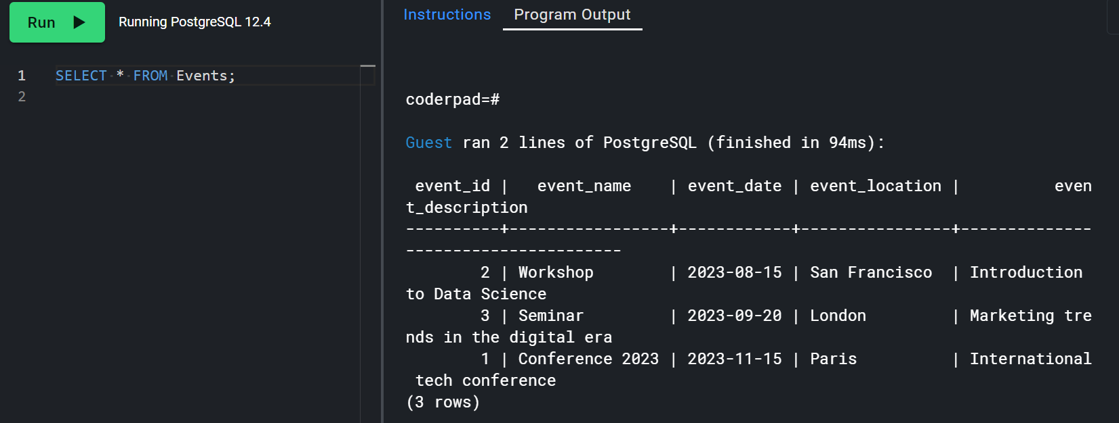

Query to Generate Attendee List for an Event:

SELECT Attendees.Attendee_Id, Attendees.Attendee_Name, Attendees.Attendee_Phone, Attendees.Attendee_Email, Attendees.Attendee_City

FROM Registrations

JOIN Attendees ON Registrations.Attendee_Id = Attendees.Attendee_Id

WHERE Registrations.Event_Id = 3

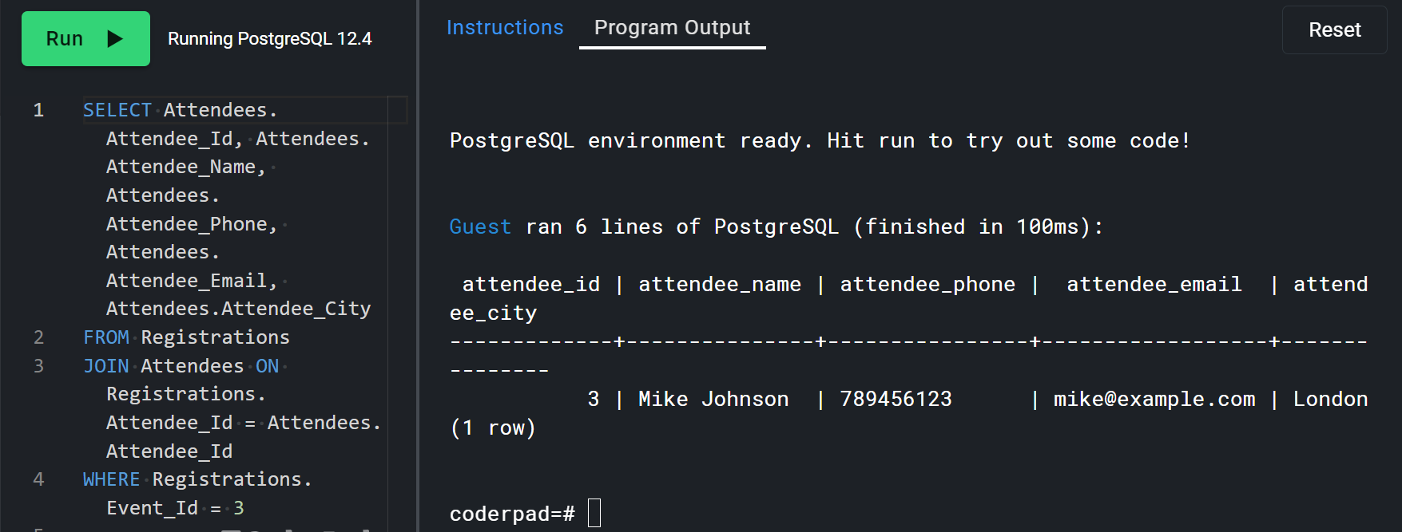

Query to Calculate Event Attendance Statistics:

SELECT COUNT(*) AS Total_Attendees, AVG(Registration_Amount) AS Average_Amount

FROM Registrations

WHERE Event_Id = 1;

