**TASK-4 OLAP OPERATIONS (using PostgreSQL)**

**1.Database Creation**

**Create a database to store the sales data (PostgreSQL)**

CREATE DATABASE sales_data;

**Create a table named "sales_sample" with the specified columns:** **Product_ld (Integer), Region (varchar(50))-like East,West etc, Date (Date), Sales_Amount (int/numeric)**

CREATE TABLE sales_sample (

Product_Id INTEGER,

Region VARCHAR(50),

Date DATE,

Sales_Amount NUMERIC

);

**2.Data Creation**

**Insert 10 sample records into the "sales_sample" table,representing sales data.**

INSERT INTO sales_sample (Product_Id, Region, Date, Sales_Amount)

VALUES

(1, 'East', '2023-01-01', 100),

(2, 'West', '2023-01-02', 200),

(3, 'North', '2023-01-03', 150),

(4, 'South', '2023-01-04', 300),

(1, 'West', '2023-01-05', 250),

(2, 'East', '2023-01-06', 180),

(3, 'South', '2023-01-07', 120),

(4, 'North', '2023-01-08', 280),

(1, 'North', '2023-01-09', 220),

(2, 'South', '2023-01-10', 190);

**3.Perform OLAP operations**

**a) Drill Down - Analyze sales data at a more detailed level. Write a query to perform drill down**

**from region to product level to understand sales performance.**

SELECT Region, Product_Id, SUM(Sales_Amount) AS Total_Sales

FROM sales_sample

GROUP BY Region, Product_Id

ORDER BY Region, Product_Id;

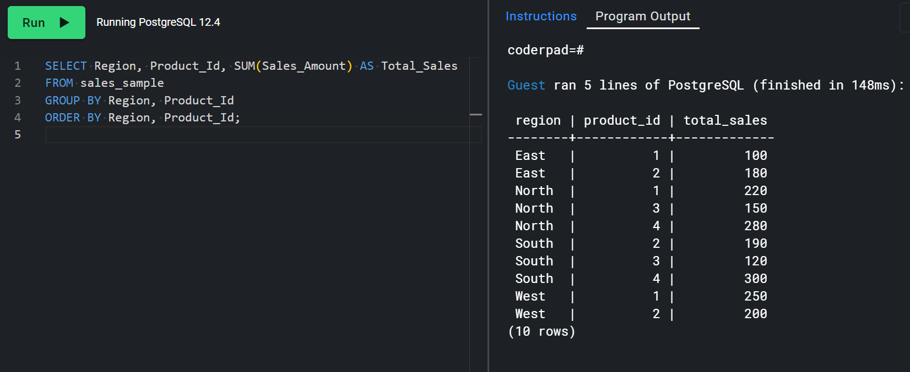

**b) Rollup - To summarize sales data at different levels of granularity. Write a query to perform**

**roll up from product to region level to view total sales by region.**

SELECT Product_Id, Region, SUM(Sales_Amount) AS Total_Sales

FROM sales_sample

GROUP BY ROLLUP (Product_Id, Region)

ORDER BY Product_Id, Region;

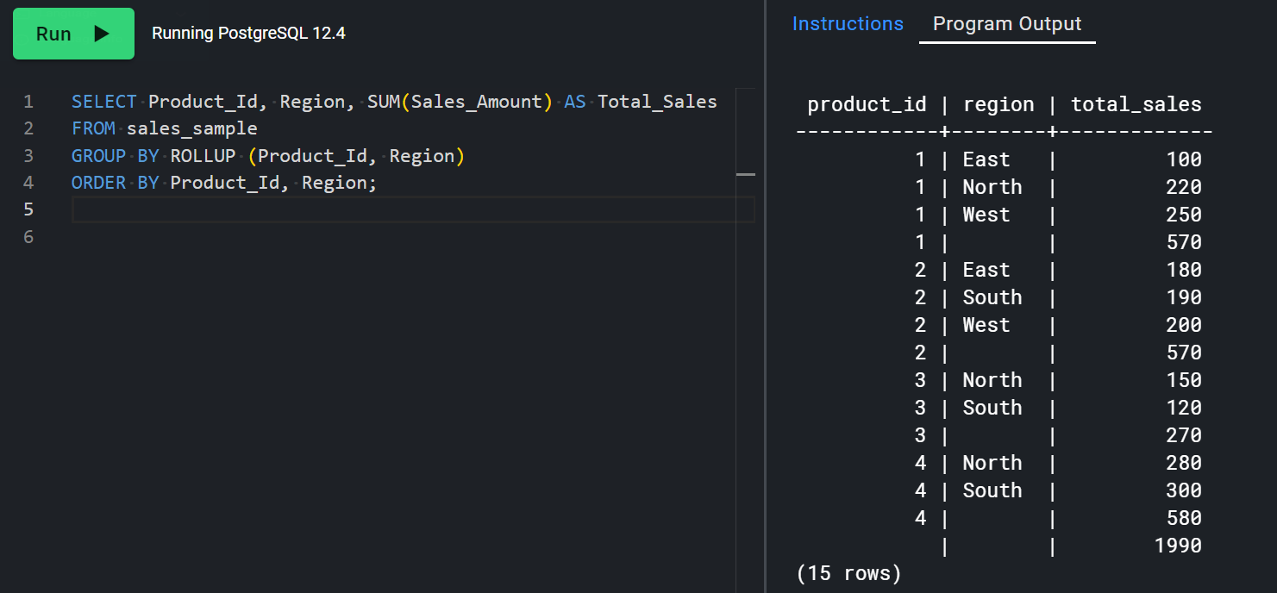

**c) Cube - To analyze sales data from multiple dimensions simultaneously. Write a query to Explore sales data from different perspectives, such as product, region and date.**

SELECT Product_Id, Region, Date, SUM(Sales_Amount) AS Total_Sales

FROM sales_sample

GROUP BY CUBE (Product_Id, Region, Date)

ORDER BY Product_Id, Region, Date;

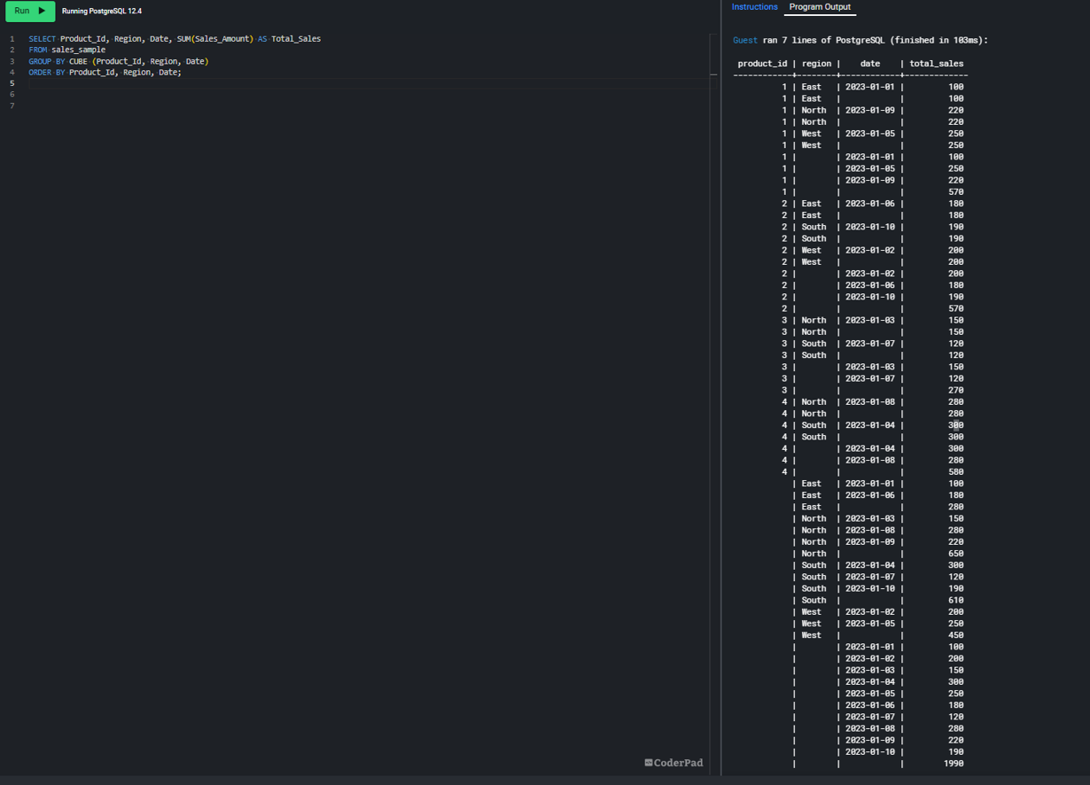

**d) Slice - To extract a subset of data based on specific criteria. Write a query to slice the data to**

**view sales for a particular region or date range**

SELECT Region, Date, SUM(Sales_Amount) AS Total_Sales

FROM sales_sample

WHERE Region = 'North' OR Date BETWEEN ' 2023-01-03' AND ' 2023-01-08'

GROUP BY Region, Date

ORDER BY Date;

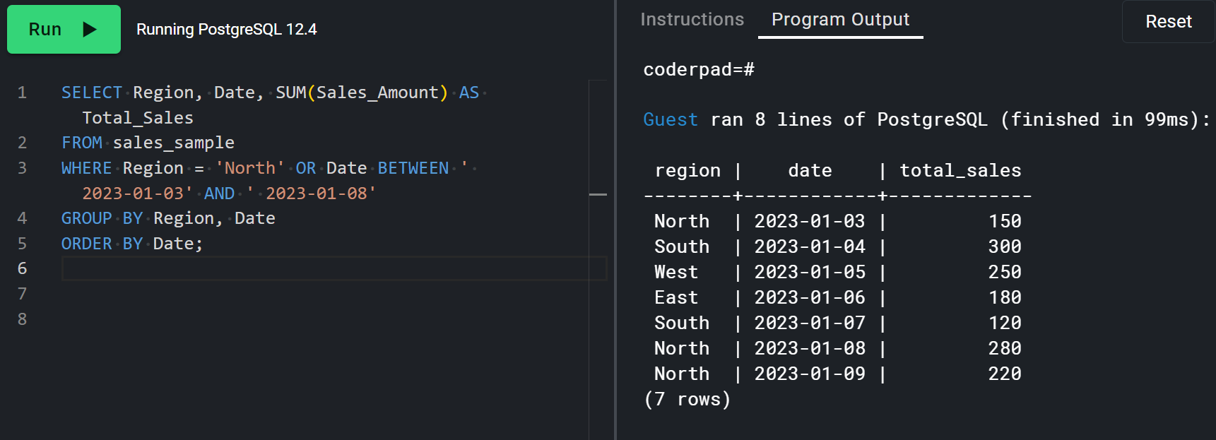

**e) Dice - To extract data based on multiple criteria. Write a query to view sales for specific combinations of product, region and date**

SELECT Product_Id, Region, Date, SUM(Sales_Amount) AS Total_Sales

FROM sales_sample

WHERE (Product_Id = '3') AND (Region = 'South') AND (Date = ' 2023-01-07')

GROUP BY Product_Id, Region, Date;

