What Makes a Show Successful?
Streaming Content Analysis: Insights and Action Plan

1. Key Insights

Insight 1: Success distribution
- After removing 2 duplicate rows, the dataset contains 100 shows. A show is labelled successful when its viewership is at or above the median (51.0): 51 shows are successful and 49 are less successful (Figure 1).
- The two groups are almost evenly balanced, which makes the data well suited to a success/less-successful classification model.

Insight 2: Genre
- Average viewership: Sci-Fi 87.1, Action 74.7, Drama 58.6, Thriller 48.5, Documentary 40.2, Comedy 37.4 (Figure 2).
- Every Sci-Fi and Action show in the data is successful, compared with about 55% of Drama, 36% of Thriller, 10% of Documentary and 5% of Comedy shows.

Insight 3: Rating vs viewership
- Rating and viewership are only moderately related (correlation 0.57), so they do not always move together (Figure 3).
- Documentaries average a rating of 8.2, the same as Sci-Fi, yet their average viewership is only 40.2. Of the 40 shows rated 8.0 or higher, 12 are still less successful.

Insight 4: Language
- Average viewership by language: Korean 69.6, English 64.2, Japanese 55.5, Spanish 54.7, Hindi 46.4, French 35.4.
- Japanese (6 shows) and French (9 shows) have small samples, and language partly overlaps with genre mix, so these differences should be read with care.

Insight 5: Budget
- Budget has the strongest link to viewership (correlation 0.93). Shows with a budget of 80 or more average 80.9 viewership (36 shows), while shows under 40 average 36.0 (37 shows).
- Budget is also the top-ranked feature in the Random Forest (Figure 4). Because big-budget titles are concentrated in Sci-Fi and Action, this shows association, not proof that spending alone causes viewership.

Insight 6: Content combinations
- The strongest genre-language groups (3 or more shows) are Sci-Fi in English (94.2), Drama in Korean (85.3), Action in English (79.9) and Action in Spanish (77.2).
- These groups contain only 4 to 7 shows each, so they are useful pointers rather than firm conclusions.

Insight 7: Random Forest
- The Random Forest classifies shows as successful or less successful using genre, language, runtime, release year, budget and rating.
- Feature importance ranks Budget first (about 0.47), then Runtime (about 0.21), Rating (about 0.09) and Release Year (about 0.05). Individual genre and language indicators each contribute under 0.04 (Figure 4).

2. Practical Action Plan
Content teams can use historical genre, language, runtime, release year, budget and rating patterns to identify characteristics associated with stronger audience performance. Ratings should not be used alone to estimate viewership. Genre-language combinations and budget should also be considered when evaluating future content opportunities. The Random Forest model can be used as a supporting analytical tool for classifying potential high-performing titles.

3. Visualisations
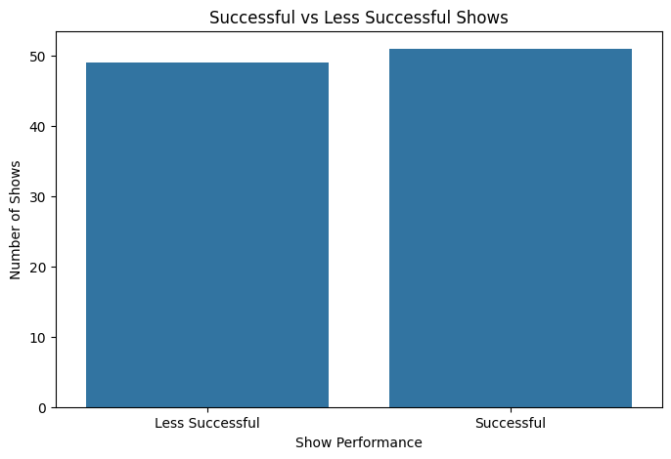
Figure 1: Successful vs less successful shows
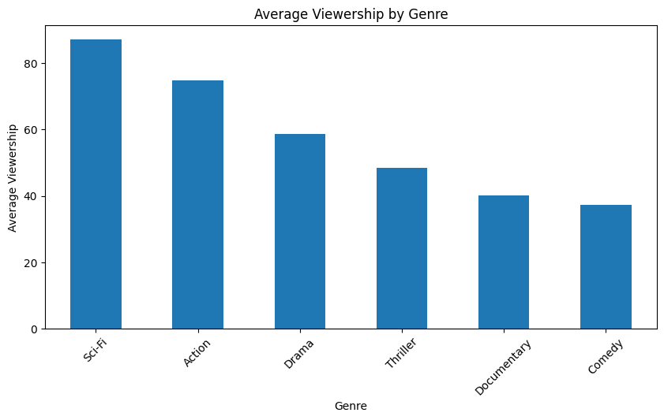
Figure 2: Average viewership by genre
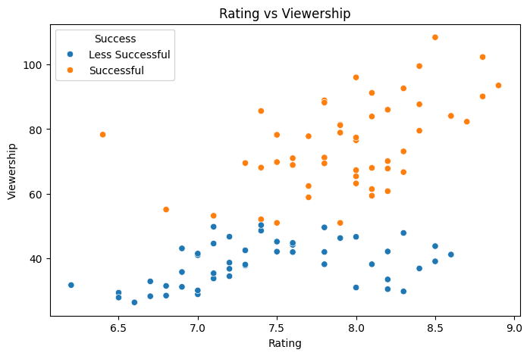
Figure 3: Rating vs viewership
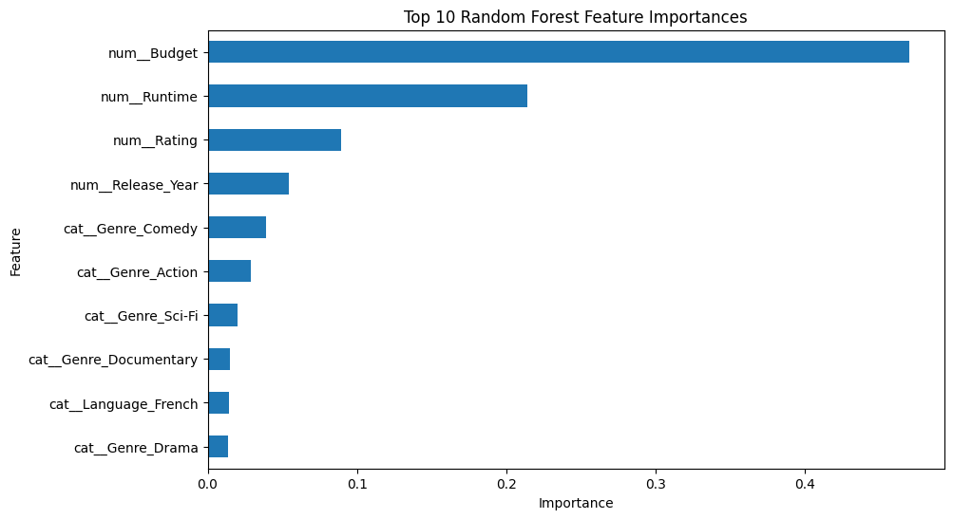
Figure 4: Top 10 Random Forest feature importances

4. Data Preparation Notes
- Removed 2 duplicate rows (SHOW_006 and SHOW_021).
- Standardised text values: "drama" to Drama, "ENGLISH" to English, "SciFi" to Sci-Fi.
- Treated invalid values as missing and filled them with the column median: negative runtime and budget, a rating of 15.5, and a viewership of 9999.
- Filled missing rating and budget with the median, and the missing genre with the most common genre.
- Defined success as viewership at or above the median.

