When Should Farmers Irrigate?
Smart Agriculture: Key Insights and Decision Tree Results

1. Summary
This report summarises seven insights from soil-moisture sensor data (soil moisture, temperature, humidity, rainfall and crop stage) and a Decision Tree model trained to predict irrigation status. The aim is to support sensor-based irrigation decisions that reduce unnecessary water use compared with fixed schedules.

2. Key Insights

Insight 1: Temperature is the strongest predictor
- The Decision Tree feature importance shows Temperature at about 0.68, the most influential feature for predicting irrigation status.

Insight 2: Soil moisture is an important irrigation indicator
- Soil Moisture has an importance of about 0.18.
- This supports using soil-moisture sensor readings to judge whether irrigation may be required.

Insight 3: Humidity also contributes to irrigation decisions
- Humidity has an importance of about 0.13.
- Environmental conditions should therefore be considered together with soil moisture.

Insight 4: Rainfall had little influence in this Decision Tree
- Rainfall received 0 feature importance in this particular model.
- This does not mean rainfall is unimportant in real farming; in this dataset it added no predictive contribution to the tree. Figure 2 shows irrigation was recorded only at rainfall of 5 or less, so rainfall still appears to suppress irrigation.

Insight 5: Crop stage was not selected by the trained tree
- Crop Stage also had 0 importance.
- This may be due to the limited dataset size or the distribution of crop-stage values.

Insight 6: The model achieved 82% accuracy
- The Decision Tree correctly classified 82% of the 22 test observations.
- Class 0 (no irrigation) had an F1-score of 0.87, while Class 1 (irrigation) had an F1-score of 0.71.
- With only 22 test rows, these figures are sensitive to a few predictions and should be read as indicative.

Insight 7: Sensor-based irrigation can support better scheduling
- Instead of relying only on fixed irrigation schedules, farmers can combine soil moisture, temperature, humidity and rainfall to decide when irrigation should be considered.
- This can help identify situations where irrigation may be delayed or avoided because soil conditions already indicate sufficient moisture.

3. Decision Tree Results
Target: Irrigation_Status. Test set: 22 observations. Accuracy: 82%. F1-score: 0.87 (class 0) and 0.71 (class 1).
Feature | Importance
Temperature | ≈ 0.68
Soil_Moisture | ≈ 0.18
Humidity | ≈ 0.13
Rainfall | 0
Crop_Stage | 0

4. Visualisations
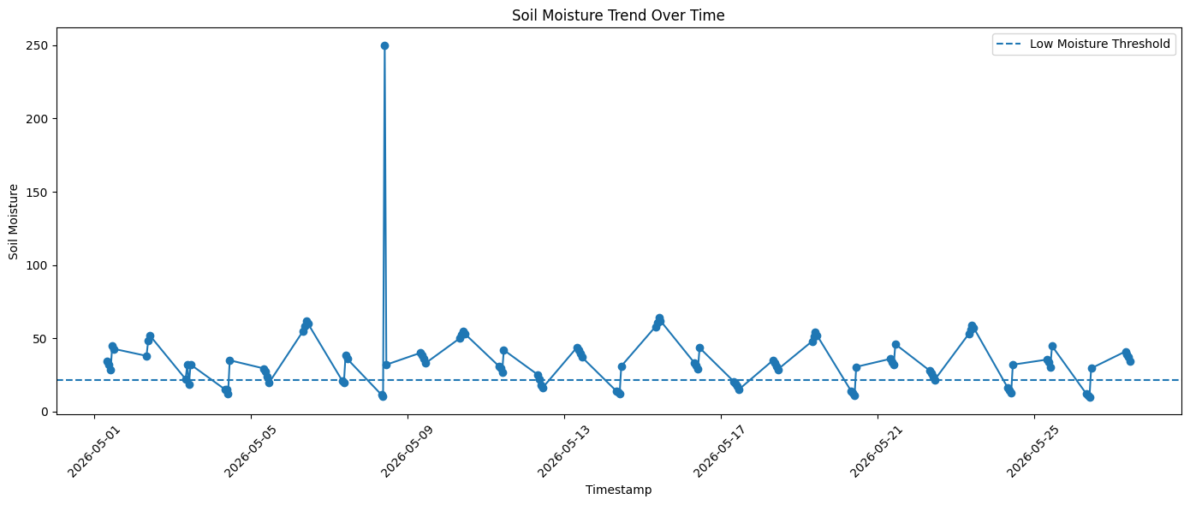
Figure 1: Soil moisture trend over time
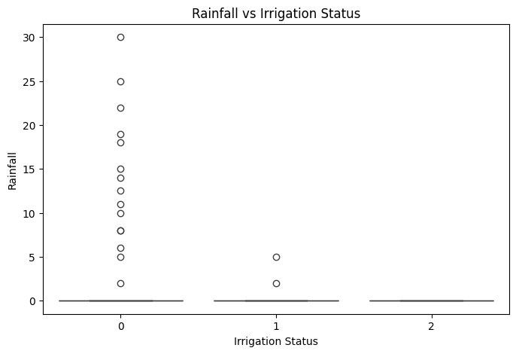
Figure 2: Rainfall vs irrigation status
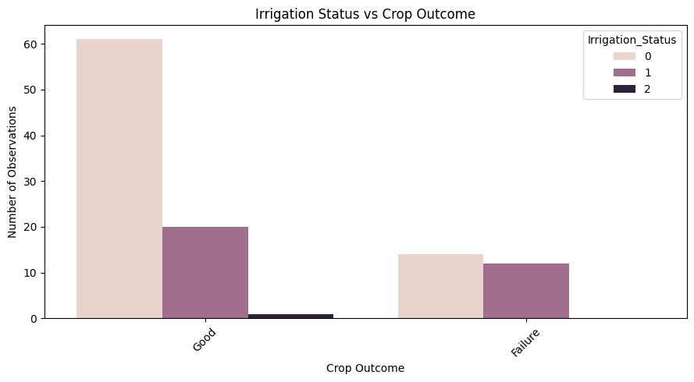
Figure 3: Irrigation status vs crop outcome
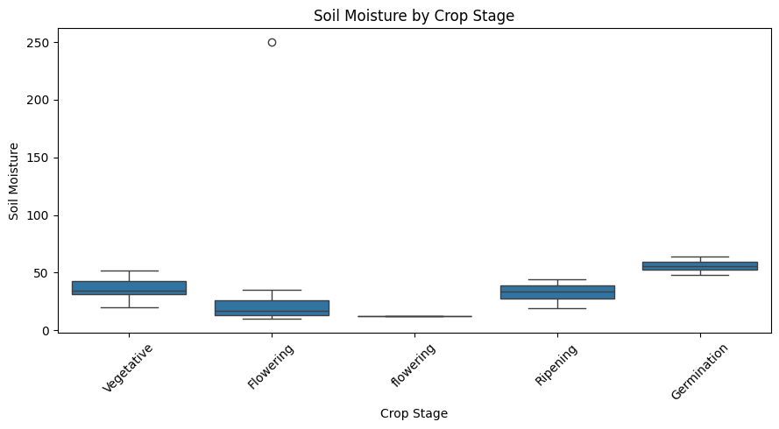
Figure 4: Soil moisture by crop stage

