STUDENT PERFORMANCE ANALYTICS SYSTEM

1. Project Title
Student Performance Analytics System

2. Objective
The objective of this project is to analyze student marks and attendance using Python, Pandas, and NumPy. It calculates total marks, averages, grades, pass/fail results, and identifies top-performing students.

3. Technologies Used

- Python
- Pandas
- NumPy
- Visual Studio Code

4. Dataset Description
The project uses a CSV file named "students.csv" containing 20 student records. It includes student ID, name, department, Python marks, Maths marks, English marks, and attendance.

5. Implementation
The program reads student data from the CSV file using Pandas. NumPy is used to calculate averages. Functions and conditional statements determine grades and pass/fail results. Pandas calculates class statistics and identifies the top three performers.

6. Key Features
- Calculates total marks and average marks.
- Assigns grades to students.
- Determines pass/fail status.
- Calculates class average, highest average, and lowest average.
- Displays subject-wise averages.
- Identifies the top three performers.

7. Output Screenshots
Insert screenshots of the program code and successful terminal output.
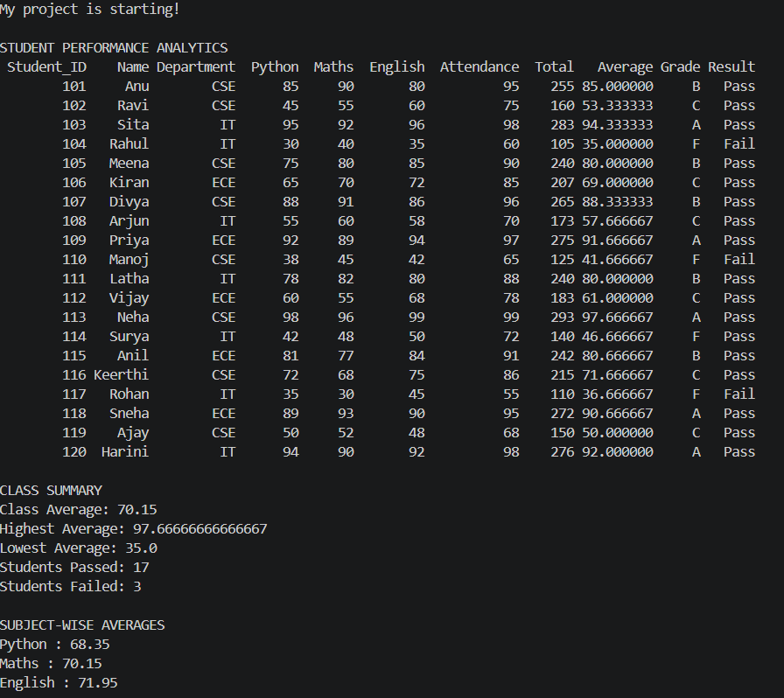
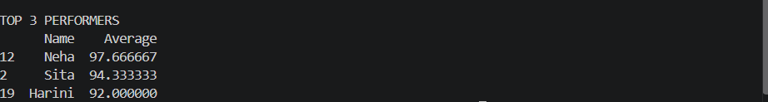
8. Final Outcome
The Student Performance Analytics System was successfully developed using Python, Pandas, and NumPy. The system analyzes student marks, calculates total and average marks, assigns grades, identifies pass/fail results, calculates class and subject-wise averages, and displays the top three performers. This project helps understand student performance through data analysis and improves practical knowledge of Python programming and data handling.
9. Challenges and Learning
I learned how to read CSV files, use Pandas and NumPy, write Python functions, apply conditions, calculate statistics, and display analytical results.

10. GitHub Repository Link
https://github.com/priya63371-pixel/student-performance-analytics

