1. Name of method in Thread class to pause execution?
ANS—sleep(),wait()
2. Role of "volatile" keyword.
ANS--package custom;
public class q2 implements Runnable {
private volatile int count = 0;
@Override
public void run() {
for (int i = 0; i <5 ; i++) {
count++;
System.out.println(count);
}
}
public static void main(String[] args) {
Thread t1=new Thread(new q2());
Thread t2=new Thread(new q2());
t1.start();
t2.start();
}
}
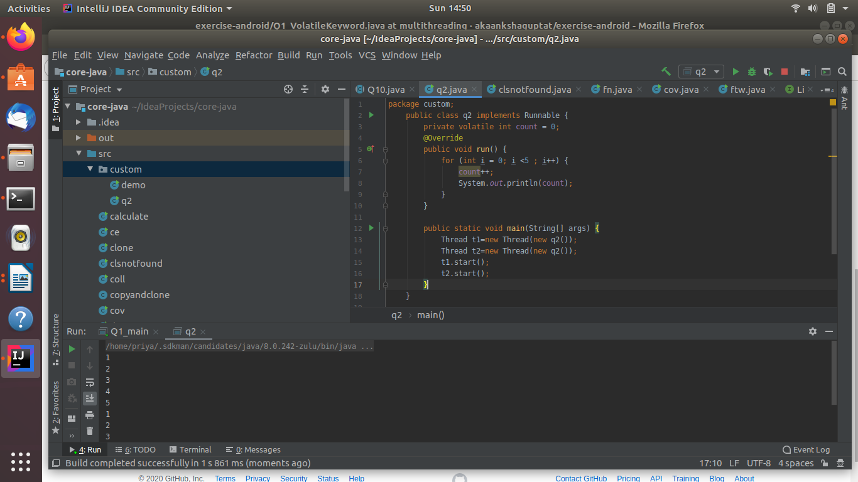
3. Write a program to create a thread using Thread class and Runnable interface each.
ANS--public class q3_a extends Thread
{
public void run(){
System.out.println("thread running");
}
public static void main(String[] args) {
q3_a tc= new q3_a();
tc.start();
}
}
by runnable
public class q3_b implements Runnable {
@Override
public void run() {
System.out.println("thread running");
}
public static void main(String[] args) {
Thread tc=new Thread(new q3_b());
tc.start();
}
}
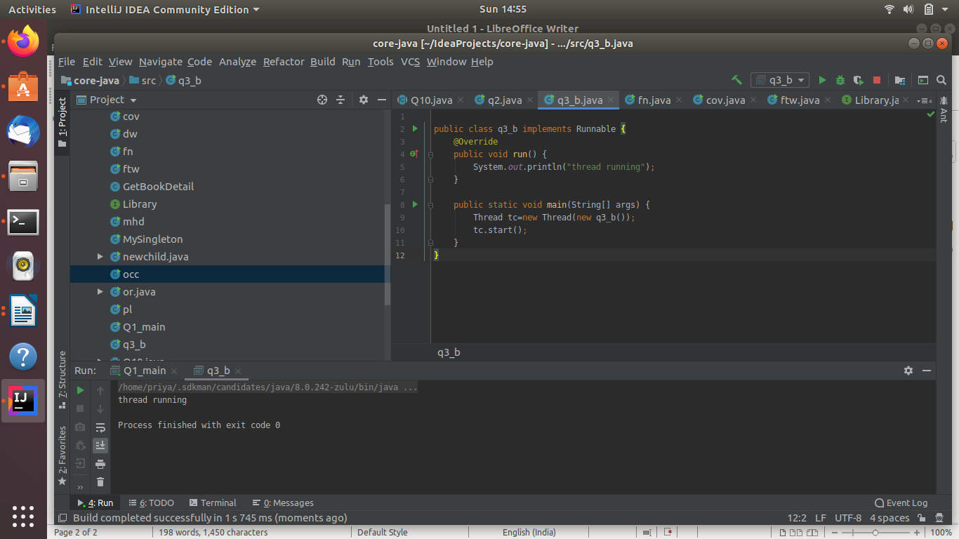
4. Write a program using synchronization block
ANS--public class q4 extends Thread{
public int count=0;
//using synchronized method
public void run() {
for (int i = 0; i < 10; i++) {
System.out.println("Inside thread classs using synchronized method "+ i);
incrementCount();
synchronizedBlock();
}
System.out.println("count=="+count);
}
//synchronized method
private synchronized void incrementCount() {
count++;
}
//synchronized block
private void synchronizedBlock() {
//using synchronized block
synchronized(this)
{
count++;
}
}
public static void main(String[] args) {
q4 q3_synchroni=new q4();
q4 q3_synchroni1=new q4();
q3_synchroni.start();
q3_synchroni1.start();
}
}
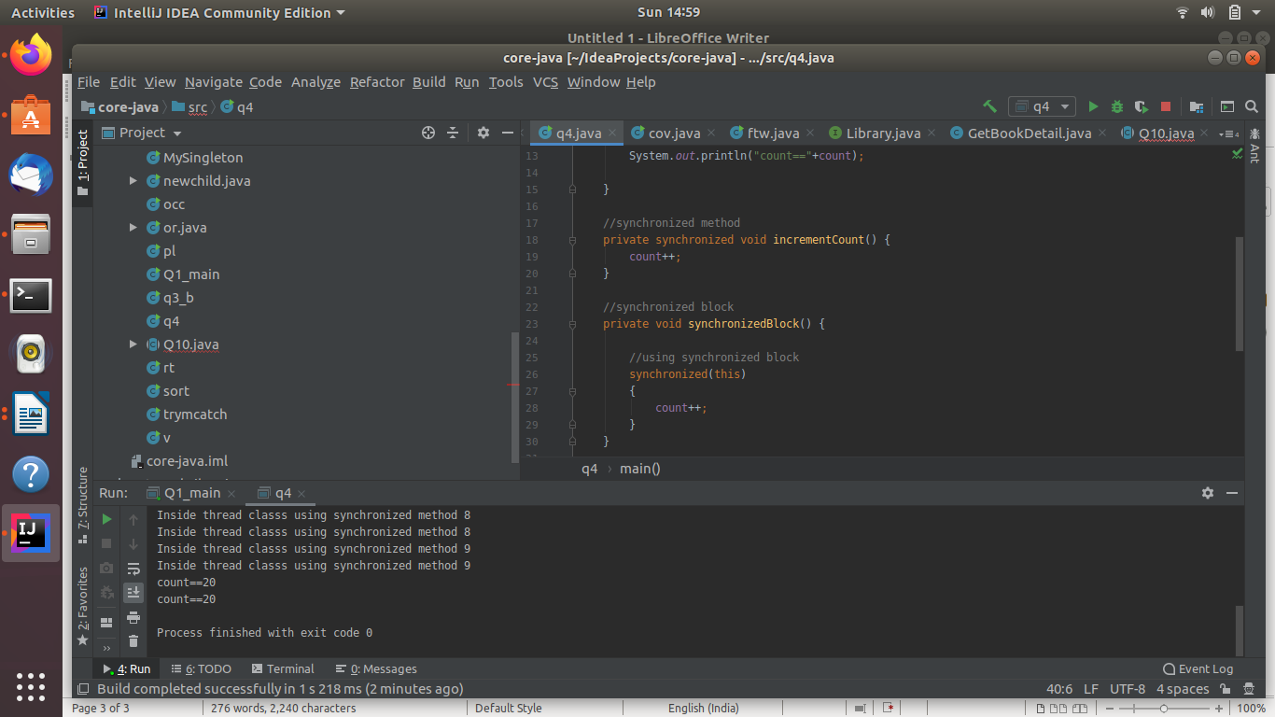
5. Write a program using synchronization method
ANS--
6. Write a program to create a Thread pool of 2 threads where one Thread will print even numbers and other will print odd numbers.
ANS--import java.util.concurrent.ExecutorService;
import java.util.concurrent.Executors;
public class q5 {
public static void main(String[] args){
ExecutorService executor= Executors.newFixedThreadPool(2);
executor.submit(new OddThread());
executor.submit(new EvenThread());
executor.shutdown();
}
}
class EvenThread implements Runnable{
@Override
public synchronized void run() {
for(int i=1;i<=10;i++){
if(i%2==0){
try {
Thread.sleep(10);
} catch (InterruptedException e) {
e.printStackTrace();
}
System.out.println("even number "+i);
}
}
notify();
}
}
class OddThread implements Runnable{
@Override
public synchronized void run() {
for(int i=1;i<=10;i++){
if(i%2==1){
try {
Thread.sleep(10);
} catch (InterruptedException e) {
e.printStackTrace();
}
System.out.println("odd number "+i);
}
notify();
}
}
}
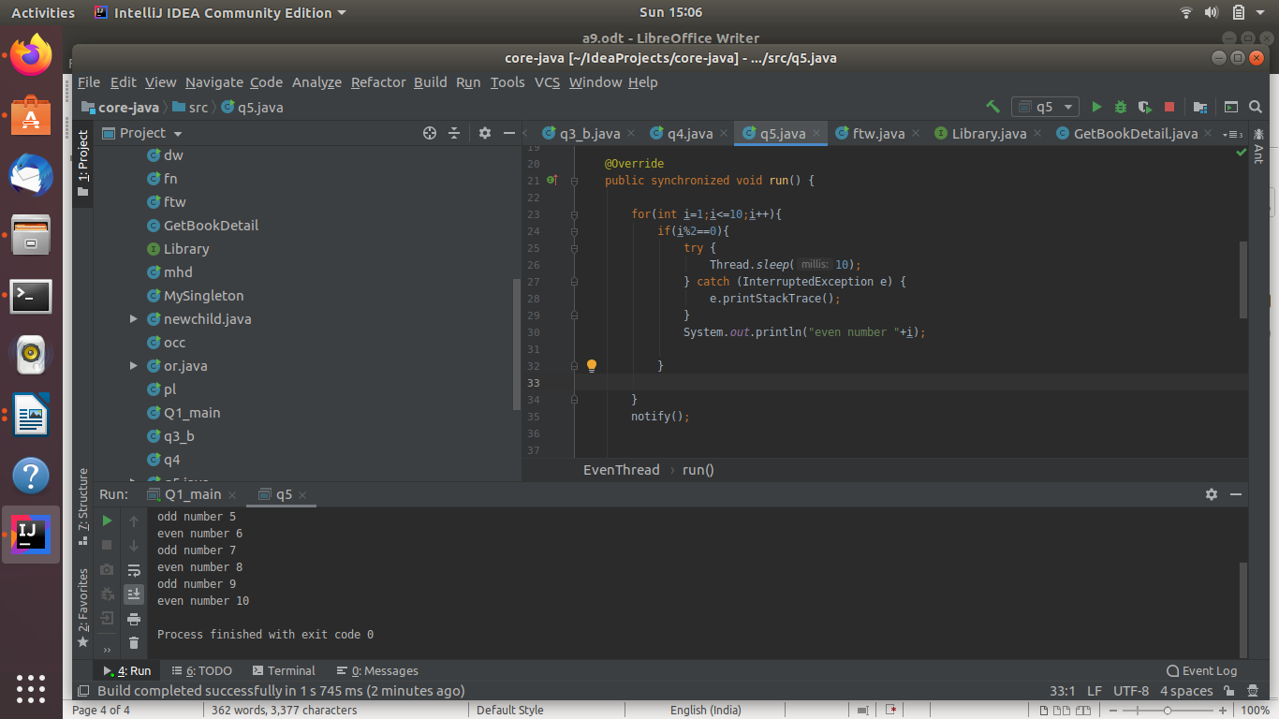
7. Write a program to demonstrate wait and notify methods.
ANs--public class q6{
public static void main(String[] args){
ThreadB b = new ThreadB();
b.start();
synchronized(b){
try{
System.out.println("Waiting for b to complete...");
b.wait();
}catch(InterruptedException e){
e.printStackTrace();
}
System.out.println("count is: " + b.count);
}
}
}
class ThreadB extends Thread{
int count;
@Override
public void run(){
synchronized(this){
for(int i=0; i<100 ; i++){
count += i;
}
notify();
}
}
}
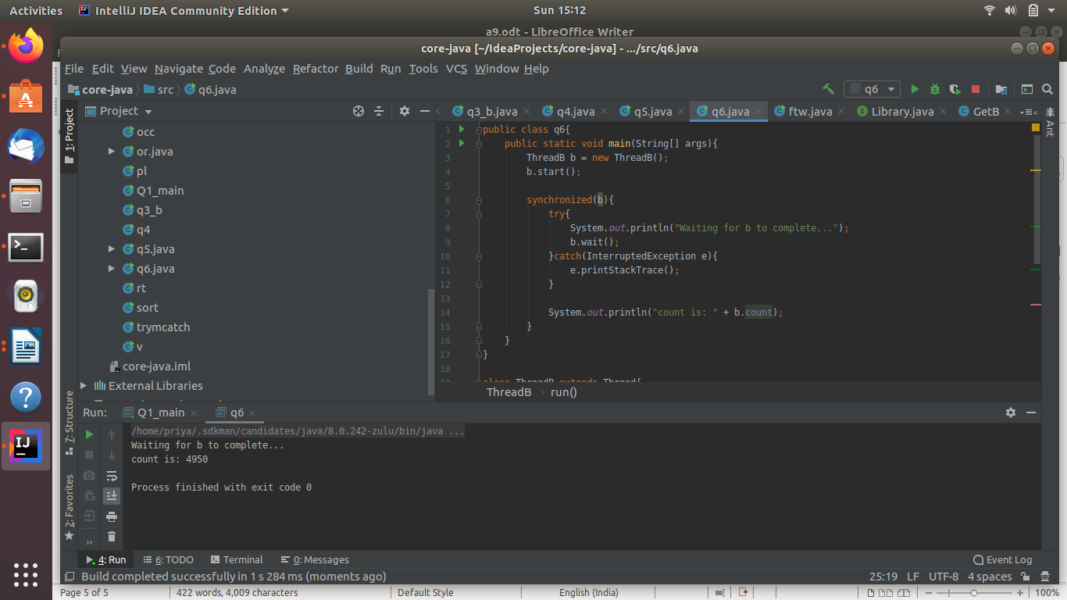
8. Write a program to demonstrate sleep and join methods.
Ans--public class q8 extends Thread{
public void run(){
for(int i=1;i<=5;i++){
try{
Thread.sleep(500);
}catch(Exception e){System.out.println(e);}
System.out.println(i);
}
}
public static void main(String args[]){
q8 t1=new q8();
q8 t2=new q8();
q8 t3=new q8();
t1.start();
try{
t1.join();
}catch(Exception e){System.out.println(e);}
t2.start();
t3.start();
}
}
