Q1. Write a program to replace a substring inside a string with other string ?
Ans--public static void main(String[] args) {
String s1="hello";
String s2=s1.replace("e","world");
System.out.println("string after replacing substring " +s2);
}
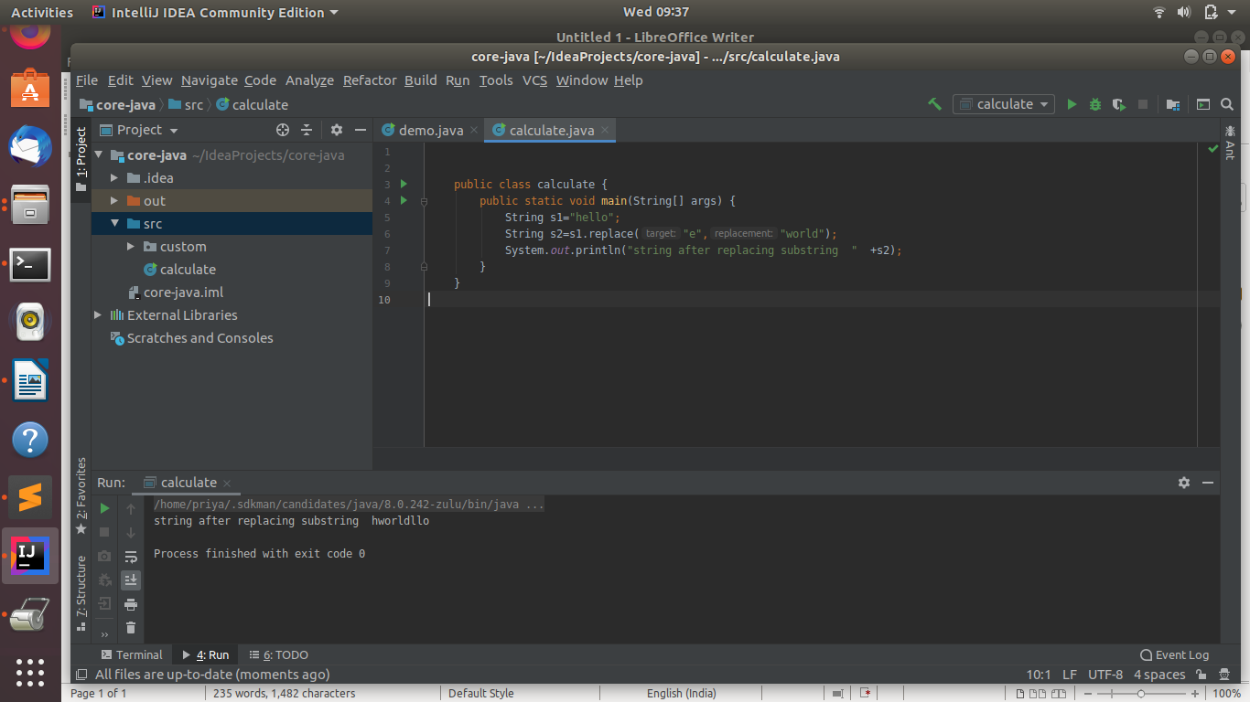
Q2. Write a program to find the number of occurrences of the duplicate words in a string and print them ?
ANS--import java.lang.*;
import java.util.*;
public class dw{
public static void main(String[] args) {
Scanner sc=new Scanner(System.in);
System.out.println("enter string");
String s1=sc.nextLine();
String words[]=s1.split(" ");
System.out.println("duplicate words :occurences");
int count=0;
for (int i = 0; i <words.length ; i++) {
count=1;
for (int j = i+1; j < words.length; j++) {
if(words[i].equals(words[j])&&words[i]!="#"){
count++;
words[j]="#";
}
}
if(count>1 && words[i]!="#"){
System.out.println(words[i]+":"+count);
}
}
}
}
output:-
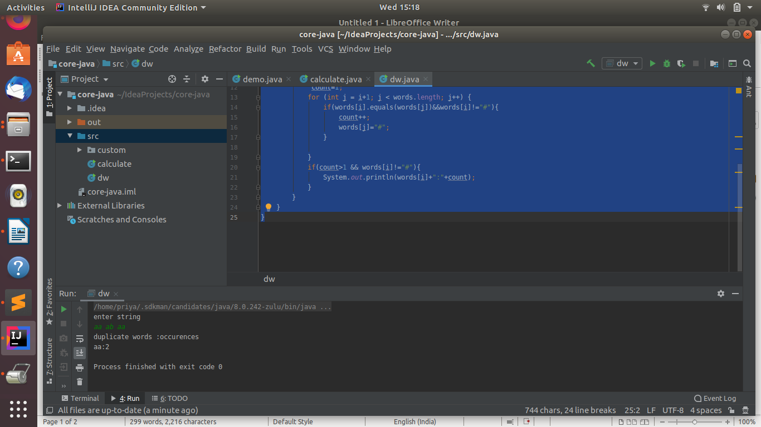
Q3. Write a program to find the number of occurrences of a character in a string without using loop?
ANS--import java.util.*;
import java.lang.*;
public class occ{
public static void main(String[] args) {
Scanner sc=new Scanner(System.in);
System.out.println("enter string");
String s1=sc.nextLine();
System.out.println("enter character");
String s2=sc.nextLine();
int count=s1.length()-s1.replace(s2,"").length();
System.out.println("occurence of "+s2+" is "+count);
}
}
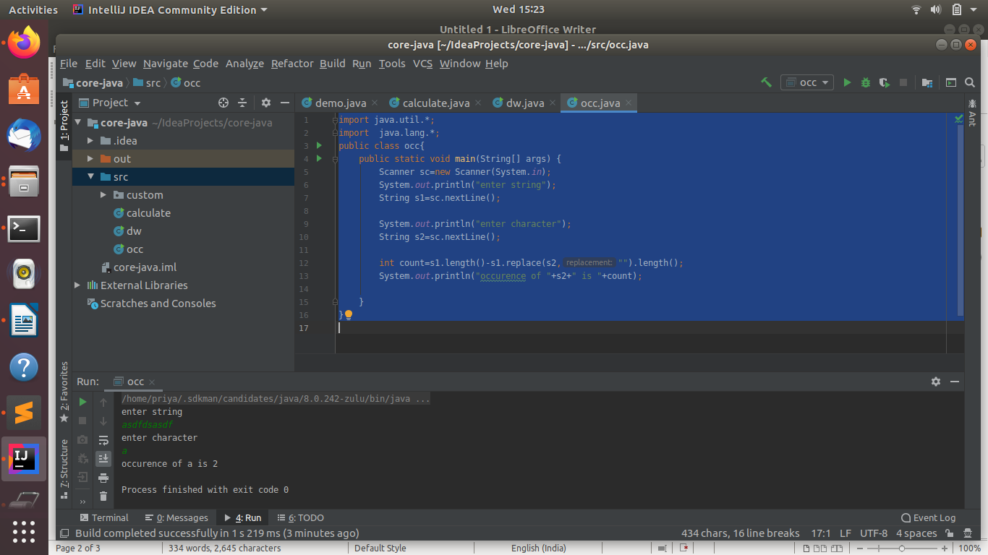
Q4. Calculate the number & Percentage Of Lowercase Letters,Uppercase Letters, Digits And Other Special Characters In A String
ANS--import java.util.*;
import java.lang.*;
public class pl {
public static void main(String[] args) {
Scanner sc =new Scanner(System.in);
String s1=sc.nextLine();
int lo=0,up=0,di=0,sp=0;
for(int i=0;i<s1.length();i++){
if(Character.isLowerCase(s1.charAt(i))){
lo++;
}
else if(Character.isUpperCase(s1.charAt(i))){
up++;
}
else if(Character.isDigit(s1.charAt(i))){
di++;
}
else{
sp++;
}
}
int len=s1.length();
float lo1=((float) lo/len)*100;
float up1=((float)up/len)*100;
float di1=((float)di/len)*100;
float sp1=((float)sp/len)*100;
System.out.println("lower case percentage "+lo1);
System.out.println("upper case percentage "+up1);
System.out.println("digit percentage "+di1);
System.out.println("special char percentage "+sp1);
}}
output--
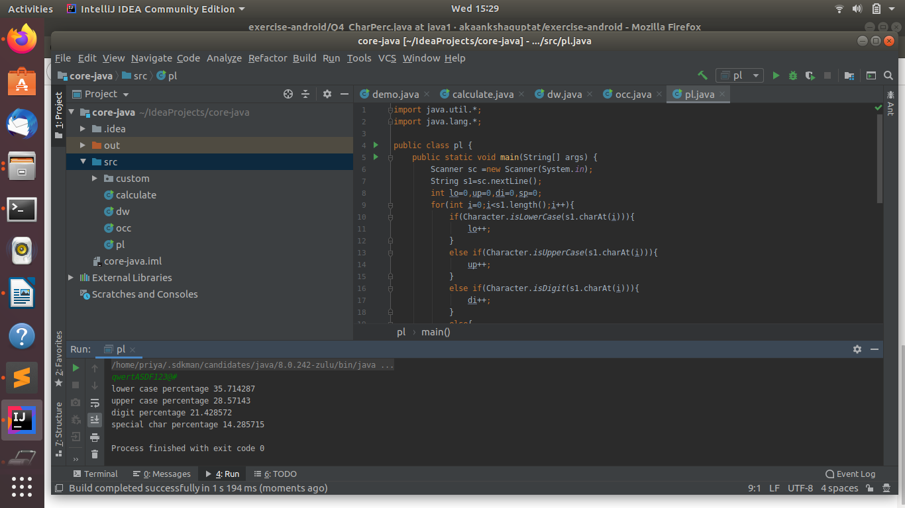
Q5. Find common elements between two arrays.
ANS--import java.util.*;
import java.lang.*;
public class ce{
public static void main(String[] args) {
Scanner sc=new Scanner(System.in);
System.out.println("enter array1 size");
int m=sc.nextInt();
System.out.println("enter array2 size");
int n=sc.nextInt();
int arr1[]=new int[m];
int arr2[]=new int[n];
System.out.println("enter array 1 elements");
for(int i=0;i<m;i++){
arr1[i]=sc.nextInt();
}
System.out.println("enter array 2 elements");
for(int j=0;j<n;j++){
arr2[j]=sc.nextInt();
}
int s=m<n?m:n; //small array length
int l=m>n?m:n; //large array length
System.out.println("common elements");
for(int k=0;k<s;k++){
for(int q=0;q<l;q++){
if(arr1[k]==arr2[q])
{
System.out.println(arr1[k]);
}
}
}
}
}
output--
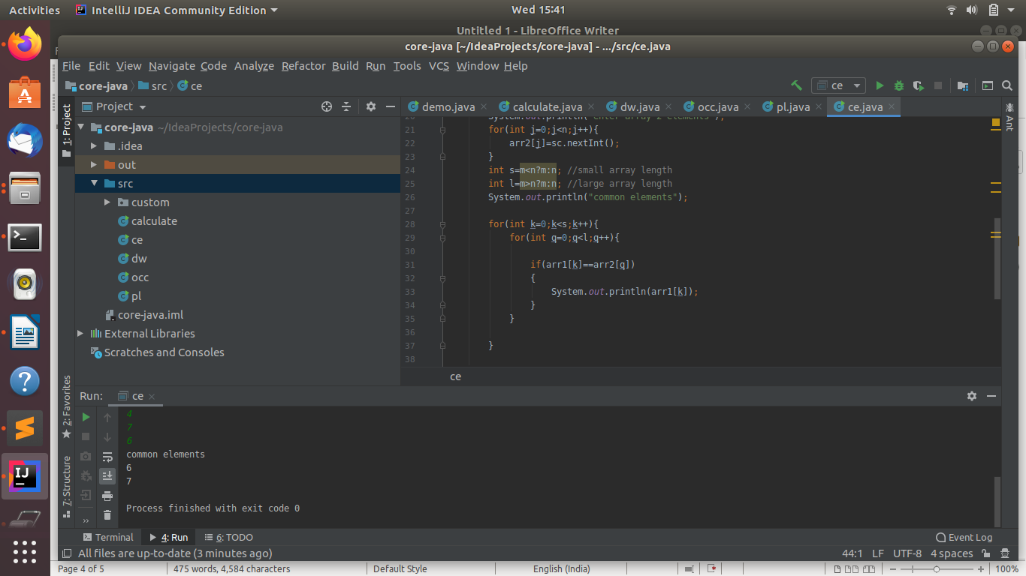
Q6. There is an array with every element repeated twice except one. Find that element
ANS--import java.util.*;
import java.lang.*;
public class rt {
public static void main(String[] args) {
System.out.println("enter size of array");
Scanner sc =new Scanner(System.in);
int m=sc.nextInt();
System.out.println("enter element of array");
int ar[]=new int[m];
for (int i = 0; i <m; i++) {
ar[i]=sc.nextInt();
}
Arrays.sort(ar);
boolean flag=true;
for (int j = 0; j <m-1; j=j+2) {
if((ar[j]!=ar[j+1]))
{
System.out.println(ar[j]);
flag=false;
break;
}
}
if (flag){
System.out.println(ar[m-1]);
}
}
}
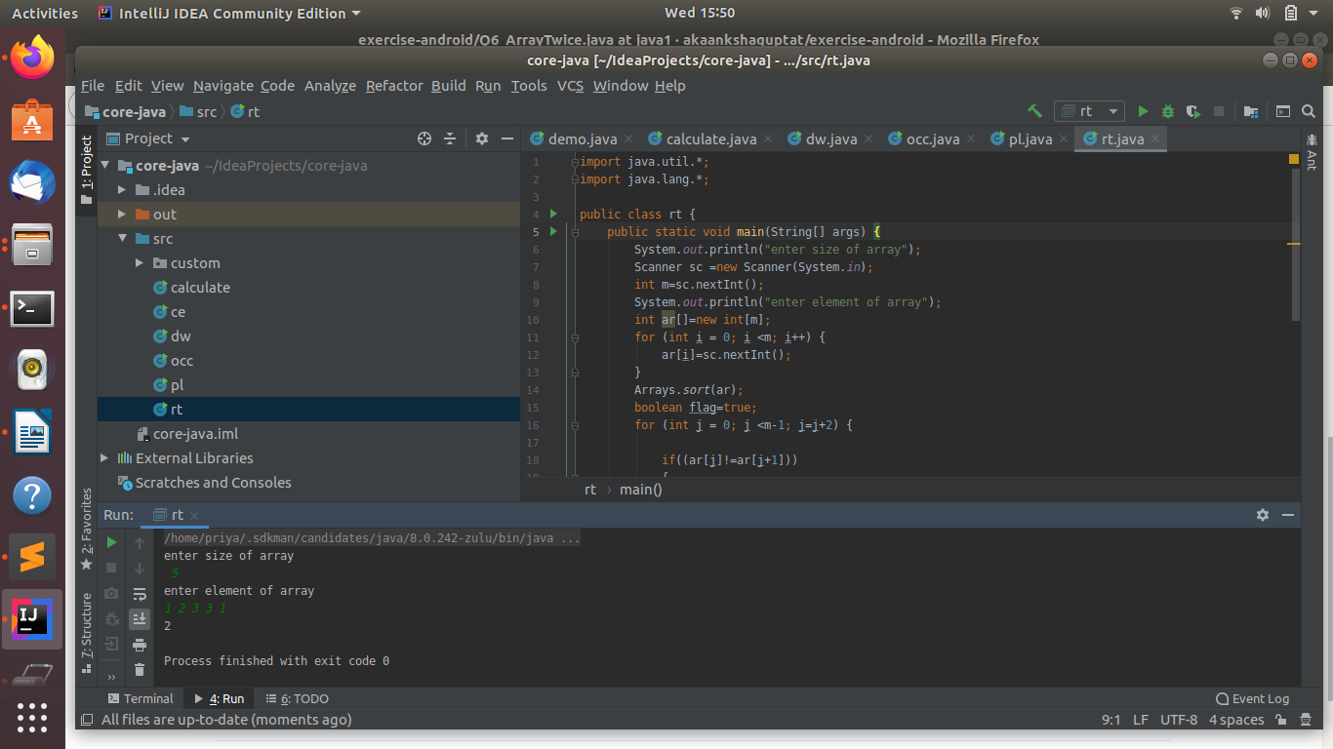
Q7. Write a program to print your Firstname,LastName & age using static block,static method & static variable respectively
ANS--import java.lang.*;
import java.util.*;
public class fn{
static{
String firstname="Priya";
System.out.println(firstname);
}
static void printLastName(){
String lastname="Patel";
System.out.println(lastname);
}
static int age=23;
public static void main(String[] args) {
printLastName();
System.out.println(age);
}
}
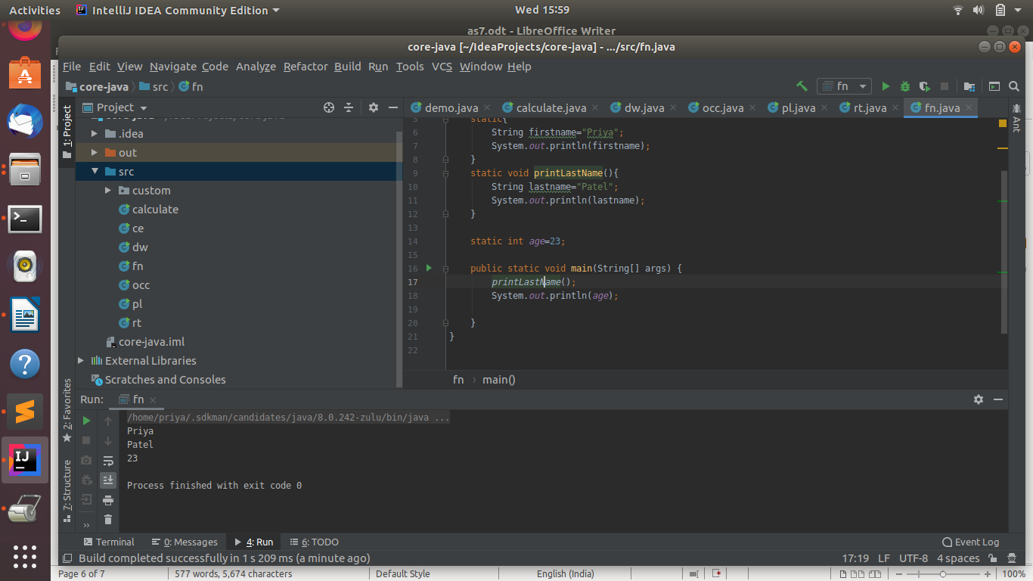
Q8. Write a program to reverse a string and remove character from index 4 to index 9 from the reversed string using String Buffer
ANS--import java.lang.*;
import java.util.Scanner;
public class v
{
public static void main(String[] args) {
String s1;
Scanner sc=new Scanner(System.in);
System.out.println("enter string");
s1=sc.nextLine();
StringBuffer sb=new StringBuffer();
sb.append(s1);
sb.reverse();
sb.delete(4,9);
System.out.println("new string is "+sb);
}
}
output--
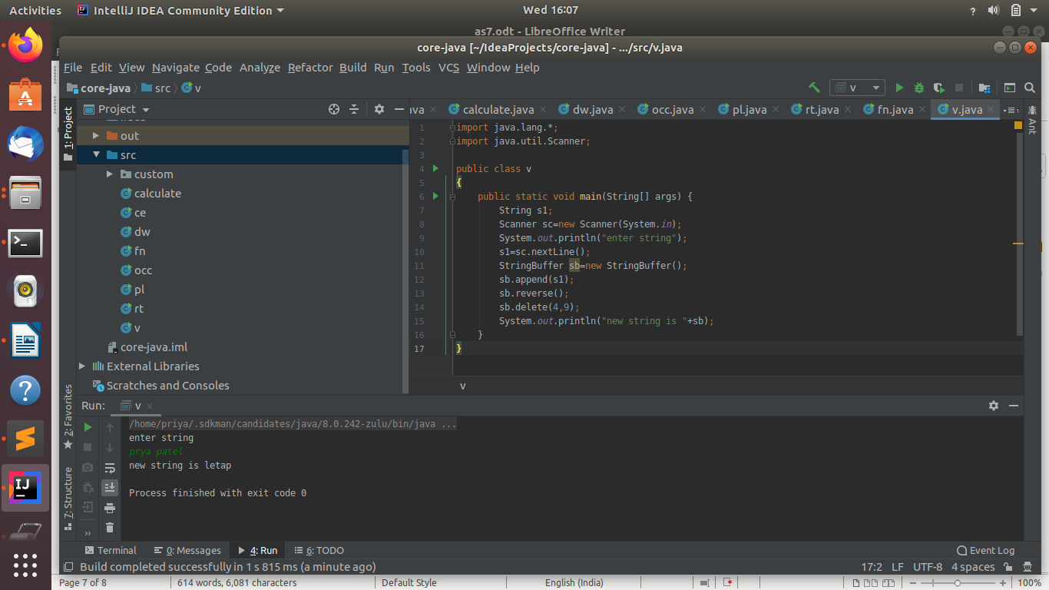
Q9.Write a program to display values of enums using a constructor & getPrice() method (Example display house & their prices)
ANS--
Q10.Write a single program for following operation using overloading
A) Adding 2 integer number
B) Adding 2 double
C) multiplying 2 float
D) multiplying 2 int
E) concate 2 string
F) Concate 3 String
ANS--import java.lang.*;
public class cov {
void add(int a,int b){
System.out.println(a+b);
}
void add(double a,double b)
{
System.out.println(a+b);
}
void multiply(float a,float b){
System.out.println(a*b);
}
void multiply(int a,int b){
System.out.println(a*b);
}
void concatenate(String a,String b){
System.out.println(a+b);
}
void concatenate(String a,String b,String c){
System.out.println(a+b+c);
}
public static void main(String[] args) {
cov ob=new cov();
ob.add(5,5);
ob.add(10.10,10.10);
ob.multiply(5,5);
ob.multiply(2.1f,2.1f);
ob.concatenate("ab","cd");
ob.concatenate("aa","ff","gg");
}
}
output--
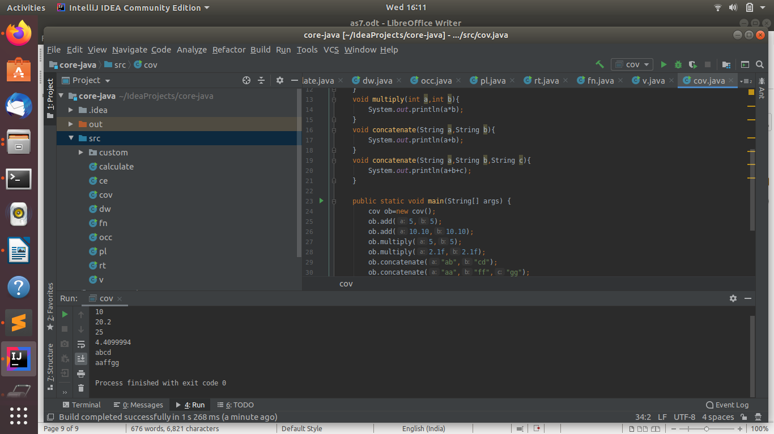
Q11.Create 3 sub class of bank SBI,BOI,ICICI all 4 should have method called getDetails which provide there specific details like rateofinterest etc,print details of every banks
ANS--class Bank{
void getDetails(double rate){
System.out.println("rate is "+rate);
}
}
class SBI extends Bank{
void getDetails(double rate){
System.out.println("rate is "+rate);
}
}
class BOI extends Bank{
void getDetails(double rate){
System.out.println("rate is "+rate);
}
}
class ICICI extends Bank{
void getDetails(double rate){
System.out.println("rate is "+rate);
}
}
public class or{
public static void main(String[] args) {
SBI sb =new SBI();
BOI b =new BOI();
ICICI i= new ICICI();
sb.getDetails(4.0);
b.getDetails(3.3);
i.getDetails(45.5);
}
}
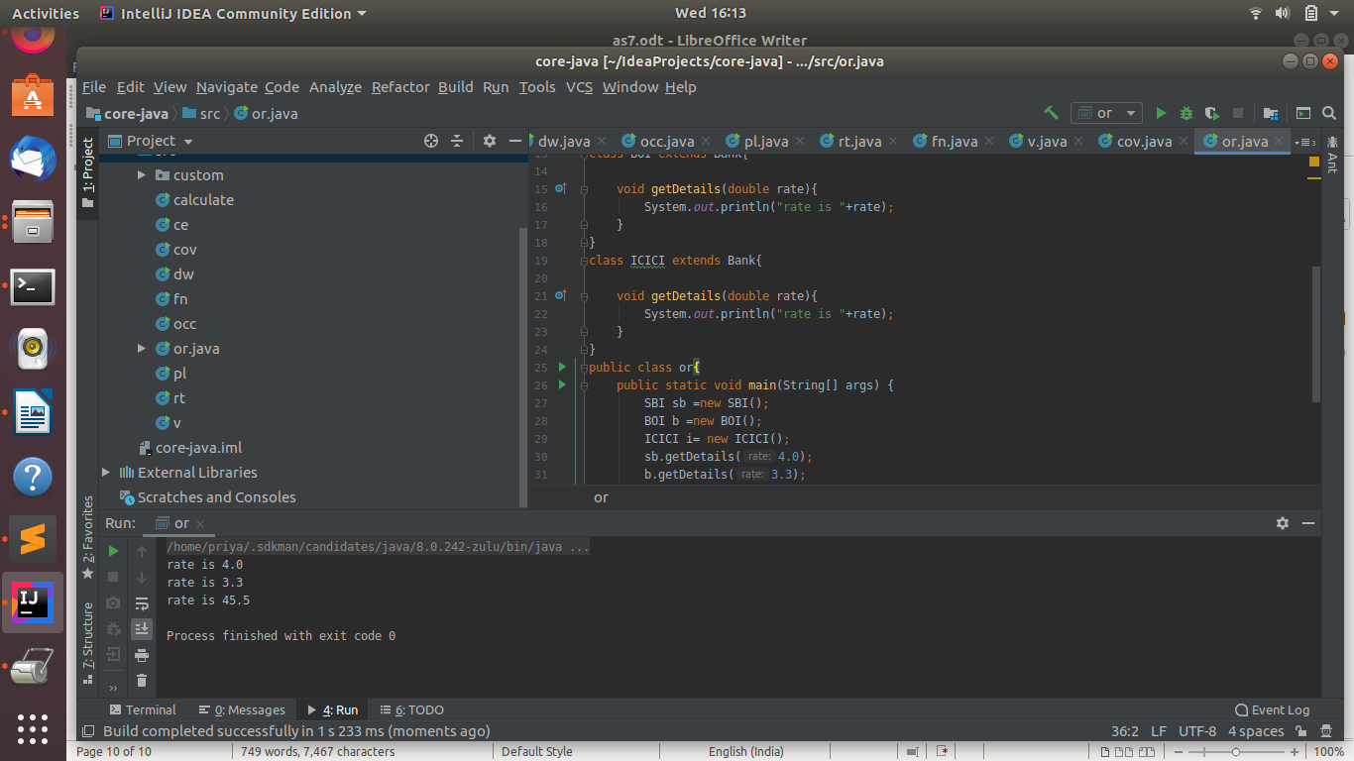
output--

