- Write Java code to define List . Insert 5 floating point numbers in List, and using an iterator, find the sum of the numbers in List.
ANS--
mport java.util.ArrayList;
import java.util.Iterator;
import java.util.Scanner;
public class q1 {
public static void main(String[] args) {
Scanner sc=new Scanner(System.in);
float element;
ArrayList<Float> l1= new ArrayList<Float>();
System.out.println("enter 5 element");
for (int i = 0; i <5; i++) {
element=sc.nextFloat();
l1.add(element);
}
float sum=0f;
Iterator<Float> iterator = l1.iterator();
while(iterator.hasNext())
{
sum=sum+iterator.next();
}
System.out.println("sum of list is : "+sum);
}
}
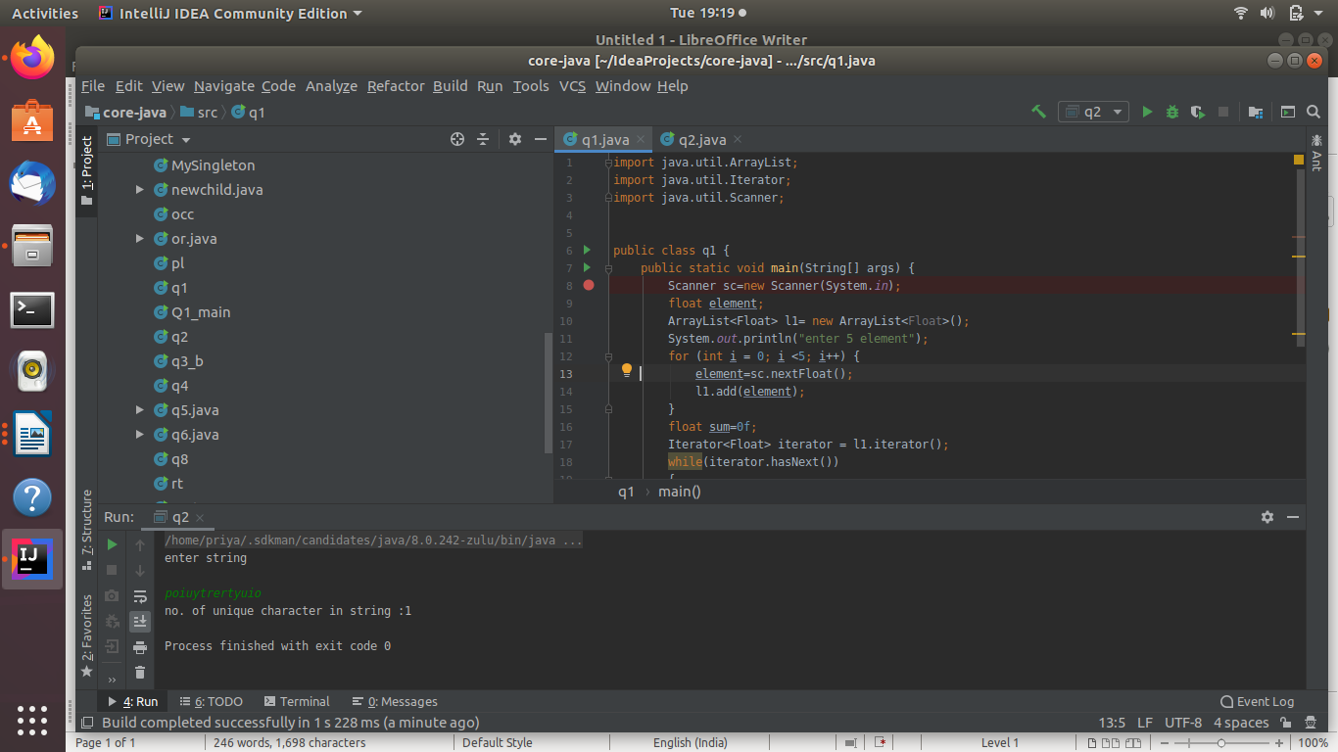
- Write a method that takes a string and returns the number of unique characters in the string.
ANS--import java.util.HashSet;
import java.util.Scanner;
import java.util.Set;
public class q2 {
public static void main(String[] args) {
String s1;
System.out.println("enter string");
Scanner sc=new Scanner(System.in);
s1=sc.nextLine();
String s2[]=s1.split("");
Set<String> set1 = new HashSet<String>();
for (int i = 0; i < s2.length; i++) {
set1.add(s2[i]);
}
System.out.println("no. of unique character in string :"+ set1.size());
}
}

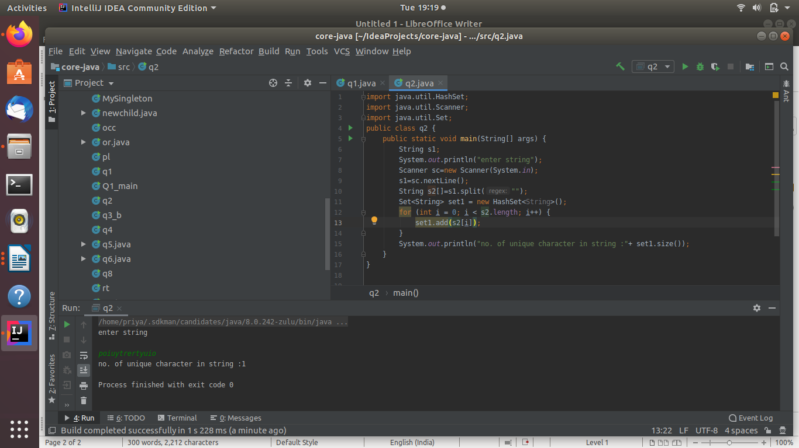
- Write a method that takes a string and print the number of occurrence of each character characters in the string.
ANS--import java.util.HashMap;
import java.util.HashSet;
import java.util.Scanner;
public class q3 {
static void occurence(String s1){
HashMap<Character,Integer> h1=new HashMap<Character, Integer>();
char[] s3=s1.toCharArray();
for (char c: s3) {
if(h1.containsKey(c))
{
//System.out.println(c);
h1.put(c, h1.get(c)+1);
}
else
{
h1.put(c, 1);
}
}
System.out.println(s1+" : "+h1);
}
public static void main(String[] args) {
String s1;
Scanner sc =new Scanner(System.in);
System.out.println("enter string");
s1=sc.nextLine();
occurence(s1);
}
}
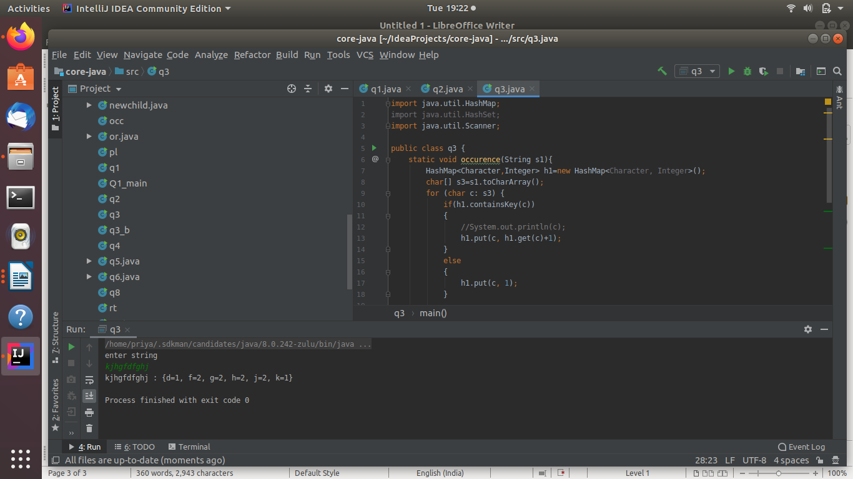
- Write a program to sort HashMap by value.
ANS-
import java.util.*;
public class Q4 {
public static void main(String[] args) {
LinkedHashMap<String, String> hm = new LinkedHashMap<>();
Scanner sc=new Scanner(System.in);
String key,val;
for (int i = 0; i <5 ; i++) {
System.out.println("enter key: value pair");
key=sc.nextLine();
val=sc.nextLine();
hm.put(key,val);
}
Map<String, String> result = sortMap(hm);
for (Map.Entry<String, String> entry : result.entrySet())
{
System.out.print("Key: " + entry.getKey());
System.out.println(" Value: " + entry.getValue());
}
}
public static LinkedHashMap<String, String> sortMap(LinkedHashMap<String, String> map) {
List<Map.Entry<String, String>> hm1 = new LinkedList<>(map.entrySet());
Collections.sort(hm1, (o1, o2) -> o1.getValue().compareTo(o2.getValue()));
LinkedHashMap<String, String> result = new LinkedHashMap<>();
for (Map.Entry<String, String> entry : hm1)
{
result.put(entry.getKey(), entry.getValue());
}
return result;
}
}
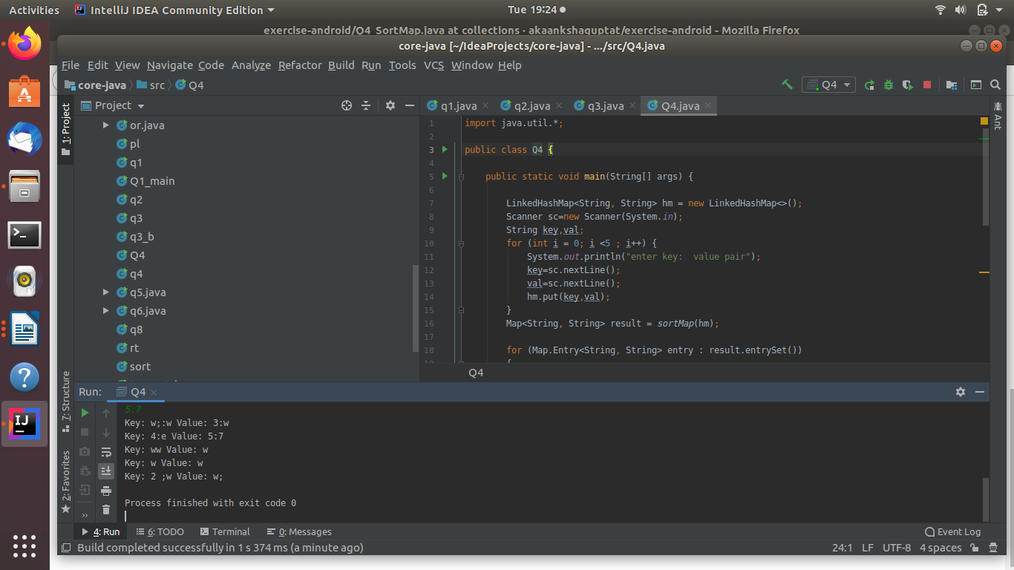
- Write a program to sort Employee objects based on highest salary using Comparator. Employee class{ Double Age; Double Salary; String Name
ANS--import java.util.ArrayList;
import java.util.Collections;
import java.util.Comparator;
class Employee
{
int age,salary;
String name;
// Constructor
public Employee(int age, String name, int salary)
{
this.age = age;
this.name = name;
this.salary = salary;
}
// Used to print student details in main()
public String toString()
{
return "age = "+this.age + " name= " + this.name +
" salary " + this.salary;
}
}
class SortbySalary implements Comparator<Employee>
{
// Used for sorting in ascending order of
// roll number
public int compare(Employee a, Employee b)
{
if(b.salary>a.salary)
return 1;
else
return -1;
}
}
class Q5 {
public static void main(String[] args) {
ArrayList<Employee> ar = new ArrayList<Employee>();
ar.add(new Employee(20, "priya1", 10000));
ar.add(new Employee(30, "priya2", 30000));
ar.add(new Employee(40, "priya3", 20000));
System.out.println("Unsorted");
for (int i = 0; i < ar.size(); i++)
System.out.println(ar.get(i));
Collections.sort(ar, new SortbySalary());
System.out.println("\nSorted by salary");
for (int i = 0; i < ar.size(); i++)
System.out.println(ar.get(i));
}
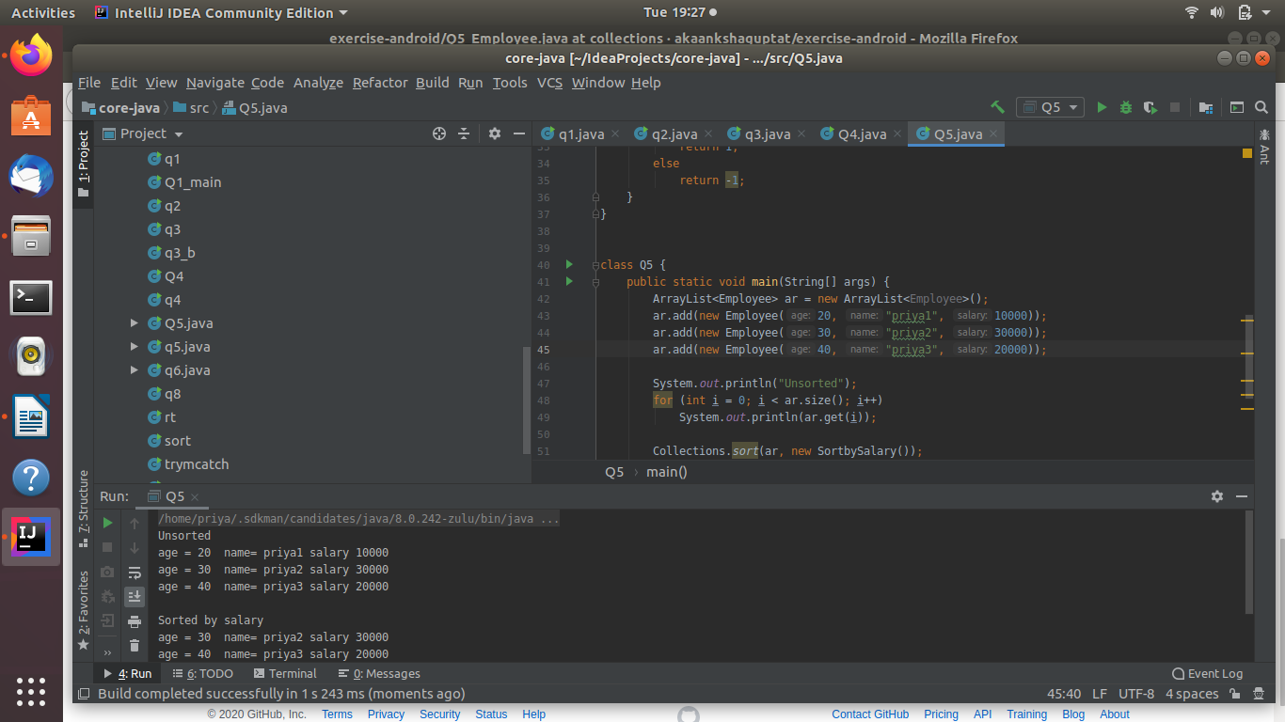
- Write a program to sort the Student objects based on Score , if the score are same then sort on First Name . Class Student{ String Name; Double Score; Double Age
ANS--import java.util.ArrayList;
import java.util.Collections;
import java.util.Comparator;
class Student
{
int age,score;
String name;
// Constructor
public Student(int age, String name, int score)
{
this.age = age;
this.name = name;
this.score = score;
}
// Used to print student details in main()
public String toString()
{
return "age = "+this.age + " name= " + this.name +
" salary " + this.score;
}
}
class SortbyScore implements Comparator<Student>
{
public int compare(Student a, Student b)
{
if(b.score!=a.score)
return b.score - a.score;
else
{
return a.name.compareTo(b.name);
}
}
}
class Q6 {
public static void main(String[] args) {
ArrayList<Student> ar = new ArrayList<Student>();
ar.add(new Student(20, "priya1", 100));
ar.add(new Student(30, "abcd", 60));
ar.add(new Student(30, "priya2", 60));
ar.add(new Student(40, "priya3", 80));
System.out.println("Unsorted");
for (int i = 0; i < ar.size(); i++)
System.out.println(ar.get(i));
Collections.sort(ar, new SortbyScore());
System.out.println("\nSorted by score");
for (int i = 0; i < ar.size(); i++)
System.out.println(ar.get(i));
}
}
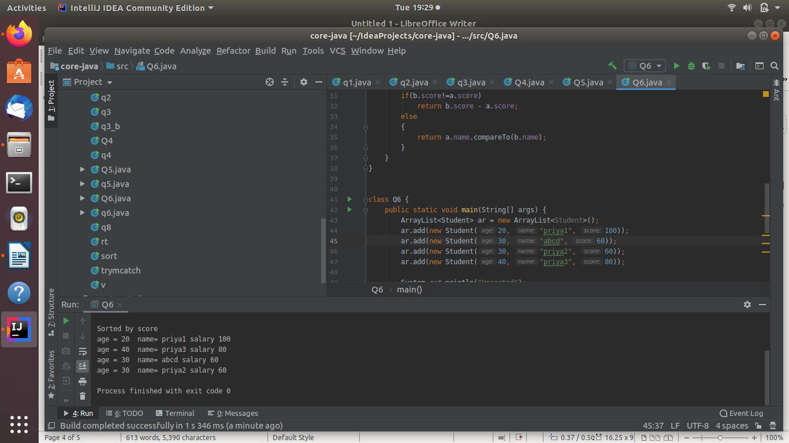
- Print the elements of an array in the decreasing frequency if 2 numbers have same frequency then print the one which came first.
ANS--
- Design a Data Structure SpecialStack that supports all the stack operations like push(), pop(), isEmpty(), isFull() and an additional operation getMin() which should return minimum element from the SpecialStack. (Expected complexity O(1))
ANS--
import java.util.Stack;
class Q8 extends Stack<Integer>
{
Stack<Integer> min = new Stack<>();
void push(int x)
{
if(isEmpty() == true)
{
super.push(x);
min.push(x);
}
else
{
super.push(x);
int y = min.pop();
min.push(y);
if(x < y)
min.push(x);
else
min.push(y);
}
}
public Integer pop()
{
int x = super.pop();
min.pop();
return x;
}
int getMin()
{
int x = min.pop();
min.push(x);
return x;
}
public static void main(String[] args)
{
Q8 s = new Q8();
s.push(10);
s.push(2);
s.push(3);
System.out.println("stack=="+s);
System.out.println("min element "+s.getMin());
s.push(1);
System.out.println("stack=="+s);
System.out.println("min element "+s.getMin());
}
}
