1. Create Java classes having suitable attributes for Library management system.Use OOPs concepts in your design.Also try to use interfaces and abstract classes.
ANS—Q1_main
import java.util.Scanner;
public class Q1_main implements Library {
GetBookDetail getBookDetail;
public static void main(String[] args) {
Scanner sc = new Scanner(System.in);
Q1_main m = new Q1_main();
while (true) {
System.out.println("Library managent system");
System.out.println("1. Add books");
System.out.println("2. Display book info");
System.out.println("press the key to continue");
int n = sc.nextInt();
sc.nextLine();
switch (n) {
case 1:
// sc.next();
System.out.println("please enter book id");
String id = sc.nextLine();
System.out.println("please enter book name");
String name = sc.nextLine();
System.out.println("please enter book author");
String author = sc.nextLine();
System.out.println("please enter book publisher");
String publisher = sc.nextLine();
GetBookDetail getBookDetail = new GetBookDetail(id, name, author, publisher);
m.addBook(getBookDetail);
System.out.println("Book added sucessfully");
break;
case 2:
m.showBookinfo();
break;
default:
break;
}
}
}
@Override
public boolean addBook(GetBookDetail detail) {
getBookDetail=detail;
return true;
}
@Override
public boolean showBookinfo() {
System.out.println("Book id :" +getBookDetail.getBookID());
System.out.println("Book Name :"+getBookDetail.getTitle());
System.out.println("Book author :"+getBookDetail.getAuthor());
System.out.println("Book Publisher :"+getBookDetail.getPublisher());
return true;
}
}
interface Library
public interface Library {
public boolean addBook(GetBookDetail detail);
public boolean showBookinfo();
}
GetBookDetail
public class GetBookDetail {
private String bookID;
public GetBookDetail(String bookID, String title, String author, String publisher) {
this.bookID = bookID;
this.title = title;
this.author = author;
this.publisher = publisher;
}
//This attribute contains book unique ID
private String title;
//This attribute contains author name
private String author;
//This attribute contains publisher name
private String publisher;
//This attribute contains total page in the book
public String getBookID() {
return bookID;
}
public void setBookID(String bookID) {
this.bookID = bookID;
}
public String getTitle() {
return title;
}
public void setTitle(String title) {
this.title = title;
}
public String getAuthor() {
return author;
}
public void setAuthor(String author) {
this.author = author;
}
public String getPublisher() {
return publisher;
}
public void setPublisher(String publisher) {
this.publisher = publisher;
}
}
output---
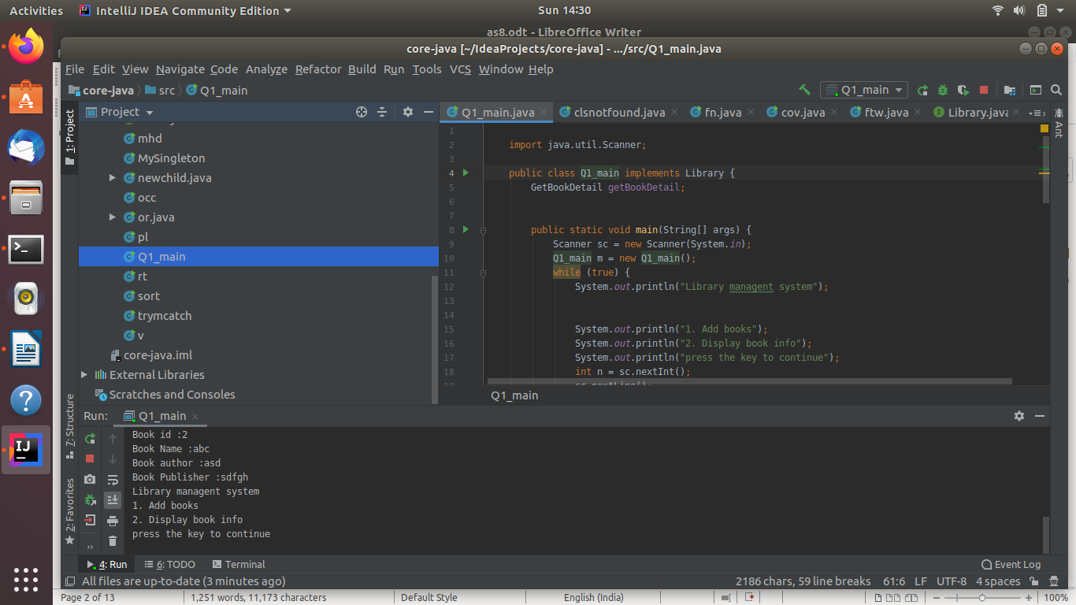
2. WAP to sorting string without using string Methods?.
ANS--import java.util.*;
import java.lang.*;
public class sort {
public static void main(String[] args) {
Scanner sc= new Scanner(System.in);
int a=sc.nextInt();
int arr[];
arr=new int[a];
for(int i=0;i<a;i++)
{
arr[i]=sc.nextInt();
}
for(int i=0;i<a;i++)
{
for(int j=i+1;j<a;j++)
{
if(arr[i]>arr[j])
{
arr[i]=arr[i]+arr[j];
arr[j]=arr[i]-arr[j];
arr[i]=arr[i]-arr[j];
}
}
}
for(int i=0;i<a;i++)
{
System.out.println(arr[i]);
}
}
}
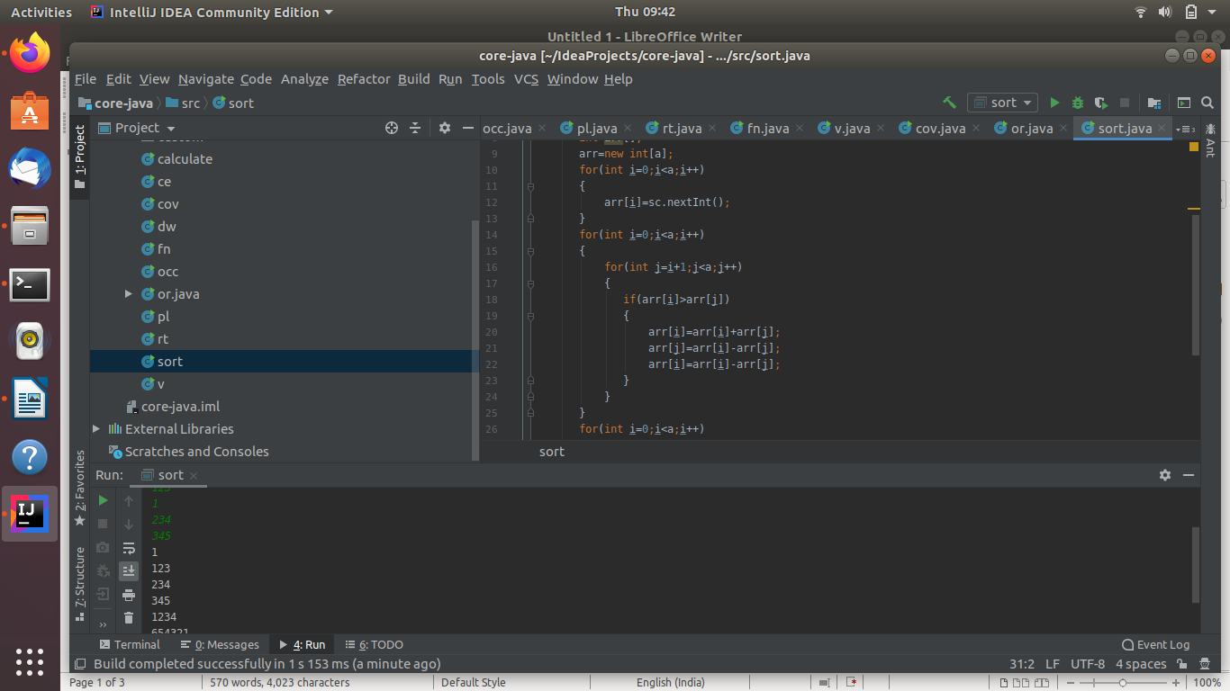
3. WAP to produce NoClassDefFoundError and ClassNotFoundException exception.
ANS--
public class clsnotfound {
public static void main(String args[]) {
try
{
Class.forName("Hello");
}
catch (ClassNotFoundException ex)
{
ex.printStackTrace();
}
}
}
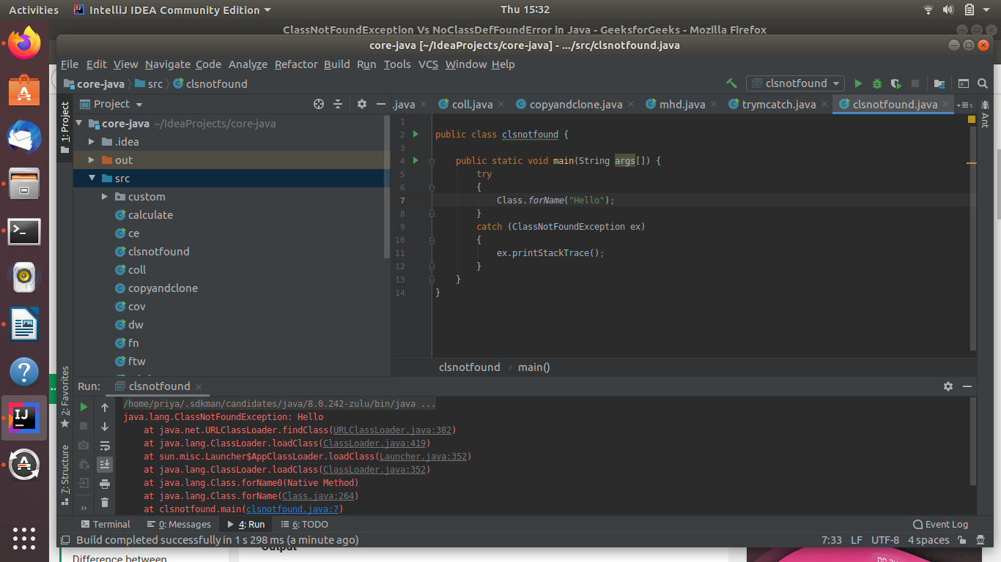
4. WAP to create singleton class.
ANS--public class MySingleton{
private static MySingleton obj;
static{
obj = new MySingleton();
}
private MySingleton(){
}
public static MySingleton getInstance(){
return obj;
}
public void func(){
System.out.println("hello");
}
public static void main(String a[]){
MySingleton ms = getInstance();
ms.func();
}
}
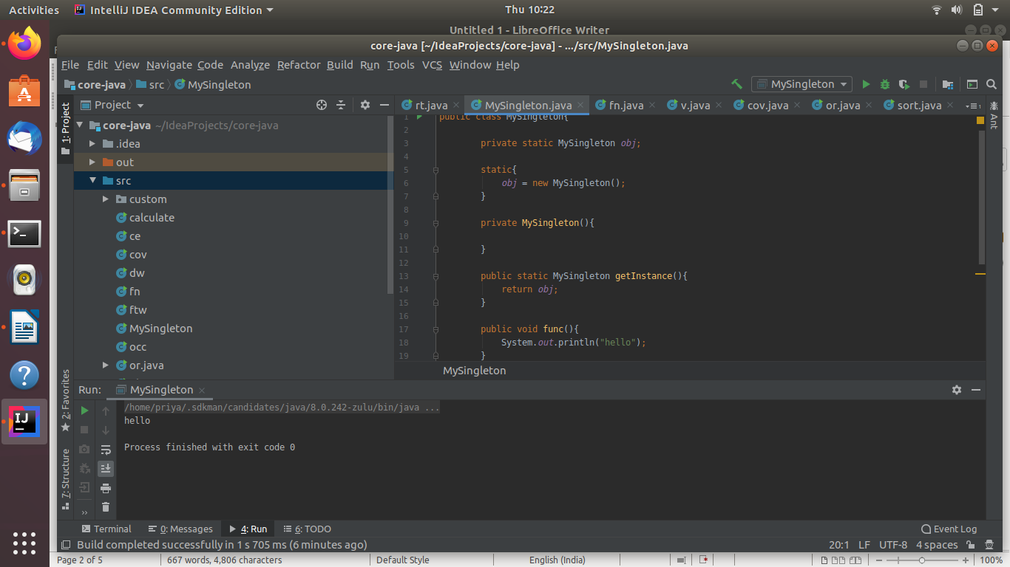
5. WAP to show object cloning in java using cloneable and copy constructor both.
ANS--public class clone implements Cloneable{
@Override
protected Object clone() throws CloneNotSupportedException {
return super.clone();
}
String name="priya";
public static void main(String[] args) {
clone c1=new clone();
try
{
clone c2=(clone) c1.clone();
System.out.println(c2.name);
} catch (CloneNotSupportedException e) {
e.printStackTrace();
}
}
}
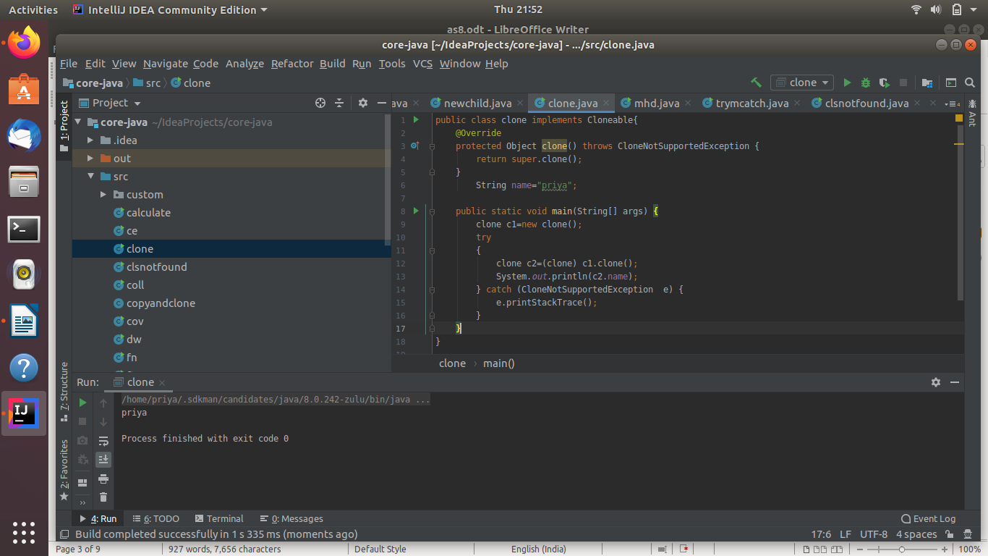
6. WAP showing try, multi-catch and finally blocks.
ANS--public class trymcatch{
public static void main(String[] args) {
try
{
int a=50/0;
}
catch(ArithmeticException e)
{
System.out.println(e);
}
catch(Exception e)
{
System.out.println(e);
}
finally
{
System.out.println("finally block");
}
}
}
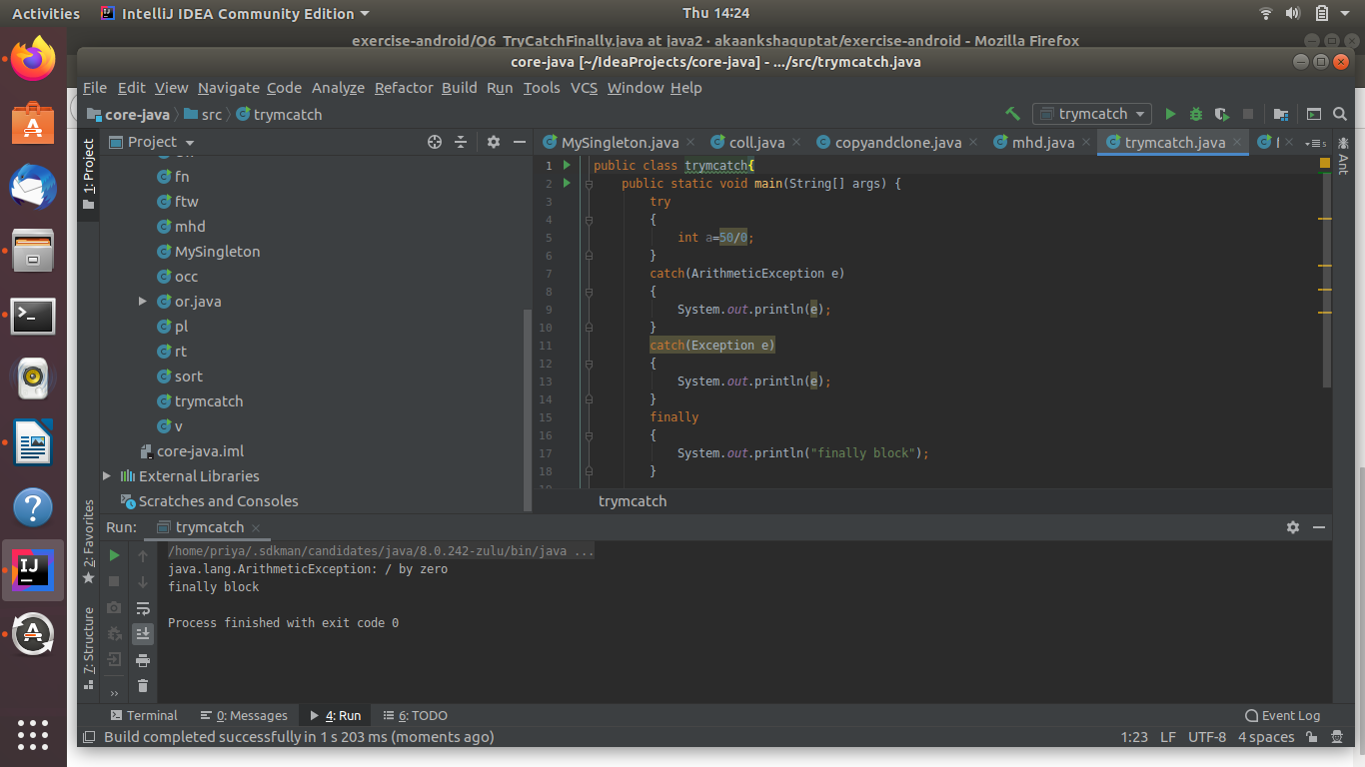
7. WAP to convert seconds into days, hours, minutes and seconds.
ANS--import java.lang.*;
import java.util.*;
public class mhd {
public static void main(String[] args) {
float sec,min;
int hour,day;
Scanner sc=new Scanner(System.in);
System.out.println("enter seconds");
sec=sc.nextFloat();
min=sec/60;
hour=(int)min/60;
day=hour/24;
System.out.println("seconds: "+sec);
System.out.println("minutes: "+min);
System.out.println("hour: "+hour);
System.out.println("days: "+day);
}
}
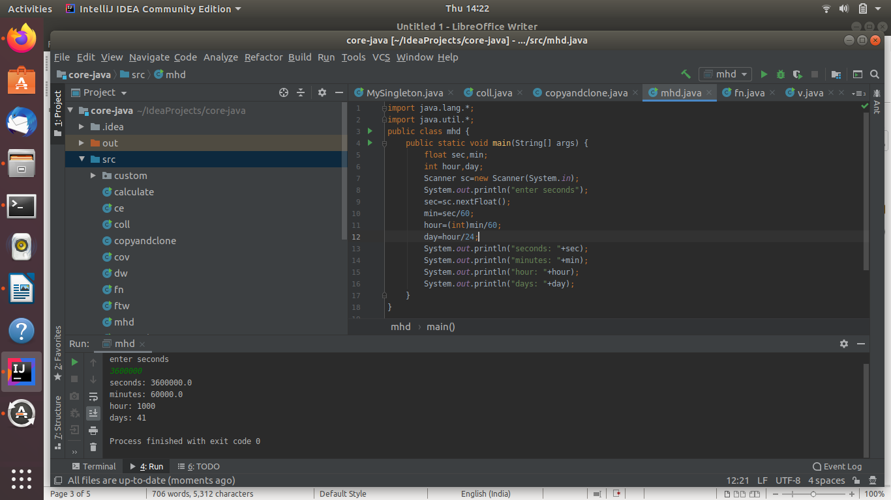
8. WAP to read words from the keyboard until the word done is entered. For each word except done, report whether its first character is equal to its last character. For the required loop, use a
a)while statement
b)do-while statement
ANS--
mport java.util.Scanner;
public class coll {
public static void main(String[] args) {
Scanner sc = new Scanner(System.in);
String s1;
do {
System.out.println("enter a word");
s1=sc.nextLine();
if(!s1.equals("done")){
if(s1.charAt(0)==s1.charAt(s1.length()-1))
{
System.out.println("first and last character of "+s1+" is equal");
}
}
}while(!s1.equals("done"));
}
}
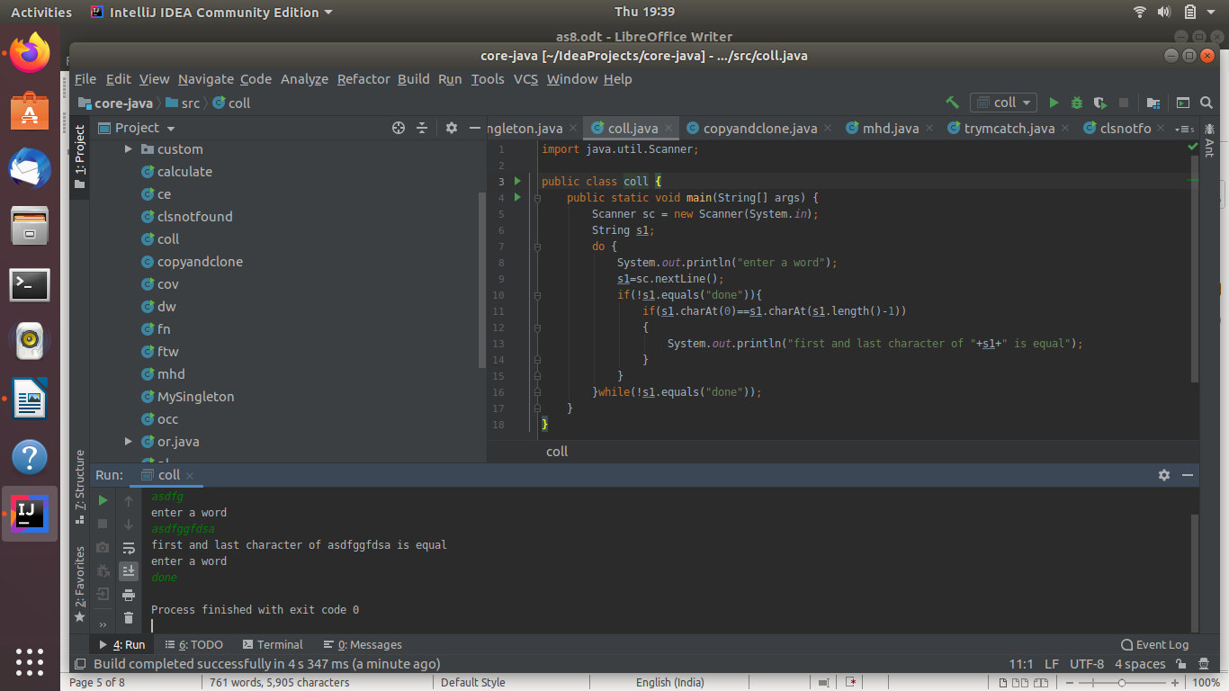
9.Design classes having attributes for furniture where there are wooden chairs and tables, metal chairs and tables. There are stress and fire tests for each products.
10. Design classes having attributes and method(only skeleton) for a coffee shop. There are three different actors in our scenario and i have listed the different actions they do also below
* Customer
-Pays the cash to the cashier and places his order, get a token number back
- Waits for the intimation that order for his token is ready
- Upon intimation/notification he collects the coffee and enjoys his drink
( Assumption: Customer waits till the coffee is done, he wont timeout and cancel the order. Customer always likes the drink served. Exceptions like he not liking his coffee, he getting wrong coffee are not considered to keep the design simple.)
* Cashier
- Takes an order and payment from the customer
- Upon payment, creates an order and places it into the order queue
- Intimates the customer that he has to wait for his token and gives him his token
( Assumption: Token returned to the customer is the order id. Order queue is unlimited. With a simple modification, we can design for a limited queue size)
* Barista
- Gets the next order from the queue
- Prepares the coffee
- Places the coffee in the completed order queue
- Places a notification that order for token is ready
11. Convert the following code so that it uses nested while statements instead of for statements:
int s = 0;
int t = 1;
for (int i = 0; i < 10; i++)
{
s = s + i;
for (int j = i; j > 0; j−−)
{
t = t * (j - i);
}
s = s * t;
System.out.println("T is " + t);
}
System.out.println("S is " + s);
ANS--
public static void main(String[] args) {
int s = 0;
int t=1;
int i=0;int j;
while(i<10)
{
s = s + i;
j=i;
while(j>0) {
t = t * (j - i);
j--;
}
s = s * t;
System.out.println("T is " + t);
i++;
}
System.out.println("S is " + s);
}
}
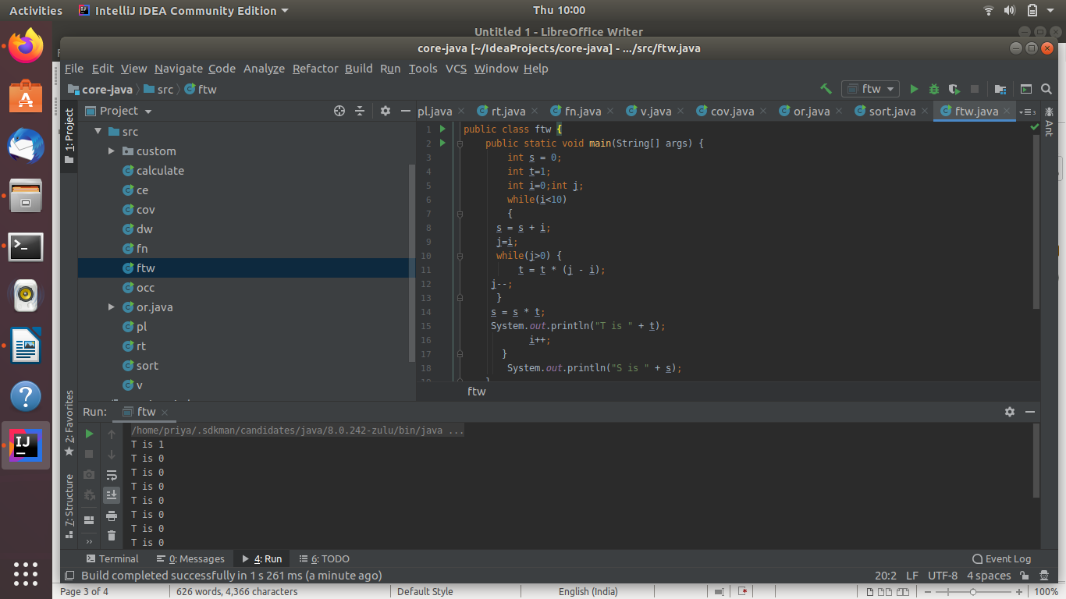
12.What will be the output on new Child(); ?
class Parent extends Grandparent {
{
System.out.println("instance - parent");
}
public Parent() {
System.out.println("
}
static {
System.out.println("static - parent");
}
}
class Grandparent {
static {
System.out.println("static - grandparent");
}
{
System.out.println("instance - grandparent");
}
public Grandparent() {
System.out.println("
}
}
class Child extends Parent {
public Child() {
System.out.println("
}
static {
System.out.println("static - child");
}
{
System.out.println("instance - child");
}
}
ANS--public class newchild {
public static void main(String[] args) {
Child ch=new Child();
}
}
class Parent extends Grandparent {
{
System.out.println("instance - parent");
}
public Parent() {
System.out.println("constructor - parent");
}
static {
System.out.println("static - parent");
}
}
class Grandparent {
static {
System.out.println("static - grandparent");
}
{
System.out.println("instance - grandparent");
}
public Grandparent() {
System.out.println("constructor - grandparent");
}
}
class Child extends Parent {
public Child() {
System.out.println("constructor - child");
}
static {
System.out.println("static - child");
}
{
System.out.println("instance - child");
}
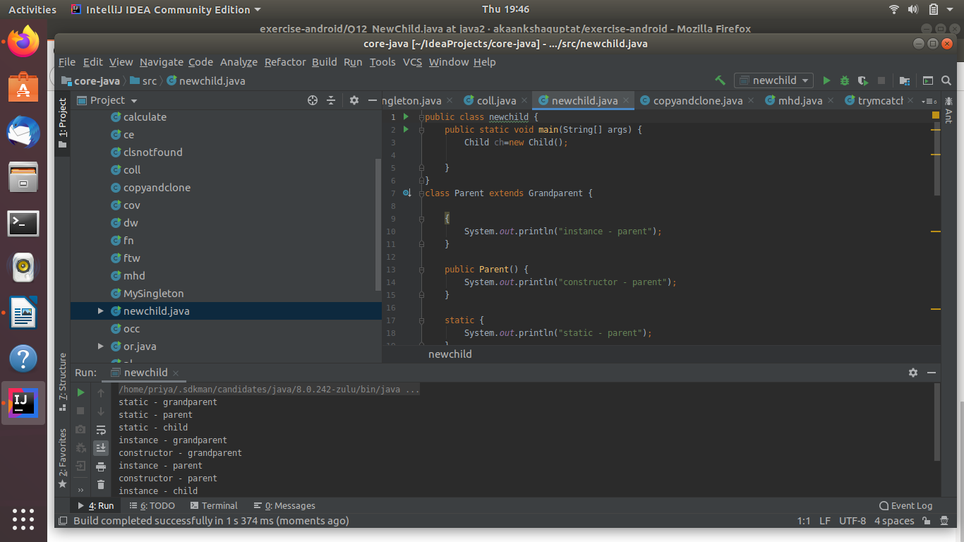
Q13. Create a custom exception that do not have any stack trace.
AnS--
class MyException extends Exception {
public MyException(String s) {
super(s);
}
}
public class b {
public static void main(String args[]) {
try {
throw new MyException("myException1");
} catch (MyException ex) {
System.out.println("Caught");
System.out.println(ex.getMessage());
}
}
}
