- Write a program to replace a substring inside a string with another string.
Ans--
fun main(args: Array<String>) {
var str = "hello"
val oldValue = "e"
val newValue = "hello"
val output = str.replace(oldValue, newValue)
print(output)
}
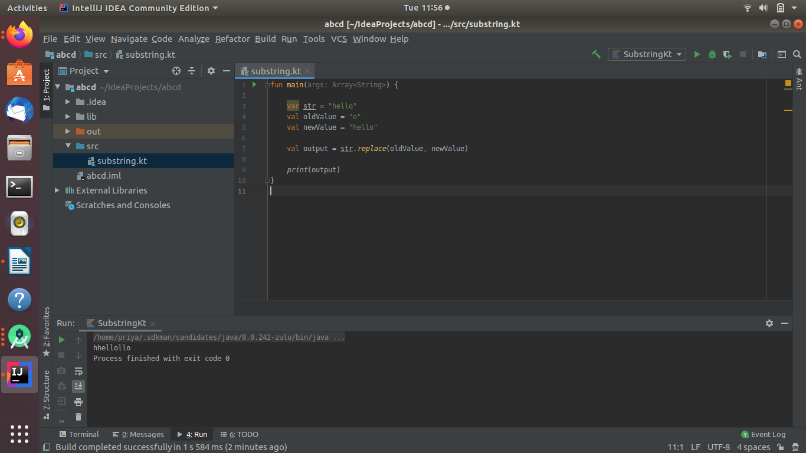
2. Write a program to find the number of occurrences of the duplicate words in a string and print them.
ANS--fun main(args: Array<String>) {
val list = listOf("orange", "apple", "apple", "banana", "water", "bread", "banana")
println(list.groupingBy { it }.eachCount().filter { it.value > 1 })
}
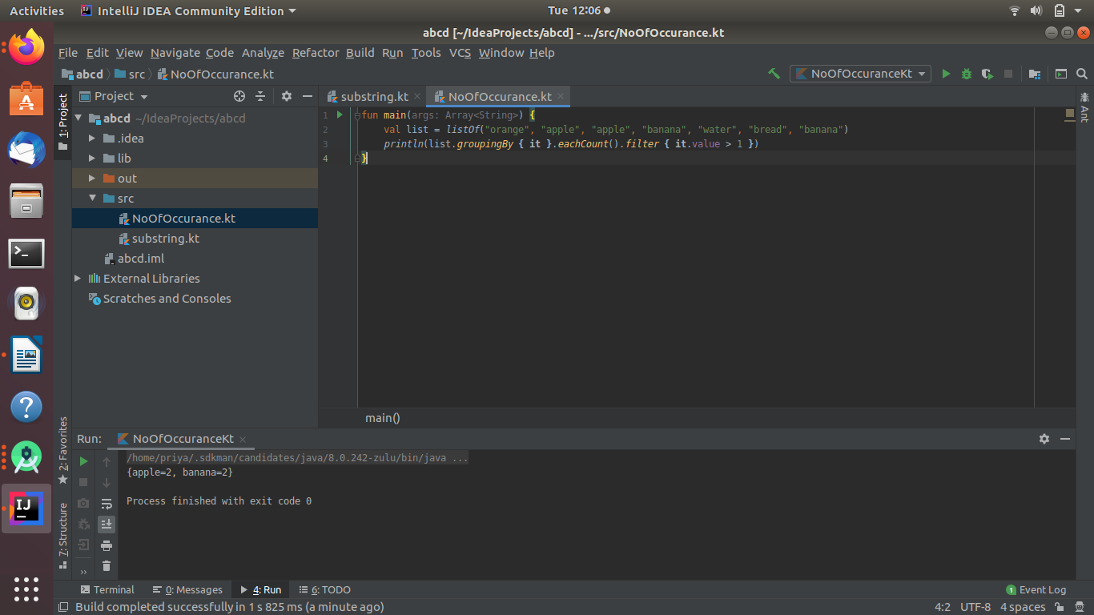
3. Write a program to find the number of occurrences of a character in a string without using loop.
ANS--fun main(args: Array<String>) {
val str = "tothenew"
val ch = 't'
var frequency = 0
for (i in 0..str.length - 1) {
if (ch == str[i]) {
++frequency
}
}
println("Frequency of $ch = $frequency")
}
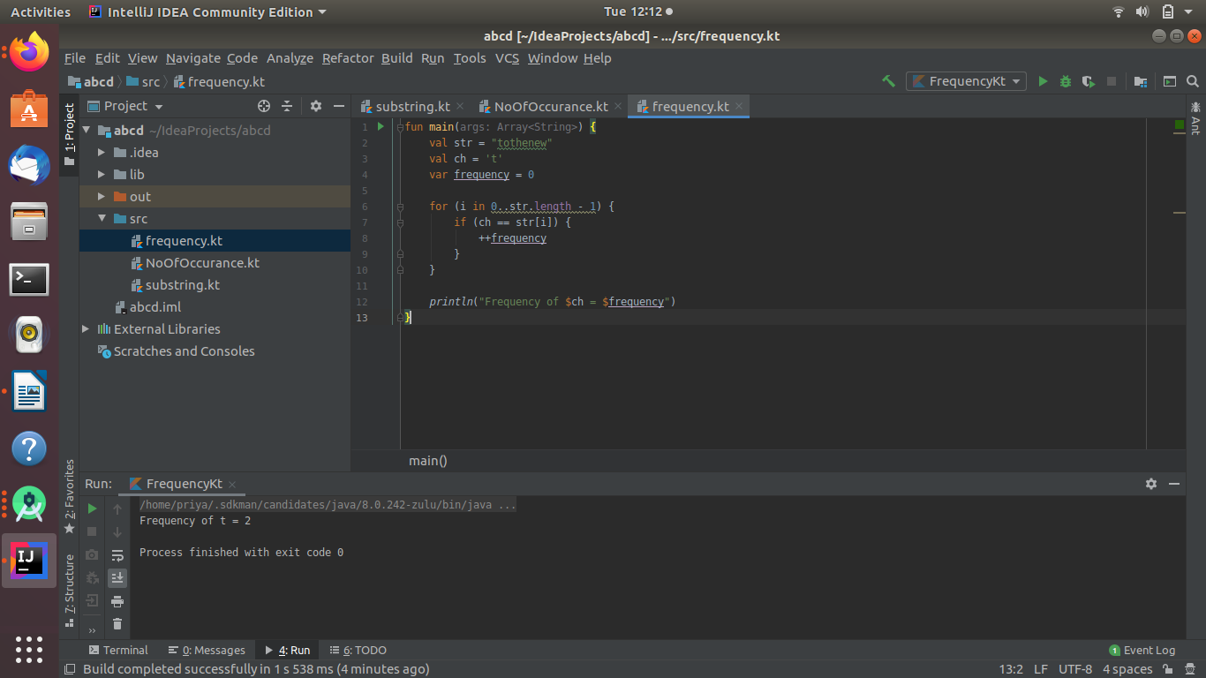

4. Calculate the number & Percentage Of Lowercase Letters,Uppercase Letters, Digits And Other Special Characters In A String.
ANS--
fun main(args: Array<String>) {
print("enter string")
var str = readLine()!!
var lo = 0
var up = 0
var di = 0
var sp = 0
for (i in 0 until str.length) {
if (str[i].isLowerCase())
lo++
else if (str[i].isUpperCase())
up++
else if (str[i].isDigit())
di++
else
sp++
}
var len = str.length.toFloat();
var lo1 = (lo / len) * 100;
var up1 = (up / len) * 100;
var di1 = (di / len) * 100;
var sp1 = (sp / len) * 100;
println("lower case percentage " + lo1);
println("upper case percentage " + up1);
println("digit percentage " + di1);
println("special char percentage " + sp1);
}
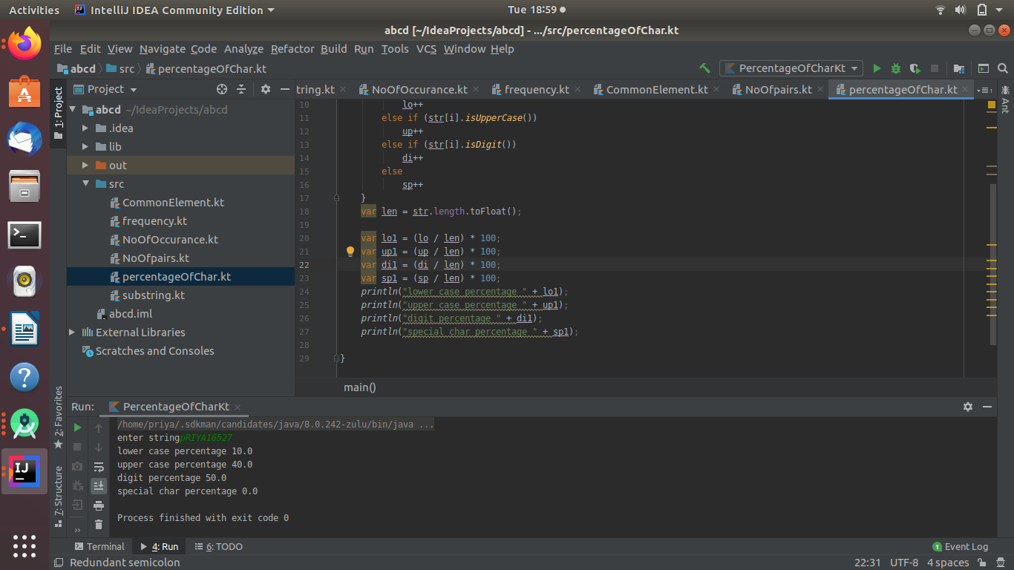
5. Find common elements between two arrays.
ANS--fun main(a: Array<String>) {
val arr1 = intArrayOf(4, 7, 3, 9, 2)
val arr2 = intArrayOf(3, 2, 12, 9, 40, 32, 4)
println("common element in both")
for (i in arr1.indices) {
for (j in arr2.indices) {
if (arr1[i] == arr2[j]) {
println(arr1[i])
}
}
}
}
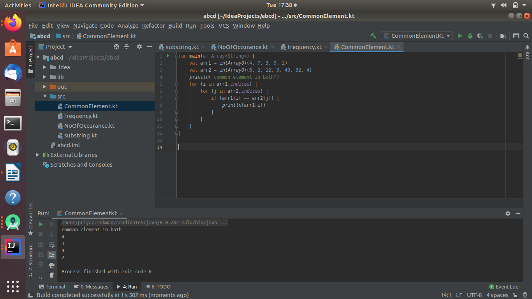
6. Check letter in string which do not have pair.
ANS--fun main(args: Array<String>) {
println("enter string")
var str = readLine()!!.toString()
val charArray = str.toCharArray()
for (i in 0..str.length-1){
for (j in i + 1 ..str.length-1){
if (charArray[i] == charArray[j]) {
charArray[i] = '#'
charArray[j] = '#'
}
}
}
for (i in 0..charArray.size-1){
if (charArray[i] != '#') {
println(charArray[i])
}
}
}
