1.How are inline and block elements different from each other?
ANS--<!DOCTYPE html>
<html>
<body >
<p>"to the new"</p>
<p>"to the new2"</p>
<p>
<span>"to the new"</span>
<span>"to the new"</span>
</p>
</body>
</html>
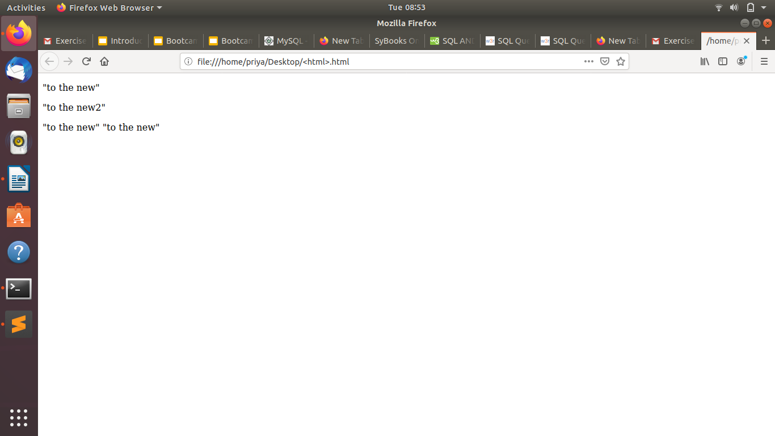
2.Explain the difference between visibility:hidden and display:none
ans--
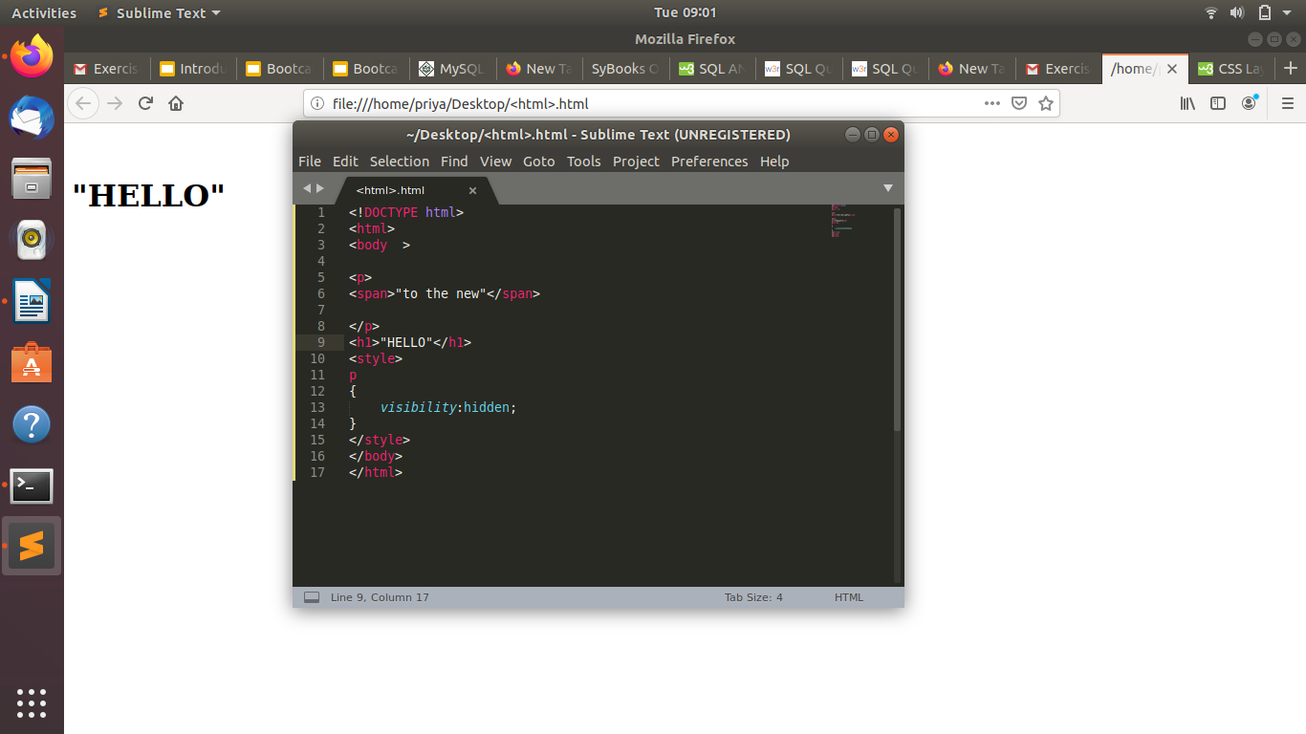
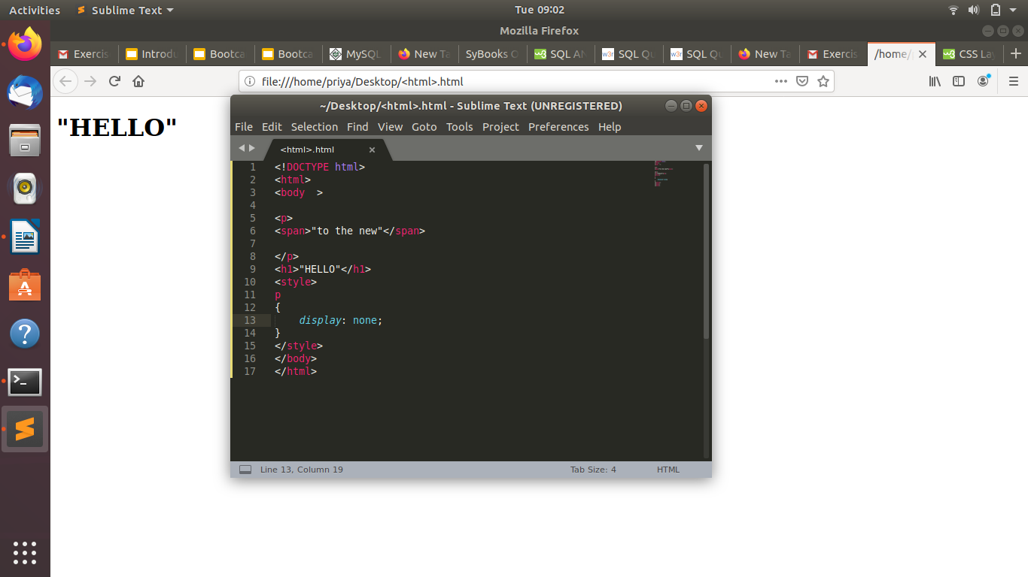
3. Explain the clear and float properties.
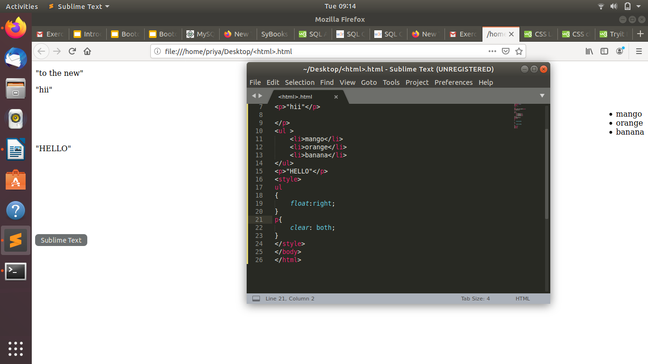
4. explain difference between absolute, relative,fixed and static.
ANS--Static - this is the default value, all elements are in order as they appear in the document.
- Relative - the element is positioned relative to its normal position.
- Absolute - the element is positioned absolutely to its first positioned parent.
- Fixed - the element is positioned related to the browser window.
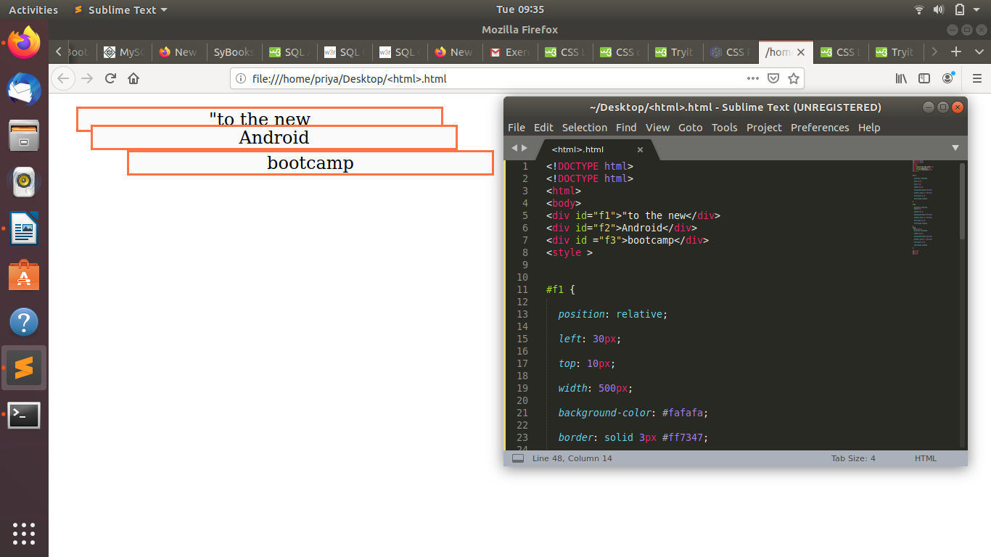
5. Write the HTML code to create a table in which there are 4 columns( ID , Employee Name, Designation, Department) and at least 6 rows. Also do some styling to it.
ANS--
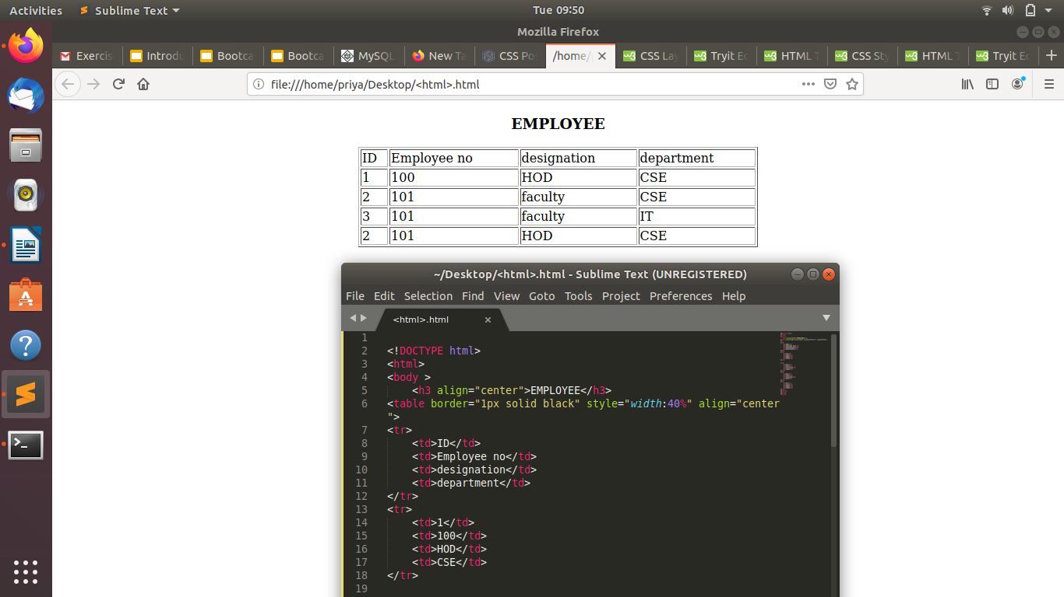
6. Why do we use meta tags?
ANS--The <meta> tag provides metadata about the HTML document. Metadata will not be displayed on the page, but will be machine parsable.Meta elements are ypically used to specify page description, keywords, author of the document, last modified, and other metadata.
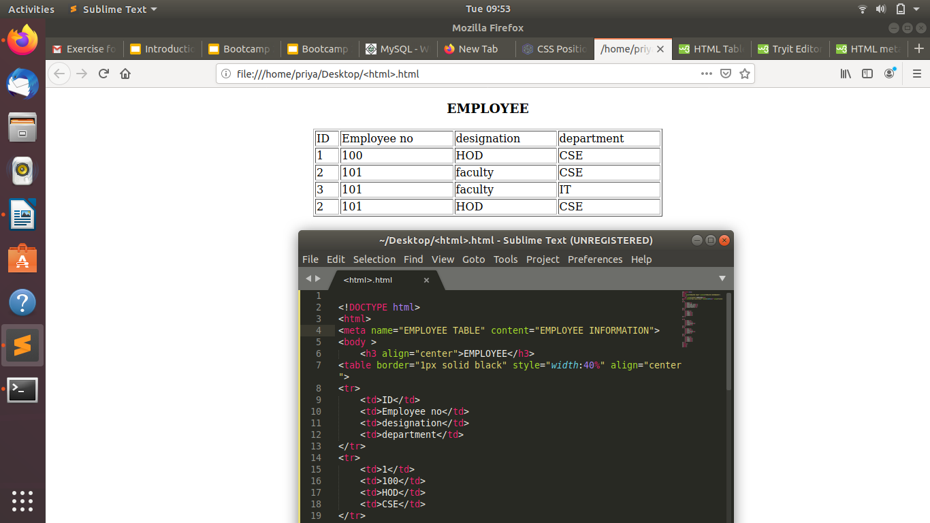
7. Explain box model.
ANS--
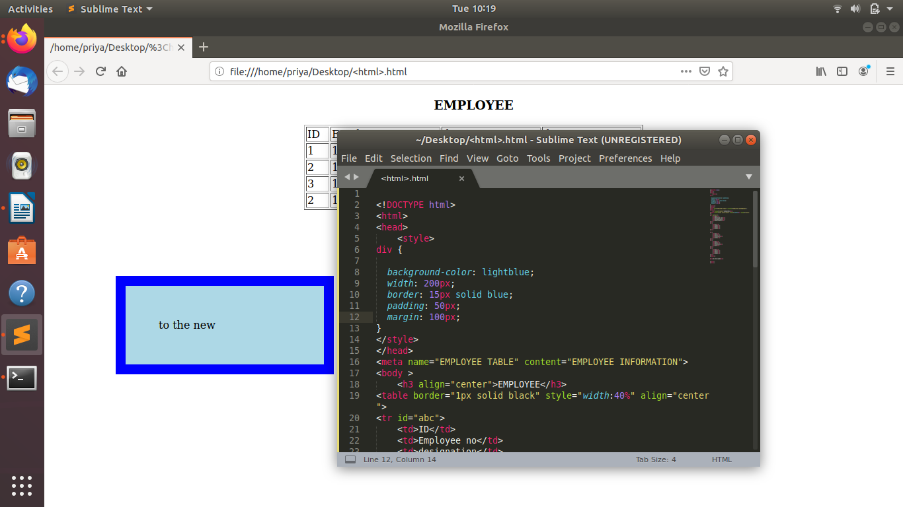
8. What are the different types of CSS Selectors?
ANS—id selector
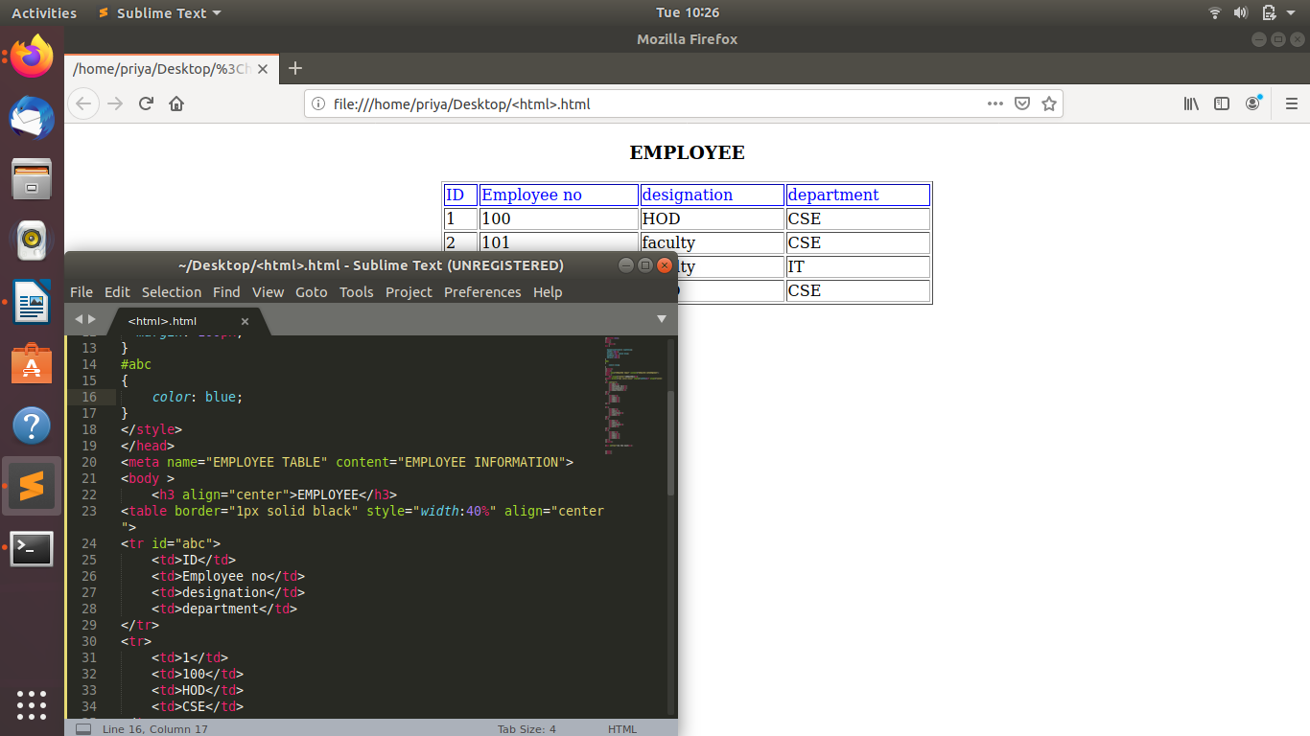
class
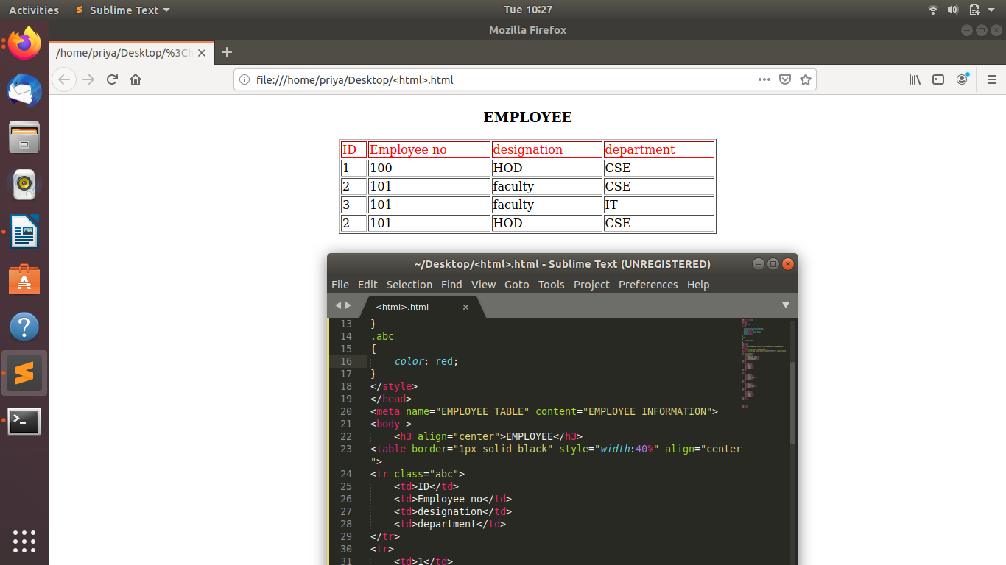
group selector
class selector
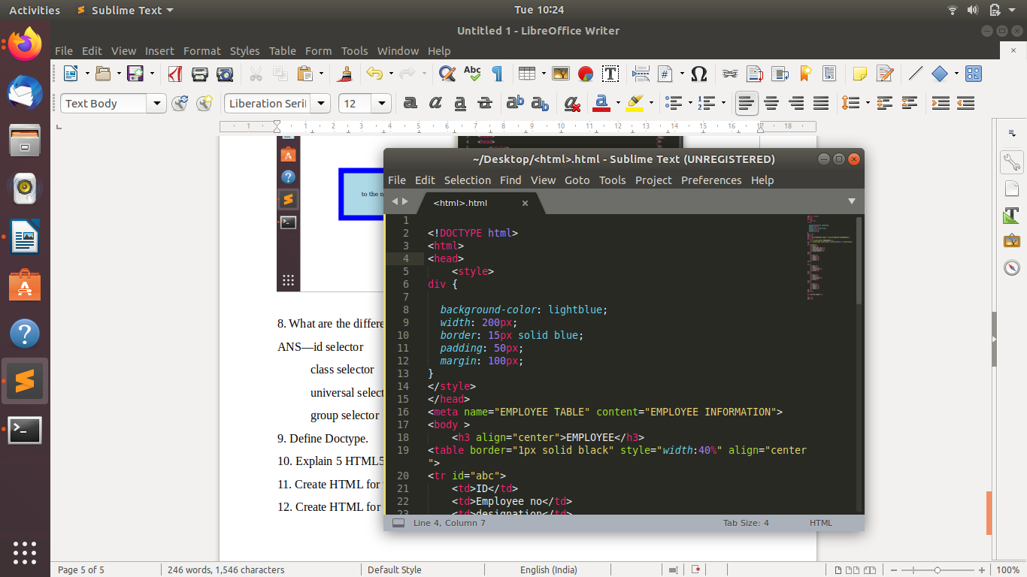
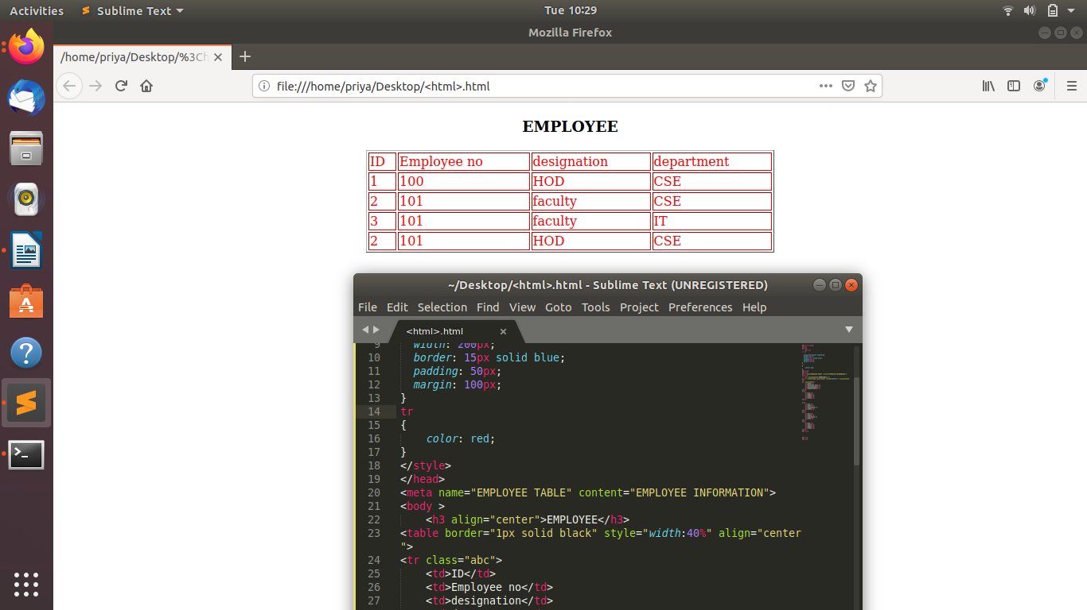
9. Define Doctype.
ANS--
10. Explain 5 HTML5 semantic tags.
11. Create HTML for web-page.jpg (check resources, highest weightage for answers)
12. Create HTML for form.png (check resources, highest weightage for answers)

