- Prompt for amount, interest rate and no. of years and calculate simple interest.
ANS--function SI(p,r,t) {
var s;
s=(p*r*t)/100;
return s;
}
var x=SI(100,8,10);
console.log(x);
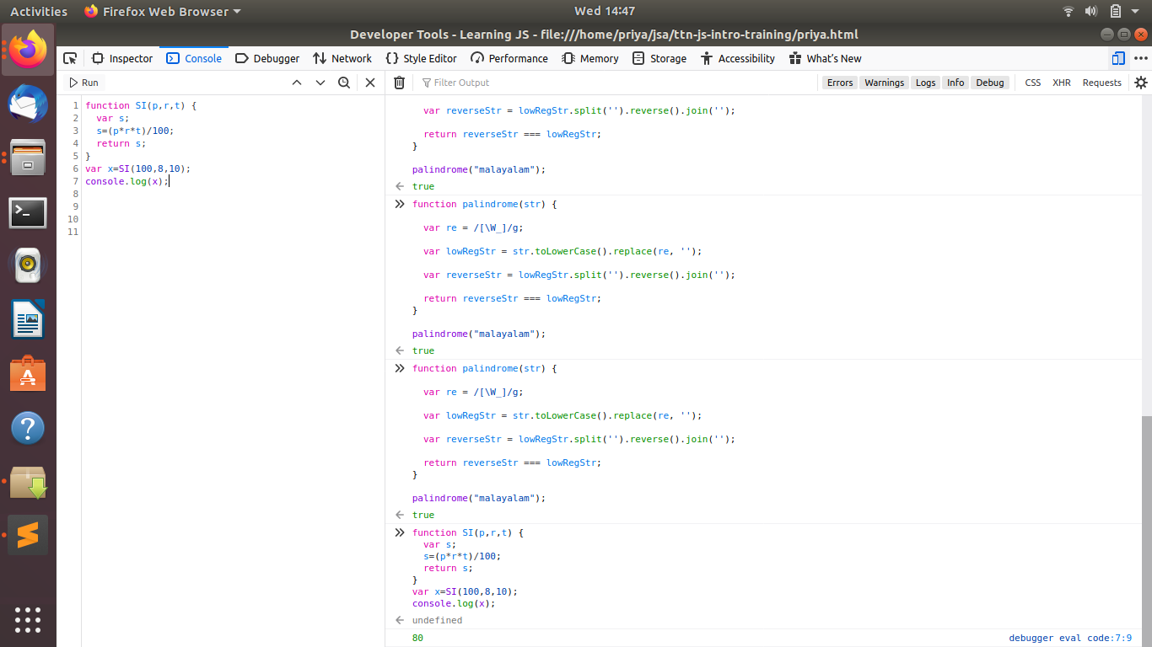
is palindrome string
ANS---function pl(n)
{
var x;var y=0;
while(n>0)
{
x=n%10;
y=y*10+x;
n=parseInt(n/10);

}
return y;
}
var a;
a=pl(353);
if(a==353)
{
console.log("true");
}
else
{
console.log("false");
}
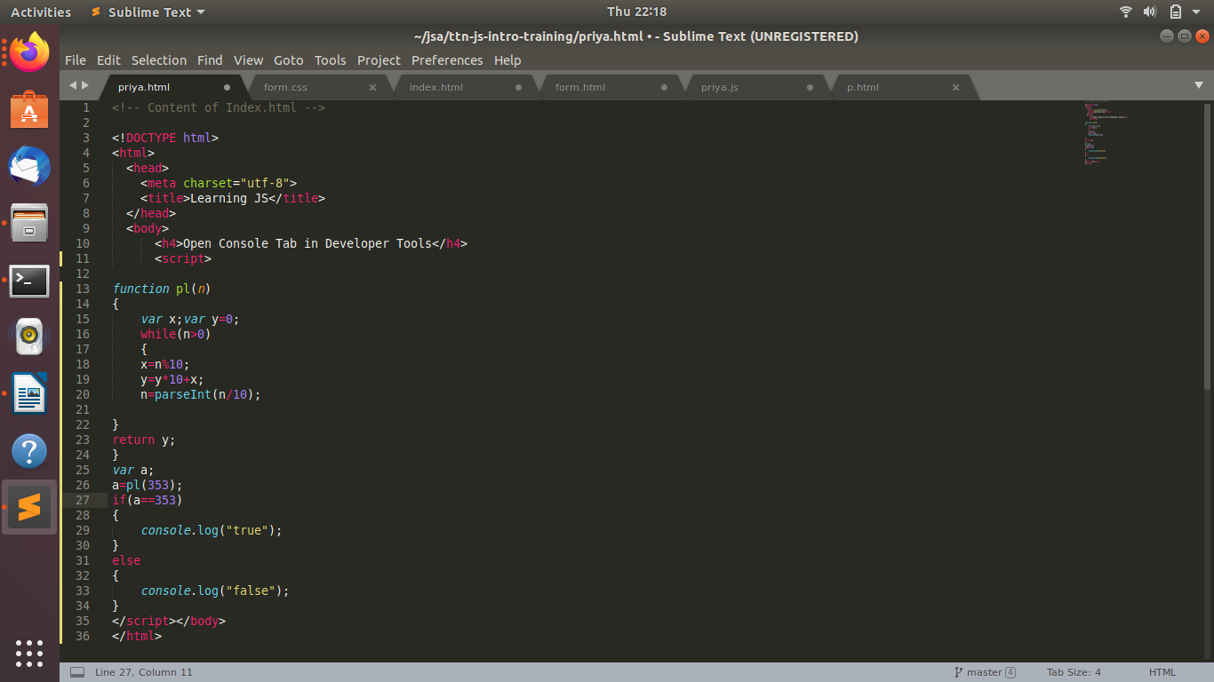
- Area of circle
ANS—function area(n)
{
var a;
a=3.14*Math.pow(n,2);
return a;
}
var q=area(3);
console.log(q);
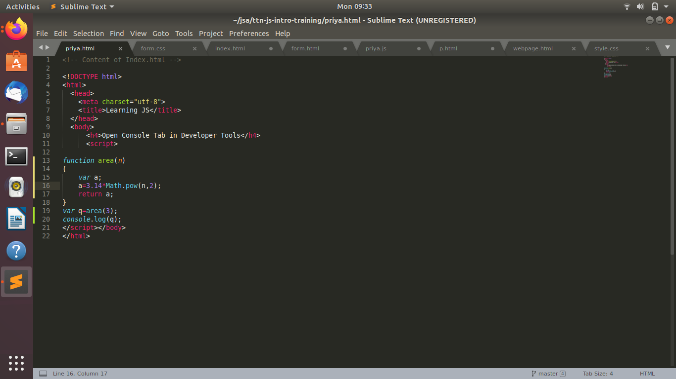
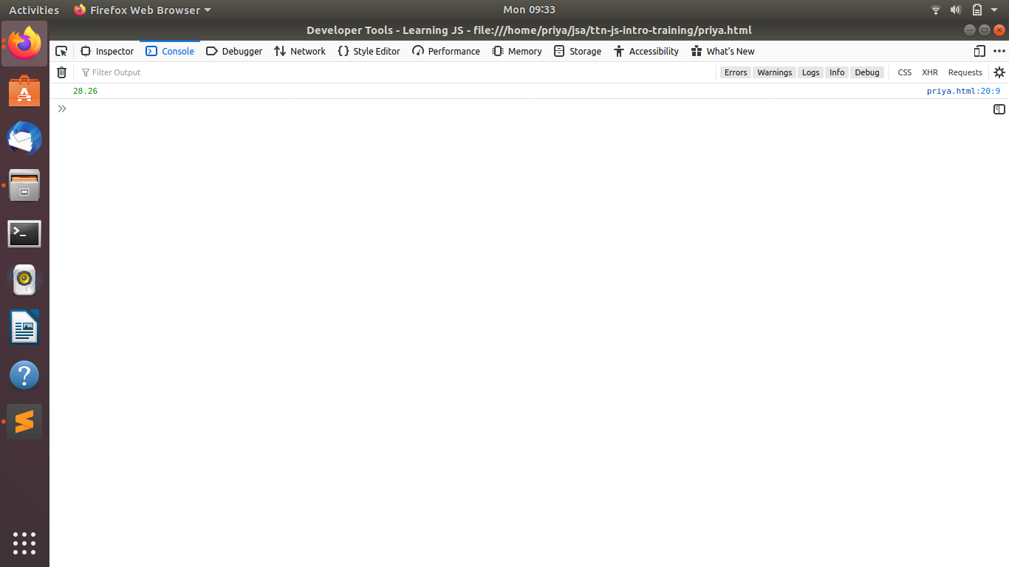
- Copy information of one object to another and log it to console.
ANS--
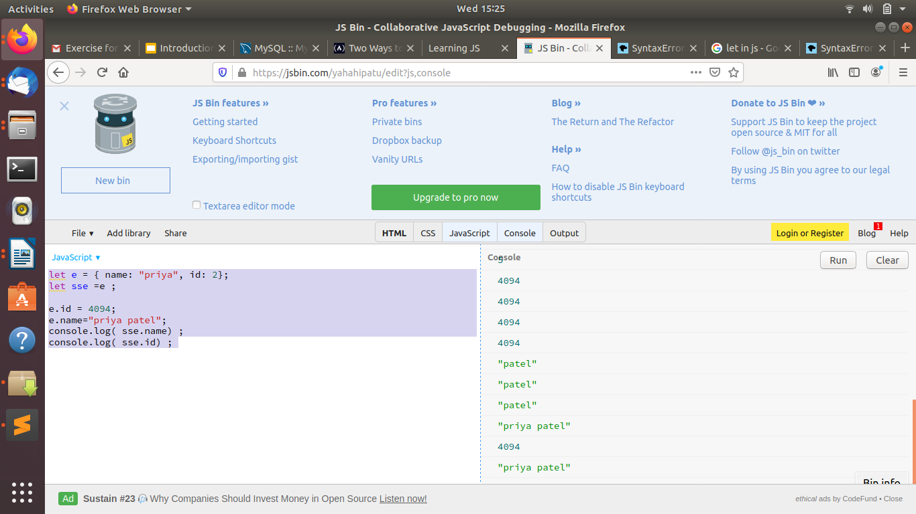
let e = { name: "priya", id: 2};
let sse =e ;
e.id = 4094;
e.name="priya patel";
console.log( sse.name) ;
console.log( sse.id) ;

- create a list of objects of Employee with info as follow :
  - Name, age, salary ,DOB
  - filter all employees with salary greater than 5000
  - group employee on the basis of their age
  - fetch employees with salary less than 1000 and age greater than 20. Then give them an increment 5 times their salary.
ANS—<!DOCTYPE html>
<html>
<head>
<meta charset="utf-8">
<title>Learning JS</title>
</head>
<body>
<h4>Open Console Tab in Developer Tools</h4>
<script>

var Employee = [
{
name: "pri",
Age: 15,
salary: 10000,
DOB:20-12-1990
},
{
name: "patel",
Age: 20,
salary: 2000,
DOB:12-12-1990
},
{
name: "priya",
Age: 25,
salary: 3000,
DOB:12-12-1997,
}
];
console.log(Employee);
var i;
var j=0;
var aa=[];
for(i=0;i<Employee.length;i++)
{
if(Employee[i].salary>5000)
{
aa[j]=Employee[i];
j++;
}
}
console.log(aa);
</script>
</body></html>

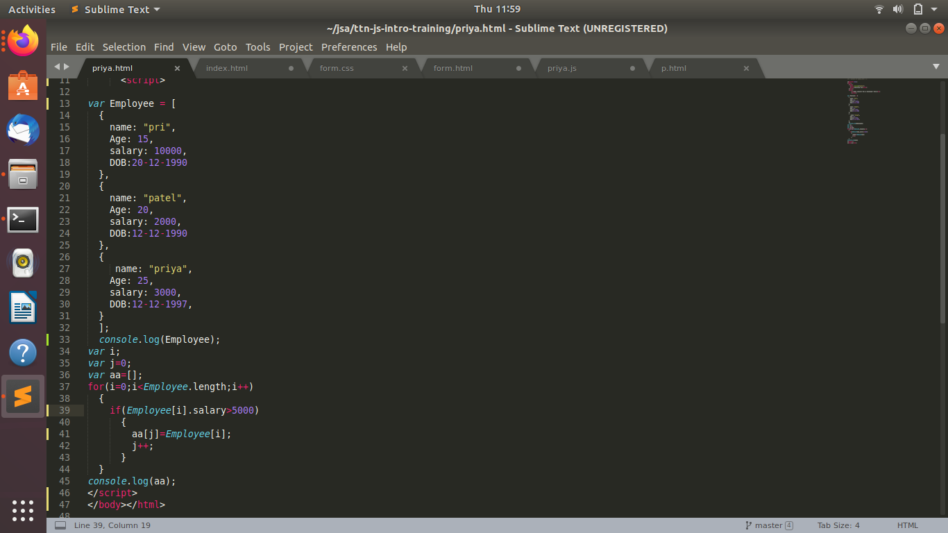
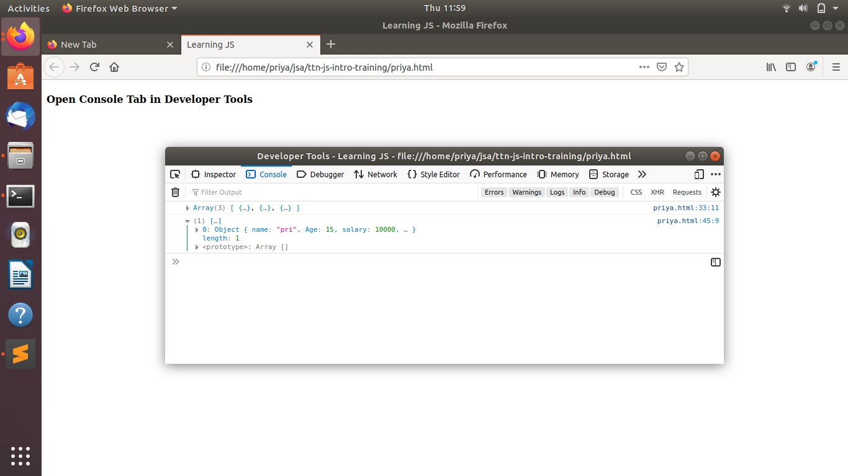
*var b=[];var a=[];
var k=0,m=0;
for(i=0;i<Employee.length;i++)
{
if(Employee[i].Age>=20)
{
b[k]=Employee[i].name;
}
else
{
a[m]=Employee[i].name;
}
m++;k++;
}
console.log(b);
console.log(a);
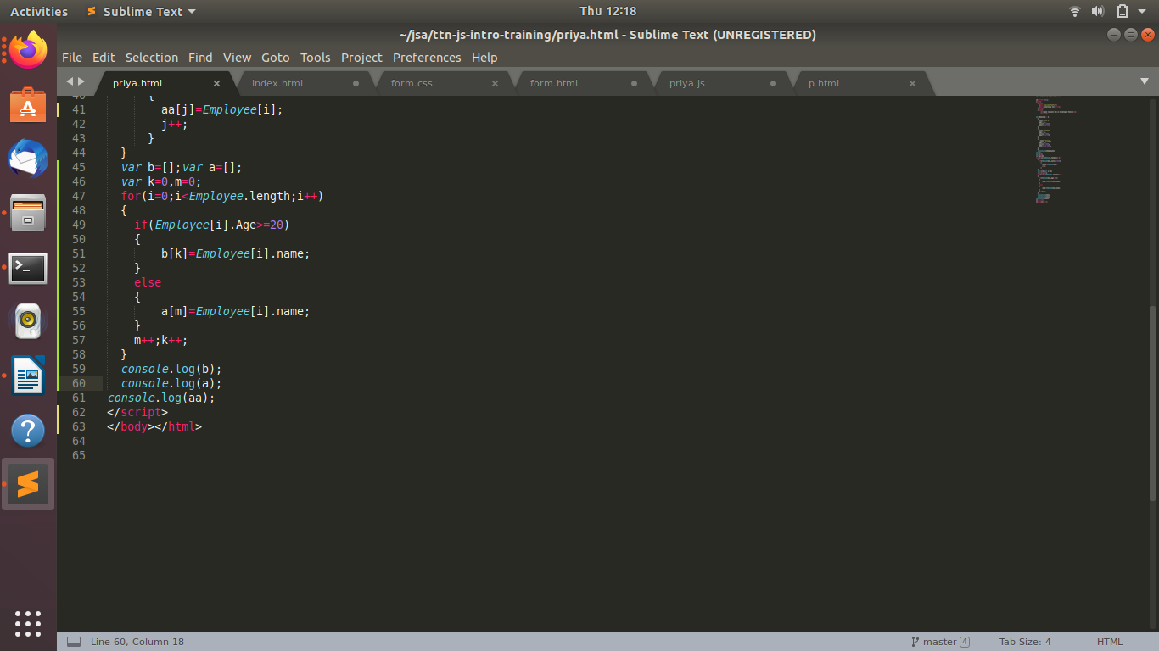
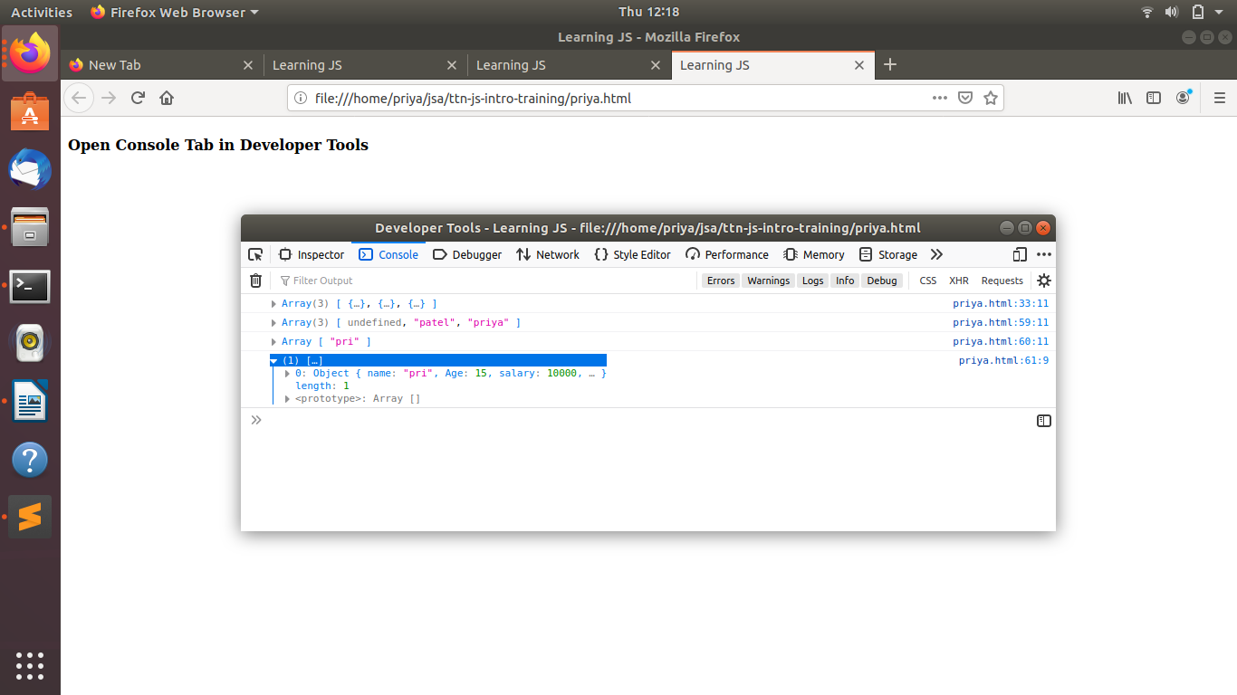
*var i;
var j=0;
var aa=[];
for(i=0;i<Employee.length;i++)
{
if(Employee[i].salary<1000&&Employee[i].Age>20)
{
aa[j]=Employee[i];
j++;
Employee[i].salary=5*Employee[i].salary;
}
}
