Problem Statement: There can be multiple customers, who can place multiple orders on the site. Now a sales person can handle these orders will distribute into multiple sales persons (One order will be assign to one salesperson only). So a sales person can have multiple orders of multiple customers
- Create Database
ANS—create assignment;
use assignment;
- Design Schema
ANS--

- Create tables
ANS—create table customer(c_id,c_name,order_id);
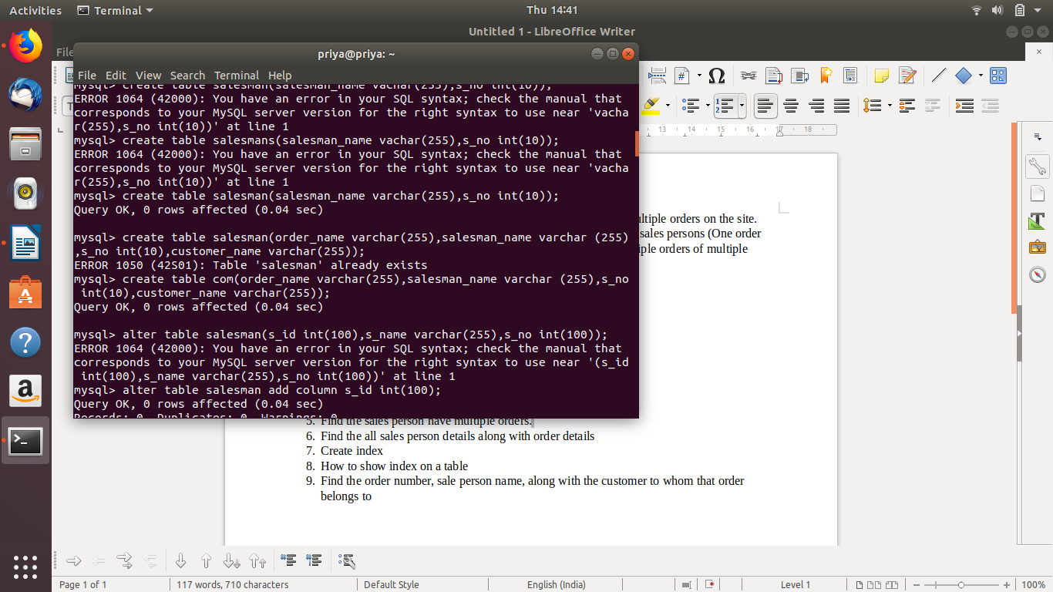
- Insert sample data
ANS—insert into oredrs(o_id,order_name)values(1,”desktop”);
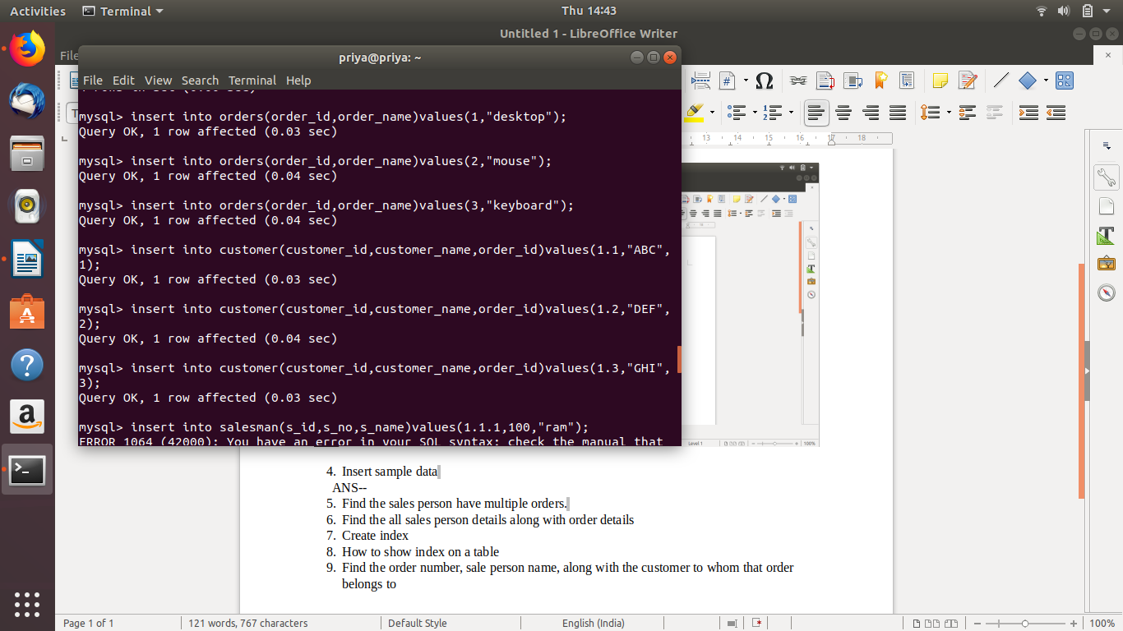
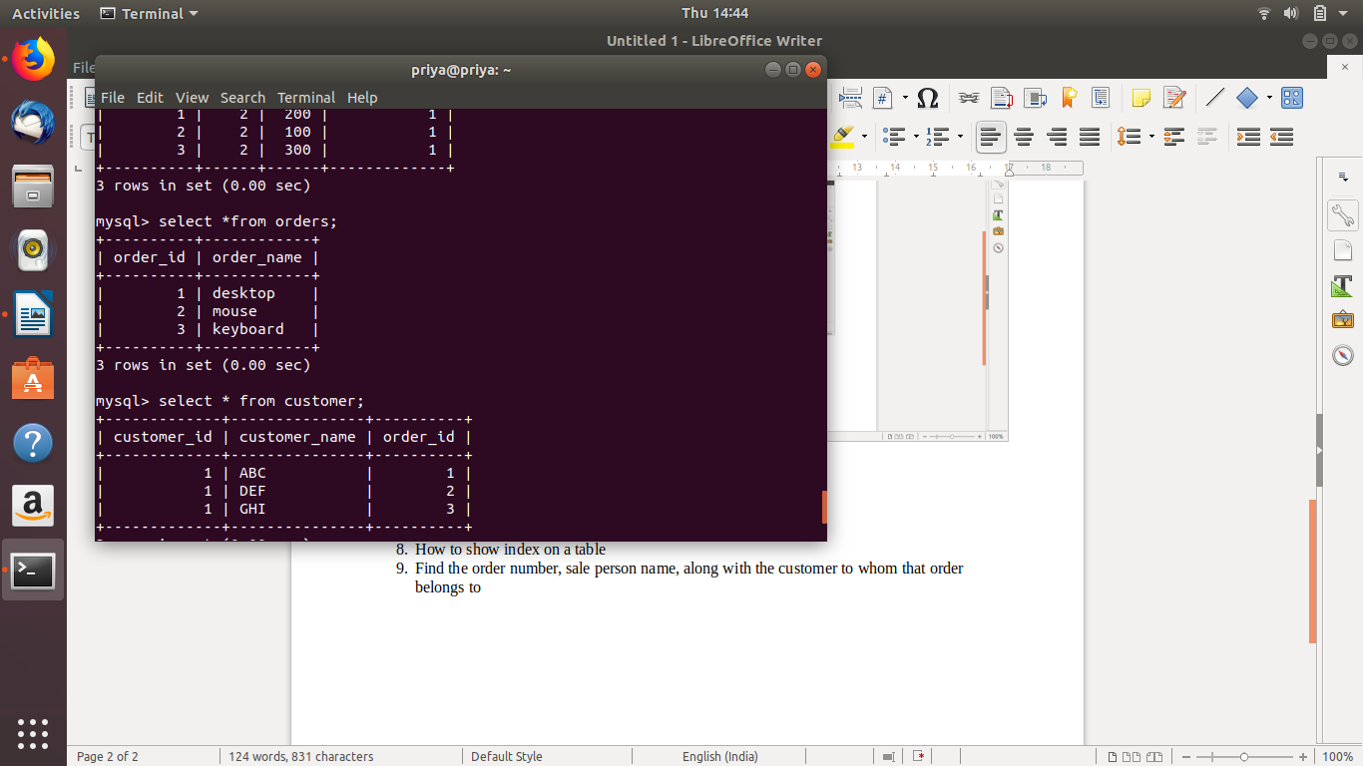
- Find the sales person have multiple orders.
ANS--select *from salesman where s_id IN (select distinct s_id from com a where exists (select *from com cm where cm.s_id=a.s_id));
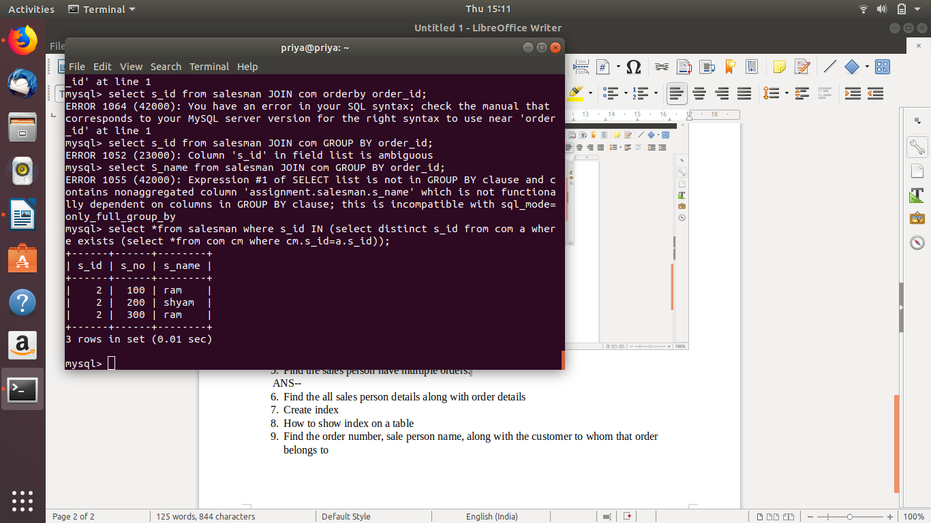
- Find the all sales person details along with order details
ANS-- select distinct salesman.s_name,orders.order_name from salesman inner join com cm on salesman.s_id=cm.s_id inner join orders on orders.order_id=cm.order_id;
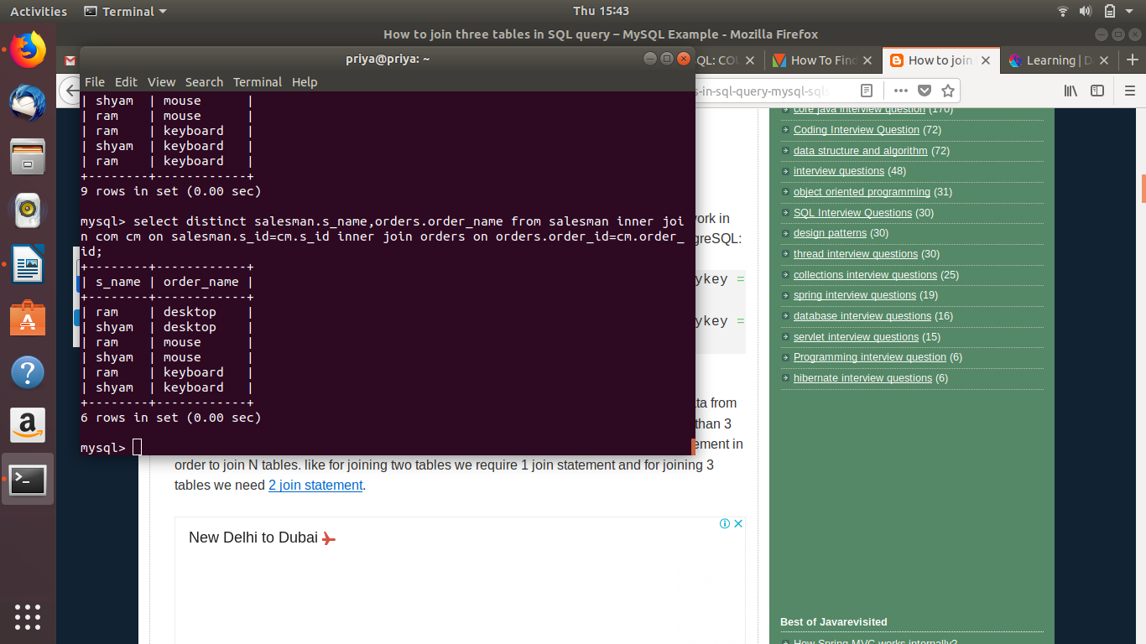
- Create index
ANS--ALTER TABLE customer ADD INDEX customer_in (customer_name);
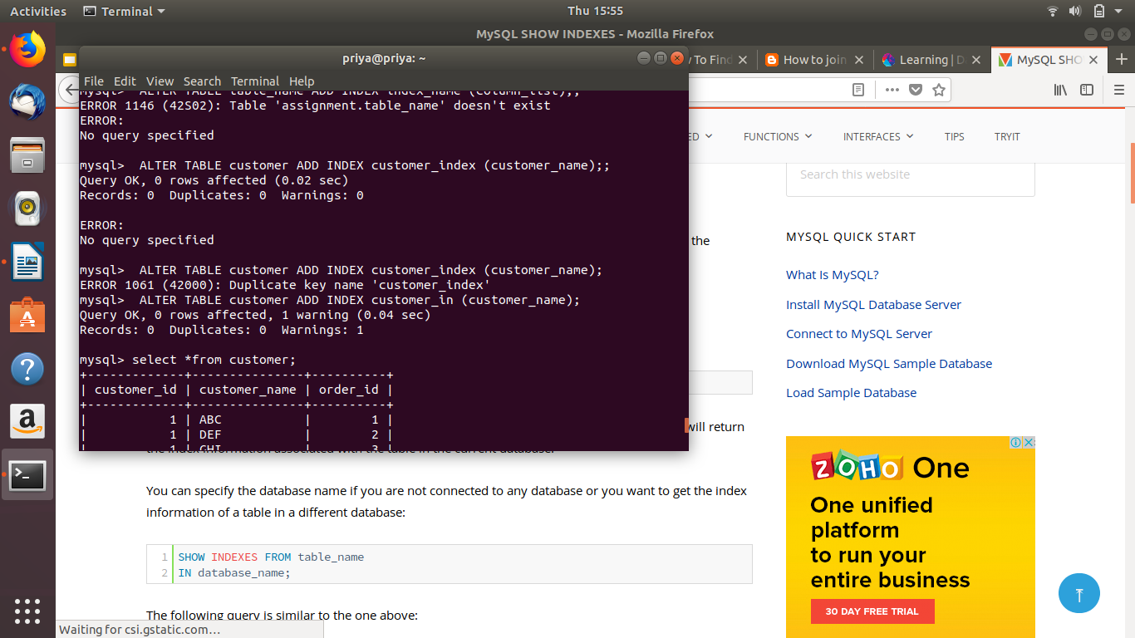

- How to show index on a table
ANS--show indexes from customer;
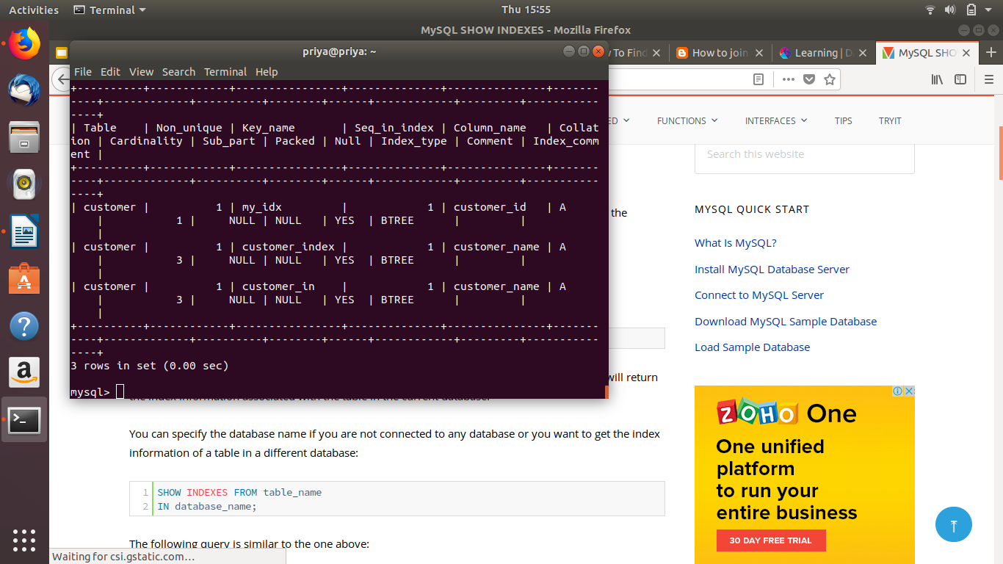
- Find the order number, sale person name, along with the customer to whom that order belongs to
ANS--select distinct salesman.s_name,orders.order_name,customer.customer_name from salesman inner join com cm on salesman.s_id=cm.s_id inner join orders on orders.order_id=cm.order_id inner join customer on cm.customer_id=customer.customer_id;
