**TEAM NAME:**

**Phenomenal4**

**Batch-4**

**TEAM MEMBERS**

***DEPARTMENT: COMPUTER SCIENCE AND ENGINEERING***

**NAME:** G. Naga Sai SriPriya

**ROLLNO:** 19131A0574

**EMAIL:**19131a0574@gvpce.ac.in

**MOBILE**: 9390959734



**NAME:** Suphiya

**ROLLNO:** 19131A05N0

**EMAIL:**19131a05n0@gvpce.ac.in

**MOBILE**: 9394249471

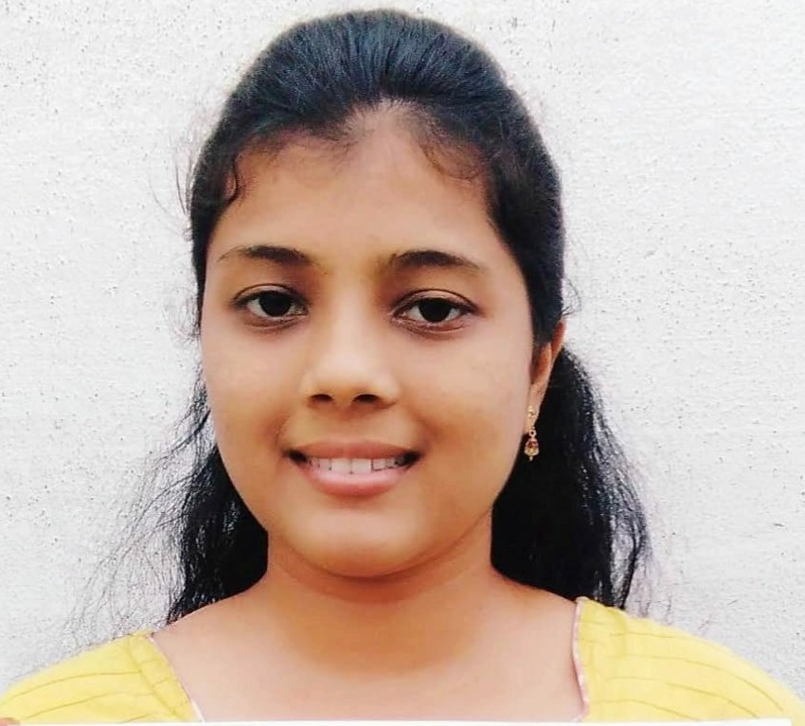

**NAME:** T. Gopala

Krishnam Raju

**ROLLNO:** 19131A05N4

**EMAIL:**19131a05n4@gvpce.ac.in

**MOBILE**: 9573955681

22



**NAME:** V.Gowtham Kumar

**ROLLNO:** 19131A05R0

**EMAIL:**19131a05r0@gvpce.ac.in

**MOBILE**: 9010021630



**PROJECT GUIDE**

**NAME:** Dr.R.Velumani

**EMAIL:** [velumani@gvpce.ac.in](mailto:velumani@gvpce.ac.in)

**MOBILE**:

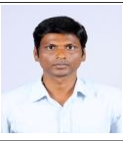

***Abstract***

The objective of Notes and password management system is to manage passwords for different accounts on internet. The user shall be able to save all the username and passwords information of the accounts user holds on the internet using this application and it also provides better facility to bring out the easy circulation of important notes. At any time user can view and edit the information they have saved. Unfortunately, complex passwords of different accounts are difficult to remember. Fortunately, this application helps the users.

***Domains where our solution can be implemented***

Business Enterprises

Educational organisations

***Our solution helping the selected domains***

It helps us to solve problems regarding security like unauthorized access, summarizing the notes for quick reference.

***Our engineering sol*ution**

When you use this application, the different passwords are stored in the notes and we use a single master password to access them. In case of unauthorized access, the user gets an alert notification as we are using three factor authentication process.

.

***Team’s vision***

Our main vision is to create an application which helps users to make notes at any time and to generate very strong passwords for security of user’s information and make them available whenever they need.