Connecting to Hive Database in JSP

**Content**

1. Tomcat Installation
2. Eclipse Installation
3. Adding Jars
4. Configuring Tomcat
5. Running a sample code
6. Reference links
7. Tomcat Installation

* Download and install Tomcat Server in your virtual machine using the following link:

<https://tomcat.apache.org/download-70.cgi>

* And install the tomcat server in your virtual machine

1. Eclipse installation:

* Download **eclipse IDE** **for J2EE** in order to create a java web projects.

This can be downloaded in <https://eclipse.org/> site

Please make sure that you have selected the correct operating system

* Open the eclipse IDE and install the software updates which are required for our project

In eclipse IDE:

Go to Help > Install new software Window

1. Enter the official website in **“Work With “** column ( Here I have downloaded Mars version)
2. Select the following checkboxes to create a web project

* Database development,
* Web, XML, Java EE and OSGi Enterprise Development

1. After installing these software, restart your eclipse IDE

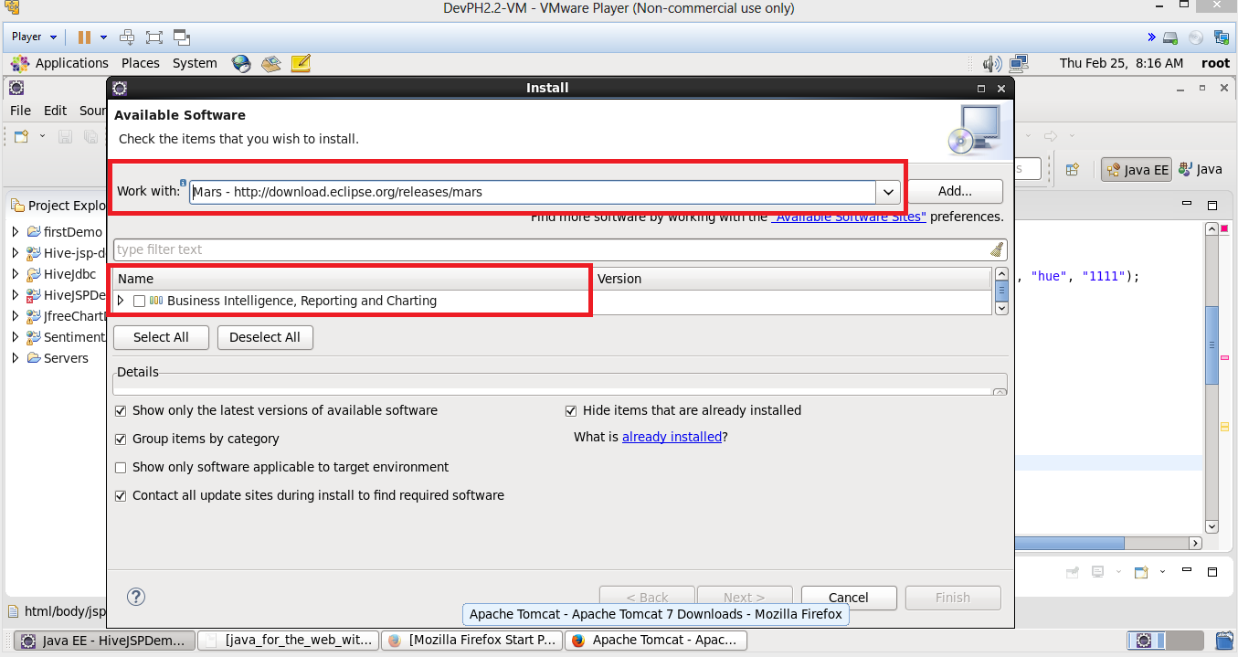

1. Adding Jars:

* Create a new java project to communicate with the hive database by

File -> New ->Dynamic Web Project

* Add the following jars in your Project

|  |  |  |
| --- | --- | --- |
| hive-jdbc.jar | Httpcore.jar | xmlbeans.jar |
| hive-service.jar | jpox-core.jar | hive-exec.jar |
| commons-httpclient.jar | jpox-rdms.jar | servlet.api.jar |
| hadoop-common.jar | jstl-1.2.jar | jdo.api.jar |
| hadoop-core.jar | libfb303-0.9.0.jar | hive-cli.jar |
| hive-common-0.xx.jar | libthrift-0.9.0.jar | antlr-runtime.jar |
| Httpclient.jar | standard-1.0.6.jar | mysql-connector-java.jar |
| slf4j-log4j12-1.6.1.jar | hive-metastore.jar | Derby.jar |
| slf4j.api.jar | commons-io-2.4.jar | commons-logging.jar |
| log4j-1.2.16.jar |  |  |

* These jars to be added in WEB-INF Classes directory. This can be run by right click the project > Built Path > Configure Built Path
* Select Deployment Assessment > select the WEB-INF/classes

Click on Add > Archives from File System > Next > Add button.

* Now select the above libraries from Hive and Hadoop installation directory.

*Note: Few Lib will not be present so download those from internet*

Now we have added all the libraries required, let’s configure the Tomcat Server with our project

1. Configuring Tomcat:

* To add and configure the Tomcat server, Go to Project > Right Click > Built Path > Configure Built Path
* Select Targeted Run time in the Left > Click on New Button
* Select Apache dropdown > Tomcat Version X > Next
* Enter the correct path **“Tomcat Installation Directory**”. If you have downloaded tomcat mention that using **Browse** button, else click on **Download and Install**..
* Click Finish button
* Now we have to change the port number for the Tomcat server as **8080 is used by ambari**. Follow the link to change the Port number

<http://www.codejava.net/servers/tomcat/how-to-change-port-numbers-for-tomcat-in-eclipse>

These are the Steps for configuring the jars and Tomcat server in our project

1. Running a sample code

* Create a new JSP file by selecting Project > New > JSP file
* The newly created JSP file will be under the Web Content Folder
* Open the JSP file and enter the code as given below
* This is the sample code in which I have connected the hive database using **beeline i.e., hive server2**.
* Here in the code, I have given owner permission to hue user ( you can use the user who has view permission) as we are going to perform select operation

 6. Reference:

1. <https://tomcat.apache.org/download-70.cgi>
2. <http://www.codejava.net/servers/tomcat/how-to-change-port-numbers-for-tomcat-in-eclipse>
3. <https://community.hortonworks.com/articles/594/connecting-eclipse-to-hive.html>
4. <https://eclipse.org/>
5. <https://cwiki.apache.org/confluence/display/Hive/HiveServer2+Clients>