AI FAQ Assistant AI - AI-powered FAQ and customer support automation.

TEAM : 5

TEAM LEADER: PRIYADHARSHINI A

TEAM MEMBERS:

PRIYADHARSHNI P

PRIYA LAKSHMI J

PRIYA S

Description
The AI FAQ Assistant is a secure, AI-enabled REST API that lets support teams create, organise, search and publish frequently asked questions from one central backend. It is built with Node.js and Express.js, keeps its data in MongoDB, and uses Mongoose for schema modelling and validation.
Access is controlled with JSON Web Tokens (JWT), so sessions stay stateless and private routes stay guarded, while user passwords are protected with bcrypt hashing. Google Gemini drafts FAQs and answers automatically, keyword search makes published content easy to find, and a centralized error handler returns clean, consistent JSON without exposing internal database details.

Scenario-Based Case Study

Background
Priya is a customer-support operations manager at a growing software company. Her team answers the same questions about accounts, billing and setup every day, yet the answers are scattered across documents and chat threads. Nobody can say which questions come up most often, and new agents spend weeks learning where to look.

Problem
- Writing and updating FAQ content by hand is slow, so documentation quickly falls out of date.
- Customers and agents cannot find answers quickly because there is no keyword or semantic-style search.
- Drafting a clear, consistent reply for every new question takes valuable agent time.
- Questions are not grouped into categories, which hides trends in what customers ask.
- There is no permission layer, so anyone with access could edit or delete another author’s content.

Solution
The AI FAQ Assistant gives Priya’s team one secure API in front of a single FAQ database. Registered users log in to receive a JWT, authors create or generate FAQs (Google Gemini drafts the question, answer and category), and everyone else can search and read published entries. Business logic lives in controllers and services, separate from any front end, so a web dashboard or mobile app can be added later without touching the backend.

Usage
- Authenticated authors: register, log in, ask the AI to draft an FAQ or an answer, save the result, and edit or delete only the FAQs they created.
- Public readers: list FAQs, open a single entry and search by keyword without needing an account.

Outcome
Priya’s team now produces FAQ content in minutes instead of hours. Mongoose validation keeps every record complete and correctly categorised, JWT protection ensures that only an FAQ’s author can change it, and keyword search lets customers find answers on their own, which reduces repetitive tickets and frees agents for harder problems.

1. Software Requirements
- Operating System: Windows 10/11, macOS or a current Linux distribution.
- Node.js (v18 or later): JavaScript runtime that executes the server and its routes.
- npm (v9 or later): package manager used to install and script the project dependencies.
- Express.js (v4 or v5): minimal web framework used to define the REST endpoints.
- MongoDB / Mongoose ODM: NoSQL database for users and FAQs (local install or MongoDB Atlas), with Mongoose providing schemas and validation.
- Google Gemini API key: credential from Google AI Studio, used by the @google/genai SDK for the AI features.
- Postman / ThunderClient: API clients for sending requests and checking responses.
- Code Editor: Visual Studio Code or any comparable IDE.

2. Hardware Requirements
- Processor: Intel Core i5 (8th generation or newer), AMD Ryzen 5 or equivalent.
- RAM: 8 GB minimum; 16 GB recommended when MongoDB, the API and an editor run together.
- Storage: at least 1 GB of free disk space for dependencies, database files and project code.
- Network: a stable internet connection for Gemini API calls (and MongoDB Atlas, if used).

Epic-1: Project Architecture
The API is organised as a layered Express application. Every request passes through the gateway and the middleware before a controller uses models or services to reach MongoDB or Google Gemini. Each layer has a single responsibility, which keeps the code easy to test and extend.
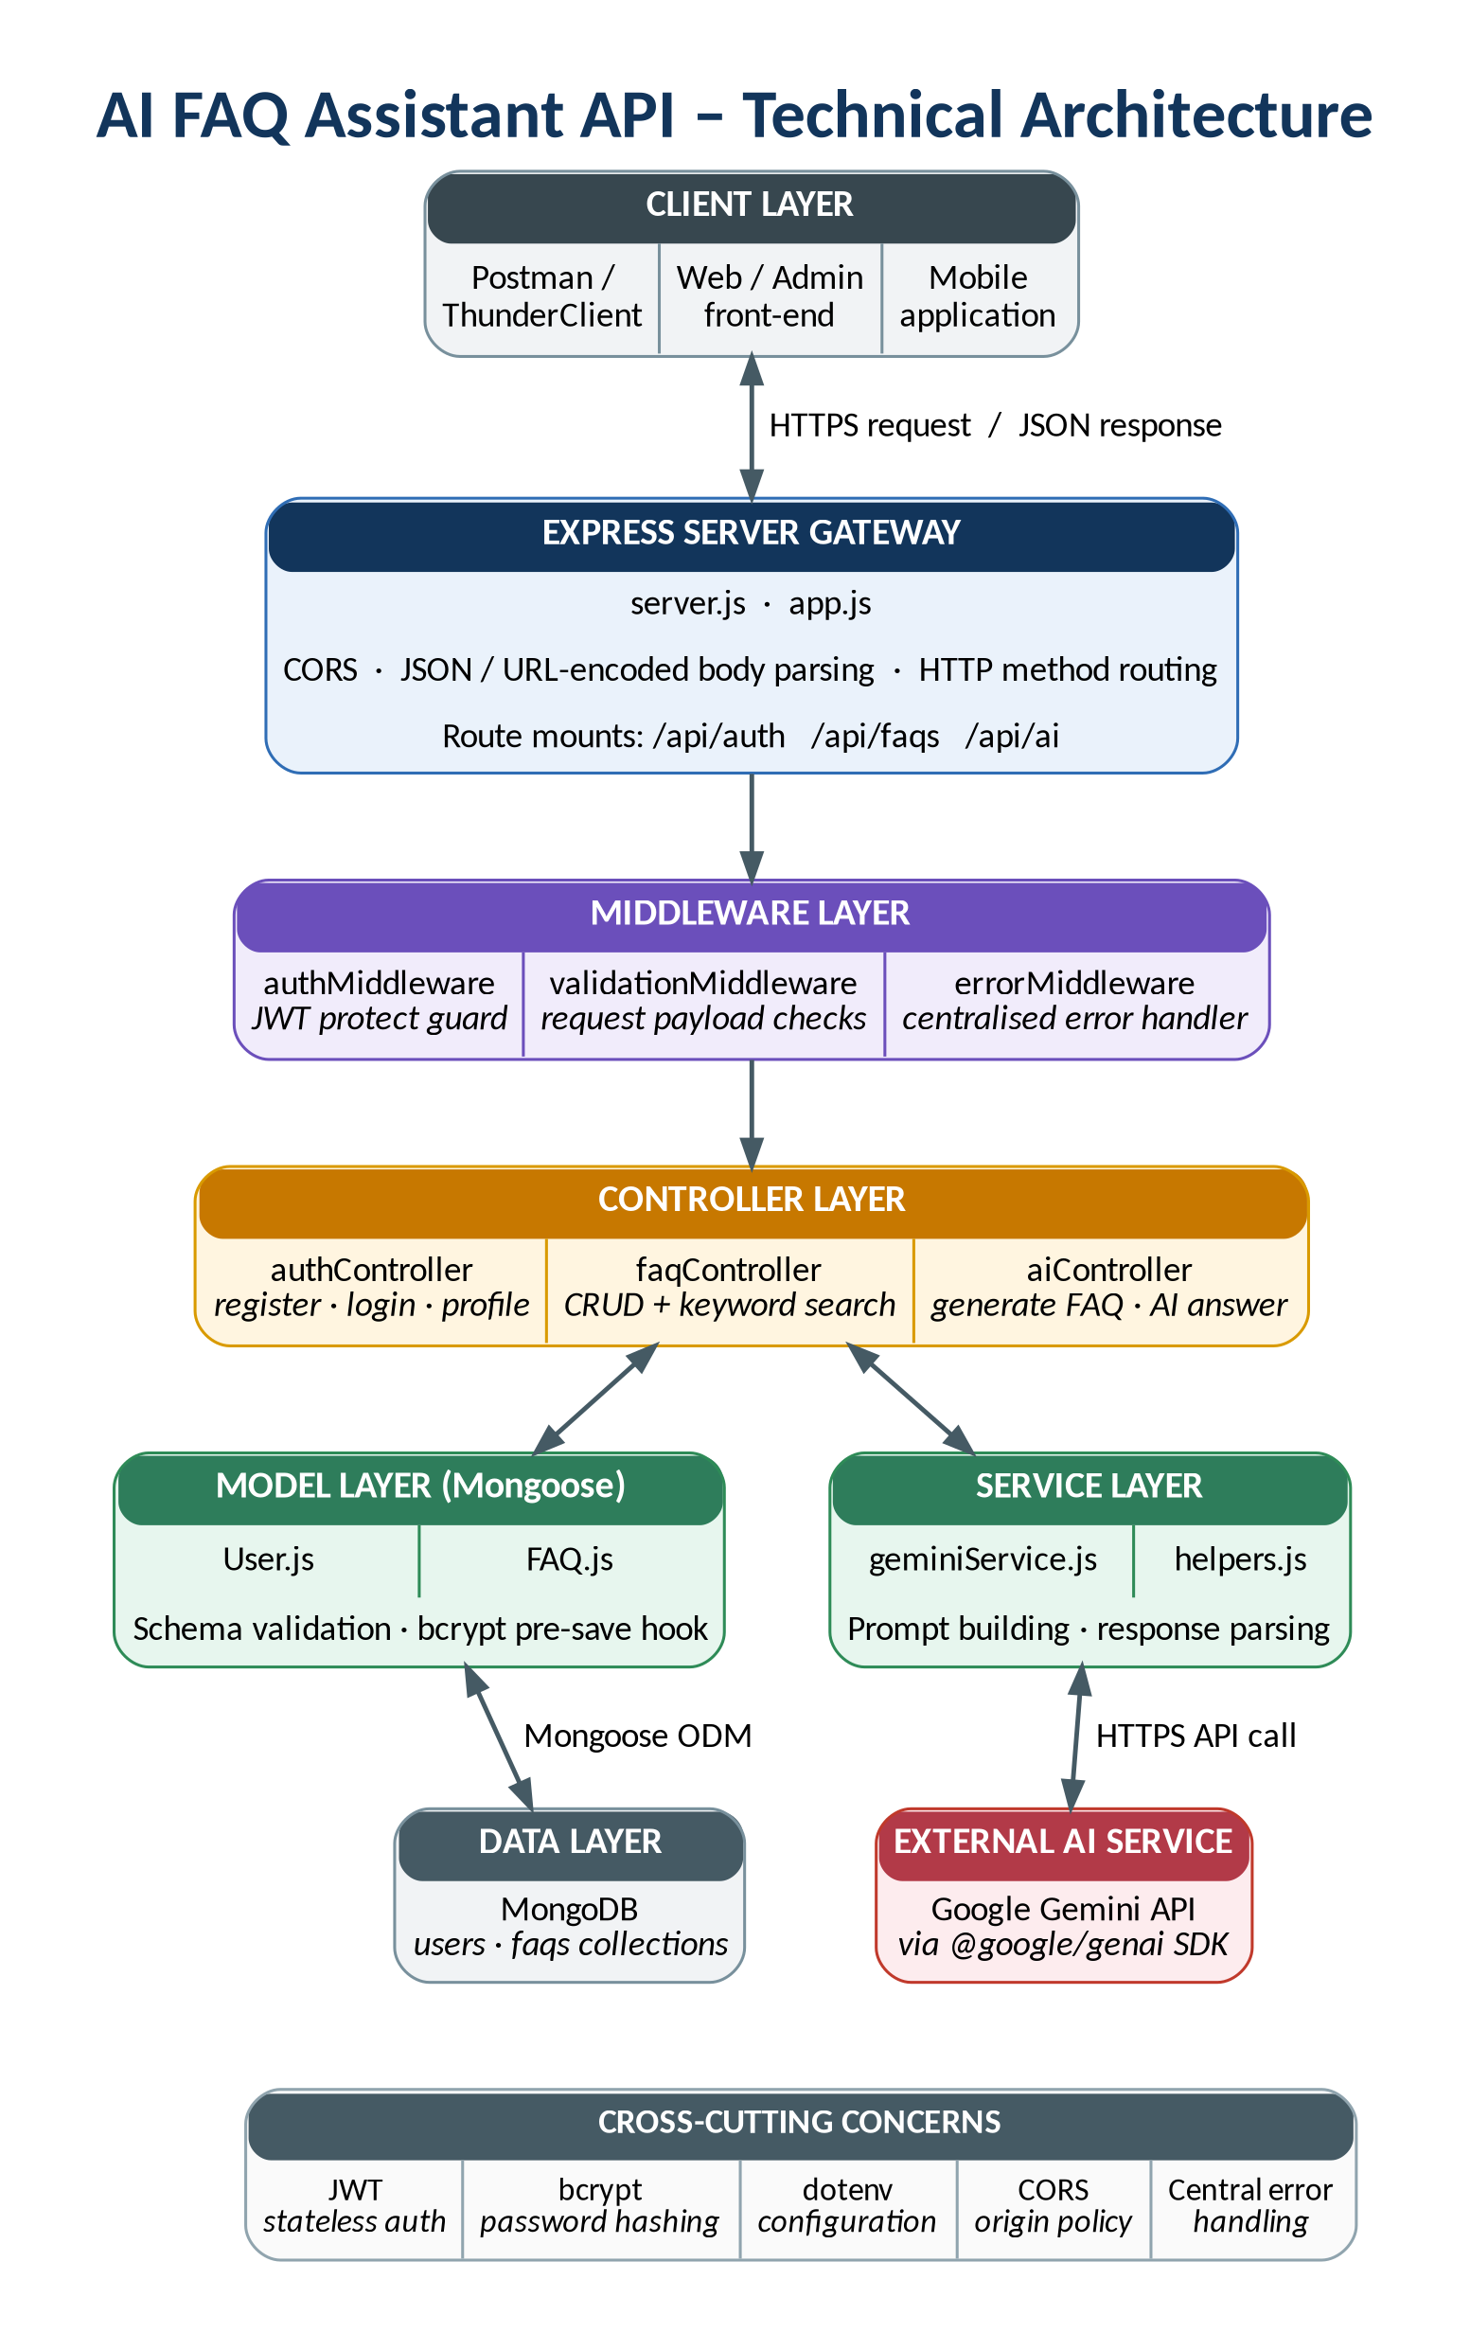
Figure 1: Technical architecture of the AI FAQ Assistant API

Components Definition
- Client Interface: Postman, ThunderClient or a front-end app sends HTTP requests and reads the JSON that comes back.
- Express Server Gateway: listens on the configured port, maps GET, POST, PUT and DELETE routes, parses JSON bodies, enables CORS and mounts the /api/auth, /api/faqs and /api/ai routers.
- Middleware Layer: authMiddleware verifies the Bearer token and loads the user, validationMiddleware checks request payloads, and errorMiddleware turns any error into a consistent response.
- Controllers: authController, faqController and aiController receive validated requests, apply the business rules and prepare the response.
- Models (Mongoose): the User and FAQ schemas define fields, validation rules and hooks, and translate operations into MongoDB queries.
- Service Layer: geminiService wraps the Google Gemini SDK so prompts and response parsing stay out of the controllers.
- Data and External Services: MongoDB persists users and FAQs; the Gemini API generates FAQ drafts and answers.

The flowchart below follows a single request from arrival to response and shows where authentication, validation and error handling take place.
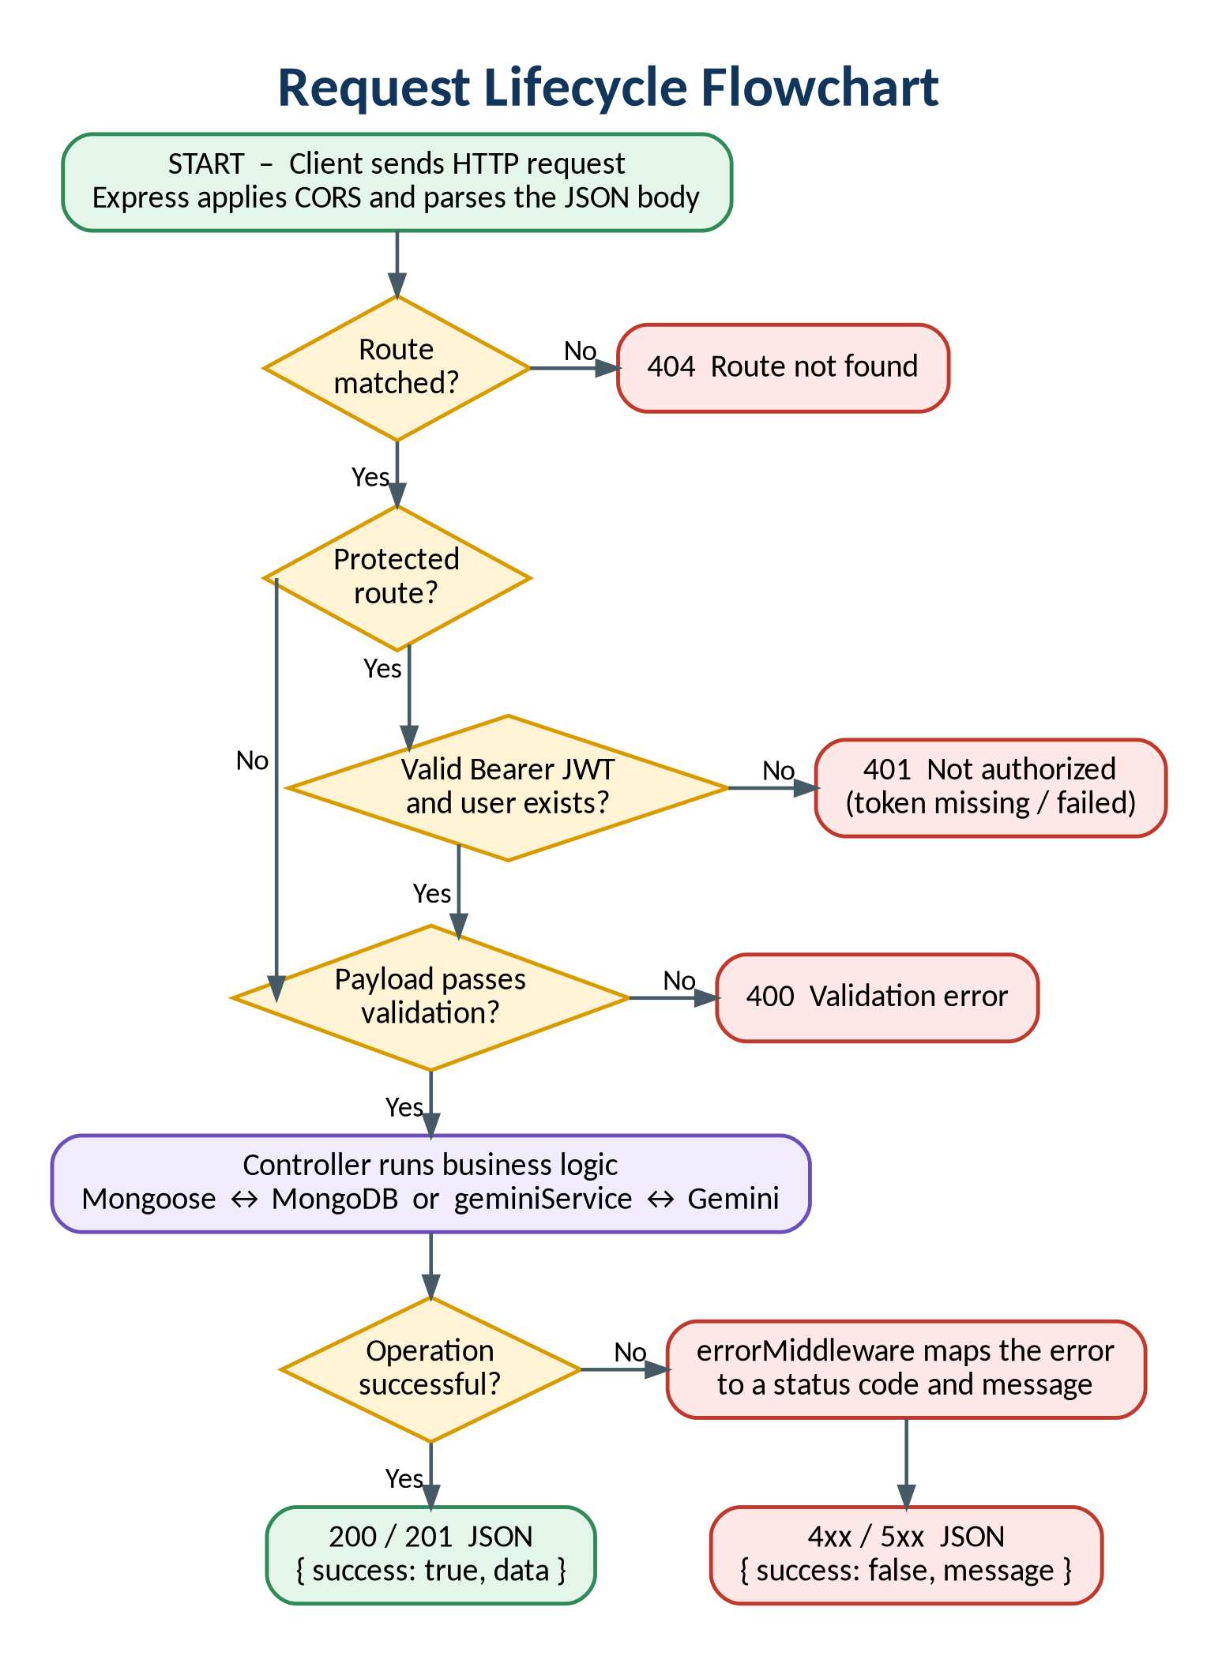
Figure 2: Request lifecycle flowchart

Entity-Relationship (ER) Diagram Description
The database uses MongoDB collections linked by object references. Two entities are stored (User and FAQ). Two are logical concepts that exist in code or in API responses: AI Generation, a draft produced by Gemini before it is saved, and Category, a grouping derived from the FAQ category field.
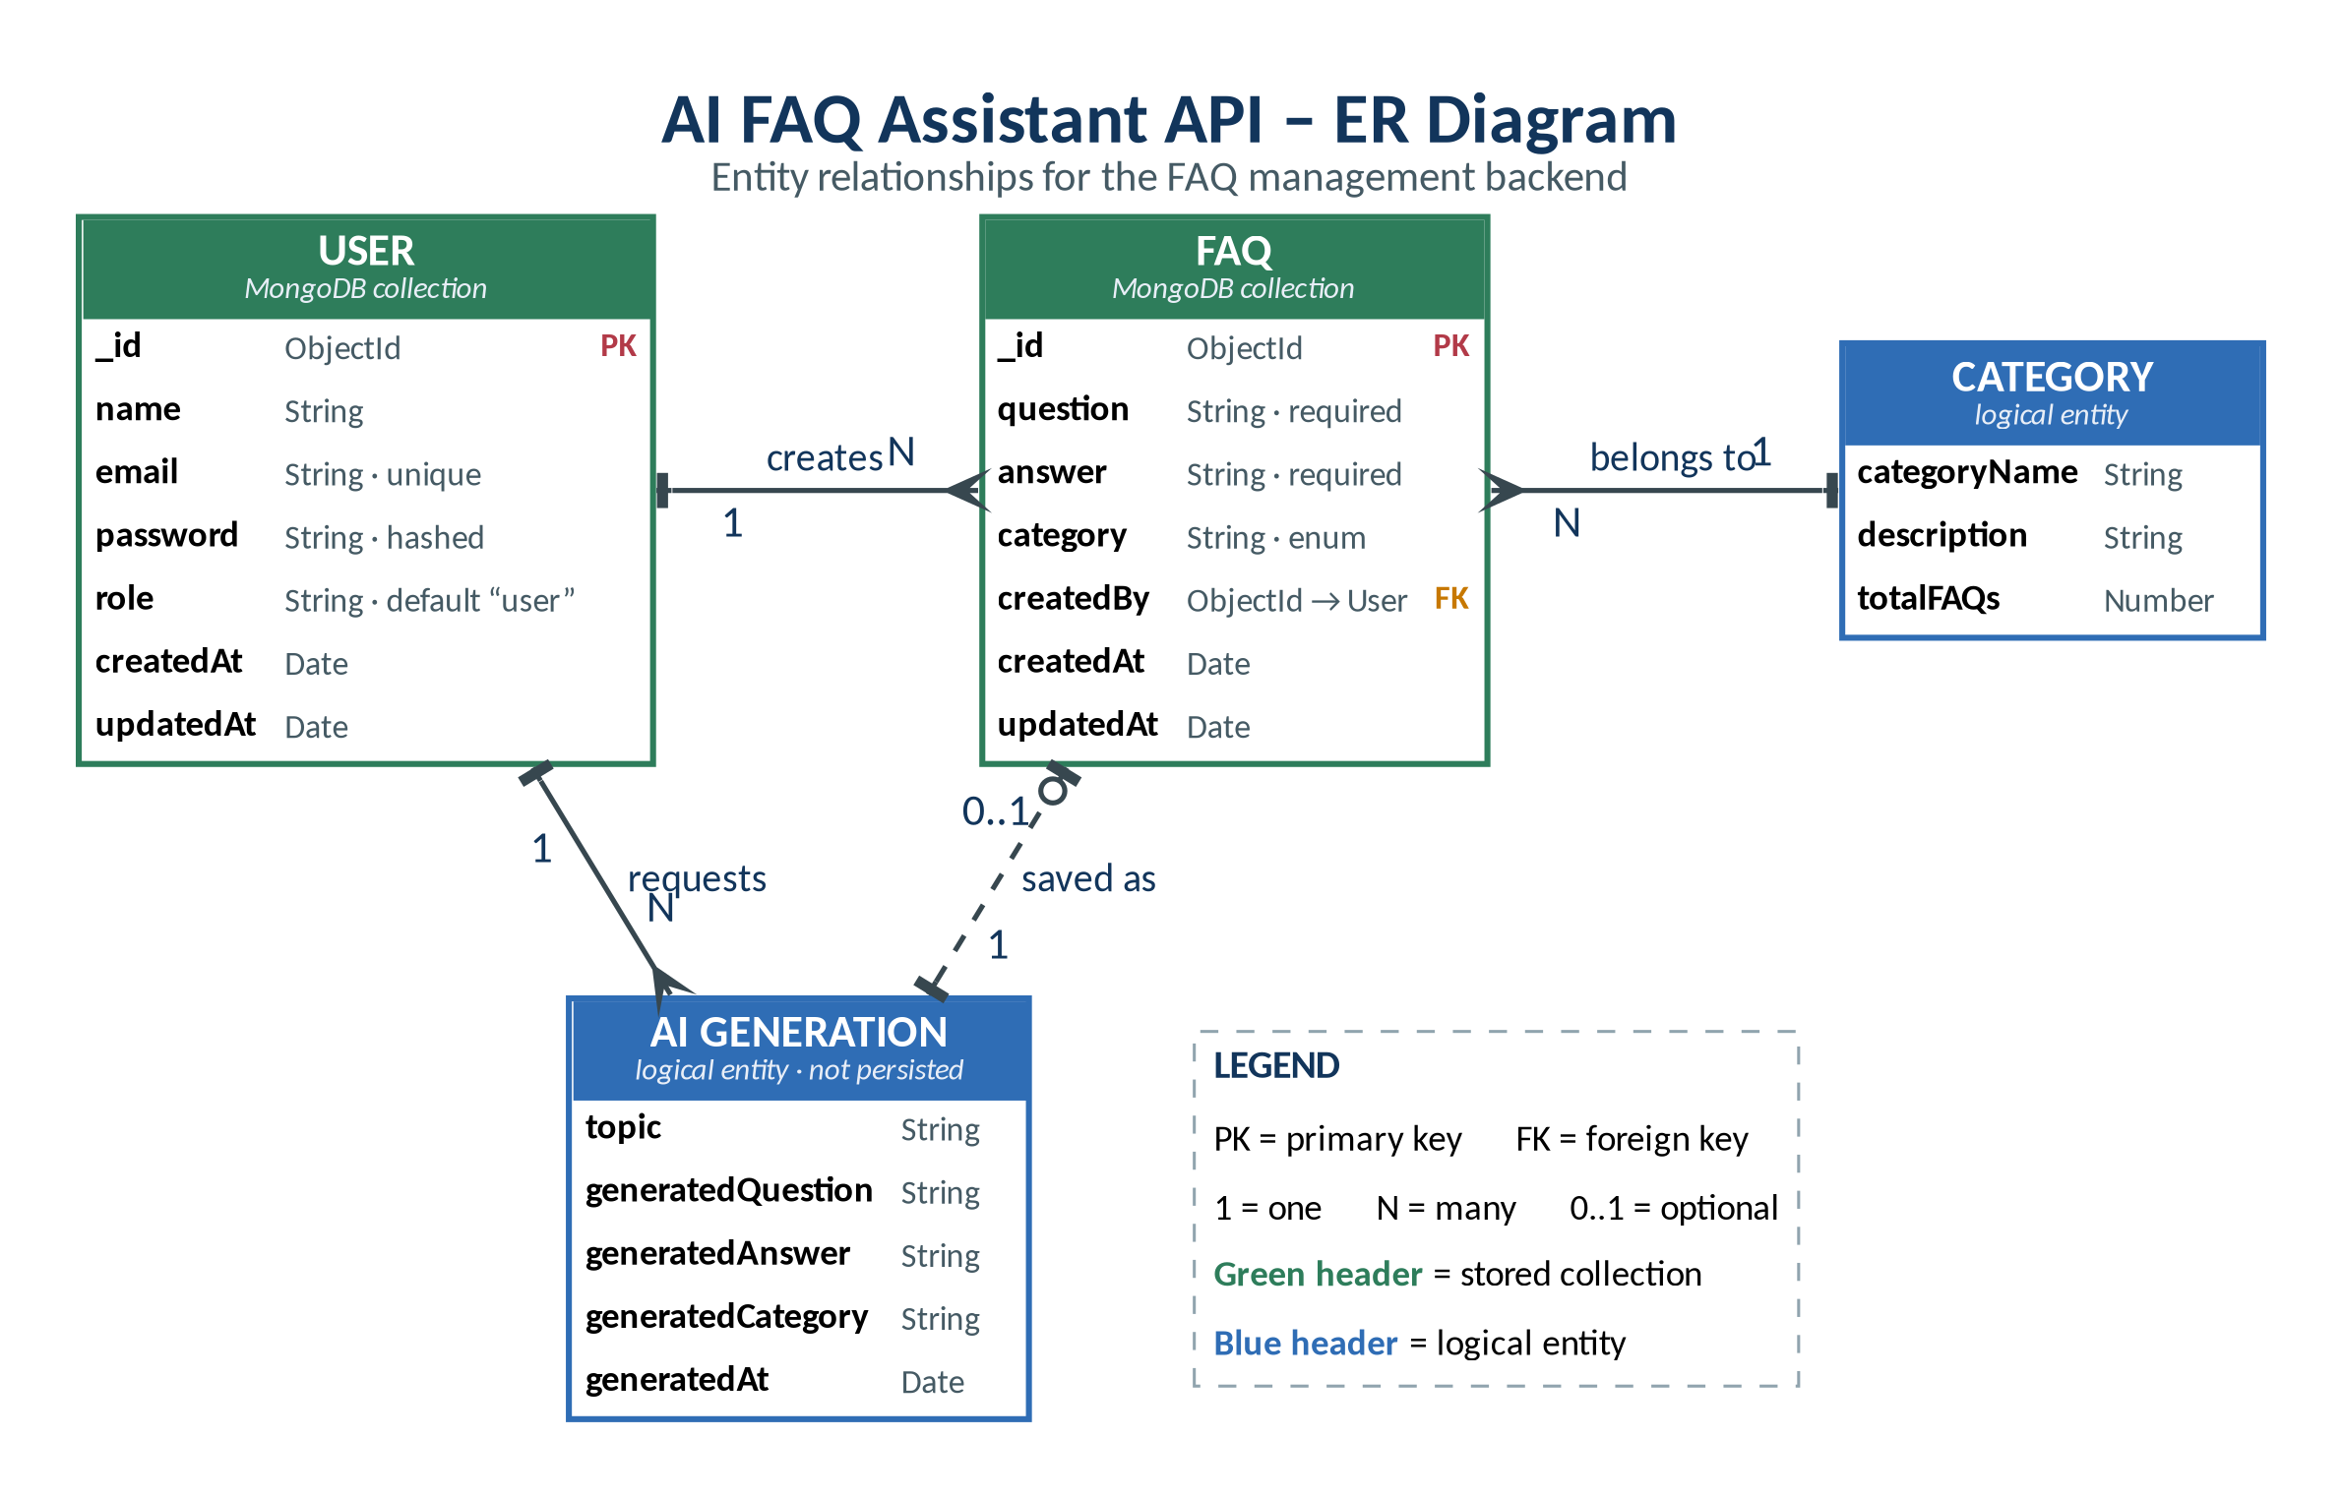
Figure 3: Entity-relationship diagram

1. User Entity
- _id (Primary Key - ObjectId): unique identifier generated by MongoDB.
- name (String, Required): display name of the user.
- email (String, Required, Unique): login identifier, stored in lowercase and format-checked.
- password (String, Hashed, Required): at least 6 characters, hashed with bcrypt before saving.
- role (String, Default: "user"): access level of the account.
- createdAt: timestamp added automatically by Mongoose.
- updatedAt: timestamp refreshed automatically on every update.

2. FAQ Entity
- _id (Primary Key - ObjectId): unique identifier of the FAQ.
- question (String, Required): the question text, trimmed.
- answer (String, Required): the answer text, trimmed.
- category (String, Required, Enum): Technology, Education, Health, Banking or General (default: General).
- createdBy (Foreign Key referencing User Collection): the author, used to enforce ownership.
- createdAt: timestamp added automatically by Mongoose.
- updatedAt: timestamp refreshed automatically on every update.

3. AI Generation Entity (Logical)
(Produced dynamically by Google Gemini and returned to the client; it is not stored as its own collection.)
- topic (String): subject supplied by the user.
- generatedQuestion (String): question drafted by Gemini.
- generatedAnswer (String): answer drafted by Gemini.
- generatedCategory (String): category suggested for the FAQ.
- generatedAt: time the draft was generated.

4. Category Entity (Logical)
- categoryName (String): name of the group, for example Technology.
- description (String): short note on what the category covers.
- totalFAQs (Number): number of FAQs in the category, calculated when needed.

Key Structural Mappings
User → FAQ (One-to-Many): one registered user can author many FAQ records, and each record stores the author’s id in createdBy.
Category → FAQ (One-to-Many): one category groups many FAQ documents.
User → AI Generated FAQ (One-to-Many): one user can request many AI drafts; a draft becomes an FAQ only after it is saved.
FAQ → Search Results (Logical Relationship): a search request returns the FAQ documents whose text matches the query keywords.

Key Features
- JWT Authentication & Authorization: signed tokens protect private endpoints and keep sessions stateless.
- AI FAQ Generation: Google Gemini drafts questions, answers and category suggestions from a single topic.
- Semantic FAQ Search: keyword-driven search returns relevant FAQs quickly for readers and agents.
- Complete CRUD Operations: create, read, update and delete FAQ records through a consistent API.
- Category Management: FAQs are grouped under validated categories for simple browsing.
- Password Encryption: passwords are salted and hashed with bcrypt; plain text is never stored.
- Centralized Error Handling: one middleware returns uniform error responses and hides internal details.
- Schema Validation: Mongoose rules reject incomplete or invalid data before it reaches the database.
- RESTful API Architecture: modular routes and controllers make the backend easy to scale and maintain.
- MongoDB Integration: flexible document storage accessed through the Mongoose ODM.

Roles and Responsibilities

Admin
- Manage every registered user.
- View, update and delete any FAQ.
- Monitor AI-generated content.
- Manage FAQ categories.
- Access the complete system functionality.

Content Creator
- Create new FAQs.
- Edit the FAQs they authored.
- Delete the FAQs they own.
- Generate FAQs with AI assistance.
- Organise FAQs under categories.

Authenticated User
- View public FAQs.
- Search FAQs by keyword.
- Request AI-assisted answers.
- Access their own profile information.

Public User
- View published FAQs.
- Search FAQs.
- Cannot create, edit or delete FAQ records.
- Has no access to protected API endpoints.

Permission summary
Capability | Admin | Content Creator | Authenticated User | Public User
View and search FAQs | Yes | Yes | Yes | Yes
Create an FAQ | Yes | Yes | — | —
Edit / delete own FAQs | Yes | Yes | — | —
Edit / delete any FAQ | Yes | — | — | —
Generate an FAQ with AI | Yes | Yes | — | —
Request an AI answer | Yes | Yes | Yes | —
Manage users and categories | Yes | — | — | —

User Flow
The diagram shows how each kind of user moves through the API: public readers go straight to the read-only routes, while everyone else registers or logs in, receives a JWT and is then routed by role.
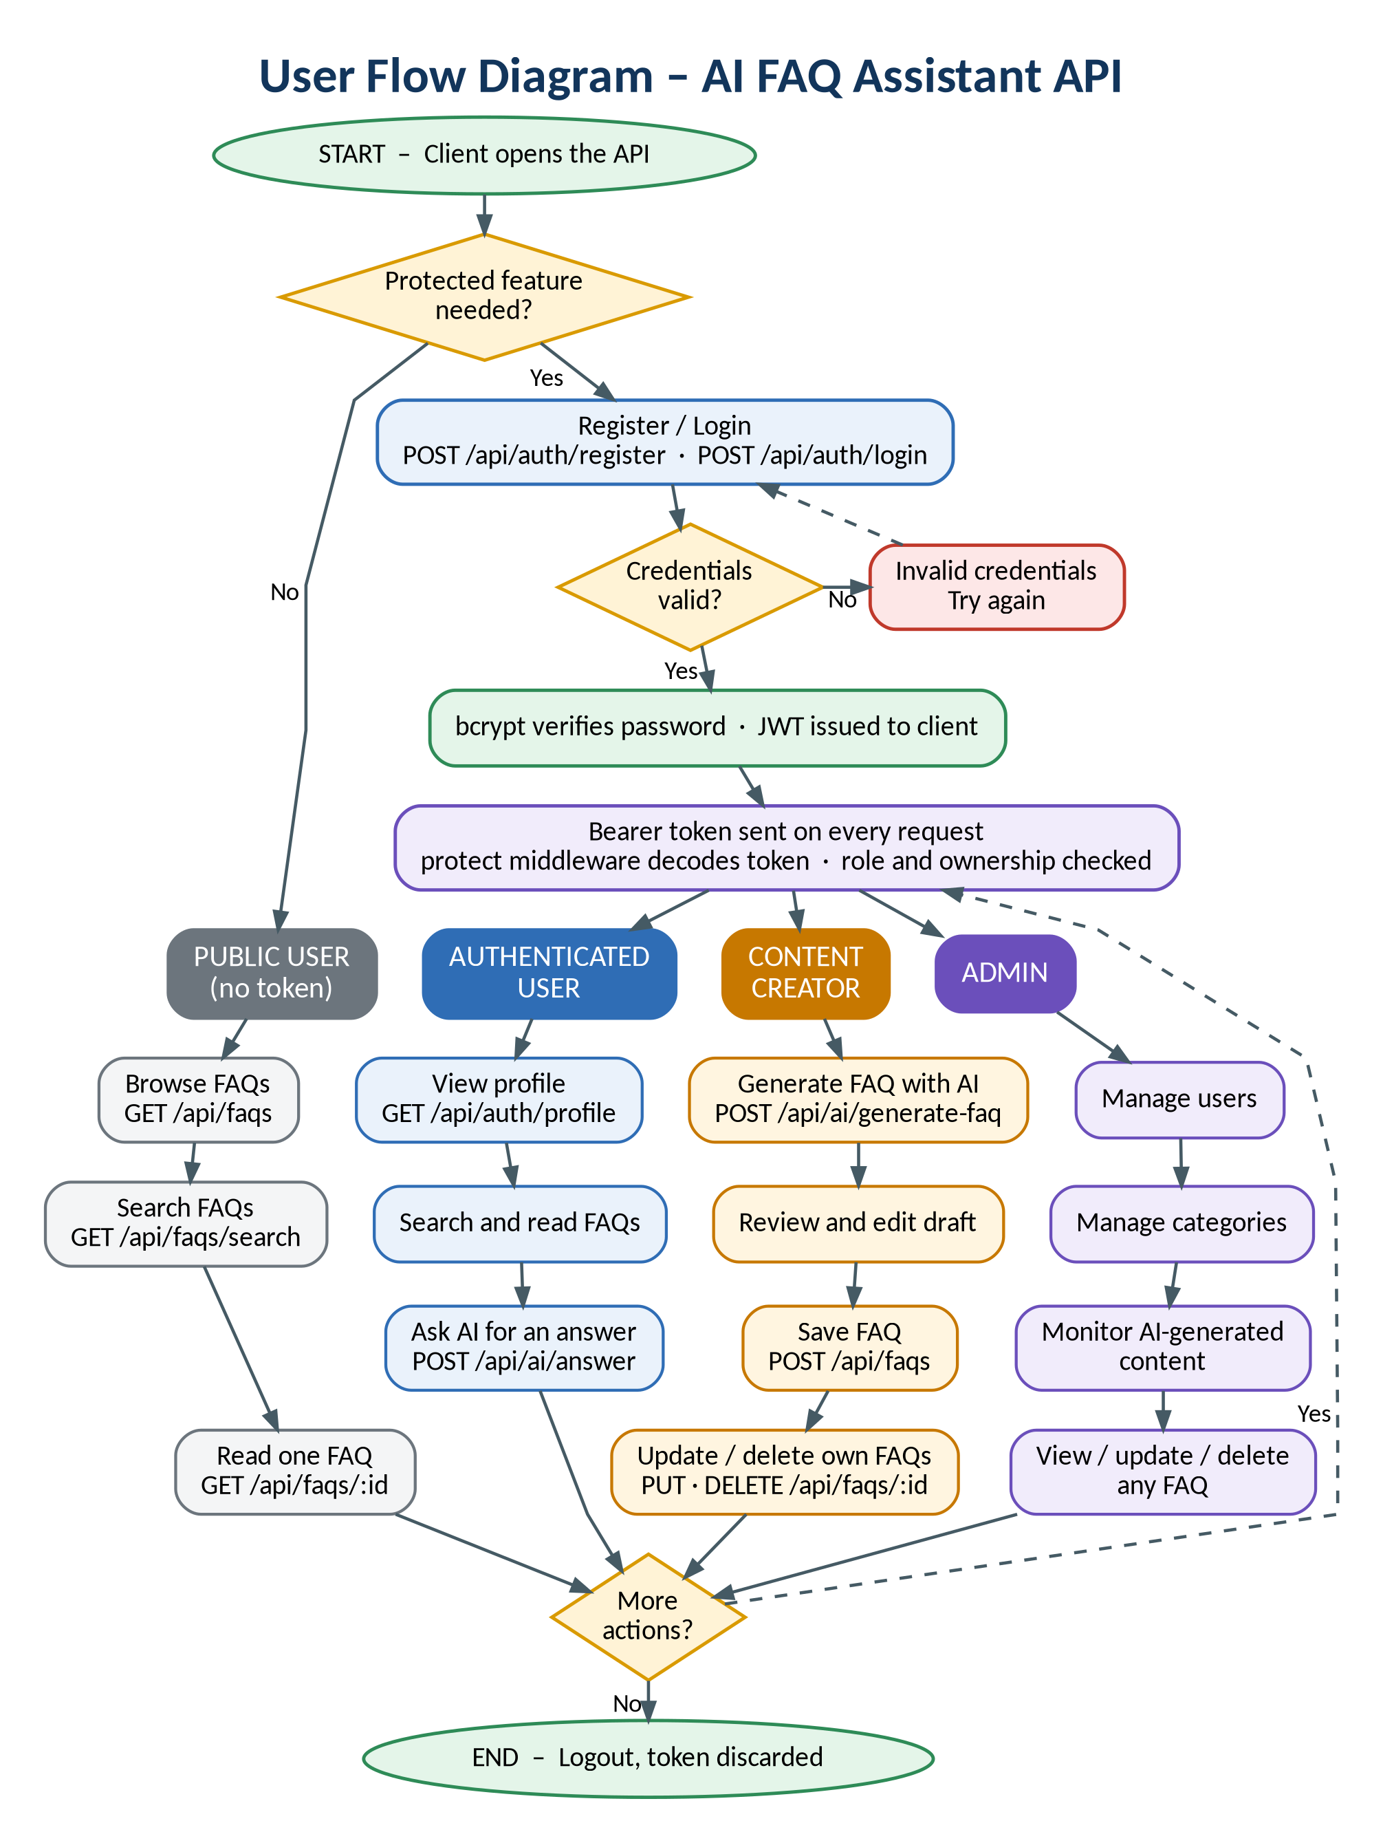
Figure 4: User flow diagram

MVC Architecture Pattern
The source code follows the Model-View-Controller pattern so that data rules, request handling and routing stay separate. In this headless API the “view” is the routing layer that exposes the JSON endpoints.
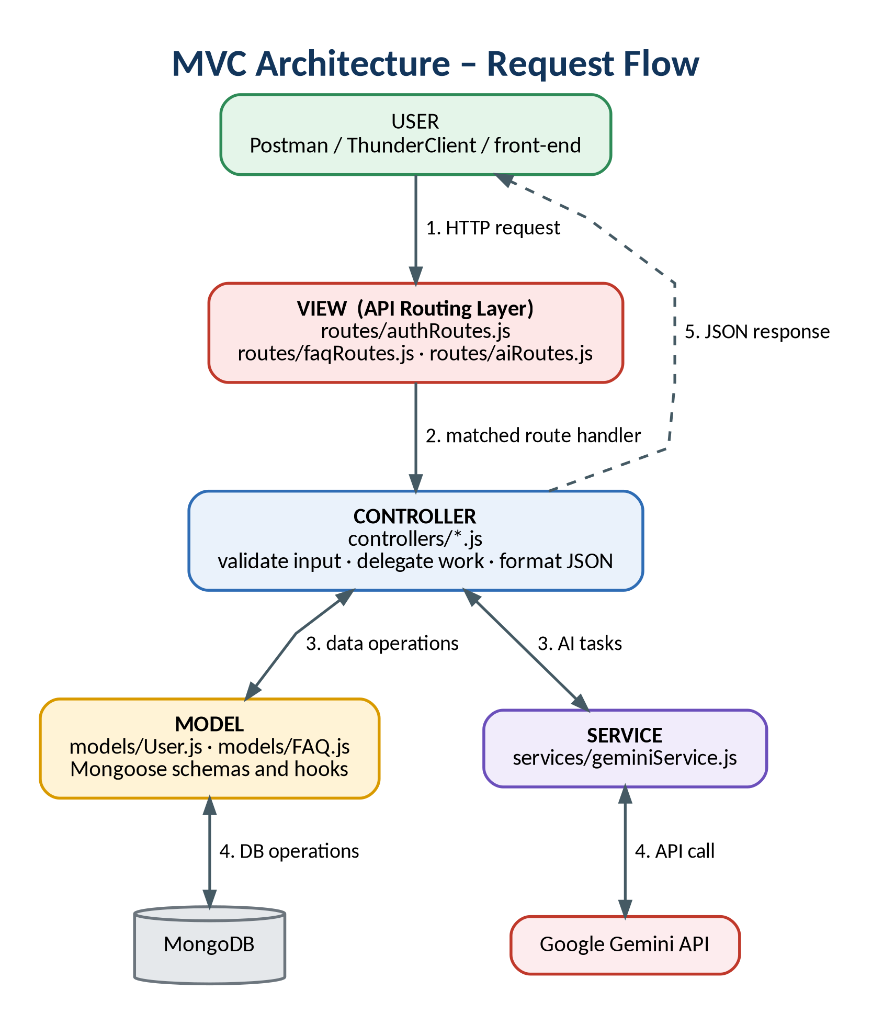
Figure 5: MVC architecture and request flow

Model Layer (Data Blueprint)
Models describe how data is stored. The User and FAQ Mongoose schemas declare every field’s type, whether it is required, default values and validation messages, and they map directly to MongoDB collections. Hooks such as the bcrypt pre-save step run here, so the rules apply no matter which controller writes the data.

Controller Layer (Execution Matrix)
Controllers are the decision layer. They read the request a route hands over, confirm the inputs make sense, call the right model or service, and shape the result into the standard JSON envelope (success, message, data). They contain no routing code and no schema definitions.

View Layer (Routing Network Interface)
Because this is a pure backend service there are no HTML templates. Each file in routes/ links a URL and HTTP method to its middleware chain and controller function, and the JSON returned to the client acts as the presentation of the data.

Epic 2: Project Setup and Configuration

Creating Project Folder
- Create a new folder named after your project (for example, FAQ).
- Inside that folder, create a subfolder called src.
- Open the project folder in Visual Studio Code.

Server Setup (npm init)
Open a terminal in the root folder of the project and run:
BASH
npm init -y
npm install express mongoose dotenv cors jsonwebtoken bcrypt @google/genai
npm install --save-dev nodemon

Add these scripts to package.json so the server can be started with npm run dev:
JSON
"scripts": {
"start": "node src/server.js",
"dev": "nodemon src/server.js"
}

Create a .env file in the project root and keep it out of version control:
.ENV
PORT=5000
NODE_ENV=development
MONGO_URI=mongodb://127.0.0.1:27017/faq_assistant
JWT_SECRET=replace_with_a_long_random_string
GEMINI_API_KEY=your_google_gemini_api_key

File and Folder Structure Matrix
PLAINTEXT
FAQ/
├── src/
│ ├── config/
│ │ └── db.js
│ ├── controllers/
│ │ ├── aiController.js
│ │ ├── authController.js
│ │ └── faqController.js
│ ├── middleware/
│ │ ├── authMiddleware.js
│ │ ├── errorMiddleware.js
│ │ └── validationMiddleware.js
│ ├── models/
│ │ ├── FAQ.js
│ │ └── User.js
│ ├── routes/
│ │ ├── aiRoutes.js
│ │ ├── authRoutes.js
│ │ └── faqRoutes.js
│ ├── services/
│ │ └── geminiService.js
│ ├── utils/
│ │ └── helpers.js
│ ├── app.js
│ └── server.js
├── .env
└── package.json

Folder / file | Purpose
config/ | Database connection (db.js).
controllers/ | Request handlers for authentication, FAQs and AI features.
middleware/ | JWT protection, request validation and centralized error handling.
models/ | Mongoose schemas for User and FAQ.
routes/ | Endpoint definitions that connect URLs to controllers.
services/ | Google Gemini integration (geminiService.js).
utils/ | Small shared helper functions.
app.js / server.js | Express configuration and the server entry point.

Epic 3: Backend Development

Core System Script Implementations

1. Gateway Server Node (src/server.js)
The entry point connects to MongoDB first, then starts the HTTP listener, and exits cleanly if startup fails or a promise is rejected without a handler.
JAVASCRIPT
// app.js loads dotenv, so it must be required before PORT is read
const app = require('./app');
const connectDB = require('./config/db');

const PORT = process.env.PORT || 5000;

const startServer = async () => {
try {
// 1. Connect to MongoDB before accepting traffic
await connectDB();

// 2. Start the HTTP listener
const server = app.listen(PORT, () => {
console.log(
`Server running in ${process.env.NODE_ENV || 'development'} mode on port ${PORT}`
);
});

// 3. Shut down cleanly if a promise is rejected without a catch
process.on('unhandledRejection', (err) => {
console.error(`Unhandled Rejection: ${err.message}`);
server.close(() => process.exit(1));
});
} catch (error) {
console.error('Failed to start the server:', error.message);
process.exit(1);
}
};

startServer();

It relies on a small connection helper, src/config/db.js:
JAVASCRIPT
const mongoose = require('mongoose');

const connectDB = async () => {
const conn = await mongoose.connect(process.env.MONGO_URI);
console.log(`MongoDB connected: ${conn.connection.host}`);
};

module.exports = connectDB;

2. Gateway Express Setup (src/app.js)
app.js builds the Express application: global middleware, a health-check route, the three routers, a 404 fallback and, last of all, the centralized error handler.
JAVASCRIPT
const express = require('express');
const cors = require('cors');
const dotenv = require('dotenv');
const { errorHandler } = require('./middleware/errorMiddleware');

dotenv.config();

const app = express();

// Global middleware
app.use(cors());
app.use(express.json());
app.use(express.urlencoded({ extended: false }));

// Health-check route
app.get('/', (req, res) => {
res.json({
success: true,
message: 'AI FAQ Assistant API is running.',
version: '1.0.0',
});
});

// Feature routers
app.use('/api/auth', require('./routes/authRoutes'));
app.use('/api/faqs', require('./routes/faqRoutes'));
app.use('/api/ai', require('./routes/aiRoutes'));

// Unknown route -> 404 JSON
app.use((req, res) => {
res.status(404).json({
success: false,
message: `Route not found: ${req.originalUrl}`,
});
});

// Centralized error handler (must be registered last)
app.use(errorHandler);

module.exports = app;

3. Security Access Middleware (src/middleware/authMiddleware.js)
protect guards private routes. It reads the Bearer token, verifies it with the JWT secret, loads the matching user without the password hash, and rejects the request with 401 if anything is wrong.
JAVASCRIPT
const jwt = require('jsonwebtoken');
const User = require('../models/User');

const protect = async (req, res, next) => {
const header = req.headers.authorization;

// 1. Expect: Authorization: Bearer <token>
if (!header || !header.startsWith('Bearer ')) {
return res.status(401).json({
success: false,
message: 'Not authorized, token missing',
});
}

try {
// 2. Verify the signature and expiry
const token = header.split(' ')[1];
const decoded = jwt.verify(token, process.env.JWT_SECRET);

// 3. Attach the user (without the password hash) to the request
req.user = await User.findById(decoded.id).select('-password');

if (!req.user) {
return res.status(401).json({
success: false,
message: 'Not authorized, user not found',
});
}

next();
} catch (error) {
return res.status(401).json({
success: false,
message: 'Not authorized, token failed',
});
}
};

module.exports = { protect };

4. Centralized Error Handler Middleware (src/middleware/errorMiddleware.js)
Every error ends up here. The handler maps duplicate keys, validation failures and bad ids to friendly messages and status codes, and logs a stack trace only for genuine server errors.
JAVASCRIPT
const errorHandler = (err, req, res, next) => {
let statusCode = res.statusCode === 200 ? 500 : res.statusCode;
let message = err.message;

// Status set by a library, e.g. 429 from the Gemini SDK
if (err.status) statusCode = err.status;

// Duplicate key (e.g. email already registered)
if (err.code === 11000) {
statusCode = 400;
const field = Object.keys(err.keyValue)[0];
message = `Duplicate field value entered: ${field}. Please use another value.`;
}

// Mongoose validation failure
if (err.name === 'ValidationError') {
statusCode = 400;
message = Object.values(err.errors).map((e) => e.message).join(', ');
}

// Malformed ObjectId
if (err.name === 'CastError') {
statusCode = 404;
message = `Resource not found with id of ${err.value}`;
}

// Only unexpected server errors are logged with a stack trace
if (statusCode === 500) console.error(err.stack);

res.status(statusCode).json({
success: false,
message,
...(process.env.NODE_ENV === 'development' && { stack: err.stack }),
});
};

module.exports = { errorHandler };

Epic 4: Database Configuration

Mongoose Schema Definitions

1. Identity Resource Document Schema (src/models/User.js)
The user schema validates the profile fields and hashes the password in a pre-save hook, so plain-text passwords never reach the database.
JAVASCRIPT
const mongoose = require('mongoose');
const bcrypt = require('bcrypt');

const userSchema = new mongoose.Schema(
{
name: {
type: String,
required: [true, 'Name is required'],
trim: true,
},
email: {
type: String,
required: [true, 'Email is required'],
unique: true,
lowercase: true,
trim: true,
match: [/^\S+@\S+\.\S+$/, 'Please provide a valid email address'],
},
password: {
type: String,
required: [true, 'Password is required'],
minlength: [6, 'Password must be at least 6 characters long'],
},
role: { type: String, default: 'user' },
},
{ timestamps: true }
);

// Hash the password before the document is saved
userSchema.pre('save', async function () {
if (!this.isModified('password')) return;
const salt = await bcrypt.genSalt(10);
this.password = await bcrypt.hash(this.password, salt);
});

// Compare a plain-text password with the stored hash (used at login)
userSchema.methods.matchPassword = function (enteredPassword) {
return bcrypt.compare(enteredPassword, this.password);
};

module.exports = mongoose.model('User', userSchema);

2. FAQ Resource Document Schema (src/models/FAQ.js)
The FAQ schema stores the content, restricts category to an approved list and links each record to its author through createdBy.
JAVASCRIPT
const mongoose = require('mongoose');

const CATEGORIES = ['Technology', 'Education', 'Health', 'Banking', 'General'];

const faqSchema = new mongoose.Schema(
{
question: {
type: String,
required: [true, 'Question is required'],
trim: true,
},
answer: {
type: String,
required: [true, 'Answer is required'],
trim: true,
},
category: {
type: String,
required: [true, 'Category is required'],
enum: {
values: CATEGORIES,
message: `{VALUE} is not a valid category. Choose from ${CATEGORIES.join(', ')}`,
},
default: 'General',
},
// Reference to the author, used to enforce ownership
createdBy: {
type: mongoose.Schema.Types.ObjectId,
ref: 'User',
required: [true, 'Creator user reference is required'],
},
},
{ timestamps: true }
);

module.exports = mongoose.model('FAQ', faqSchema);

API Router Interface Endpoints

1. Public Authentication Operations (src/routes/authRoutes.js)
JAVASCRIPT
const express = require('express');
const router = express.Router();

const {
registerUser,
loginUser,
getUserProfile,
} = require('../controllers/authController');
const { protect } = require('../middleware/authMiddleware');
const {
validateRegister,
validateLogin,
} = require('../middleware/validationMiddleware');

// Public routes
router.post('/register', validateRegister, registerUser);
router.post('/login', validateLogin, loginUser);

// Protected route
router.get('/profile', protect, getUserProfile);

module.exports = router;

Method | Endpoint | Access | Purpose
POST | /api/auth/register | Public | Create an account and receive a JWT.
POST | /api/auth/login | Public | Verify credentials and receive a JWT.
GET | /api/auth/profile | Private | Return the logged-in user’s profile.

2. Protected FAQ Operations (src/routes/faqRoutes.js)
JAVASCRIPT
const express = require('express');
const router = express.Router();

const {
createFAQ,
getAllFAQs,
getFAQById,
updateFAQ,
deleteFAQ,
searchFAQs,
} = require('../controllers/faqController');
const { protect } = require('../middleware/authMiddleware');
const { validateFAQ } = require('../middleware/validationMiddleware');

// Public routes (read-only)
// NOTE: /search is declared before /:id so "search" is not treated as an id
router.get('/search', searchFAQs);
router.get('/', getAllFAQs);
router.get('/:id', getFAQById);

// Protected routes (write operations)
router.post('/', protect, validateFAQ, createFAQ);
router.put('/:id', protect, updateFAQ);
router.delete('/:id', protect, deleteFAQ);

module.exports = router;

Method | Endpoint | Access | Purpose
GET | /api/faqs/search?q= | Public | Find FAQs that match a keyword.
GET | /api/faqs | Public | List all published FAQs.
GET | /api/faqs/:id | Public | Read a single FAQ.
POST | /api/faqs | Private | Create an FAQ owned by the caller.
PUT | /api/faqs/:id | Private | Update an FAQ (author only).
DELETE | /api/faqs/:id | Private | Delete an FAQ (author only).

3. AI Automation Operations (src/routes/aiRoutes.js)
JAVASCRIPT
const express = require('express');
const router = express.Router();

const {
generateAIAnswer,
generateAIFAQ,
} = require('../controllers/aiController');
const { protect } = require('../middleware/authMiddleware');
const {
validateAIAnswer,
validateAIFaq,
} = require('../middleware/validationMiddleware');

// Protected so the Gemini quota cannot be abused anonymously
router.post('/answer', protect, validateAIAnswer, generateAIAnswer);
router.post('/generate-faq', protect, validateAIFaq, generateAIFAQ);

module.exports = router;

Method | Endpoint | Access | Purpose
POST | /api/ai/answer | Private | Ask Gemini for an answer to a question.
POST | /api/ai/generate-faq | Private | Generate a question, answer and category from a topic.

The flowchart below shows what happens when an author asks the AI to draft an FAQ, from the token check to saving the accepted draft.
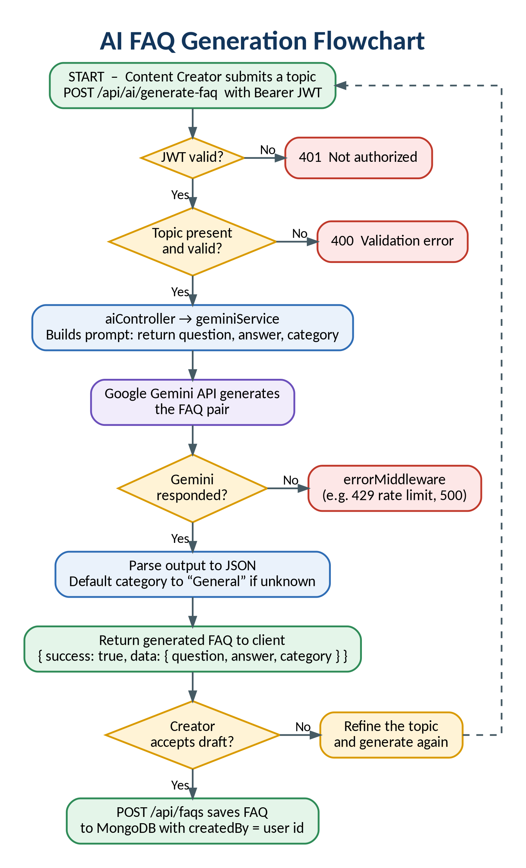
Figure 6: AI FAQ generation flowchart

Epic 5: Project Executions

Running the API Application
- Install Postman or ThunderClient (VS Code extension).
- Make sure MongoDB is running and the .env file is filled in, then start the development server:
BASH
npm run dev

When startup succeeds, the terminal prints Server running in development mode on port 5000.

API Testing Specification Demo
Work through the requests below in order. Copy the token from the login response and send it on private routes in the header shown here; every response uses the same success / message / data envelope.
HEADERS FOR PRIVATE ROUTES
Authorization: Bearer <JWT Token>
Content-Type: application/json

1. Identity Onboarding Path Registration
- Route: POST /api/auth/register
- Access: Public
- Payload Request Body JSON:
JSON
{
"name": "Priya Sharma",
"email": "priya@faqassistant.com",
"password": "securepassword123"
}

- Expected response: 201 Created
JSON
{
"success": true,
"message": "User registered successfully",
"data": {
"_id": "665f1c2ab8e4d2a1f0c9d001",
"name": "Priya Sharma",
"email": "priya@faqassistant.com",
"token": "eyJhbGciOiJIUzI1NiIsInR5cCI6IkpXVCJ9..."
}
}

2. Profile Login Verification Quey
- Route: POST /api/auth/login
- Access: Public
- Payload Request Body JSON:
JSON
{
"email": "priya@faqassistant.com",
"password": "securepassword123"
}

- Expected response: 200 OK
JSON
{
"success": true,
"message": "Login successful",
"data": {
"_id": "665f1c2ab8e4d2a1f0c9d001",
"name": "Priya Sharma",
"email": "priya@faqassistant.com",
"token": "eyJhbGciOiJIUzI1NiIsInR5cCI6IkpXVCJ9..."
}
}

3. Resource Entity Creation (FAQ)
- Route: POST /api/faqs
- Access: Private (Bearer <JWT Token>)
- Payload Request Body JSON (category must be Technology, Education, Health, Banking or General):
JSON
{
"question": "How do I configure custom category tags?",
"answer": "Open the settings panel, add your keyword tags and save the changes.",
"category": "Technology"
}

- Expected response: 201 Created
JSON
{
"success": true,
"message": "FAQ created successfully",
"data": {
"question": "How do I configure custom category tags?",
"answer": "Open the settings panel, add your keyword tags and save the changes.",
"category": "Technology",
"createdBy": "665f1c2ab8e4d2a1f0c9d001",
"_id": "665f1d7fb8e4d2a1f0c9d0a2",
"createdAt": "2026-06-26T11:46:07.410Z",
"updatedAt": "2026-06-26T11:46:07.410Z",
"__v": 0
}
}

4. Keyword Resource Entity Fetching (Search)
- Route: GET /api/faqs/search?q=configure
- Access: Public
- Expected response: 200 OK, with the number of matches in count
JSON
{
"success": true,
"message": "FAQs retrieved successfully",
"count": 1,
"data": [
{
"_id": "665f1d7fb8e4d2a1f0c9d0a2",
"question": "How do I configure custom category tags?",
"answer": "Open the settings panel, add your keyword tags and save the changes.",
"category": "Technology",
"createdBy": {
"_id": "665f1c2ab8e4d2a1f0c9d001",
"name": "Priya Sharma",
"email": "priya@faqassistant.com"
}
}
]
}

5. AI Intelligent Content Automation (Generate FAQ Pair)
- Route: POST /api/ai/generate-faq
- Access: Private (Bearer <JWT Token>)
- Payload Request Body JSON:
JSON
{
"topic": "Resetting a forgotten account password"
}

- Expected response: 200 OK (a draft only; save it with POST /api/faqs)
JSON
{
"success": true,
"message": "FAQ generated successfully",
"data": {
"question": "How do I reset a forgotten account password?",
"answer": "Choose the Forgot password link on the login page, enter your registered email address and follow the link sent to your inbox to set a new password.",
"category": "General"
}
}

Common error responses
Status | When it happens | Message
400 | Validation fails or an email is already registered. | Field-level validation text or “Duplicate field value entered”.
401 | Bearer token is missing, invalid or belongs to a deleted user. | “Not authorized, token missing / token failed / user not found”.
404 | Route is unknown or the FAQ id is malformed. | “Route not found” or “Resource not found with id of …”.
429 | The Gemini API rate limit is reached. | Message passed through from the Gemini SDK.

API TESTING VIDEO:
https://drive.google.com/file/d/13EVoTAqTlOlSu21mk6FTVSwpwckoLZDL/view?usp=drivesdk

DEMO LINK: https://drive.google.com/file/d/1zd38XQPoBsHOHnaNr7MqE3XptPynz2oA/view?usp=drivesdk

