Predictive analytics

**LAB 4 : Python Library Pandas**

**Name - Shalu priya**

**SAP - 500107625**

**Roll No - R2142220839**

**Course – B.Tech CSE**

**Batch – 4 (NH)**

**Q1.  Loading and Inspecting Data:**

·         Load various data formats (CSV, Excel, JSON) into Pandas DataFrames.

·         Explore DataFrame attributes like shape, columns, dtypes, head, tail, info, describe.

·         Practice selecting columns and rows using different methods (indexing, slicing, loc, iloc).

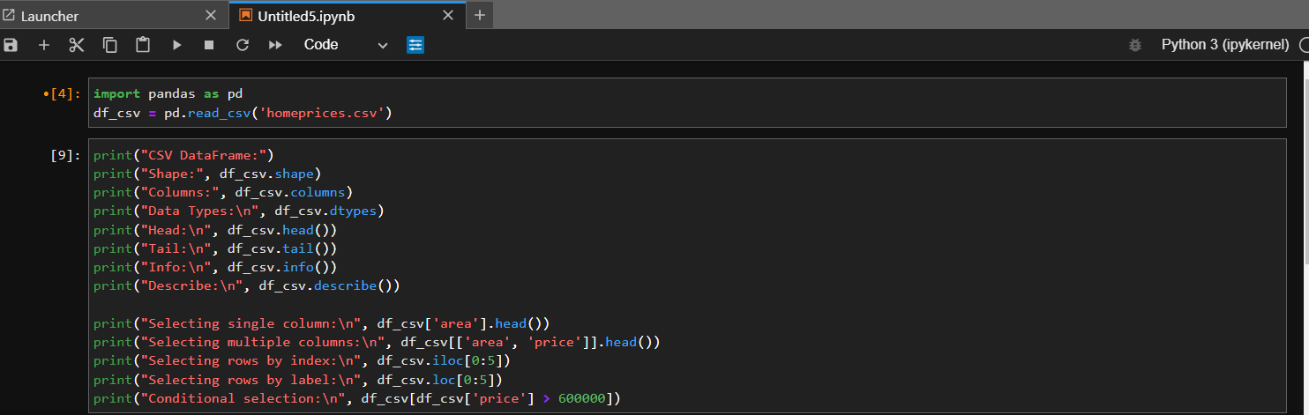

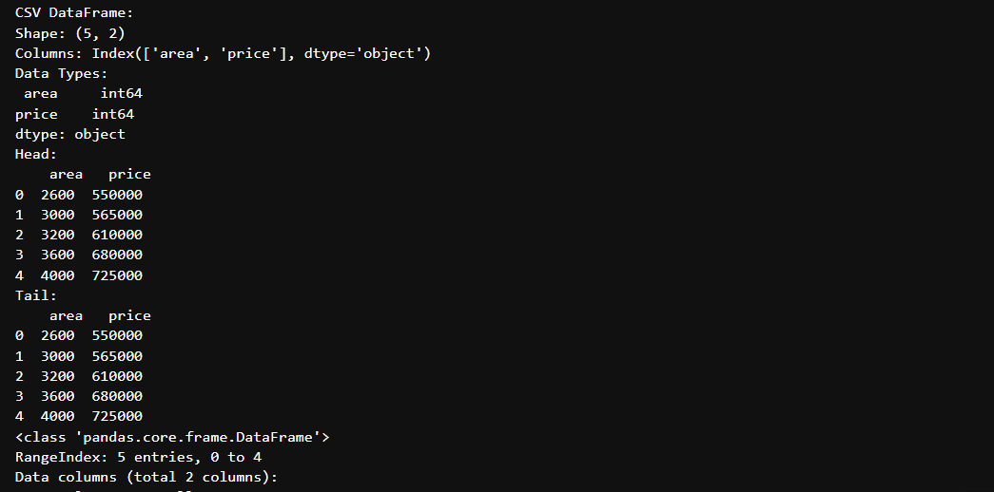

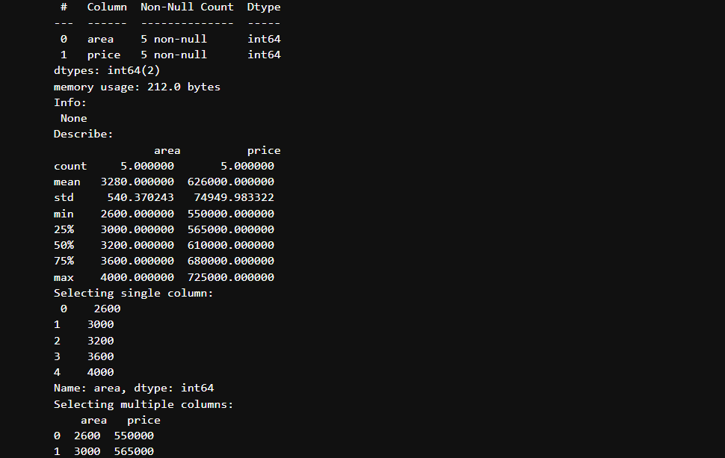

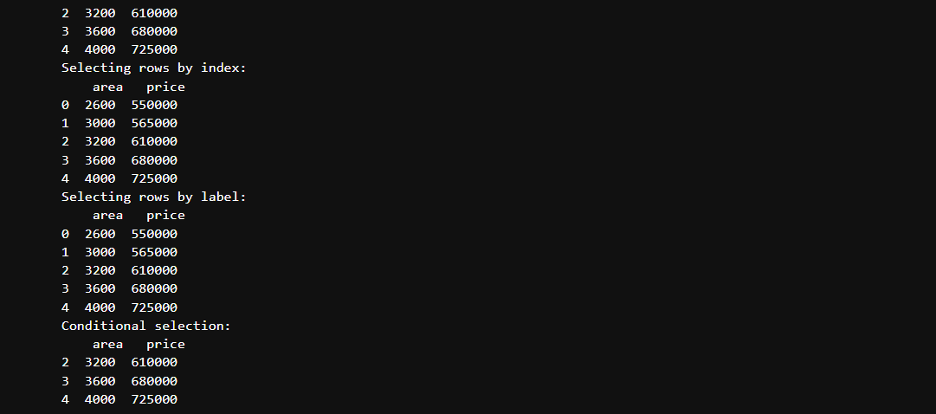

**Q2. Data Cleaning and Preparation**

* Identify missing values using isnull and isna.
* Handle missing values using fillna, dropna, interpolation.
* Apply scaling techniques (min-max, z-score) to numerical columns.
* Create dummy variables for categorical columns.

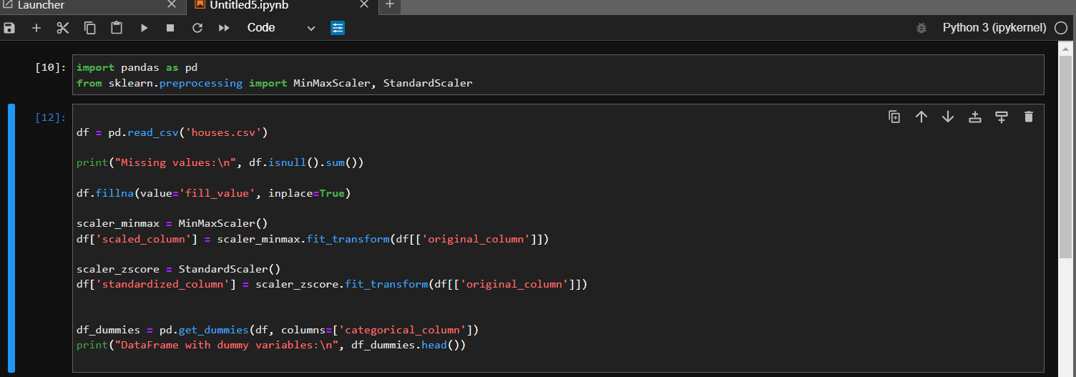

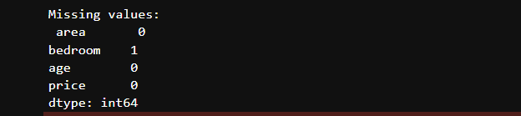

**Q3. Aggregation and Grouping:**

Calculate summary statistics (mean, median, count, etc.) using groupby.

Create pivot tables for data summarization.

Combine DataFrames using concat, merge, and join.

Practice different join types (inner, outer, left, right).

