**Predictive Analytics**

**Lab-5**

**Name: Shalu Priya**

**Sap id: 500107625**

**Batch: B5(AIML-NH)**

Descriptive Statistics of data:

* 1. Measure of Central Tendency: Mean, Geometric mean, Harmonic mean, Mode, Median

**Code:**

# Selecting relevant numerical columns for analysis

numeric_columns = ['age', 'height_cm', 'weight_kg', 'body fat_%', 'diastolic', 'systolic', 'gripForce', 'sit and bend forward_cm', 'sit-ups counts', 'broad jump_cm']

# Mean

**mean_values = df[numeric_columns].mean()**

# Geometric Mean (ignoring negative and zero values as they are not valid for geometric mean)

**geom_mean_values = df[numeric_columns].apply(lambda x: stats.gmean(x[x > 0]))**

# Harmonic Mean (ignoring negative and zero values)

**harmonic_mean_values = df[numeric_columns].apply(lambda x: stats.hmean(x[x > 0]))**

# Mode

**mode_values = df[numeric_columns].mode().iloc[0]**

# Median

**median_values = df[numeric_columns].median()**

# Central Tendency Results

**central_tendency = pd.DataFrame({**

**'Mean': mean_values,**

**'Geometric Mean': geom_mean_values,**

**'Harmonic Mean': harmonic_mean_values,**

**'Mode': mode_values,**

**'Median': median_values**

**})**

**print("Central Tendency:\n", central_tendency)**

**Output:**

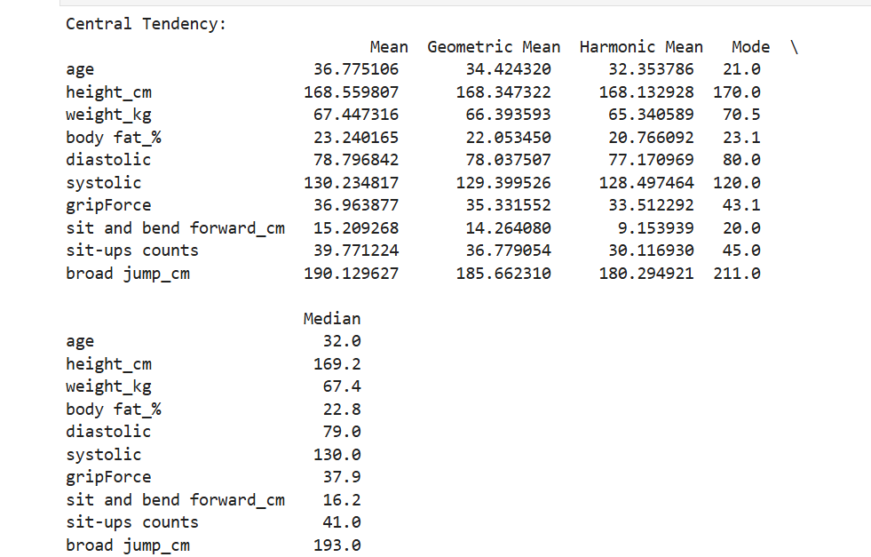

* 1. Measure of Dispersion: Variance, Standard deviation, Shape of Data (Symmetric, Skewness), Inter Quartile Range (IQR) / percentiles, Range, Mean Absolute Deviation(MAD)

**Code:**

# Mean Absolute Deviation (MAD)

**mad_values = df[numeric_columns].apply(lambda x: np.mean(np.abs(x - np.mean(x))))**

# Dispersion Results

**dispersion = pd.DataFrame({**

**'Variance': variance_values,**

**'Standard Deviation': std_dev_values,**

**'Skewness': skewness_values,**

**'IQR': iqr_values,**

**'Range': range_values,**

**'MAD': mad_values**

**})**

**print("Dispersion:\n", dispersion)**

**Output:**

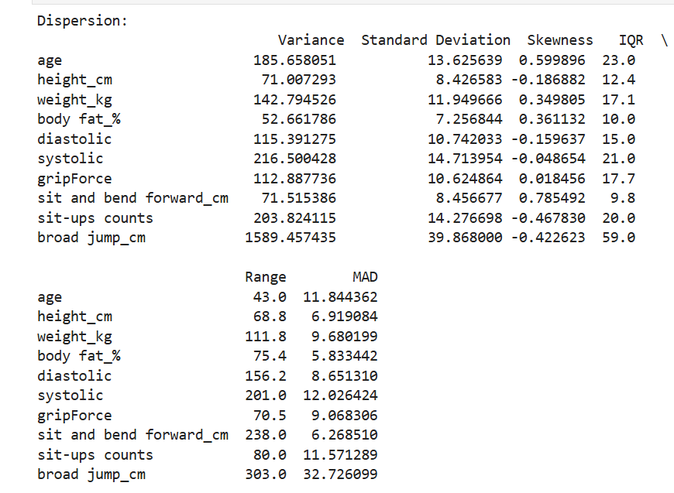

1.3 Correlation between features.

**Code:**

# Correlation Matrix (default is Pearson correlation)

**correlation_matrix = df[numeric_columns].corr()**

**print("Correlation Matrix:\n", correlation_matrix)**

**Output:**

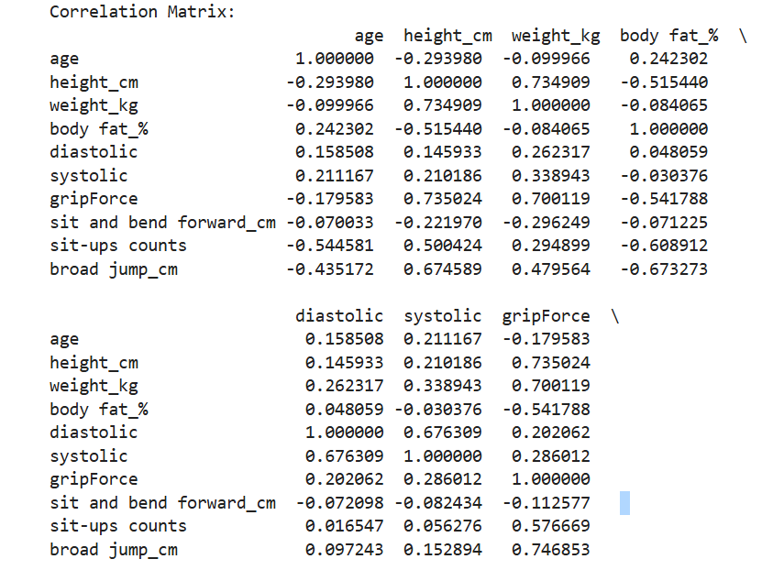

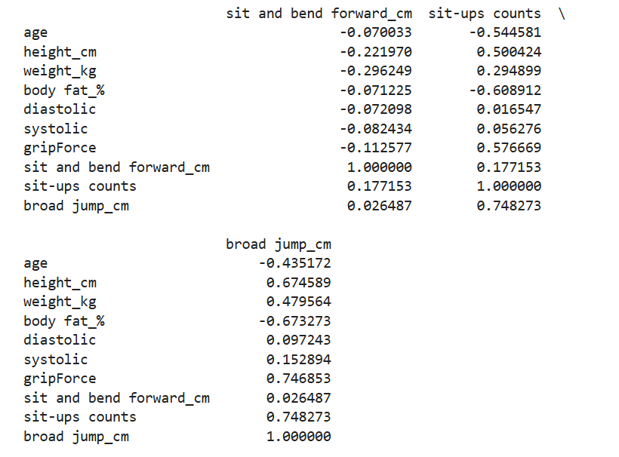

1.4. Visualizing Data Distribution: Boxplot, Histograms, Density plots, Scatterplot, Bar chart

**Code:**

**Boxplot:**

# Boxplot for each numerical feature

**sns.boxplot(data=df[numeric_columns])**

**plt.title('Boxplot of Numerical Features')**

**plt.xticks(rotation=90)**

**plt.show()**

**Output:**

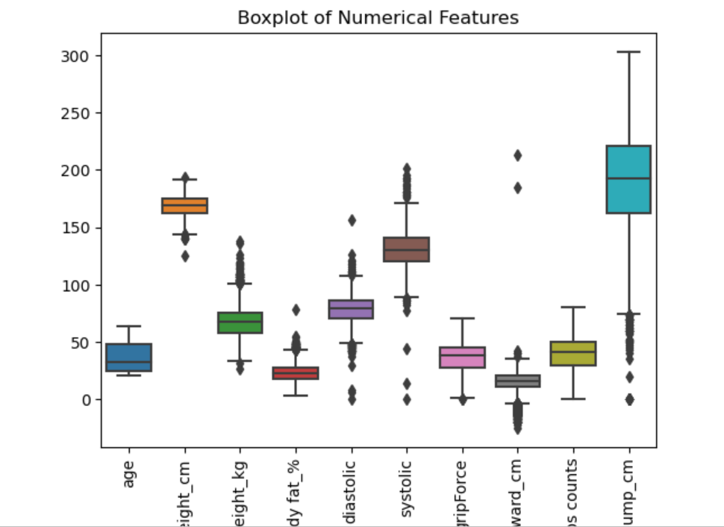

**Histograms**

# Histogram for each feature

**df[numeric_columns].hist(figsize=(10, 8), bins=10)**

**plt.suptitle('Histograms of Numerical Features')**

**plt.show()**

**Output:**

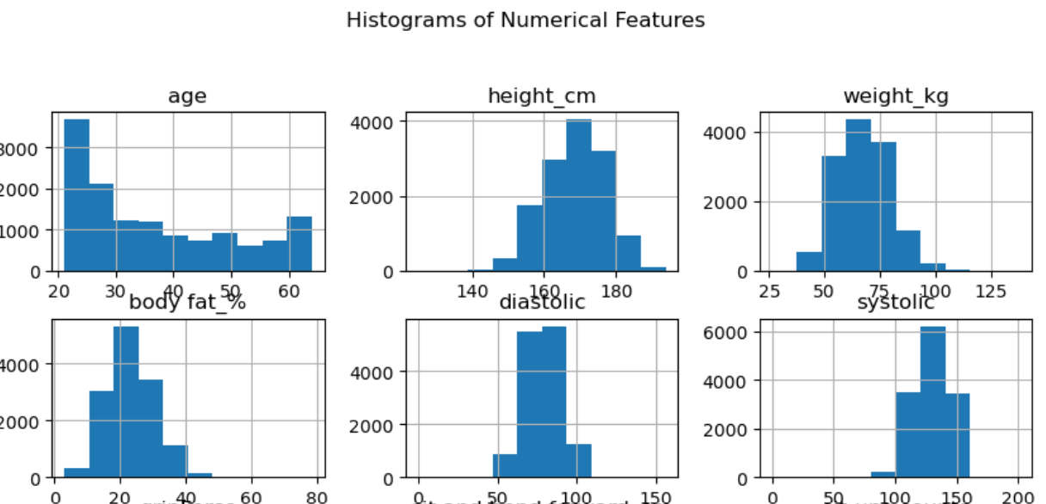

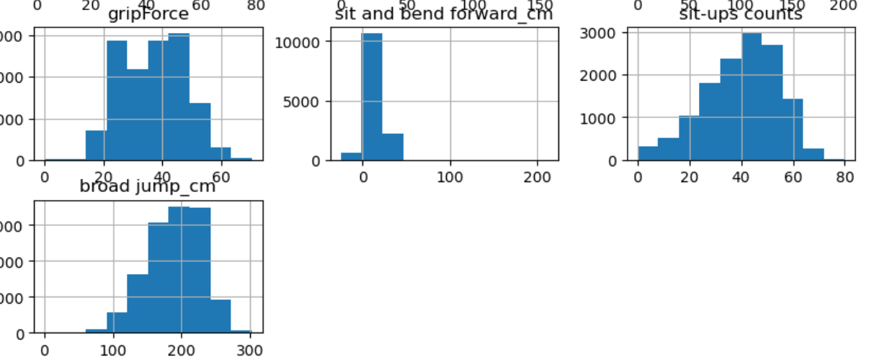

**Density Plots:**

# Density Plot for each feature

**df[numeric_columns].plot(kind='density', subplots=True, layout=(4,3), figsize=(12,10), sharex=False)**

**plt.suptitle('Density Plots of Numerical Features')**

**plt.show()**

**Output:**

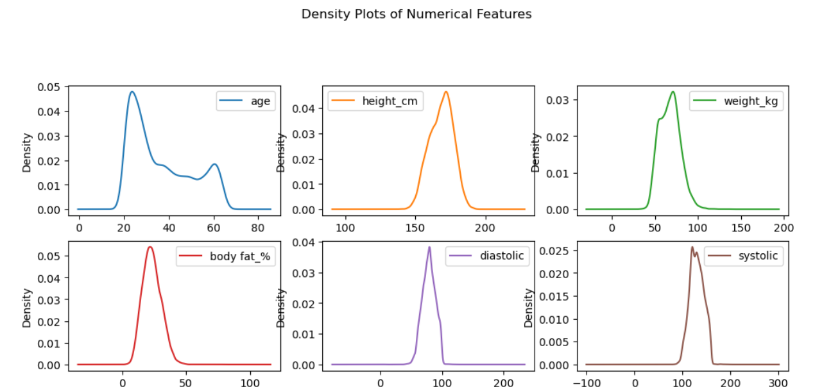

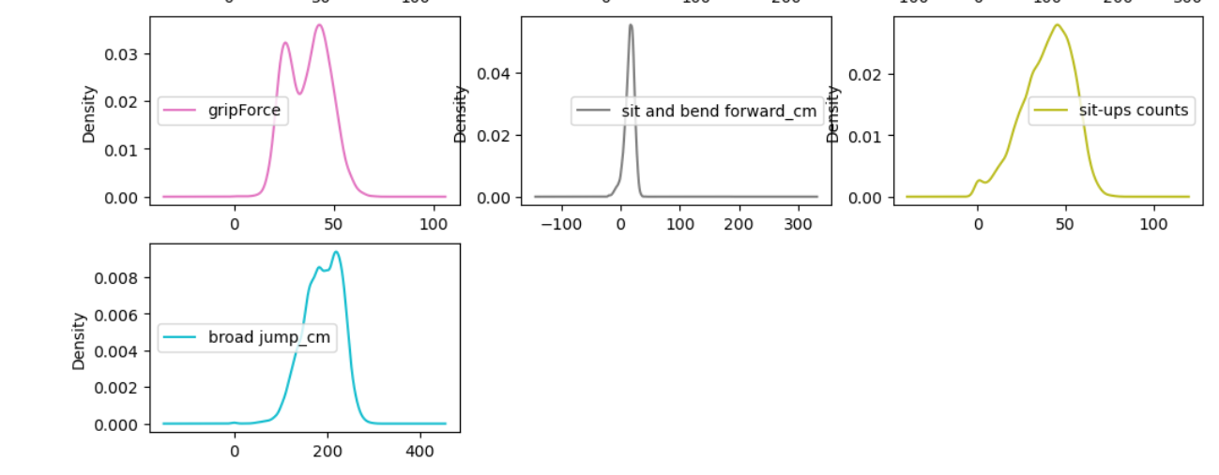

**Scatterplots:**

# Scatterplot between 'height_cm' and 'weight_kg'

**sns.scatterplot(x='height_cm', y='weight_kg', data=df)**

**plt.title('Scatterplot between Height and Weight')**

**plt.show()**

**Output:**

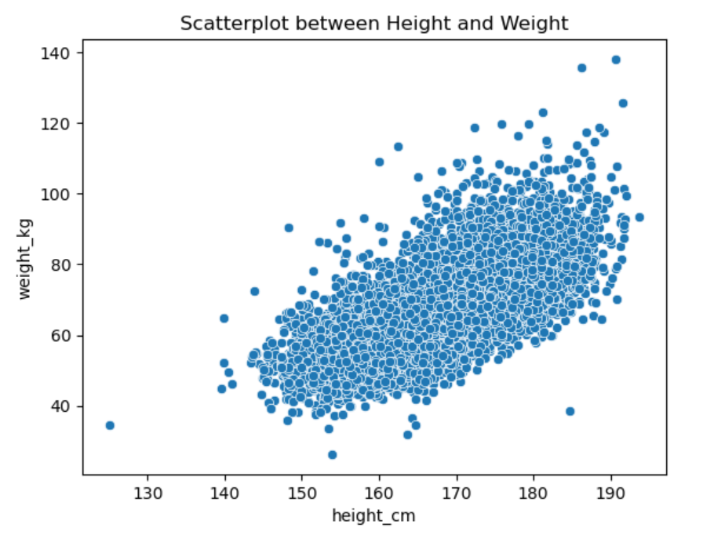

**Bar Chart:**

# Bar chart of Value Counts for 'age' (or any other column)

**df['age'].value_counts().plot(kind='bar')**

**plt.title('Bar Chart of Age Distribution')**

**plt.xlabel('Age')**

**plt.ylabel('Count')**

**plt.show()**

**Output:**

