Predictive analytics

Name : Shalu Priya

Sap : 500107625

Roll : R2142220839

Batch : 4 (Non-H)

Course : B.Tech CSE AIML

Experiment – 1

1. **Write a Python program to perform basic arithmetic operations (addition, subtraction, multiplication, division, and modulus) on two numbers.**

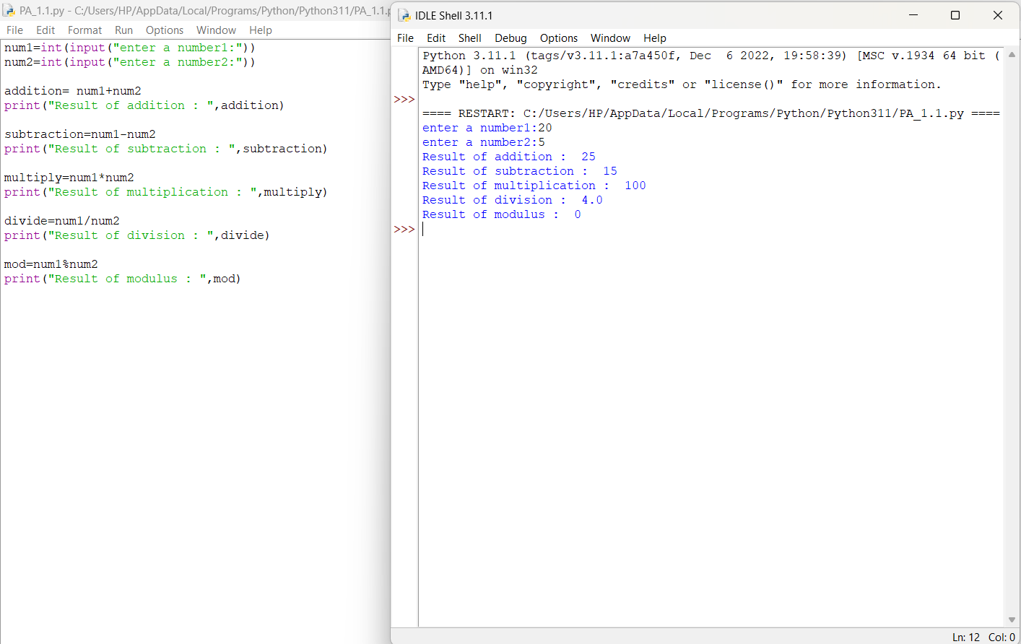

1. **Create variables of different data types (integer, float, string, boolean) and perform basic operations on them.**

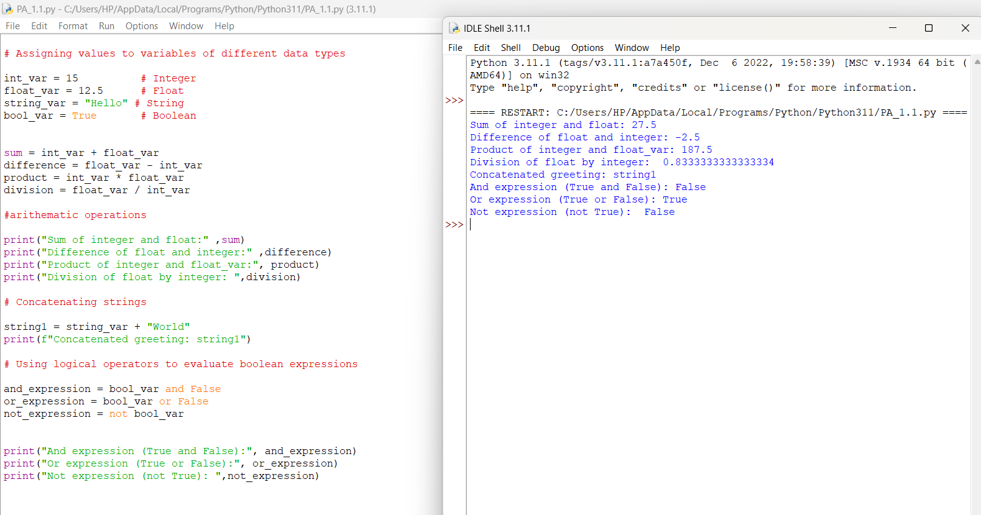

1. **Write a program to take user input, process it, and display the result.**

Prompt the user to enter their name.

Greet the user using their name.

Calculate and print the user's age based on their birth year.

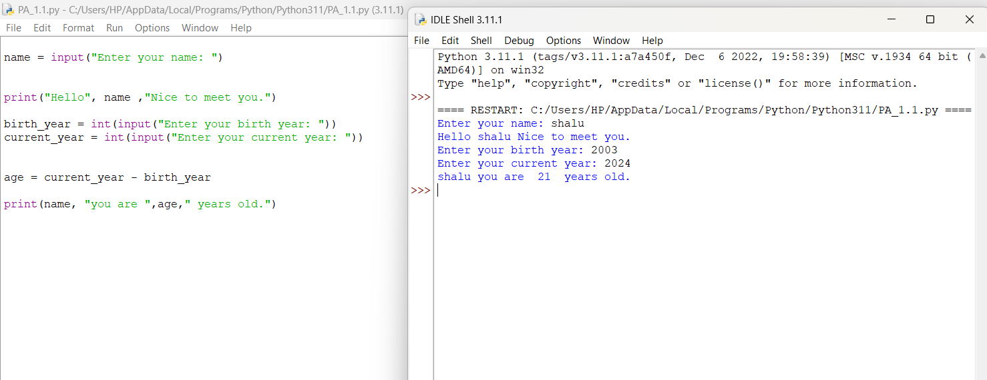

1. Write a program to check if a number is even or odd.
   1. Prompt the user to enter a number.
   2. Use the modulus operator to determine if the number is even or odd.
   3. Print the appropriate message.

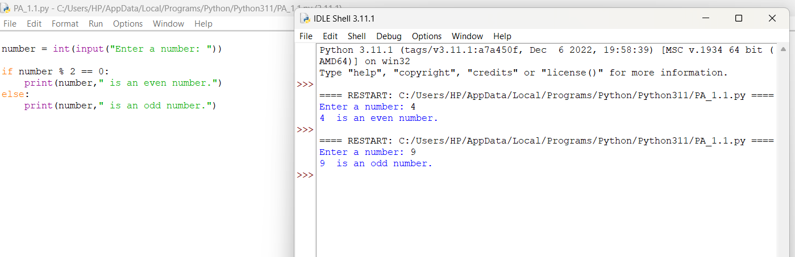

1. Write a program to print the numbers from 1 to 10 using both for and while loops.

Use a for loop to iterate through a range of numbers.

Use a while loop with a counter variable.

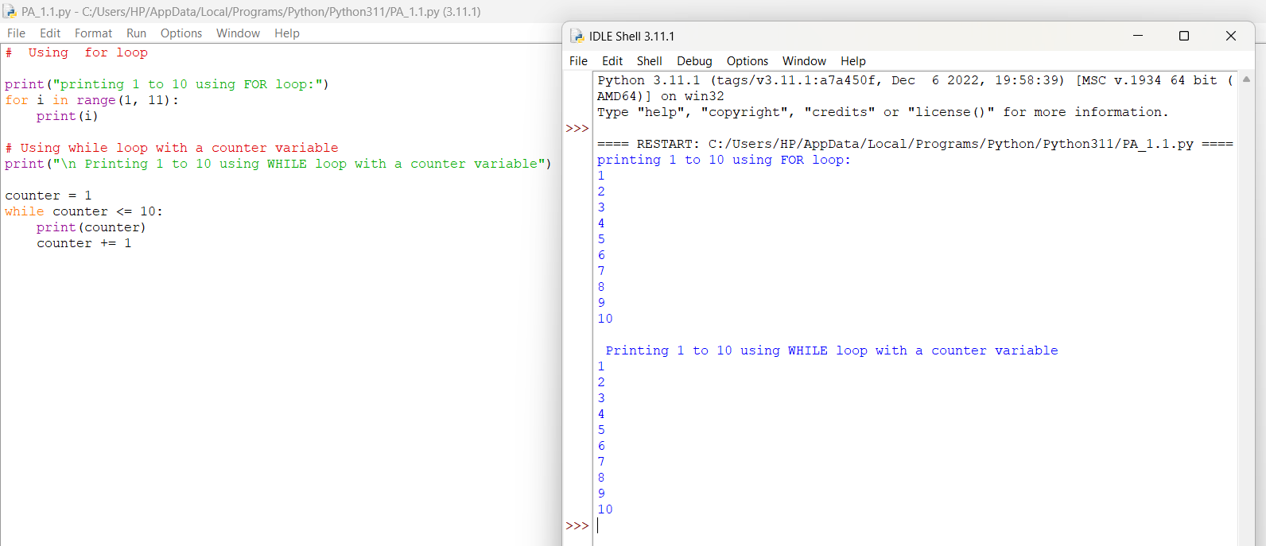

1. Create a list, access elements, modify elements, and perform list operations.

Create a list of fruits.

Access elements using indexing.

Modify elements in the list.

Add and remove elements from the list.

Find the length of the list.

Sort the list in ascending and descending order.

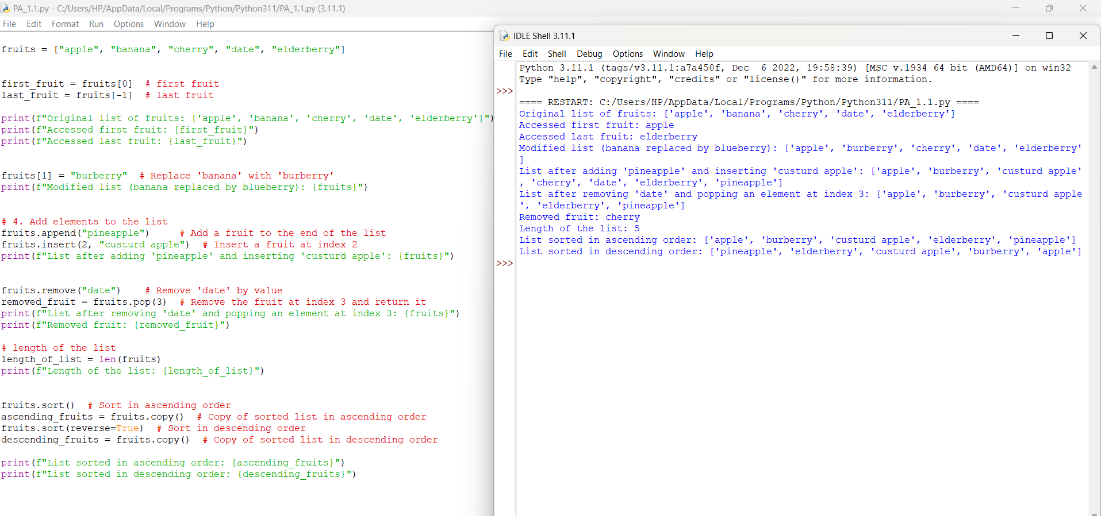

1. **Manipulate strings using various built-in functions.**

Create a string variable and find the length of the string.

Convert the string to uppercase and lowercase.

Check if a substring exists in the string.

Split the string into a list of words.

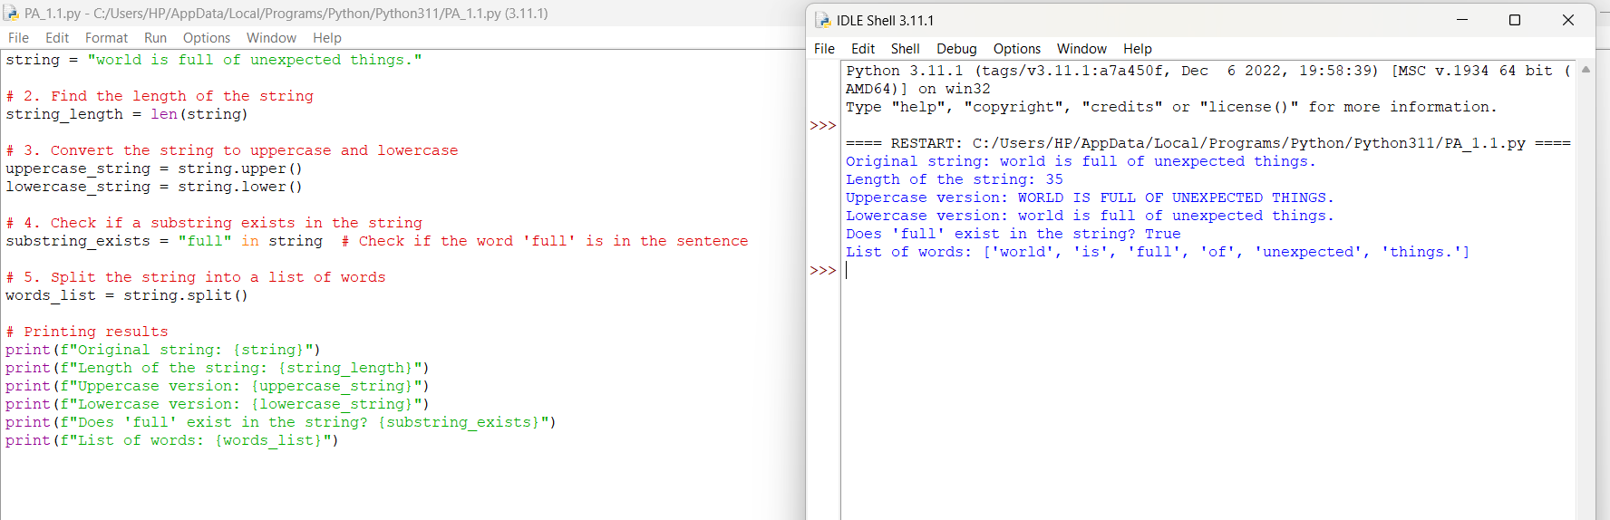

1. **Write a program to find the largest and smallest number in a list.**

