PREDECTIVE ANALYTICS

Lab -3

Name : shalu priya

Sap : 500107625

Roll no: R2142220839

Course : b.tech cse

Batch : 4 (nh)

Submitted to : Priyanka singh

Q1. Array Creation and Manipulation:

* Create different types of arrays (1D, 2D, 3D) using various methods (np.array, np.arange, np.linspace, etc.).
* Perform basic operations on arrays (indexing, slicing, reshaping, concatenation).
* Investigate array attributes like shape, size, dtype, ndim.
* Use methods like reshape, resize, flatten,

Code :

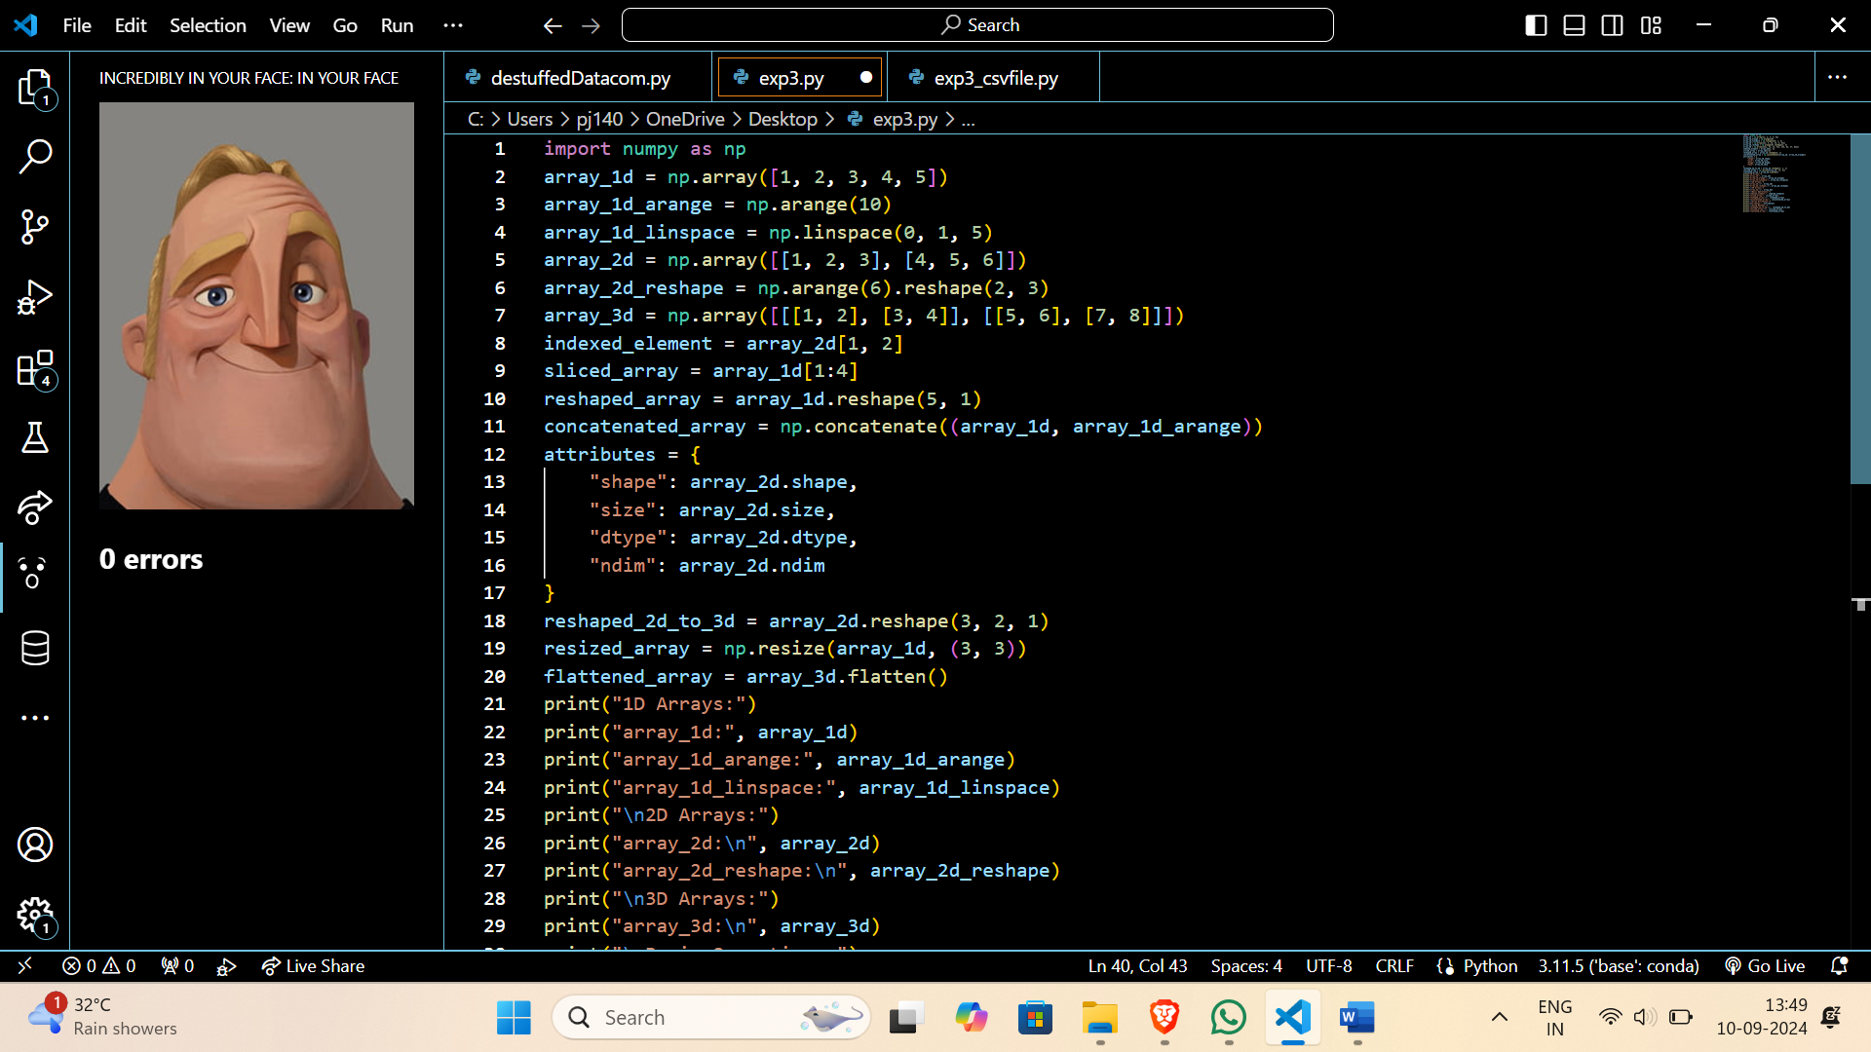

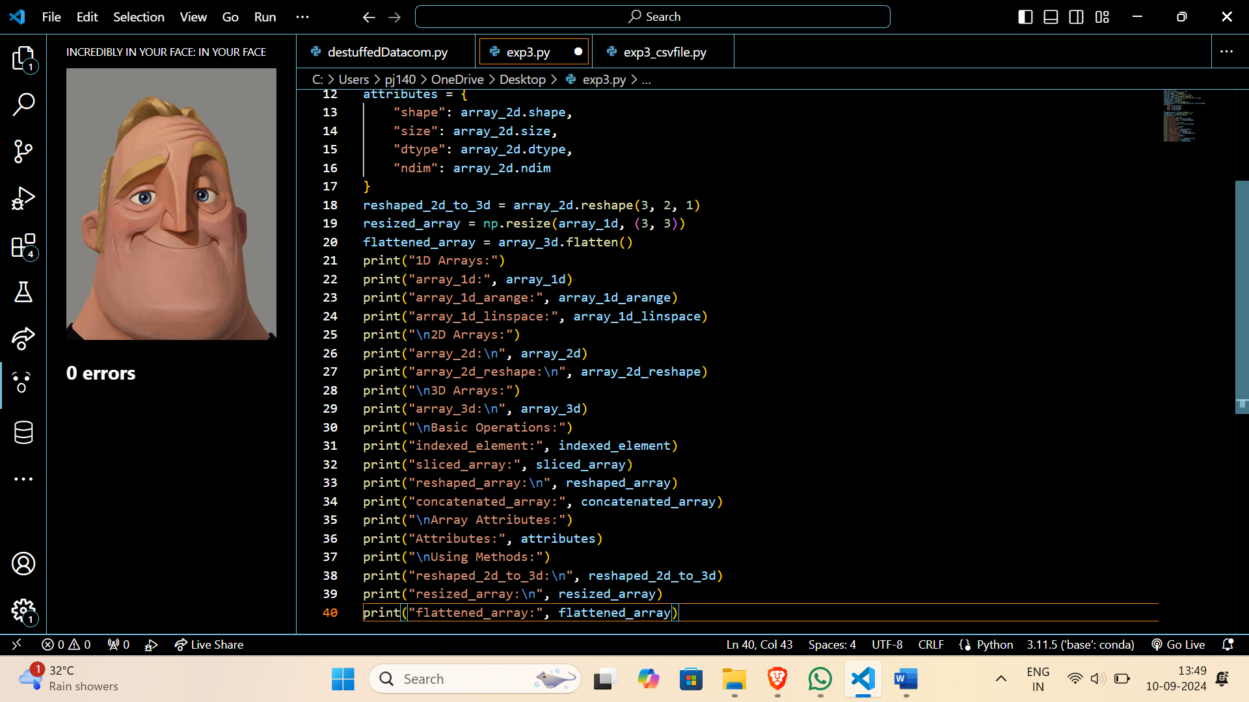

Output:

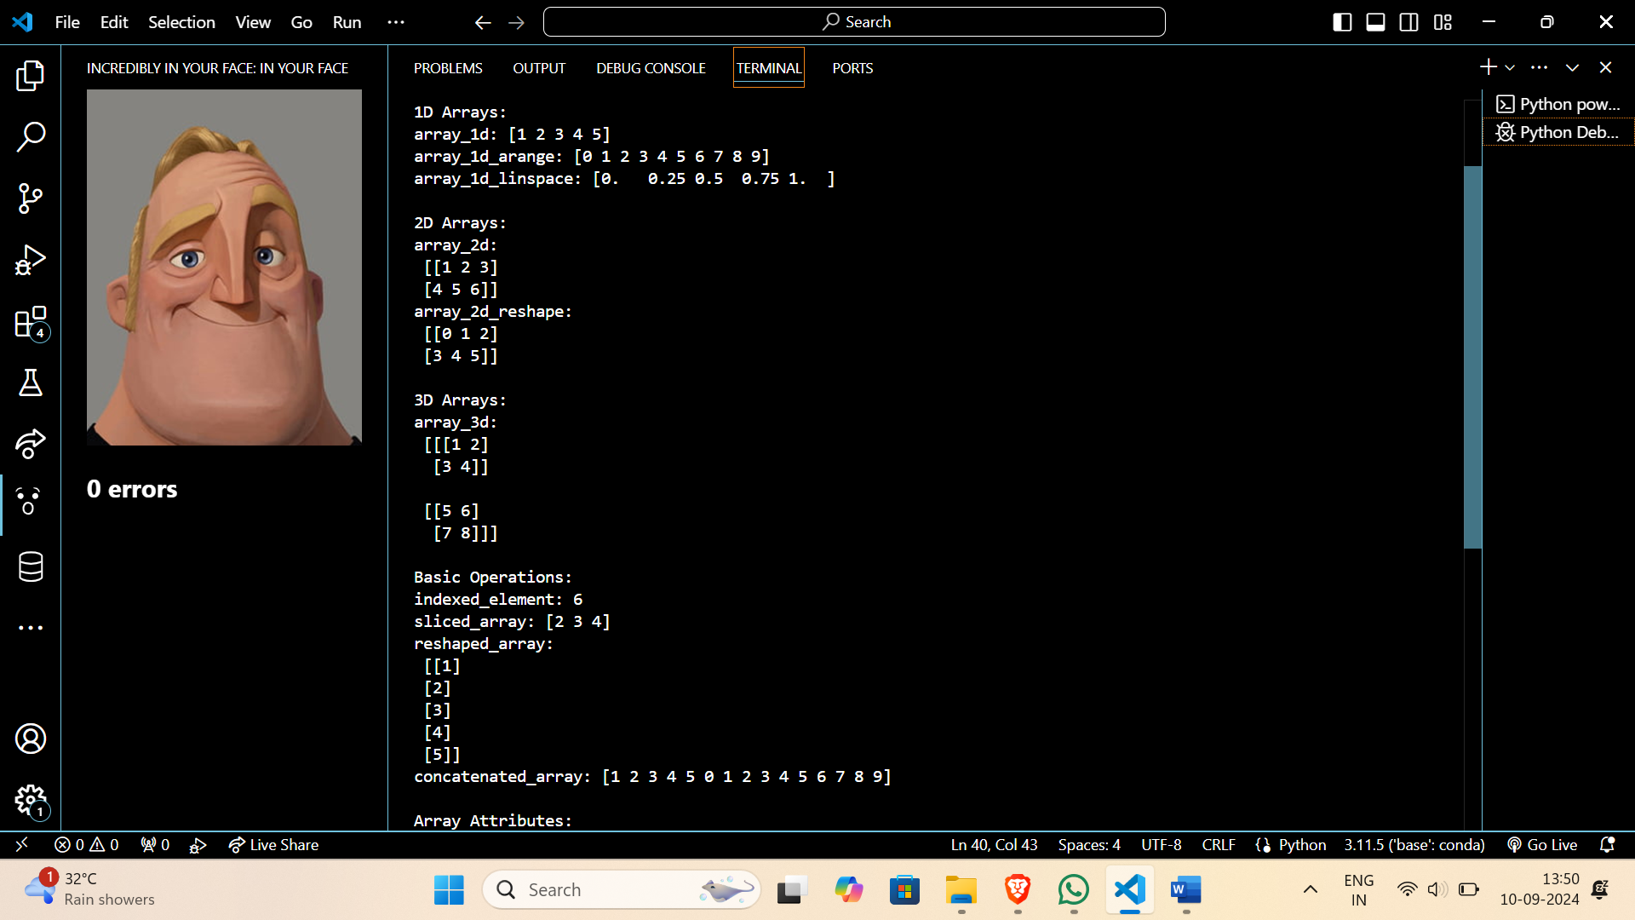

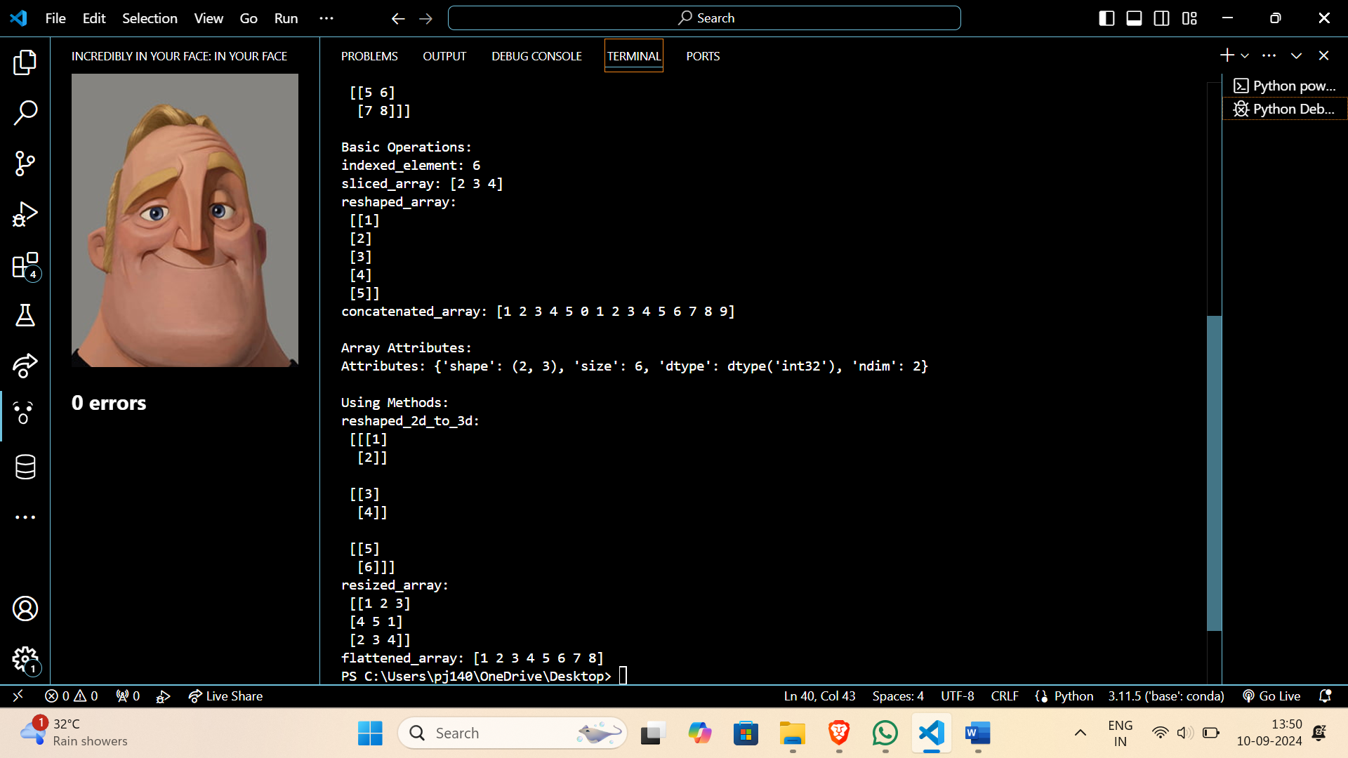

Q2. **Data Loading and Preprocessing:**

* Load a dataset (e.g., CSV, Excel) using NumPy.
* Clean and preprocess the data (handling missing values, normalization, standardization).
* Calculate mean, median, standard deviation, variance, and other statistical measures.

Code :

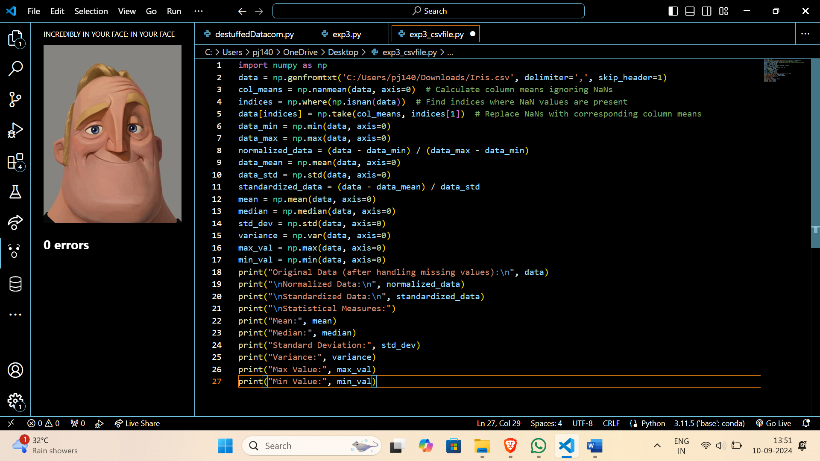

Output:

