GIT Document

git init

git add .

git commit -m "dashboard"

git remote add origion MultiPlayerGame.git

git remote -v

git push origion master

pull code from any branch-

git checkout branchname

git pull <remote> <branchname>

<https://www.youtube.com/watch?v=sgzkY5vFKQQ>

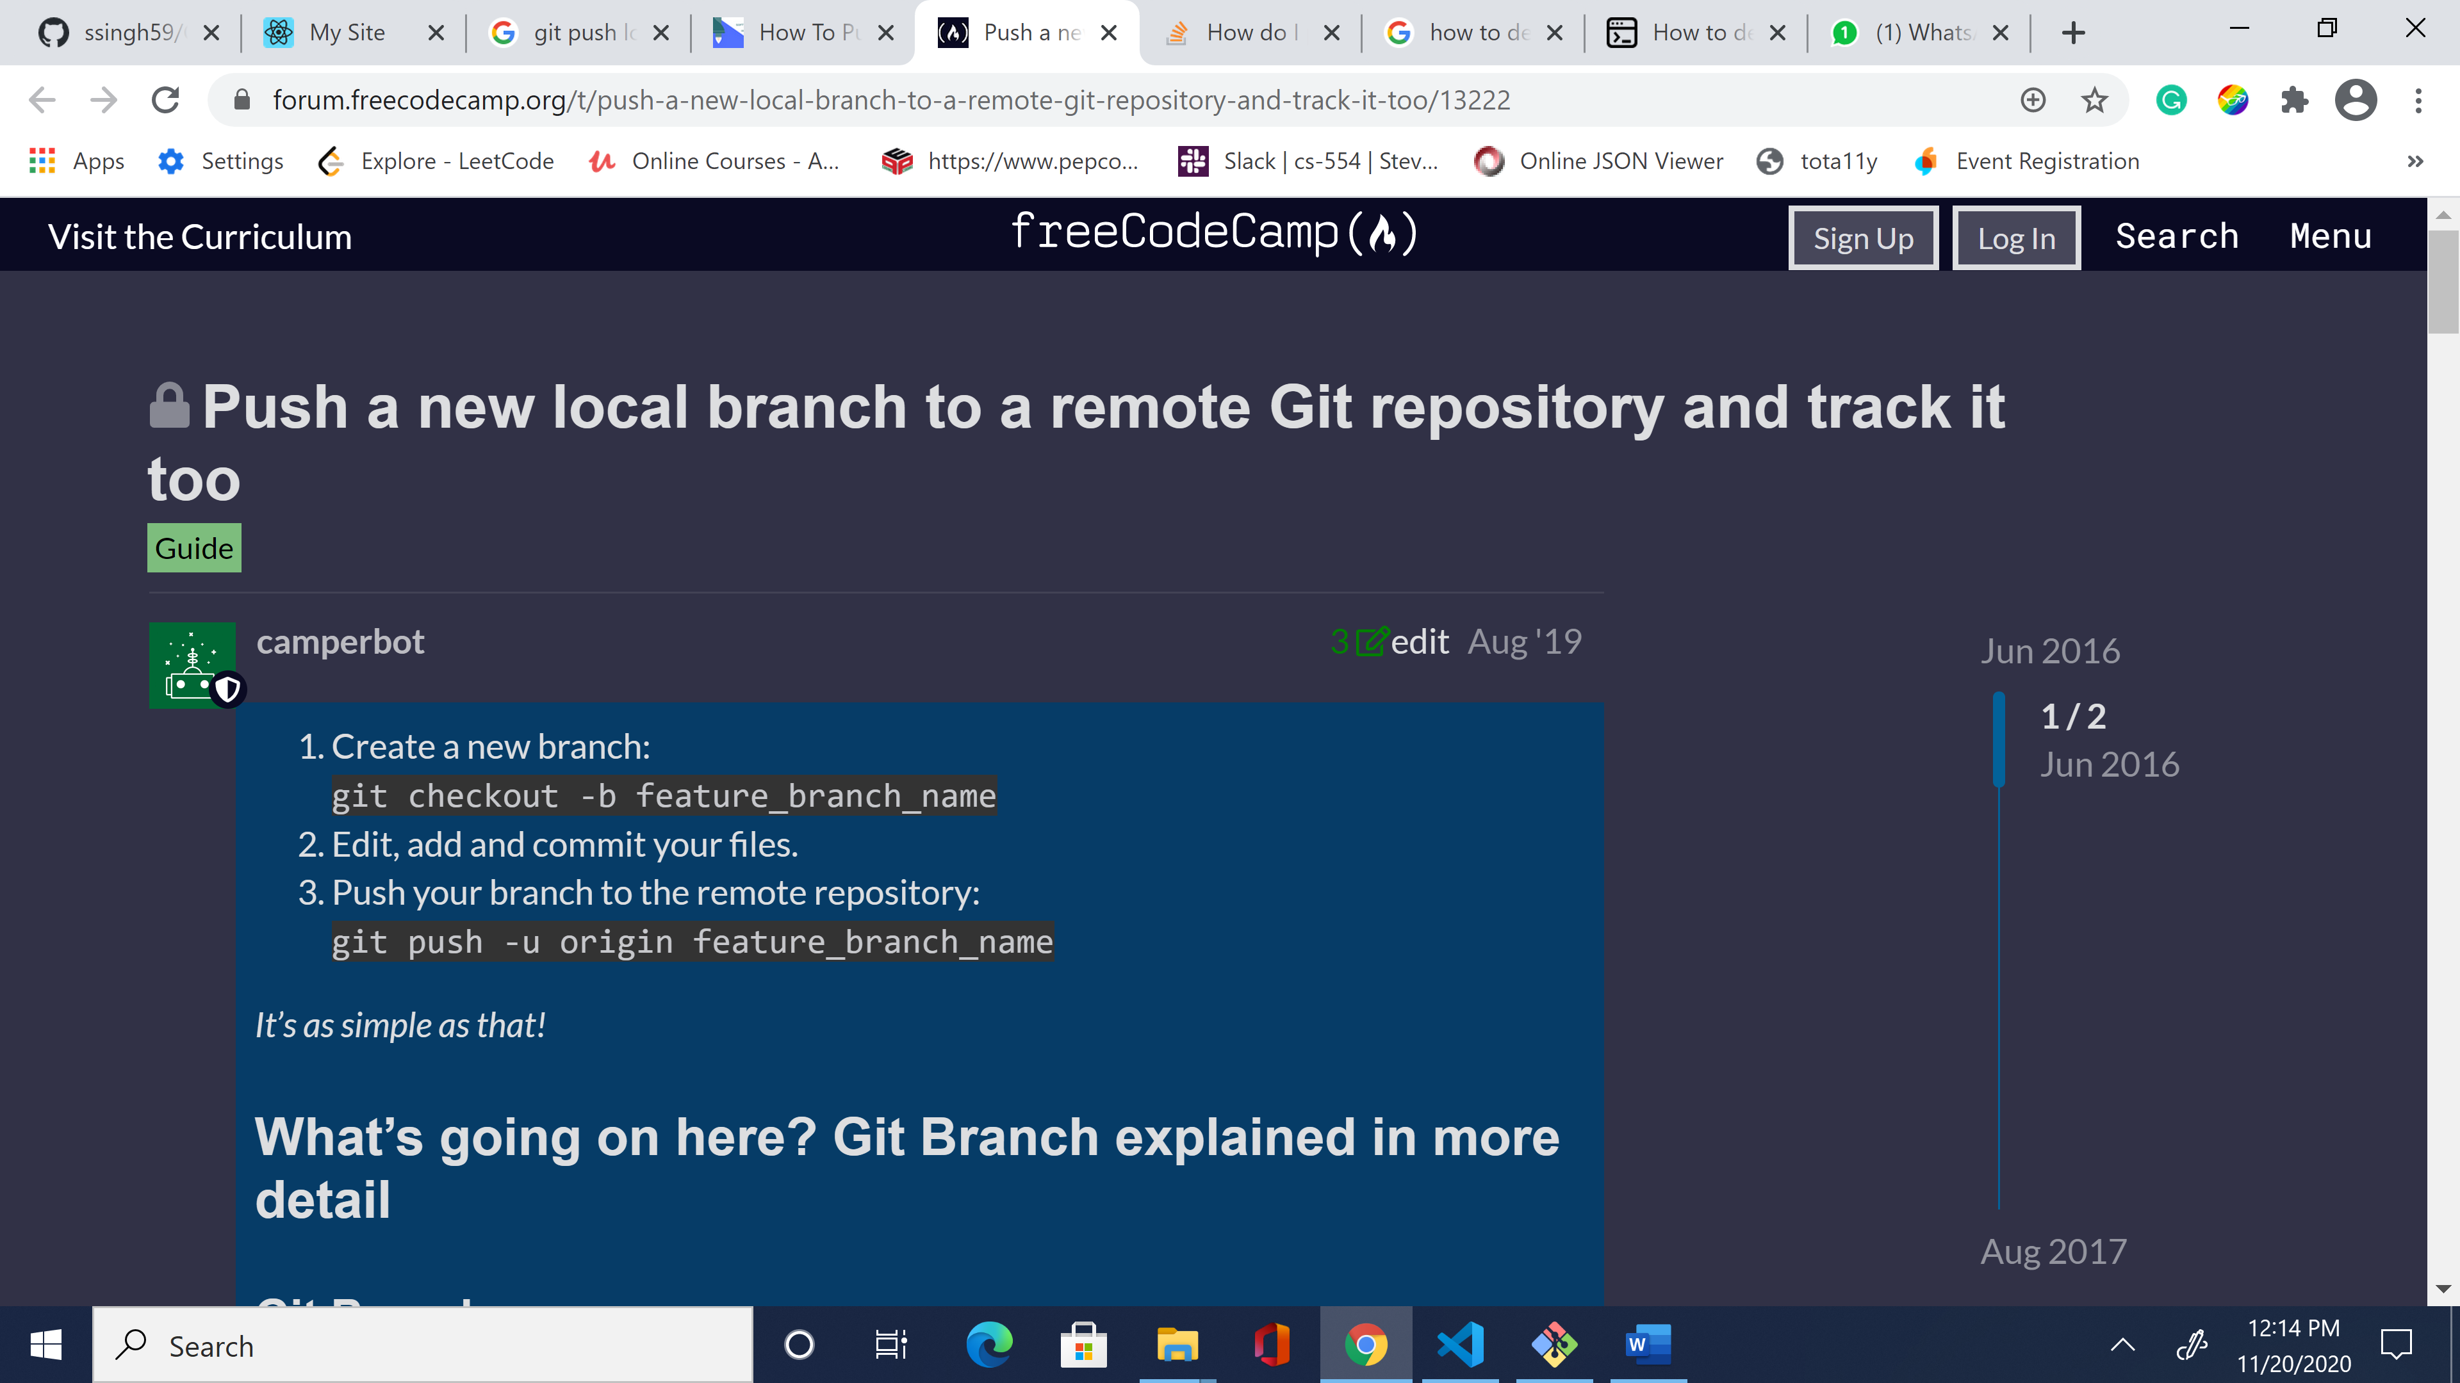

Delete branch

