**PROJECT TITLE: NOISE POLLUTION MONITORING-IoT**

**Phase 2-Innovation**

**Sensors:**

1. **Microphones:**

**These are the primary sensors used to capture sound waves and convert them into electrical signals. They come in different types, such as condenser microphones, electret microphones, and MEMS (Micro-Electro-Mechanical Systems) microphones.**

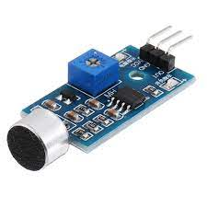

1. **Sound Level Meters:**

**These are specialized devices with built-in microphones and circuitry designed for accurate sound level measurement. They often include display screens for real-time monitoring.**

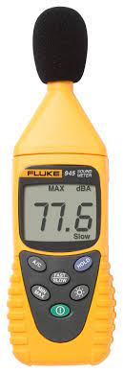

1. **Acoustic Sensors:**

**Some systems use specialized acoustic sensors that can detect specific frequency ranges or patterns of noise, helping identify sources of noise pollution.**

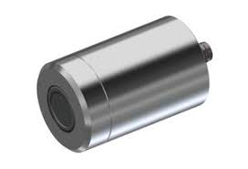

1. **Weather Sensors:**

**Weather conditions can affect noise propagation, so temperature, humidity, and wind speed sensors may be integrated to account for these factors in noise level measurements.**

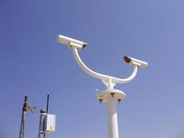

1. **GPS:**

**Global Positioning System (GPS) receivers are used to geotag noise measurements, allowing for spatial analysis and mapping of noise pollution.**

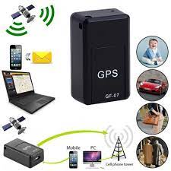

1. **Data Loggers:**

**These devices record and store noise data over time, allowing for long-term monitoring and analysis.**

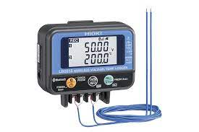

**7.Remote Sensors:**

**Wireless or network-connected sensors can be deployed at various locations and communicate data to a central monitoring system, enabling real-time**

1. **Environmental Sensors:**

**In addition to noise level sensors, environmental sensors measuring air quality, vibration, or light levels may be integrated to provide a more comprehensive understanding of the environment.**

**Steps for Algorithm:**

**1. Start**

**2. Gather Data:**

**- Collect noise data from sensors (e.g., microphones).**

**- Convert analog data to digital if needed.**

**3. Preprocess Data:**

**- Filter out irrelevant noise.**

**- Normalize data if necessary.**

**4. Analyze Data:**

**- Calculate noise levels.**

**- Compare to predefined thresholds.**

**5. Decision Point:**

**- Is the noise level above the threshold?**

**- Yes: Proceed to the next step.**

**- No: Continue monitoring.**

**6. Alert Generation:**

**- Generate an alert or notification.**

**- Specify the type and severity of the alert.**

**7. Notify Authorities:**

**- Send alerts to relevant authorities or individuals.**

**8. Store Data:**

**- Save historical noise data for analysis and reporting.**

**9. Visualization:**

**- Generate graphs or charts for noise trends.**

**- Provide a user interface for real-time monitoring.**

**10. Reporting:**

**- Generate noise pollution reports periodically or on demand.**

**11. End**

**Flow chart:**

Start

Gather data

End

Report

Visualisation

Store data

Notify authorities

Give Alert

Decision

point

p

poi

p

Point

Analyse data

Preprocess data

Block Diagram

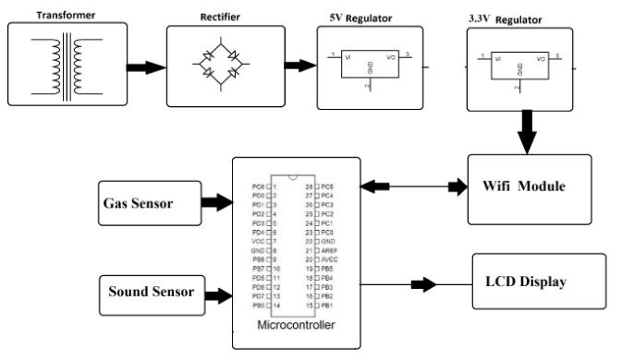

**Description:**

1. **Transformer**

**A transformer is a type of neural network architecture used in machine learning and deep learning, designed for processing sequences of data by using attention mechanisms to capture relationships between elements in the sequence. It has been influential in various natural language processing tasks and beyond.**

1. **Rectifier**

**rectifier is an electrical device that converts alternating current, which periodically reverses direction, to direct current, which flows in only one direction. The reverse operation is performed by an inverter. The process is known as rectification, since it "straightens" the direction.**

1. **Microcontroller**

**A microcontroller is a compact integrated circuit (IC) that contains a processor, memory, and input/output peripherals. It is designed to execute specific tasks and is commonly used in embedded systems, such as in household appliances, automotive systems, and electronic gadgets. Microcontrollers are programmed to perform various functions and are a fundamental component in the field of embedded electronics and robotics.**

1. **Voltage regulator**

**voltage regulator is a system designed to automatically maintain a constant voltage. A voltage regulator may use a simple feed-forward design or may include negative feedback. It may use an electromechanical mechanism, or electronic components. Depending on the design, it may be used to regulate one or more AC or DC voltages.**

**Applications**

**1. Urban Planning: Helps city planners identify noisy areas and plan for noise-reducing measures, such as sound barriers or zoning regulations.**

**2. Environmental Impact Assessment: Used to assess the noise impact of construction, industrial, or infrastructure projects on surrounding ecosystems.**

**3. Health Studies: Enables researchers to study the health effects of noise pollution on residents living near noisy areas.**

**4. Noise Regulation Compliance: Helps authorities enforce noise ordinances and regulations by monitoring noise levels in different areas.**

**5. Noise Complaint Resolution: Allows authorities to investigate and address noise complaints from residents quickly.**

**6. Traffic Management: Helps optimize traffic flow by monitoring noise from vehicles and identifying congestion or problem areas.**

**7. Airport Noise Monitoring: Crucial for airports to manage and mitigate noise pollution in surrounding communities.**

**8. Industrial Monitoring: Assists industries in complying with noise emission standards and reducing the impact of their operations on nearby communities.**

**9. Public Awareness: Provides real-time noise data to inform the public about noise pollution levels and encourage noise reduction efforts.**

**10. Research and Data Analysis: Supports scientific studies to better understand noise pollution patterns and develop effective mitigation strategies.**

**Overall, noise pollution monitoring systems play a vital role in safeguarding public health, improving urban planning, and promoting environmental sustainability.**

**transformer:**

**A transformer is a type of neural network architecture used in machine learning and deep learning, designed for processing sequences of data by using attention mechanisms to capture relationships between elements in the sequence. It has been influential in various natural language processing tasks and beyond.**