**Task 3: SQL Data Analysis**

**Creating a database(shop) and tables (Items, sales) and inserting the dataset to these tables using Import data wizard option in the MySQL Workbench.**

**Query:**

create database shop;

use shop;

create table Items (

Item_Identifier VARCHAR(20),

Item_Weight DECIMAL(6,2),

Item_Fat_Content VARCHAR(20),

Item_Type VARCHAR(50),

Item_MRP DECIMAL(8,2)

);

select * from Items;

create table Sales (

Item_Identifier VARCHAR(20),

Outlet_Identifier VARCHAR(20),

Item_Visibility DECIMAL(6,4),

Item_Outlet_Sales DECIMAL(8,4)

);

select * from sales;

**Output Screenshot:**

**Table 1: Items**

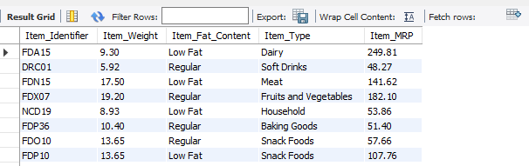

**Table 2: Sales**

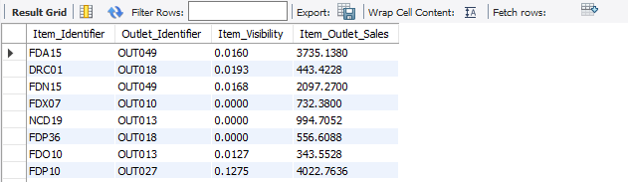

**SQL Analysis:**

1. **Write a query to retrieve all items with Item_Type = 'Dairy' and Item_MRP greater than 100. Order the result by Item_MRP in descending order.**

**Query:**

select * from items where Item_Type='Dairy' and Item_MRP > 100 order by Item_MRP desc;

**Output Screenshot:**

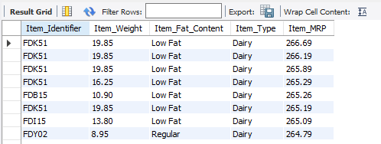

1. **Find the average Item_Outlet_Sales for each Outlet_Identifier and group the result accordingly.**

**Query:**

select Outlet_Identifier, avg(Item_Outlet_Sales) as Avg_Outlet_Sales from Sales group by Outlet_Identifier;

**Output Screenshot:**

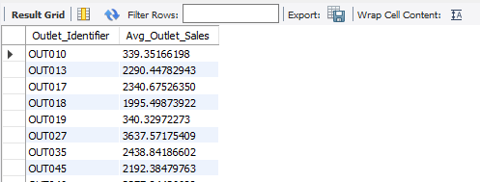

1. **List each Item_Type and its average MRP, sorted from highest to lowest.**

**Query:**

select Item_Type, avg(Item_MRP) as Avg_MRP from items group by Item_Type order by Avg_MRP desc;

**Output Screenshot:**

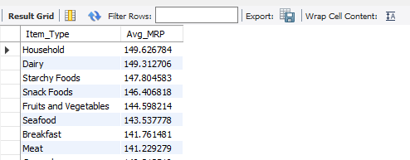

1. **Show all items that have “Regular” fat content and MRP below 100.**

**Query:**

select * from items where Item_Fat_Content='Regular' and Item_MRP < 100;

**Output Screenshot:**

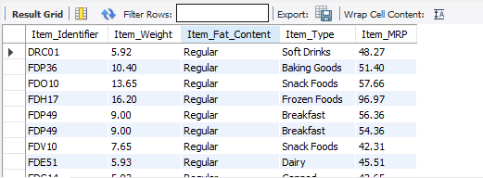

1. **Count the number of items per Item_Type.**

**Query:**

select Item_Type, count(*) as Count_Items from items group by Item_Type;

**Output Screenshot:**

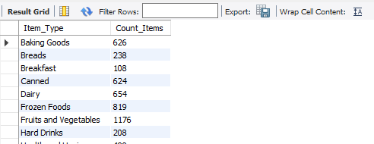

1. **Show item type, outlet identifier, and outlet sales using an INNER JOIN between Items and Sales.**

**Query:**

select i.Item_Type, s.outlet_Identifier, s.Item_Outlet_Sales from Items as i inner join Sales as s on i.Item_Identifier=s.Item_Identifier;

**Output Screenshot:**

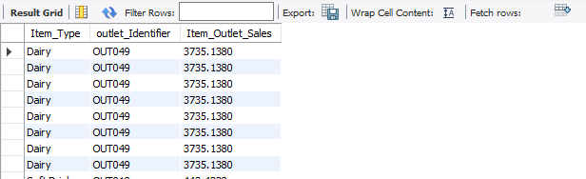

1. **Display all items with their sales info using a LEFT JOIN — include items even if not sold.**

**Query:**

select * from Items left join Sales on Items.Item_Identifier=Sales.Item_Identifier;

**Output Screenshot:**

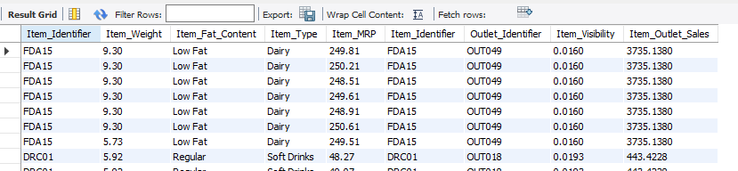

1. **Display all sales, including those whose item details are missing (use a RIGHT JOIN).**

**Query:**

select * from sales right join items on sales.Item_Identifier=items.Item_Identifier;

**Output Screenshot:**

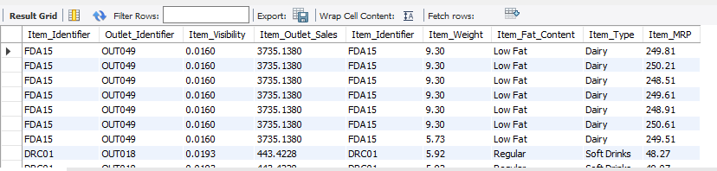

1. **Write an INNER JOIN to display Item_Identifier, Item_Type, Item_MRP, and Item_Outlet_Sales.**

**Query:**

select i.Item_Identifier, i.Item_Type, i.Item_MRP, s.Item_Outlet_Sales from Items i inner join sales s on i.Item_Identifier=s.Item_Identifier;

**Output Screenshot:**

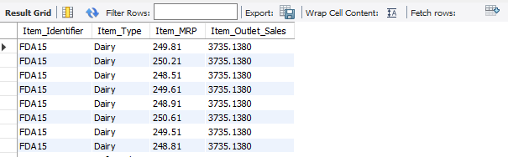

1. **Write a LEFT JOIN to display all items from the items table along with their Item_Outlet_Sales (if any). Include items even if they have no sales data.**

**Query:**

select i.Item_Identifier,i.Item_Weight,i.Item_Fat_Content,i.Item_Type, i.Item_MRP, s.Item_Outlet_Sales from items i left join sales s on i.Item_Identifier=s.Item_Identifier;

**Output Screenshot:**

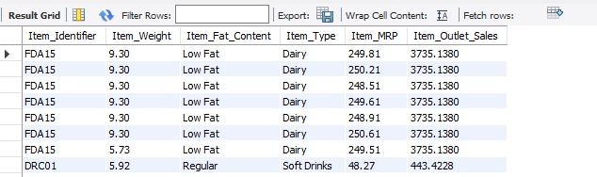

1. **Write a RIGHT JOIN to display all sales along with corresponding item details from items (if any). Include sales even if the item details are missing.**

**Query:**

select s.Item_Identifier, i.Item_Type, i.Item_MRP, s.Item_Outlet_Sales from items i right join sales s on i.Item_Identifier=s.Item_Identifier;

**Output Screenshot:**

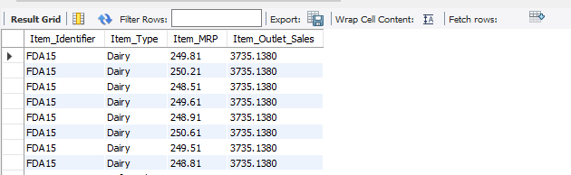

1. **Find all items whose MRP is greater than the average MRP of all items.**

**Query:**

select * from Items where Item_MRP > (select avg(Item_MRP) as Avg_MRP from Items);

**Output Screenshot:**

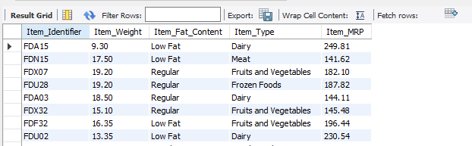

1. **Find the outlet(s) with sales higher than the average sales across all outlets.**

**Query:**

select Outlet_Identifier, Item_Outlet_Sales from sales where Item_Outlet_Sales > (select avg(Item_Outlet_Sales) from sales);

**Output Screenshot:**

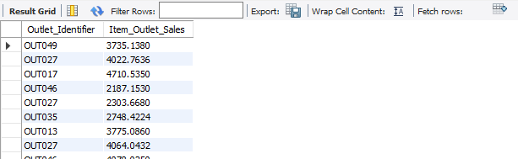

1. **Write a query to find the Item_Identifier with the maximum Item_Outlet_Sales using a subquery**.

**Query:**

select Item_Identifier, Item_Outlet_sales from sales where Item_Outlet_sales in (select max(Item_Outlet_sales) from sales);

**Output Screenshot:**

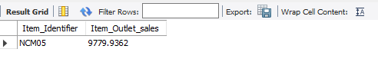

1. **Find the total sales (SUM) and average sales (AVG) for each Item_Type. Join items and sales tables appropriately.**

**Query:**

select i.Item_Type, avg(s.Item_Outlet_Sales) as Avg_Sales, sum(s.Item_Outlet_Sales) as total_Sales from items i join sales s on i.Item_Identifier=s.Item_Identifier group by i.Item_Type;

**Output Screenshot:**

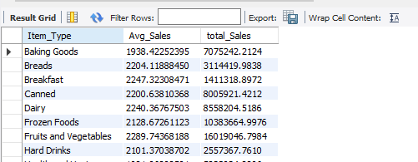

1. **Find the total sales per item type**.

**Query**:

select i.Item_Type, sum(s.Item_Outlet_sales) as total_sales from sales s join items i on i.Item_Identifier=s.Item_Identifier group by Item_Type;

**Output Screenshot:**

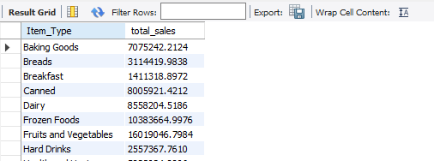

1. **Show the average visibility per Item_Type.**

**Query:**

select i.Item_Type, avg(s.Item_Visibility) as Avg_Item_Visibility from items i join sales s on i.Item_Identifier=s.Item_Identifier group by i.Item_Type;

**Output Screenshot:**

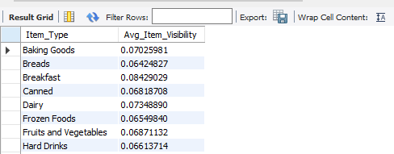

1. **Create a view that shows** **Item_Identifier, Item_Type, and total outlet sales**.

**Query**:

create view Item_sales as select i.Item_Identifier, i.Item_Type, sum(s.Item_Outlet_Sales) as Total_Sales from items i join sales s on i.Item_Identifier=s.Item_Identifier group by i.Item_Identifier, i.Item_Type;

**Output Screenshot:**

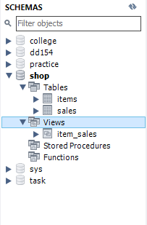

1. **Create a view for** **items with MRP above 150 and visibility below 0.02**.

**Query**:

create view Item_avalability as select i.Item_MRP, s.Item_Visibility from items i join sales s on i.Item_Identifier=s.Item_Identifier where i.Item_MRP > 150 and s.Item_Visibility < 0.02;

**Output Screenshot:**

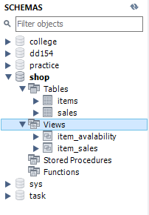

1. **Create a** **view** **called ItemSalesSummary that includes Item_Identifier, Item_Type, Item_MRP, Item_Outlet_Sales.**

**Query:**

create view ItemSalesSummary as select i.Item_Identifier, i.Item_Type, i.Item_MRP, s.Item_Outlet_Sales from items i join sales s on i.Item_Identifier=s.Item_Identifier;

**Output Screenshot:**

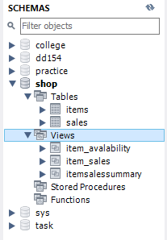

1. **Suggest an index that can optimize the query used in Q1 (WHERE Item_Type = 'Dairy' AND Item_MRP > 100 ORDER BY Item_MRP DESC).**

**Query:**

create index idx_Item_type_MRP on items(Item_Type,Item_MRP);

1. **Create indexes on Item_Identifier, Item_Type, and Outlet_Identifier to improve JOIN and filtering performance.**

**Query:**

create index idx_Item on items(Item_Identifier,Item_Type);

create index idx_Sale on sales(Outlet_Identifier);