**TASK 6: SALES TREND ANALYSIS USING AGGREGATIONS**

**Goal:**

1. Use EXTRACT(MONTH FROM order_date) for month.
2. GROUP BY year/month.
3. Use SUM() for revenue.
4. COUNT(DISTINCT order_id) for volume.
5. Use ORDER BY for sorting.
6. Limit results for specific time periods.

**Query:**

create database sales;

create table orders (order_id int, order_date date, order_amount double(10,2));

select * from orders;

**Output Screenshot:**

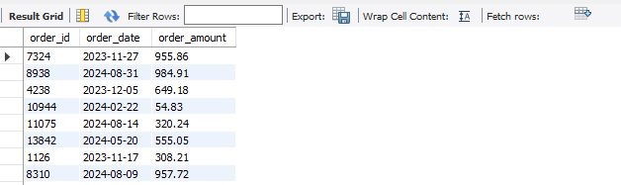

**Query:**

select month(order_date) as order_month, year(order_date) as order_year from orders;

**Output Screenshot:**

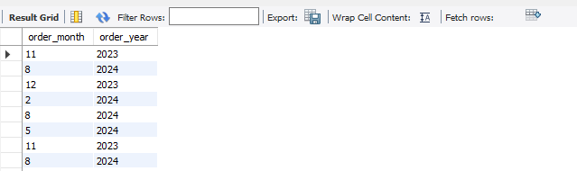

**Query:**

select month(order_date) as order_month, year(order_date) as order_year, sum(order_amount) as total_revenue, count(distinct order_id) as volume from orders where extract(year from order_date) = 2024 group by order_year, order_month order by order_year, order_month;

**Output Screenshot:**

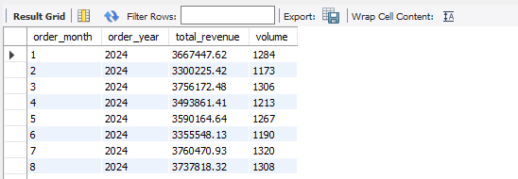

**Query:**

select month(order_date) as order_month, year(order_date) as order_year, sum(order_amount) as total_revenue, count(distinct order_id) as volume from orders group by order_year, order_month order by total_revenue desc limit 3;

**Output Screenshot:**

