SIMATS ENGINEERING
ASSESSMENT TOOL 1

COURSE NAME: COMPUTER NETWORKS
COURSE CODE: CSA07

COURSE OUTCOME COVERED
CO4:Design network topologies star, mesh, bus, and hybrid using networking devices,
transmission media, and cabling standards(BL2,BL6)
Assessment Tool Weightage: 40%

QUESTIONS: 5 Total Marks:25

Annexure A
Coding challenge

Code of Conduct:
I S HARIPRIYA (192412448) (Name / Reg No) certify that this submission is my original work and that I have adhered to the guidelines specified for this assessment.I understand that any violation of academic integrity rules will result in disciplinary action.
Signature of the student:
PRIYA

Annexure A
Coding challenge

1. Write a Python script that generates a star topology diagram (ASCII or graphical) given n
hosts and a central switch. The script must print each host label, the switch name, and the
connecting Cat6 UTP cable length.
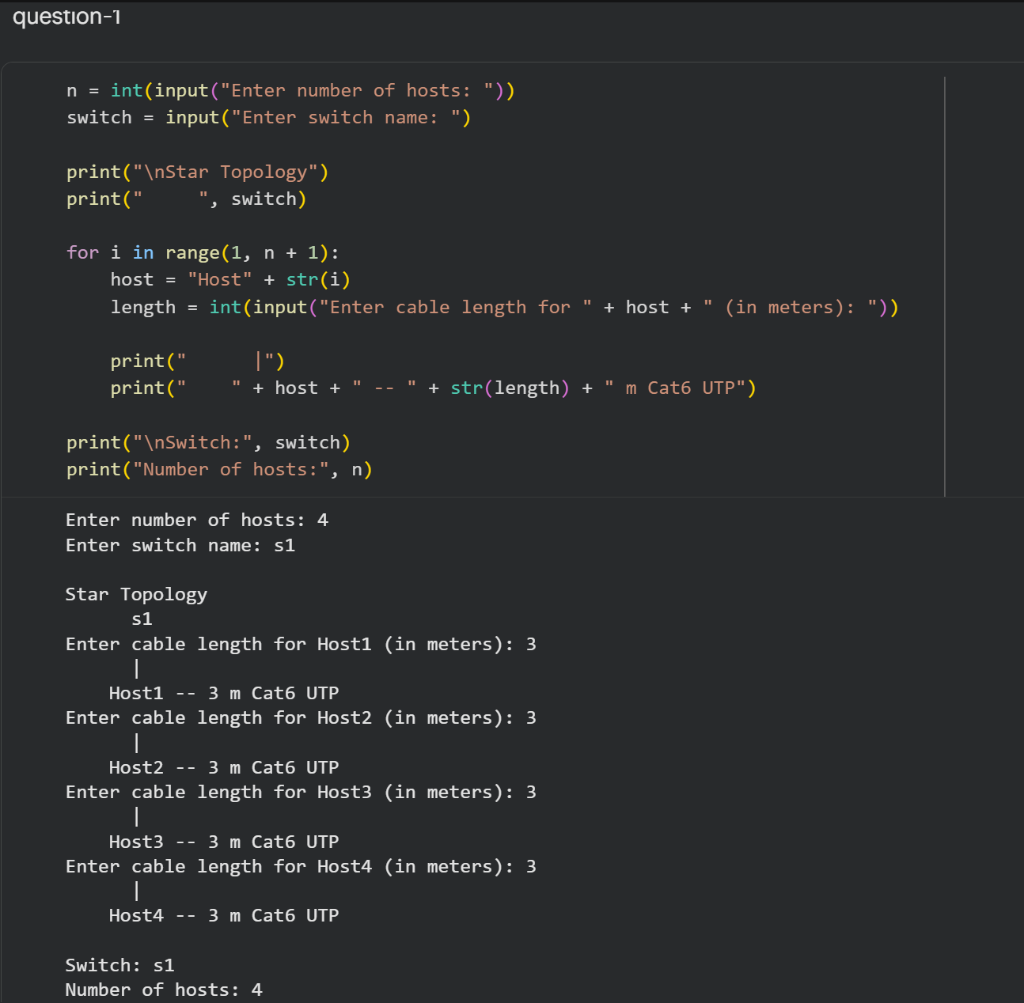

2. Code a function `validate_segment(length_m)` that returns True if the UTP segment is
within IEEE 802.3 limits (≤100 m) and False with an error message otherwise. Include at
least 3 test cases.
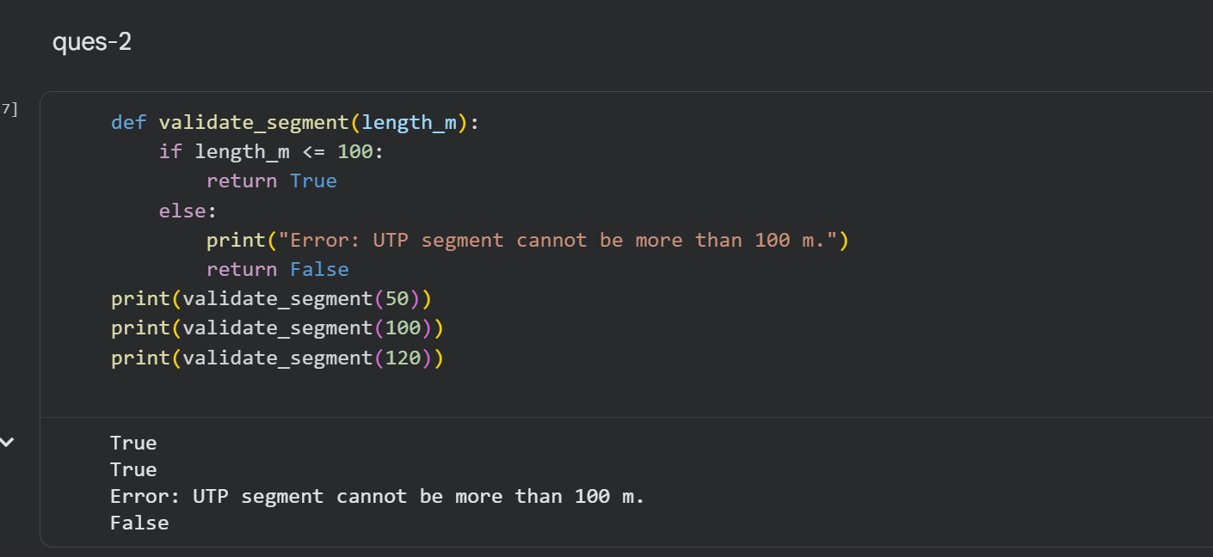

3. Write a script that simulates CSMA/CD on a star topology with 4 hosts. Log every
collision detection event and the back-off interval to a file named `csma_log.txt`.
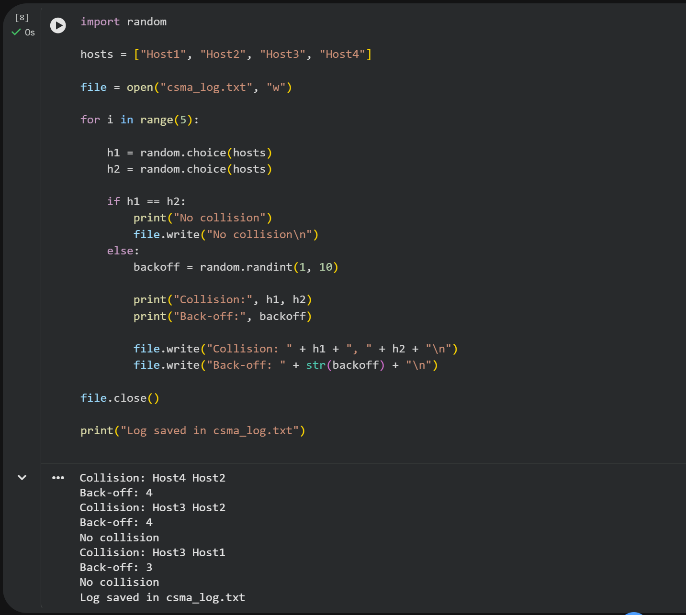

4. Using Python&#39;s `socket` library, write a client-server program that models two hosts
communicating through a star switch. Demonstrate message forwarding by printing the
switch&#39;s MAC address table after each frame transmission.
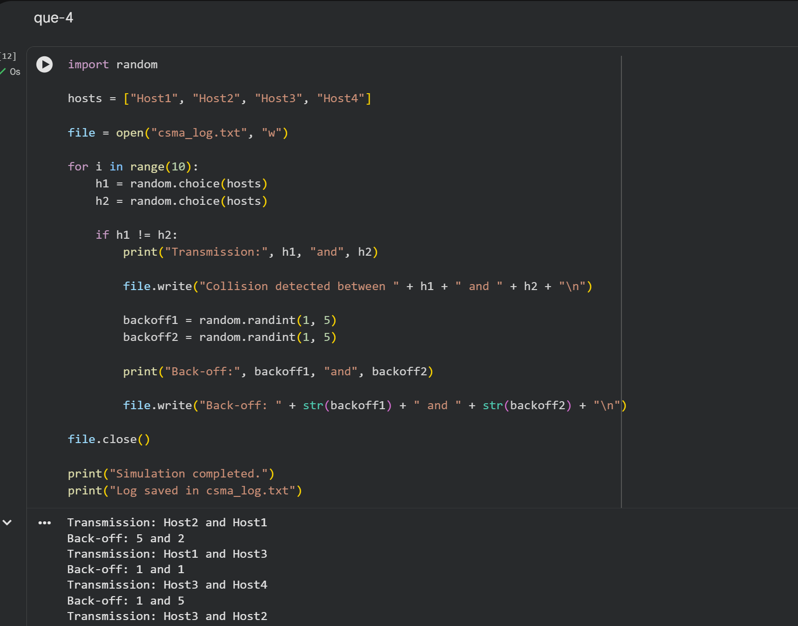

5. Create a class `StarSwitch` with methods `add_port(host_id)`, `remove_port(host_id)`, and
`broadcast(frame)`. Broadcast must send a frame to all ports except the source and log each
delivery.
