SIMATS ENGINEERING

ASSESSMENT TOOL 2

COURSE NAME: COMPUTER NETWORKS

COURSE CODE: CSA07

COURSE OUTCOME COVERED

CO4:
Design network topologies star, mesh, bus, and hybrid using networking devices, transmission media, and cabling standards

(BL2,BL6)

Assessment Tool Weightage: 30%

Annexure A

Industry Problem Solving Task

Code of Conduct:

I S HARIPRIYA (192412448) (Name / Reg No) certify that this submission is my original work and that I have adhered to the guidelines specified for this assessment.

I understand that any violation of academic integrity rules will result in disciplinary action.

Signature of the student: PRIYA

Table of Contents
Q1. Startup Office LAN — Star Topology 3
Q2. Banking Core Network — Mesh Topology 4
Q3. Classroom Computer Lab — Bus Topology 5
Q4. University Campus Network — Hybrid Topology 6
Q5. Departmental Network with VLAN-Based Segmentation 7
Rubric Self-Assessment Mapping 8

Question 1 — Star Topology for a Startup Office LAN

1.1 Client Requirement
The client is a 20-employee startup taking on a single-floor office. There is no existing cable plant, no secondary site, and the founders have explicitly asked for a network that a part-time or contract IT person can support without specialist training. Requirements distilled from the brief: minimal downtime impact per fault, predictable low cost, support for laptops, VoIP handsets and at least one shared printer, and Wi-Fi for visitors and mobile staff. Because headcount may double within a year, the design should not need to be rebuilt to accommodate growth.

1.2 Design Approach — Star Topology
A star-wired LAN anchored on one stackable access/distribution switch answers every requirement above. Each device — desktop, phone, printer, or access point — is home-run wired to the switch, so the switch's port table becomes a live map of the whole office; a contract technician can isolate a fault by watching a single port LED rather than tracing a shared cable run. Because every drop is independent, one severed cable, one bad NIC, or one accidental unplug takes down exactly one seat, not the office. Scaling is equally simple: free ports absorb new hires directly, and once the switch fills up a second unit can be stacked with the first via a short stacking cable, presenting IT with what still looks and behaves like a single logical switch.
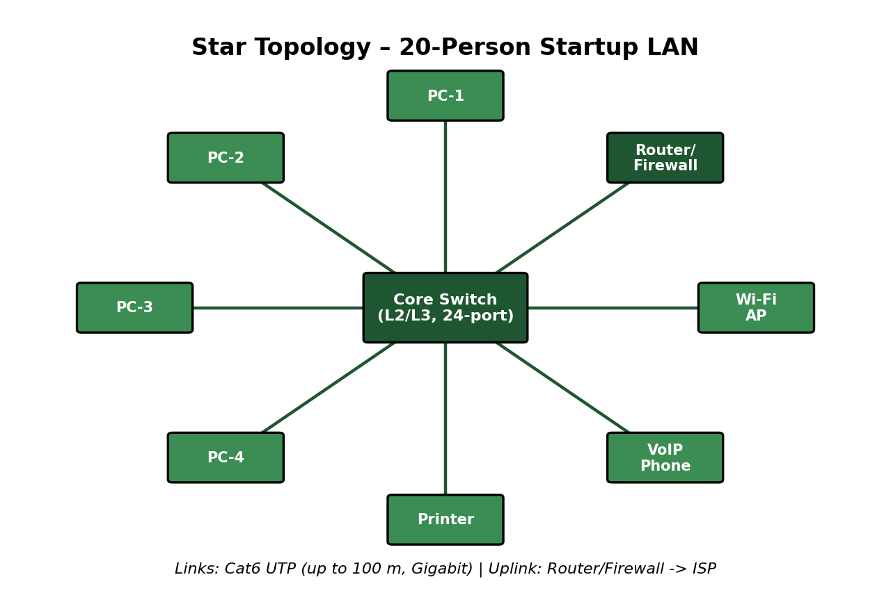
Figure 1.1 — Star-wired office LAN for the 20-seat startup (Set B).

1.3 Equipment Shortlist
Item | Suggested Product Line | Purpose
Access/Core Switch | Aruba Instant On 1960 / Netgear GS724T, 24-port PoE+ | Single wiring-closet switch serving the entire floor
Security Gateway | Ubiquiti UniFi Gateway or pfSense box | NAT, DHCP, firewall, VPN for remote staff
Wireless AP | Ubiquiti UniFi U6 or Aruba Instant On AP | Wi-Fi for staff laptops, phones, and guests
IP Phones | Any PoE SIP handset (Yealink, Grandstream) | Voice, powered directly from the switch
Shared Printer | Network-attached laser MFP | Print/scan services for all 20 staff
Backup Power | 1 kVA line-interactive UPS on the switch/gateway | Keeps the network alive through brief power cuts

1.4 Cabling and Transmission Standards
Run | Cable / Standard | Capability
Switch → each desk/phone/printer | Cat6 UTP, 568-B pinout | 100 m reach, 1 Gbps (10G to 55 m if needed later)
Switch → Wireless AP | Cat6 UTP, PoE+ fed | 100 m, powers the AP, no separate adaptor
Switch → Gateway | Cat6 copper | 1 Gbps internal uplink
Gateway → ISP hand-off | Per carrier (fibre ONT / cable modem) | As provisioned by the ISP

1.5 IP Plan
- Primary data subnet: 10.10.10.0/24, DHCP pool 10.10.10.50–150 for staff devices.
- Reserved addresses 10.10.10.2–10.10.10.20 for the switch, AP, gateway, and printer.
- A separate voice VLAN/subnet (10.10.20.0/24) is recommended once phone count exceeds ~10 handsets, to keep call quality independent of data bursts.

1.6 Why This Works
- One faulty cable/port = one affected desk, never the whole office.
- A single pane of glass (the switch's web UI) shows the entire office's connectivity status.
- Adding staff is a patch-cable exercise, not a network redesign.
- Troubleshooting time drops dramatically versus a shared-medium design.

1.7 Known Trade-offs
- The switch itself is a single point of failure — offset with a maintenance/replacement SLA and a spare unit held in reserve.
- Every device needs its own run back to the closet, so cable quantity is higher than a bus design — acceptable given the office is a single floor.

1.8 Commissioning Checks
- Certify every Cat6 run (wire-map, length, attenuation) before handover.
- Confirm each desk can reach the gateway and the public internet.
- Pull one cable deliberately and confirm no other seat is affected.
- Run a Gigabit throughput test between two desks to confirm the switch is not oversubscribed.
- Once phones are live, check call jitter/latency under simultaneous data load.
Summary: a single-switch star build gives this startup an office network that is cheap to install, trivial to fault-find, and ready to absorb headcount growth without rework.

Question 2 — Mesh Topology for a Bank's Core Network

2.1 Client Requirement
A retail bank has stated a hard requirement: transaction processing must not stop, because every second of downtime risks failed payments, regulatory penalties, and loss of customer trust. Unlike a typical office, budget is not the binding constraint here — availability is. The network must survive the loss of any single cable, port, switch, router, or WAN circuit without a visible interruption to banking applications, and it must be defensible against a compliance audit that checks for redundancy and secure, high-integrity links.

2.2 Design Approach — Mesh at the Core
The brief is answered with a meshed core: every critical core device — switches, routers, firewalls — is cross-connected to more than one peer, so there is always a second physical path available the instant the primary one fails. In practice this is deployed as a partial mesh (full mesh among the small number of core nodes is affordable; extending full mesh down to every access switch is not). Distribution switches take dual uplinks into two different core switches rather than meshing with each other, which delivers redundancy where it matters at a fraction of the cost of a true full mesh. Two independent, BGP-speaking edge routers connect to two different upstream ISPs over physically diverse paths, so a single fibre cut outside the building cannot take the bank offline. Fibre — not copper — is mandated for every core-to-core link because of its immunity to electrical interference and the very low latency it sustains, both of which matter directly to transaction integrity.
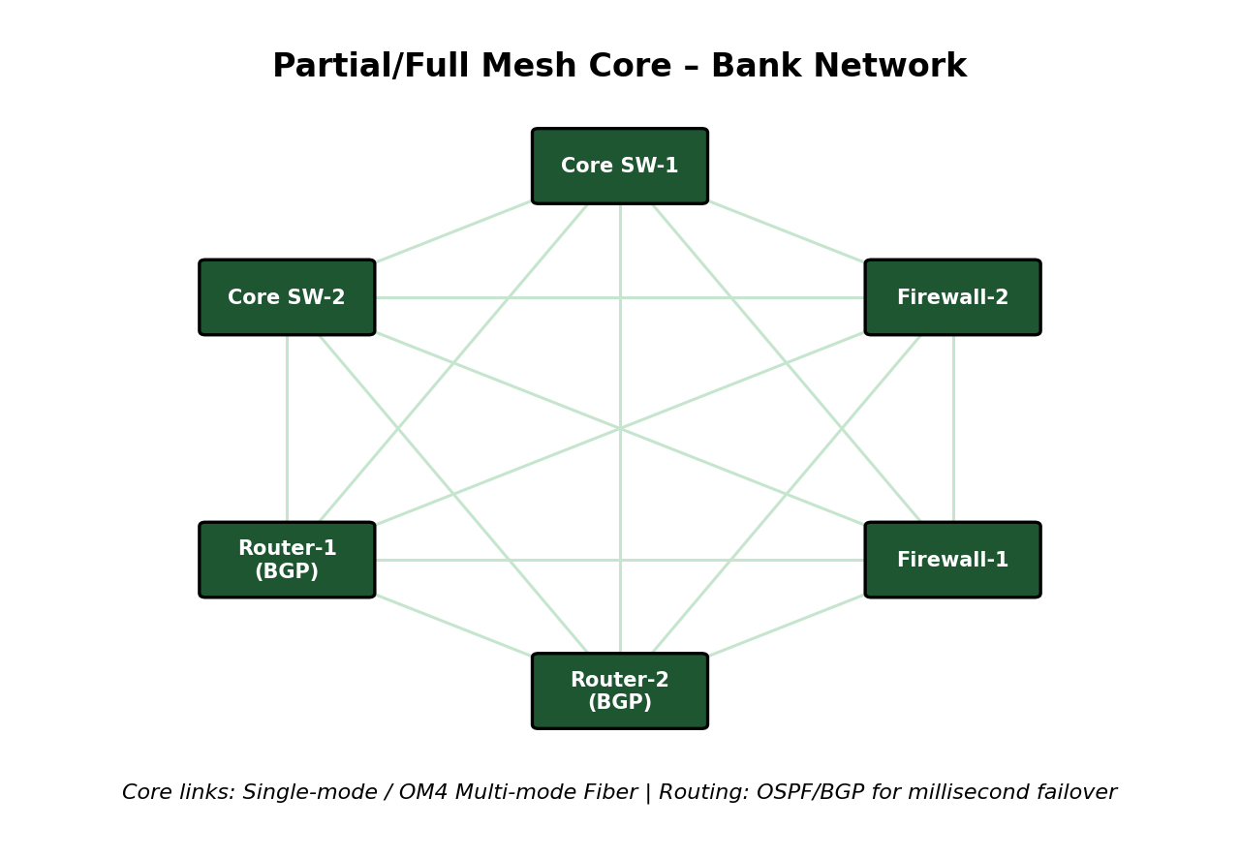
Figure 2.1 — Meshed core network for a bank's transaction-processing infrastructure (Set B).

2.3 Equipment Shortlist
Item | Suggested Product Line | Purpose
Edge Routers (pair) | Juniper MX / Cisco ASR, dual BGP peers | Redundant internet/WAN edge across two ISPs
Core Switch Fabric | Cisco Nexus or Arista 7000-series, meshed | High-throughput, loop-free meshed switching core
Firewall Cluster | Fortinet FortiGate or Palo Alto HA pair | Active-active/passive inspection and segmentation
Storage Array | Dual-controller SAN, RAID 10 | Redundant transaction-data storage
Facilities | Dual PSU per device, N+1 UPS, standby genset | Removes power as a single point of failure

2.4 Cabling and Transmission Standards
Run | Cable / Standard | Reason
Core-to-core, inter-building | Single-mode fibre (OS2) | Long reach, zero EMI susceptibility
Core-to-core, in-rack / in-DC | OM4 multi-mode fibre | High bandwidth over short data-centre spans
Distribution dual-uplinks | Diverse-path fibre or Cat6a copper | Two physically separate routes into the core
Access-layer drops | Cat6/Cat6a UTP | Teller and staff workstation connectivity

2.5 Routing and Redundancy Notes
- OSPF inside the meshed core for rapid re-convergence when a link drops.
- eBGP dual-homed to two ISPs, each on a separate physical entry point into the building.
- First-hop redundancy (VRRP) so distribution gateways never become a silent single point of failure.
- Multi-chassis link aggregation (vPC/MC-LAG) so backup links are actively forwarding, not sitting idle behind spanning-tree blocking.

2.6 Why This Works
- Any single link, device, or ISP outage is invisible to end users — traffic simply takes the alternate path.
- Fibre core delivers the latency and bandwidth headroom transaction systems need.
- Design maps directly onto the uptime and integrity expectations bank regulators audit for.
- New core nodes join the mesh without disturbing existing paths.

2.7 Known Trade-offs
- Materially higher build and running cost than a star/bus network — justified because the cost of an outage in banking far exceeds the hardware premium.
- More complex to configure and change-manage — controlled through strict change windows and automated config backup/rollback.

2.8 Commissioning Checks
- Pull each core fibre one at a time and time the re-convergence (target sub-second).
- Simulate an ISP outage on one edge router and confirm silent failover to the second.
- Stress-test the firewall cluster at projected peak transaction throughput.
- Run a full failover drill to the DR site and check recovery time/point objectives against policy.
- Confirm 24/7 SNMP/NetFlow monitoring is raising alerts to the NOC correctly.
Summary: only a meshed, fibre-based core with dual everything — links, routers, firewalls, power — meets a bank's near-zero-downtime mandate; star or bus designs cannot provide the required path redundancy.

Question 3 — Bus Topology for a Low-Budget Classroom Lab

3.1 Client Requirement
A school wants to network a single computer lab used for supervised browsing, office-suite work, and occasional file sharing between students and the instructor. The overriding constraint stated by the client is cost — there is effectively no budget line for a managed switch, redundant links, or professional installation, and the room will always be used under teacher supervision.

3.2 Design Approach — Bus Topology
Given the budget ceiling, a bus-style network is the rational choice because it removes the most expensive component of a star build — the central intelligent switch — from the bill of materials. In a traditional implementation, every PC taps directly onto a single coaxial backbone using T-connectors, with 50-ohm terminating resistors capping each end of the cable to stop signal reflection. A cheaper-to-source, modern equivalent achieves the same 'one shared line, no smart core' economics by daisy-chaining a basic unmanaged switch and Cat5e patch leads instead of coax — twisted-pair parts are now more available and easier to terminate than legacy coaxial hardware, while preserving the low cost and simplicity the client asked for. Neither variant needs a dedicated server: the instructor's own PC shares folders and a printer using the operating system's built-in sharing, which is entirely adequate for the lab's light, supervised workload.
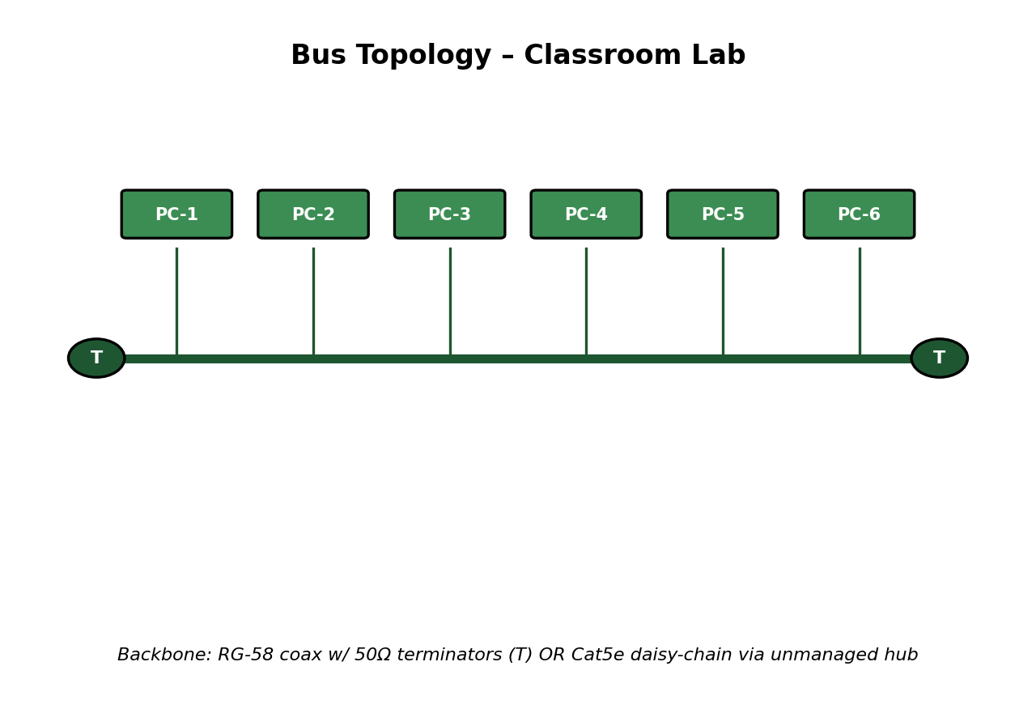
Figure 3.1 — Shared-backbone (bus) network for the school computer lab (Set B).

3.3 Equipment Shortlist
Item | Suggested Product Line | Purpose
Shared Backbone | RG-58 coax run (classic) OR Cat5e via unmanaged switch (modern) | Single line all lab PCs connect to
BNC T-Connectors | Generic BNC T-piece per station (coax variant) | Physically taps each PC onto the backbone
50-Ω Terminators | One per cable end (coax variant) | Prevents signal reflection/echo
Unmanaged Switch (modern variant) | Basic 8/16-port 100/1000 Mbps switch | Cheapest possible shared connectivity hub
Instructor PC | Existing lab PC, file/printer sharing enabled | Informal file and print server
Internet Modem/Router | Entry-level broadband router | Shared internet drop for the room

3.4 Cabling and Transmission Standards
Run | Cable / Standard | Notes
PC → Backbone (classic) | RG-58 coax, BNC connectors | 10 Mbps (10BASE2), ~185 m max segment
PC → Unmanaged Switch (modern) | Cat5e UTP | 100 m max, 100 Mbps–1 Gbps
Switch → Router | Cat5e/Cat6 UTP | Single shared internet uplink

3.5 Why This Works
- Removes the single biggest cost item (a managed switch) from the build.
- Cable footprint is smaller than a star, since students tap a shared line rather than each needing a dedicated home-run.
- Easy for non-specialist school staff to understand and maintain.

3.6 Known Trade-offs
- One cut cable disrupts the whole lab — accepted risk, managed by keeping spare cable and terminators on-site and scheduling changes outside class hours.
- More students online at once means more collisions — tolerable at typical classroom concurrency; can be upgraded to the unmanaged-switch variant if usage grows.
- No built-in fault isolation — compensated for by direct teacher supervision during lab sessions.

3.7 Commissioning Checks
- Verify backbone continuity and correct termination resistance before the first class uses the lab.
- Ping every lab PC from the instructor's machine to confirm full connectivity.
- Disconnect one station deliberately to demonstrate — and document — the shared-medium failure mode.
- Test simultaneous file access from two or three PCs to confirm acceptable performance under normal lab load.
Summary: a bus-style shared backbone (coax or its unmanaged-switch equivalent) gives the school the cheapest workable network for a supervised, light-usage lab, trading fault tolerance for a minimal bill of materials.

Question 4 — Hybrid Topology for a Multi-Building University Campus

4.1 Client Requirement
The university operates several buildings — lecture blocks, laboratories, a library, hostels, and administration — with thousands of simultaneous users and very mixed traffic (streaming lecture content, large lab file transfers, casual hostel browsing). The client needs backbone-level resilience so one building's link failure never isolates the rest of campus, building-level ease of management for the campus IT team, and cost efficiency inside high-density, budget-sensitive spaces like computer labs.

4.2 Design Approach — Hybrid, Three-Tier Model
No single topology satisfies all three needs, so the design combines them in the standard core–distribution–access hierarchy, which is what makes it 'hybrid.' At the top, campus core devices are interconnected in a ring or partial mesh over high-capacity single-mode fibre (10/40 Gbps), so a single inter-building fibre cut cannot cut off any building — traffic reroutes around the ring almost immediately. Each building's distribution switch takes two diverse fibre uplinks into that core. From the distribution switch downward, each building is wired as its own star, exactly as described for the startup office in Question 1: floor access switches fan out to individual rooms, giving the same per-cable fault isolation and easy management at building scale. Inside cost-sensitive computer labs, the access layer can fall back to the low-cost bus/unmanaged-switch pattern from Question 3 to save on switch ports where full per-seat redundancy is not needed. The result borrows mesh-grade resilience at the top, star-grade manageability in the middle, and bus-grade economy at the bottom — three topologies working together rather than one topology stretched to fit a job it isn't suited for.
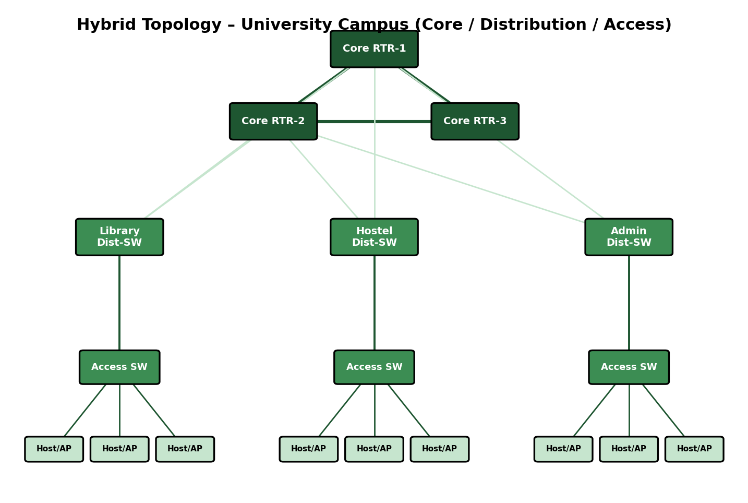
Figure 4.1 — Core / distribution / access hybrid design for the university campus (Set B).

4.3 Equipment Shortlist
Tier | Suggested Product Line | Purpose
Core | Arista 7280 / Cisco Catalyst 9500 core routers | Campus backbone, ring/partial-mesh interconnect
Distribution | Aruba CX 6300 or Cisco 9300 L3 switches (per building) | Aggregation, inter-VLAN routing, dual core uplinks
Access | Aruba/Cisco PoE access switches (per floor) | Room-level connectivity, PoE for APs/phones
Wireless | Aruba/Meraki Wi-Fi 6 APs with central controller | Campus-wide wireless, powered over Ethernet
Monitoring | PRTG/SolarWinds NMS | Central visibility across core, distribution, and access

4.4 Cabling and Transmission Standards
Run | Cable / Standard | Reach & Speed
Campus core ring/backbone | Single-mode fibre (OS2), 10/40 Gbps | Multi-km, EMI-immune
Building distribution uplinks (dual) | Single-mode or OM4 multi-mode fibre | Redundant high-speed aggregation
Access ↔ Distribution | Cat6a UTP or short fibre run | 100 m copper, longer on fibre
Access ↔ End devices/APs | Cat6 UTP with PoE+ | 100 m, 1 Gbps, powers APs/phones

4.5 Why This Works
- A ring/mesh backbone means no single inter-building fibre failure isolates a building.
- Star wiring inside each building keeps day-to-day fault-finding and moves/adds/changes simple for campus IT.
- Growth is additive — a new building means a new distribution switch and a fibre run to the core, nothing else changes.
- PoE removes the need for separate electrical work when deploying APs or VoIP phones.

4.6 Known Trade-offs
- More moving parts to design and document than a flat network — addressed with standardised per-tier configuration templates.
- Meaningful upfront fibre and hardware investment — offset by far lower ongoing outage and truck-roll costs at this scale.

4.7 Commissioning Checks
- OTDR-test every backbone fibre run before it goes live.
- Pull one core link and time how fast traffic reroutes around the ring/mesh.
- Repeat the Question-1 star fault-isolation test inside each building.
- Wireless site survey across lecture halls, library, and hostels to confirm coverage.
- Cross-campus throughput test between two distant buildings to confirm the backbone isn't the bottleneck.
Summary: combining mesh-like backbone resilience, star-like building manageability, and bus-like lab economy in one hierarchical hybrid design is what lets a campus this size stay both affordable and fault-tolerant.

Question 5 — Departmental Network with VLAN-Based Segmentation

5.1 Client Requirement
A company organised into HR, Finance, Sales, and IT departments wants each department's day-to-day traffic kept separate for security and performance, but still needs a practical way for departments to exchange approved traffic and reach the internet. Running a fully separate physical network per department would multiply cabling and hardware cost, so the client needs isolation achieved logically rather than physically.

5.2 Design Approach — Access/Core Switching with VLANs
The recommended structure uses one (or more) Layer 2 access switch per department feeding into a single Layer 3 core switch or router. Each department is assigned its own Virtual LAN; ports on the department's access switch are placed in that VLAN, so devices in the same department behave as if they shared a private switch, while any traffic destined for another department must pass through the Layer 3 core, where inter-VLAN routing and access-control lists decide what is and is not permitted. This gives the client the same practical isolation as separate physical networks — smaller broadcast domains, contained fault/security domains — without the expense of a second cable plant. The edge router provides the internet hand-off and firewall enforcement for all departments at a single, auditable choke point.
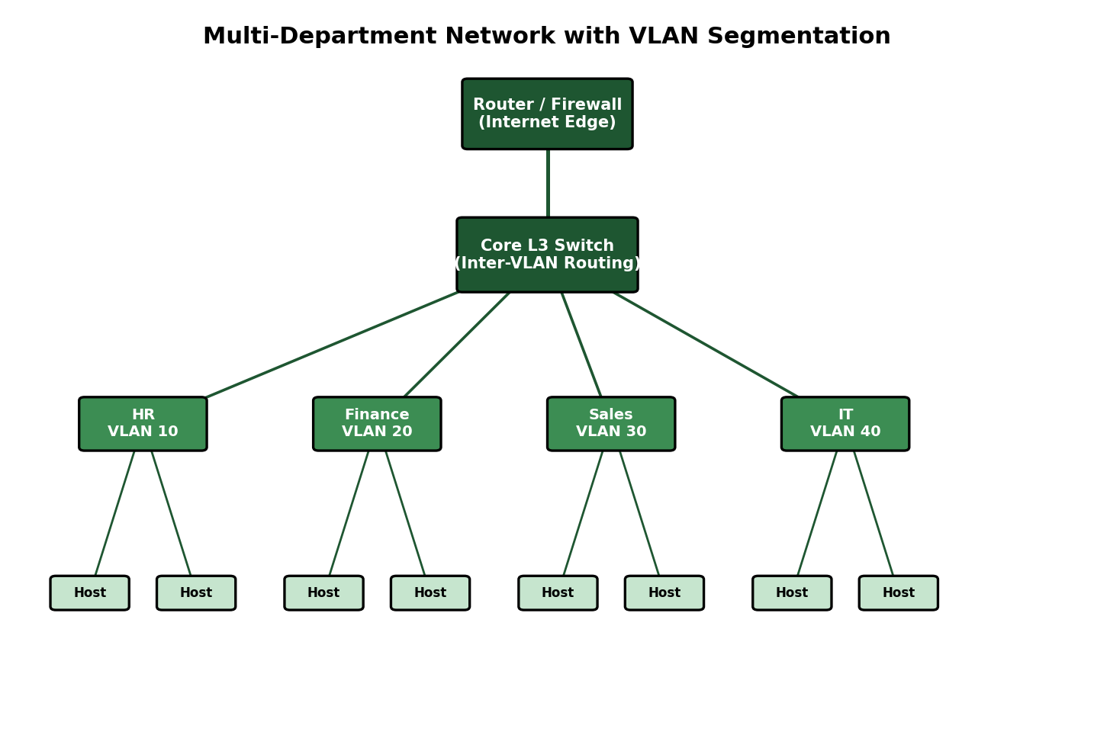
Figure 5.1 — Access/core VLAN-segmented departmental network (Set B).

5.3 Equipment Shortlist
Item | Suggested Product Line | Purpose
Access Switches (per dept.) | Aruba 2930F / Cisco 9200, VLAN-capable | Connects department end-devices on a dedicated VLAN
Core L3 Switch | Aruba CX 6300 or Cisco 3850, routed core | Inter-VLAN routing, ACL enforcement, 802.1Q trunking
Edge Router/Firewall | Fortinet FortiGate or Cisco ISR | Internet edge, NAT, firewall between departments and WAN

5.4 VLAN and Addressing Plan
Department | VLAN ID | Subnet | Access Notes
HR | VLAN 11 | 172.16.11.0/24 | Limited, logged access to Finance VLAN
Finance | VLAN 12 | 172.16.12.0/24 | Tightest ACLs of all departments; no Sales access
Sales | VLAN 13 | 172.16.13.0/24 | Access to the shared CRM/application subnet
IT | VLAN 14 | 172.16.14.0/24 | Elevated access for administration and monitoring
Shared Services | VLAN 90 | 172.16.90.0/24 | File/print/app servers reachable by all departments

5.5 Cabling and Transmission Standards
- Access switch to end-device: Cat6 UTP, 568-B termination, up to 100 m at 1 Gbps.
- Access switch to core switch: 802.1Q tagged trunk over Cat6a UTP or fibre, carrying every department's VLAN over one physical uplink.
- Core switch to edge router: routed Cat6/fibre link out to the internet edge.

5.6 Why This Works
- Security by default — cross-department traffic must pass an explicit, auditable ACL point rather than being open.
- Smaller broadcast domains keep per-department performance predictable.
- Staff moves between departments become a port re-assignment, not a re-cabling job.
- New departments are added as new VLANs, so the physical network never needs to be redesigned.

5.7 Known Trade-offs
- A trunking or VLAN-tagging mistake can leak traffic across departments — mitigated with VLAN pruning on trunks and scheduled configuration audits.
- The core switch is a single logical choke point — can be made redundant (VRRP pair) once the company's size justifies the extra cost.

5.8 Commissioning Checks
- Audit every access port's VLAN assignment against the intended department list.
- Attempt a denied cross-department flow (e.g., Sales → Finance) and confirm the ACL blocks it, then confirm an approved flow succeeds.
- Generate broadcast traffic in one VLAN and confirm it does not surface in another department's VLAN.
- Confirm every department subnet can reach the internet through the edge firewall.
- Move a test host's port to a different VLAN and confirm it immediately picks up the new department's addressing and access rules.
Summary: an access/core hierarchy with per-department VLANs delivers the isolation, security, and flexibility the client asked for, at a fraction of the cost of separate physical networks, and scales cleanly as the company adds departments or sites.

Rubric Self-Assessment Mapping
The table below maps each rubric criterion from Annexure A to the section of this answer set where it is addressed, to assist the evaluator.
Criteria | Weightage | Addressed In
Problem Analysis | 15% | Section X.1 (Client Requirement) of every question
Solution Design | 20% | Section X.2 (Design Approach)
Technical Implementation | 20% | Equipment shortlist + Addressing/VLAN plan tables
Use of Tools & Technologies | 10% | Equipment shortlist and cabling standard tables
Problem-Solving Approach | 10% | Consistent flow: requirement → design → equipment → checks
Innovation & Creativity | 10% | Layered hybrid design (Q4) and VLAN segmentation (Q5)
Testing & Validation | 5% | Section X.7/X.8 (Commissioning Checks) of every question
Documentation & Presentation | 5% | Diagrams, tables, and structured headings throughout
Teamwork / Collaboration | 5% | N/A — individual submission

