Exp. No: 15 DESIGN AND PERFORMANCE ANALYSIS OF PASSIVE OPTICAL NETWORK (PON) USING OPTISYSTEM
OBJECTIVES
- To design a wavelength-division multiplexed passive optical network (WDMPON) using OptiSystem.
- To transmit multiple optical channels through a common single-mode fiber and passive optical splitter.
- To evaluate the received signal quality using eye diagrams, Q-factor and biterror rate (BER).
SOFTWARE / HARDWARE REQUIRED
• OptiSystem Software
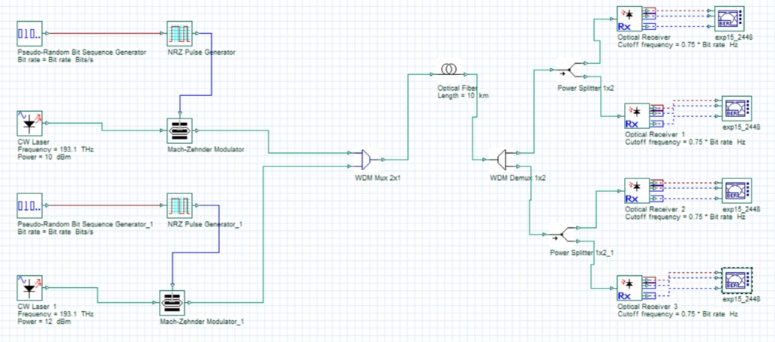
SIMULATION CIRCUIT

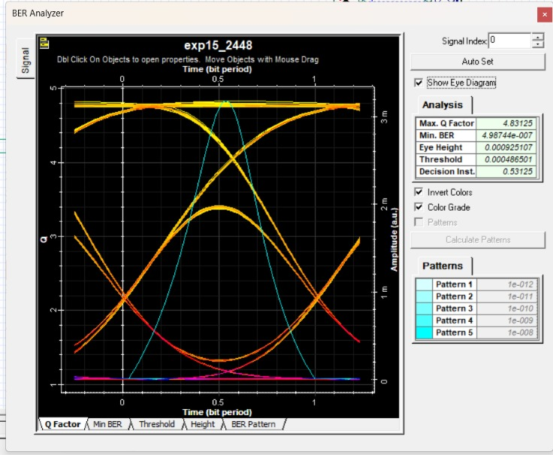
OUTPUT
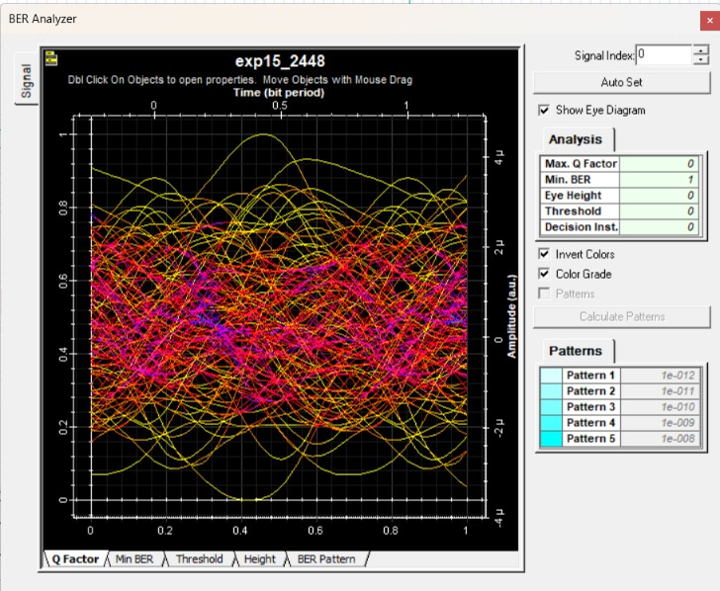
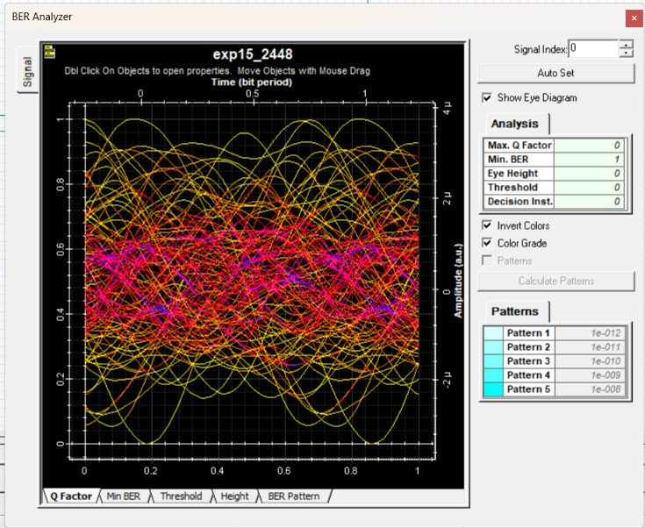
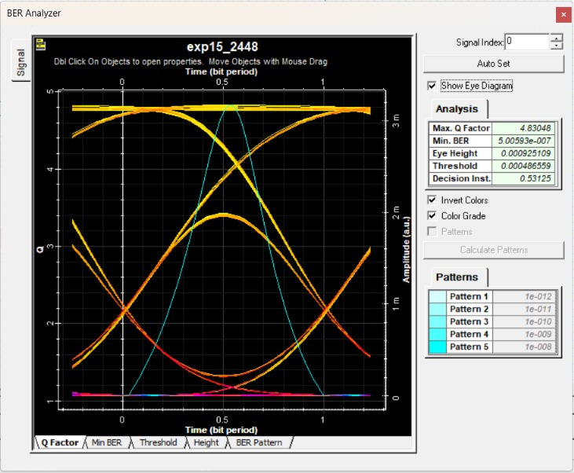
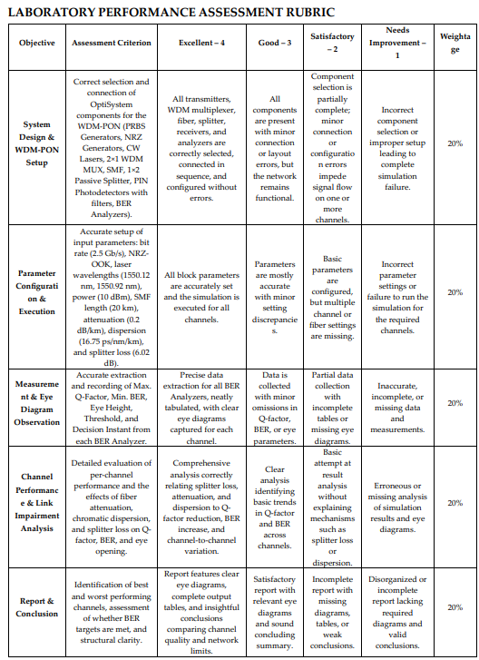
REFLECTION
This experiment provided practical knowledge of designing and analyzing a WDM Passive Optical Network (WDM-PON) using OptiSystem. Multiple optical channels were successfully transmitted through a common fiber and passive splitter, and their performance was evaluated using eye diagrams, Q-factor, and BER. The results confirmed that WDM-PON can efficiently support multiple users while maintaining good signal quality and reliable communication.
CONCLUSION
A WDM-PON system was successfully designed and tested using OptiSystem. Multiple wavelengths were multiplexed, transmi=ed through fiber, split, and detected at the receivers. Q-factor, BER, and eye-diagram results confirmed channel performance and showed the effects of a=enuation, dispersion, and spli=er loss, verifying the operation of the WDM-PON network.

