SIMATS ENGINEERING
ASSESSMENT TOOL

COURSE CODE:ECA1803 COURSE NAME: Optical Fiber Communication

Standards-Compliant Optical Fiber Link Design: From Communication Requirement to Deployment Decision
Course Outcome – CO1
Apply the concepts of guided modes in step-index and graded-index fibers, evaluate losses (Absorption, Scattering, Bending), dispersion mechanisms, and compensation techniques, including OSNR.
Nature of Assessment: Open-Ended Engineering Design Assignment Duration: 1 Week
Maximum Marks: 100
Primary Bloom’s Levels: K3 – Apply | K4 – Analyze | K5 – Evaluate | K6 – Create/Design

Code of Conduct:

I S HARIPRIYA (192412448) (Name / Reg No) certify that this submission is my original work and that I have adhered to the guidelines specified for this assessment.
I understand that any violation of academic integrity rules will result in disciplinary action.

Signature of the student: Priya

1. Introduction
This report designs a 60 km point-to-point optical link at 1550 nm that must carry 10 Gb/s today and remain upgradeable to 100 Gb/s. The work follows the path an engineer would take in practice: first translating the communication requirement into measurable optical targets, then choosing the fiber, closing the power budget, managing dispersion and polarization effects, checking signal quality (OSNR), and finally verifying every target before making a go/no-go deployment decision.
Every calculation is shown with its formula, substituted values and result, followed by a short interpretation of what the number means for the design. Four Design Decisions are recorded along the way and are brought together in the integrated link configuration in Section 7.
Table 1. Given design data
Parameter | Value
Link length / wavelength | 60 km / 1550 nm
Data rate | 10 Gb/s now (Tb = 100 ps), 100 Gb/s upgrade (Tb ≈ 10 ps)
Fiber A (step-index) | n₁ = 1.4500, n₂ = 1.4450, a = 4.0 µm
Fiber B (step-index) | n₁ = 1.480, n₂ = 1.465, a = 25 µm
Attenuation components | Absorption 0.04, Rayleigh 0.11, bending 0.03 dB/km
Transmitter / receiver | +3 dBm / −20 dBm sensitivity, 6 dB required margin
Connectors / splices | 4 × 0.4 dB / 10 × 0.08 dB
Building-entry bend loss | 0.8 dB (G.652.D), 0.1 dB (G.657.A)
Dispersion D | 17 ps/(nm·km) G.652.D, 4.5 ps/(nm·km) G.655
Source width / input pulse | 0.4 nm / 30 ps
DCF | −100 ps/(nm·km), 0.5 dB/km
PMD | 0.1 ps/√km, limit 0.1Tb
Birefringence | 1×10⁻⁷ (standard), 4×10⁻⁴ (PM)
OSNR inputs | Signal −16 dBm, ASE −39 dBm (0.1 nm), required 17 dB
Amplifier | Gain 14 dB, ASE increase 16 dB

2. Stage 1 – Interpreting the Communication Requirement

2.1 Why 1550 nm?
Silica fiber has its lowest loss near 1550 nm (≈0.18–0.2 dB/km) because Rayleigh scattering falls as 1/λ⁴ while infrared absorption has not yet risen. This band (C-band) also coincides with the gain window of erbium-doped fiber amplifiers (EDFAs), so a 60 km link can be amplified in the optical domain without regeneration. The price paid is a relatively large chromatic dispersion in standard fiber (≈17 ps/(nm·km)), which becomes the main design challenge of this report.
2.2 Ray versus wave behaviour
Ray (geometric) optics treats light as rays undergoing total internal reflection; it is a good model when the core is many wavelengths wide (V ≫ 1), as in multimode fiber, and gives NA, acceptance angle and modal delay. When the core is only a few wavelengths wide, light must be treated as an electromagnetic wave satisfying Maxwell’s equations with boundary conditions at the core–cladding interface. Only discrete field patterns (modes) can then propagate; this wave picture is required to explain single-mode operation, cut-off, mode-field diameter and polarization.
2.3 Coherence and polarization
A DFB laser with 0.4 nm spectral width is partially coherent; its finite linewidth is exactly what converts fiber dispersion into pulse broadening. The fundamental LP₀₁ mode is actually two orthogonally polarized modes. In an ideal circular core they travel at the same speed, but real fibers have small birefringence B, so the two polarizations drift apart (PMD) and the state of polarization evolves with a beat length L_B = λ/B.
2.4 NA, V-number, LP modes and cut-off
The numerical aperture NA = √(n₁² − n₂²) sets the light-gathering ability. The normalised frequency V = (2πa/λ)·NA combines geometry, index contrast and wavelength. In the weakly guiding approximation the modes are linearly polarized (LP) modes; only LP₀₁ propagates when V < 2.405, the first zero of the Bessel function J₀. The wavelength at which V = 2.405 is the cut-off wavelength λ_c; above λ_c the fiber is single-mode.
2.5 ITU-T fiber categories
Table 2. ITU-T fiber categories considered
Category | Key feature | Role in this link
G.652.D | Standard SMF, low water peak, D ≈ 17 ps/(nm·km), PMDQ ≤ 0.2 ps/√km | Main 60 km trunk
G.655 | Non-zero dispersion-shifted, D ≈ 2–10 ps/(nm·km) | Alternative trunk with lower dispersion
G.657.A | Bend-insensitive, fully G.652.D compatible | Building-entry sections with tight bends

2.6 Loss and power-budget quantities
Total attenuation combines intrinsic absorption, Rayleigh scattering and distributed micro/macro-bending. Point losses come from connectors, fusion splices and the building-entry bend. The power budget requires P_rx = P_tx − Σlosses to exceed the receiver sensitivity by the required system margin, which covers ageing, repairs and temperature effects.
2.7 Dispersion and compensation
- Modal (intermodal) dispersion – different modes arrive at different times; present only in multimode fiber.
- Chromatic dispersion – material plus waveguide dispersion; Δτ = D·Δλ·L.
- Polarization-mode dispersion (PMD) – random differential group delay between polarizations, growing with √L.
- Compensation – dispersion-compensating fiber (DCF) with negative D, fiber Bragg gratings, or electronic/coherent DSP.

2.8 OSNR and its relation to BER
Optical signal-to-noise ratio compares signal power with amplified spontaneous emission (ASE) noise measured in a 0.1 nm reference bandwidth. OSNR fixes the electrical Q-factor at the receiver, and BER ≈ ½·erfc(Q/√2): a 1 dB loss of OSNR near threshold can raise BER by more than an order of magnitude. Required OSNR here is 17 dB.
2.9 Practical constraints
- Tight bends at building entry demand a bend-insensitive fiber.
- Field-installable, standards-compliant components only (ITU-T categories).
- The design must not block a later move to 100 Gb/s, where the bit period shrinks to 10 ps.
- Cost and complexity should stay modest: a single amplifier site and passive compensation are preferred.
Design Requirement Statement
Design a 60 km, 1550 nm single-mode link using ITU-T categorised fiber that delivers 10 Gb/s with a received power at least 6 dB above −20 dBm, an output pulse width below the 100 ps bit period, PMD below 0.1Tb, and OSNR ≥ 17 dB (0.1 nm), while tolerating tight building-entry bends and offering a clear upgrade path to 100 Gb/s.

3. Stage 2 – Fiber and Propagation Selection
3.1 Numerical aperture and V-number
Fiber A:
NA = √(n₁² − n₂²) (1)
= √(1.4500² − 1.4450²) = √(2.102500 − 2.088025) = √0.014475
NA_A = 0.1203
V = (2πa / λ)·NA (2)
= (2π × 4.0 µm / 1.55 µm) × 0.1203
V_A = 1.951 (< 2.405)
Fiber B:
NA = √(1.480² − 1.465²) = √(2.190400 − 2.146225) = √0.044175 (3)
NA_B = 0.2102
V = (2π × 25 µm / 1.55 µm) × 0.2102 (4)
V_B = 21.30 (≫ 2.405)
3.2 Mode count of Fiber B
M ≈ V² / 2 (step-index) (5)
= 21.30² / 2
M ≈ 227 modes
Roughly 227 guided modes travel in Fiber B. Even a simple ray estimate of its step-index modal delay, ΔT/L ≈ n₁Δ/c, gives about 50.0 ns/km, i.e. microseconds over 60 km – thousands of times the 100 ps bit period.
3.3 Cut-off condition of Fiber A
λ_c = 2πa·NA / 2.405 (6)
= 2π × 4.0 µm × 0.1203 / 2.405
λ_c ≈ 1257 nm
Because 1550 nm > λ_c ≈ 1257 nm (equivalently V = 1.95 < 2.405), only LP₀₁ propagates: Fiber A is single-mode at the operating wavelength and also remains single-mode in the O-band above 1260 nm, consistent with G.652 cable cut-off requirements. Fiber B is multimode.
Table 3. Propagation parameters of the candidate fibers
Quantity | Fiber A | Fiber B
Relative index difference Δ | 0.345 % | 1.014 %
Numerical aperture | 0.1203 | 0.2102
V-number @ 1550 nm | 1.951 | 21.30
Guided modes | 1 (LP₀₁) | ≈ 227
Cut-off wavelength | ≈ 1257 nm | – (multimode)
Classification | Single-mode | Multimode

3.4 When is ray theory enough?
Ray theory is adequate for Fiber B: its core is 50 µm wide (≈32 wavelengths), V ≈ 21, and hundreds of modes behave almost like a continuum of rays, so acceptance angle and modal delay are well predicted. For Fiber A, with V ≈ 1.95, the core is comparable to the wavelength and rays cannot explain why only one field pattern survives. Here the wave equation derived from Maxwell’s equations must be solved; its LP-mode solutions give the cut-off condition, the mode-field diameter and the two polarization states that matter for PMD.
3.5 Comparison of fiber types
Table 4. Comparison of propagation alternatives
Property | Single-mode (SMF) | Step-index MMF | Graded-index MMF
Core diameter | 8–10 µm | 50–200 µm | 50/62.5 µm
Modal dispersion | None | Very high (∼50 ns/km) | Low (∼0.1–1 ns/km)
Bandwidth–distance | > 100 Gb/s·km scale | ∼20 MHz·km | ∼0.5–5 GHz·km
Loss @ 1550 nm | ≈0.18–0.2 dB/km | Higher | Higher
Typical reach | 10–100+ km | < 1 km | < 2 km at 10 Gb/s
EDFA compatible | Yes | No | No
Suitable for 60 km? | Yes | No | No

Design Decision 1 – Fiber and propagation regime
Selected: Fiber A, single-mode, implemented as ITU-T G.652.D for the 60 km trunk with G.657.A for building-entry sections.
Justification: V = 1.95 < 2.405 guarantees single-mode operation (λ_c ≈ 1257 nm), which removes modal dispersion entirely. Fiber B carries ≈227 modes and its modal dispersion makes 10 Gb/s over 60 km impossible. G.657.A is splice- and mode-field-compatible with G.652.D and cuts the building-entry bend loss from 0.8 dB to 0.1 dB.

4. Stage 3 – Optical Power Budget
4.1 Attenuation and fiber loss
α = α_abs + α_Rayleigh + α_bend (7)
= 0.04 + 0.11 + 0.03
α = 0.18 dB/km
A_fiber = α·L (8)
= 0.18 dB/km × 60 km
A_fiber = 10.8 dB
A_conn + A_splice = 4 × 0.4 + 10 × 0.08 (9)
= 1.6 + 0.8
= 2.4 dB
4.2 Total link loss, received power and margin
A_total = A_fiber + A_conn + A_splice + A_bend (10)
G.652.D: 10.8 + 1.6 + 0.8 + 0.8 = 14.0 dB
G.657.A: 10.8 + 1.6 + 0.8 + 0.1 = 13.3 dB
P_rx = P_tx − A_total (11)
G.652.D: 3 − 14.0 = -11.0 dBm
G.657.A: 3 − 13.3 = -10.3 dBm
M = P_rx − S_rx (12)
G.652.D: -11.0 − (−20) = 9.0 dB
G.657.A: -10.3 − (−20) = 9.7 dB
Table 5. Power budget (before dispersion compensation)
Item | G.652.D variant (dB) | G.657.A entry variant (dB)
Fiber, 60 km × 0.18 dB/km | 10.8 | 10.8
4 connectors | 1.6 | 1.6
10 splices | 0.8 | 0.8
Building-entry bend | 0.8 | 0.1
Total link loss | 14.0 | 13.3
Received power (dBm) | -11.0 | -10.3
Margin over −20 dBm | 9.0 | 9.7
Meets 6 dB requirement? | Yes | Yes

Both variants clear the 6 dB target with about 3 dB to spare. The dominant loss mechanism is distributed fiber attenuation (10.8 dB, ≈77 % of the total), and within it Rayleigh scattering (0.11 of 0.18 dB/km) is the largest term – an intrinsic property of silica that cannot be removed by installation quality.
Two practical loss-reduction actions:
- Use G.657.A at building entry – saves 0.7 dB of bend loss with no compatibility penalty.
- Reduce connectors and splices – replace patch connectors with fusion splices and specify low-loss (≤0.05 dB) splices; alternatively use ultra-low-loss (pure-silica-core) G.652 fiber at ≈0.16 dB/km, saving ≈1.2 dB.
Design Decision 2 – Power budget
Use G.652.D trunk with G.657.A building-entry sections: total loss 13.3 dB, received power -10.3 dBm, margin 9.7 dB ≥ 6 dB. The unamplified budget closes, but the ~3.7 dB surplus is too small to absorb a dispersion-compensation module later; this is carried forward into Stage 4.

5. Stage 4 – Dispersion and Polarization Management
5.1 Modal dispersion
Fiber A supports only LP₀₁, so there is no second mode to arrive late: modal dispersion is absent. In Fiber B ≈227 modes follow different path lengths and modal dispersion dominates every other effect. A graded-index profile, where the index falls parabolically from the axis, lets the longer off-axis rays travel faster in lower-index glass, equalising transit times and reducing modal dispersion by roughly a factor of Δ/8 (two to three orders of magnitude).
5.2 Chromatic dispersion and pulse broadening
Δτ = D·Δλ·L (13)
G.652.D: 17 × 0.4 × 60 = 408 ps
G.655: 4.5 × 0.4 × 60 = 108 ps
τ_out = √(τ_in² + Δτ²) (14)
G.652.D: √(30² + 408²) = 409.1 ps
G.655: √(30² + 108²) = 112.1 ps
Both values exceed the 100 ps bit period. With G.652.D the pulse spreads over about four bit slots, so energy from a ‘1’ lands in neighbouring ‘0’ slots – severe inter-symbol interference (ISI) and an eye that is effectively closed. G.655 is far better but still ≈12 ps too wide, so neither fiber works uncompensated at 10 Gb/s.
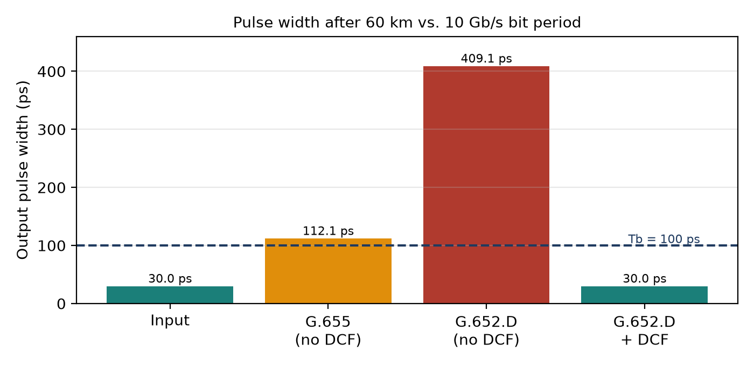
Figure 1. Output pulse width compared with the 10 Gb/s bit period

5.3 Dispersion-compensating fiber for G.652.D
D_SMF·L_SMF + D_DCF·L_DCF = 0 ⇒ L_DCF = D_SMF·L_SMF / |D_DCF| (15)
= 17 × 60 / 100
L_DCF = 10.2 km
A_DCF = 0.5 dB/km × L_DCF (16)
= 0.5 × 10.2
A_DCF = 5.1 dB
P_rx = P_tx − (A_total + A_DCF) (17)
= 3 − (14.0 + 5.1) = -16.1 dBm
Margin = -16.1 + 20 = 3.9 dB (< 6 dB)
Full first-order compensation restores the 30 ps pulse but costs 5.1 dB, and the margin drops to 3.9 dB – below the 6 dB requirement. The DCF therefore has to be paired with the 14 dB amplifier analysed in Stage 5, which lifts the received power to -2.1 dBm (margin 17.9 dB). The receiver must tolerate this level (most 10G PIN receivers overload near 0 dBm), or a fixed attenuator/gain setting can trim it.
5.4 Polarization-mode dispersion
Δτ_PMD = D_PMD·√L (18)
= 0.1 × √60
Δτ_PMD = 0.77 ps
Table 6. PMD check against the 0.1Tb criterion
Bit rate | Tb | Limit 0.1Tb | PMD (60 km) | Satisfactory?
10 Gb/s | 100 ps | 10 ps | 0.77 ps | Yes – 13× headroom
100 Gb/s | ≈10 ps | 1 ps | 0.77 ps | Yes – small headroom

PMD is comfortable at 10 Gb/s and still within limit at 100 Gb/s, though only by ≈0.2 ps. Because PMD is statistical, older or poorly cabled fiber could exceed this. Mitigation: deploy 100 Gb/s with coherent detection and DSP-based polarization demultiplexing/equalisation, which tolerates tens of ps of DGD; specifying low-PMD fiber (PMDQ ≤ 0.06 ps/√km) is a passive alternative.
5.5 Birefringence and beat length
L_B = λ / B (19)
Standard: 1.55×10⁻⁶ / 1×10⁻⁷ = 15.5 m
PM fiber: 1.55×10⁻⁶ / 4×10⁻⁴ = 3.875 mm
Standard fiber’s 15.5 m beat length means the polarization state wanders randomly along the link, but an intensity-modulated direct-detection receiver measures power only and is polarization-insensitive. PM fiber (L_B ≈ 3.9 mm) holds polarization rigidly, but it is expensive, glossier, not an ITU-T transmission category and hard to splice over 60 km. PM fiber is not required; it is only justified for polarization-sensitive devices such as interferometric sensors or modulator pigtails.
Design Decision 3 – Dispersion and polarization
Use G.652.D with a 10.2 km DCF module (−100 ps/(nm·km)) for full first-order compensation, standard (non-PM) fiber, and rely on the low 0.1 ps/√km PMD coefficient (0.77 ps over 60 km). G.655 alone still broadens pulses to 112 ps, so compensation is unavoidable; DCF on G.652.D is the standard, field-proven route and keeps the plant compatible with G.657.A tails. The DCF loss is recovered by the amplifier in Stage 5.

6. Stage 5 – OSNR and Amplification
6.1 Definition and measurement
OSNR is the ratio of signal power to ASE noise power within a fixed optical reference bandwidth, conventionally 0.1 nm (≈12.5 GHz at 1550 nm). On an optical spectrum analyser the signal peak is read with the resolution bandwidth set to 0.1 nm, and the noise floor is interpolated from either side of the channel (or measured in-band with polarization nulling for high-speed signals). In logarithmic units:
OSNR (dB) = P_signal (dBm) − P_ASE,0.1nm (dBm) (20)
= −16 − (−39)
OSNR₀ = 23 dB
6.2 Effect of the 14 dB amplifier
P_s,out = P_s,in + G (21)
= −16 + 14
P_s,out = -2 dBm
P_ASE,out = P_ASE,in + 16 dB (22)
= −39 + 16
P_ASE,out = -23 dBm
OSNR₁ = P_s,out − P_ASE,out (23)
= -2 − (-23)
OSNR₁ = 21 dB; margin = 21 − 17 = 4 dB
The amplifier raises the signal by 14 dB but the noise by 16 dB, so OSNR falls by 2 dB (an effective noise contribution consistent with a typical EDFA). The result, 21 dB, still exceeds the 17 dB requirement with 4 dB margin.
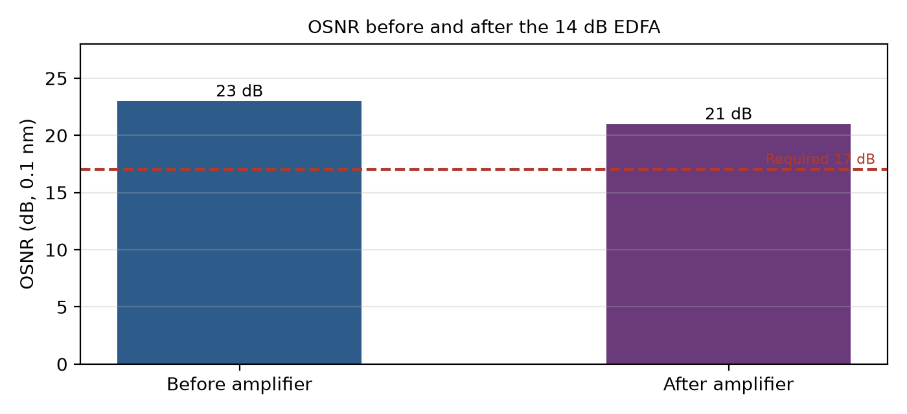
Figure 2. OSNR before and after amplification relative to the 17 dB requirement
6.3 What happens if OSNR is inadequate?
Lower OSNR means more signal–ASE beat noise at the photodiode, which widens the ‘1’ and ‘0’ levels of the eye. Q-factor drops roughly in proportion to √OSNR, and because BER ≈ ½·erfc(Q/√2) falls steeply, the link moves quickly from BER ≈ 10⁻¹² (Q ≈ 7) to 10⁻⁹ (Q ≈ 6) and below the FEC threshold. Any OSNR margin consumed by noise is margin no longer available for ageing, repairs or the 100 Gb/s upgrade, which needs roughly 10 dB more OSNR for the same modulation unless coherent detection and FEC are used.
Two OSNR-improvement measures:
- Use a low-noise-figure EDFA (NF ≤ 5 dB) placed where signal power is still high, e.g. as a booster after the transmitter or mid-span, so less ASE is added relative to the signal.
- Add a narrow optical band-pass filter (≈1 nm) before the receiver and/or use FEC, which relaxes the required OSNR by several dB.

7. Stage 6 – Verification and Integrated Link Configuration

7.1 Verification table
Table 7. Final verification of design targets
Requirement | Specified target | Achieved value | Satisfactory?
Modal condition | Single-mode at 1550 nm (V < 2.405) | V = 1.95, λ_c ≈ 1257 nm | Yes
Link loss (incl. DCF) | Closable with available power | 18.4 dB, offset by 14 dB gain | Yes
Received power & margin | ≥ −14 dBm (6 dB margin) | -1.4 dBm, margin 18.6 dB* | Yes
Pulse broadening | τ_out < 100 ps | 30 ps after 10.2 km DCF (408 ps uncompensated) | Yes
PMD | ≤ 10 ps (10G), ≤ 1 ps (100G) | 0.77 ps | Yes
OSNR | ≥ 17 dB @ 0.1 nm | 21 dB (margin 4 dB) | Yes
Bend tolerance | Tight building-entry bends | G.657.A, 0.1 dB | Yes

*Values for the recommended G.657.A building-entry configuration; with G.652.D at the entry point the received power is -2.1 dBm (margin 17.9 dB), which also passes.
7.2 Integrated link configuration
Table 8. Integrated link parameters
Parameter | Final setting
Trunk fiber | ITU-T G.652.D single-mode, 60 km, 0.18 dB/km
Building-entry fiber | ITU-T G.657.A (bend-insensitive), both ends
Transmitter | 1550 nm DFB, +3 dBm, 0.4 nm spectral width
DCF length | 10.2 km, −100 ps/(nm·km), 5.1 dB
Amplifier | EDFA pre-amplifier after DCF, gain 14 dB, low NF
Received power | ≈ -1.4 dBm (receiver overload to be verified / trimmed)
Residual dispersion | ≈ 0 ps/nm (first-order)
PMD | 0.77 ps
OSNR at receiver | 21 dB (0.1 nm)

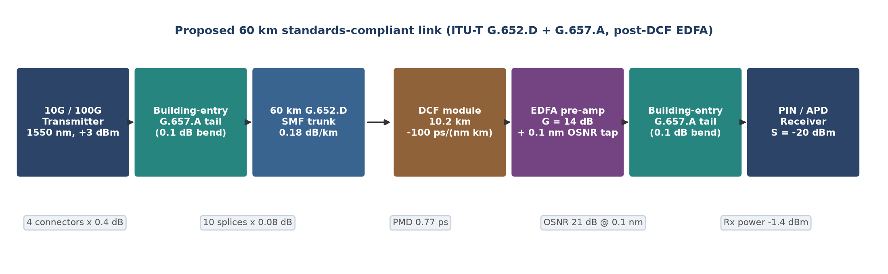
Figure 3. Block diagram of the proposed 60 km, 1550 nm link
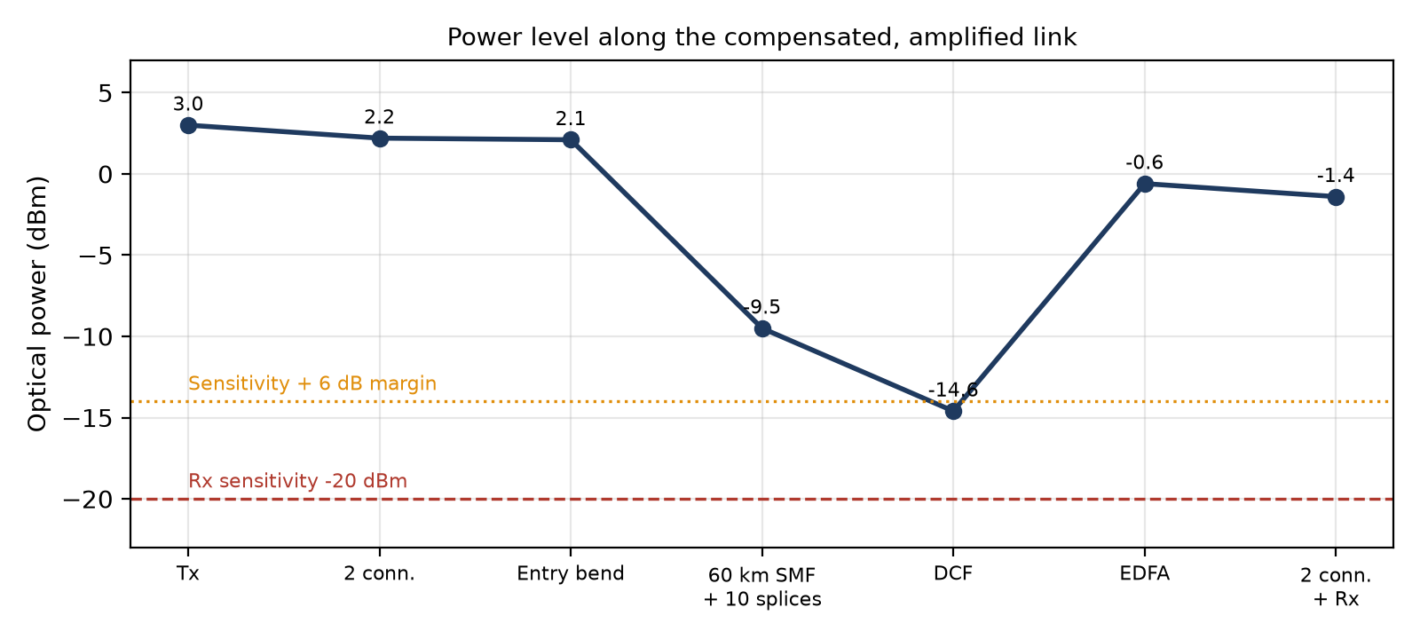
Figure 4. Power level diagram along the link
- OSNR strategy: one low-NF EDFA after the DCF; 0.1 nm OSNR monitored at the amplifier tap; optical band-pass filter at the receiver.
- Dispersion/PMD arrangement: lumped DCF at the receive end gives full first-order compensation; low-PMD standard fiber, no PM fiber.
- Power budget: 13.3 dB passive loss + 5.1 dB DCF, recovered by 14 dB gain; margin well above 6 dB.
- Fiber/propagation choice: single-mode LP₀₁ operation (V ≈ 1.95); G.652.D for low loss and EDFA compatibility, G.657.A where bends are tight – both ITU-T standardised and mutually spliceable.

8. Final System Design (K6)
The complete 60 km design is a single-span, amplified, dispersion-compensated link. A +3 dBm, 1550 nm DFB transmitter launches into a short G.657.A building-entry cable, which is fusion-spliced to the 60 km G.652.D trunk (10 splices in total along the route). At the receive site, a 10.2 km DCF module cancels the 1020 ps/nm of accumulated dispersion, and a 14 dB EDFA restores the signal before a second G.657.A building-entry section and the receiver. Four connectors are kept at patch-panel interfaces only.

8.1 Upgrade path to 100 Gb/s
Table 9. Upgrade path from 10 to 100 Gb/s
Aspect | 10 Gb/s (now) | 100 Gb/s (upgrade)
Modulation / detection | NRZ-OOK, direct detection | DP-QPSK coherent with DSP
Dispersion handling | 10.2 km DCF | DSP compensation; DCF bypassed (saves 5.1 dB)
PMD tolerance | 0.77 ps vs 10 ps limit | 0.77 ps vs 1 ps (OOK); DSP tolerates far more
OSNR requirement | 17 dB | ≈12–15 dB with SD-FEC for DP-QPSK
Fiber plant | G.652.D + G.657.A | Unchanged – no re-cabling

Because the fiber plant is standard G.652.D/G.657.A, the upgrade only changes terminal equipment. Coherent receivers compensate chromatic dispersion and PMD electronically, so the DCF can be removed, recovering 5.1 dB of loss and avoiding DCF nonlinearity. A 100 Gb/s on-off-keyed system would not be viable (Δτ and PMD near the 10 ps bit period), which is why the coherent route is specified.
9. Final Engineering Decision
Is the proposed design suitable for deployment? YES
The link as configured in Section 7 (G.652.D + G.657.A, 10.2 km DCF, 14 dB EDFA) meets every requirement. Note that the bare, uncompensated G.652.D link would be a NO because of 409 ps pulse broadening; the design decisions above are the redesign that turns it into a YES.

Table 10. Evidence for the final engineering decision
Criterion | Evidence | Verdict
Fiber suitability | Fiber A single-mode (V = 1.95); Fiber B ≈227 modes rejected | Yes
Bandwidth–distance | No modal dispersion; chromatic dispersion fully compensated | Yes
Loss and power | Rx ≈ -1.4 dBm vs −14 dBm required | Yes
Dominant loss & optimisation | Fiber attenuation (Rayleigh); G.657.A entry, fewer connectors | Yes
Dispersion and PMD | 30 ps output pulse; PMD 0.77 ps < 10 ps | Yes
OSNR | 21 dB vs 17 dB required | Yes
10 Gb/s now, 100 Gb/s later | Same fiber plant; coherent DSP upgrade | Yes

10. Concluding Summary
Starting from the requirement of a 60 km, 1550 nm, 10 Gb/s link, the analysis selected single-mode Fiber A (implemented as ITU-T G.652.D) because its V-number of 1.95 eliminates modal dispersion, and added G.657.A at building entry to tolerate tight bends. The passive power budget closed with 9.7 dB margin, but chromatic dispersion of 408 ps made the bare link unusable. A 10.2 km DCF restores the pulse to 30 ps, and a single 14 dB EDFA recovers the DCF loss while keeping OSNR at 21 dB. PMD (0.77 ps) and polarization effects are benign, so PM fiber is unnecessary. The resulting design is standards-compliant, verifiably meets every target and can move to 100 Gb/s by changing only the terminal equipment.

